Microparticle suspensions and bacteria laden droplets: Are they the same in terms of wetting signature?
Kiran Raj M, Sirshendu Misra and Sushanta K. Mitra*
Micro & Nano-scale Transport Laboratory, Waterloo Institute for Nanotechnology, Department of Mechanical and Mechatronics Engineering, University of Waterloo, 200 University Avenue West, Waterloo, Ontario N2L 3G1, Canada
* Corresponding author: skmitra@uwaterloo.ca

Abstract
Adhesion behavior of microbial pathogens on commonly encountered surfaces is one of the most pertinent questions now. We present the characterization of bacteria laden droplets and quantify the adhesion forces on highly repellent surfaces with the help of a simple experimental setup. Comparing the force signature measured directly using an in-house capillary deflection based droplet force apparatus, we report an anomalous adhesion behavior of live bacteria (E. coli) laden droplets on repellent surfaces, which stands in stark contrast to the observed adhesion signature when the doping agent is changed to inert microparticles or the same bacteria in an incapacitated state. We showed that the regular contact angle measurements using optical goniometry is unable to differentiate between the live bacteria and the dead ones (including microparticles) and thus delineate its limitations and the complementary nature of the adhesion measurements in understanding the fundamental interfacial interaction of living organisms on solid surfaces.

Introduction
Understanding the adhesion of microbial pathogens is of critical interest with implications in both personal and public health and has far reaching consequences during pandemics like COVID-19. One of the serious questions that is still under scrutiny is the nature of adhesion and subsequent survival of these microbes on surfaces like glass and metals which are ubiquitous in our daily lives. A clear understanding of the mechanism of surface adhesion of these microbes will enable us to design and develop surfaces and surface specific treatments as engineering strategies to mitigate the severe consequences of an impending pandemic and to address the larger issue of public health risks in community spaces.
The model candidates for lab scale studies of pathogens is E. coli, a gram-negative bacterium that is found in the human intestine, enjoying a symbiotic relationship.¹ It an important candidate in the research community due its ease of use and the availability of the literature, especially the vast amount of genetic data and detailed taxonomical management.² The colony formation and the biofilm development are of considerable interest in the recent times that underpins the synergistic effects of the bacterial growth with the host surface.³ E.coli find significant applications in diverse areas of science and engineering^{4–6} including microfluidics⁷, carbon sequestration⁸, superfluids⁹ and as a pedagogical tool.^{1,10} Though there are many useful applications, it remains a public health hazard, posing danger as outbreaks and adversely affecting the community hygiene plans.⁶ The severity of such events depends on the ease of transmission and one of the most effective way is to utilize surfaces that do not promote bacterial growth by introducing antibacterial agents.¹¹ Another strategy is to deploy liquid repellant surfaces which have gained considerable momentum in the last few decades in the context of ‘superhydrophobic’ or extremely water repellent surfaces which typically show a static water contact angle in air greater than 150⁰.^{12,13} A plethora of fabrication techniques have been employed to create superhydrophobic surfaces from artificially engineered coatings^{14,15} and more readily available soot particles^{16–18} which rely on the Cassie-Baxter state of wetting to repel water droplets easily.¹² A first step to understand the interaction of microbe-laden droplet on superhydrophobic surfaces is to employ microparticles as surrogates.^{19,20} However, the interaction of microbial pathogens like E.coli with these surfaces are still not explored in detail²¹ although there are a number of studies on bioactive components like vesicles²² red blood cells.²³ From a theoretical perspective, there are two approaches in understanding the bacterial adhesion: DLVO (Derjaguin–Landau–Verwey– Overbeek) theory^{24,25} and thermodynamics.^{26,27} In the former, the free energy is treated as a balance between the van der Waals forces and electrostatic forces whereas in the latter, the free energy is described in terms of the interfacial tensions between the bacteria, the solid substrate and the surrounding fluid medium.
Traditionally, the wetting characterization for such microbes on typical surfaces is the contact angle based measurements.²⁸ Advanced approaches, such as the droplet based adhesion measurement is an important tool in terms of modified substrates and underwater scenarios. In a recent study,³² a cantilever based droplet system was utilized to quantify accurately the adhesion and friction forces between the microparticle laden droplets and the solid substrate. In their experiments, they have used surfaces with different degrees of superhydrophobicity and established that the force-based measurements (such as adhesion) often provide a better understanding of the interfacial interaction of microparticle laden droplets on solid substrates.
Literature suggest that contact angle measurements have been the primary tool to characterize the repellency of E.coli on superhydrophobic surfaces.^{21,33} However, its direct signature on the adhesion force on such surfaces has never been reported. It is to be noted that the use of E. coli as a model microorganism still requires a certified Bio Safety Level II facility. Therefore, often a simplified approach^{34,35} is taken where colloidal microparticles are used as surrogates to mimic bacteria-surface interaction. This stems from the reports^{24,36} that a physico-chemical description involving colloidal principles might suffice to provide a qualitative understanding of the ensuing dynamics in the initial stage of adhesion. However, this assumption does not account for the viability and motility of bacterial cells. In this study, through direct measurement of adhesion forces, we attempt to critically evaluate the applicability of inert colloidal particles as suitable bacterial surrogates.
The present work combines the simplicity of an in-house developed adhesion measurement device with the complex interfacial dynamics of the bacterial movement within a droplet that interacts with a hydrophobic surface. The complementary nature of force-based approach is extended from inert microparticles to motile bacteria, adding the complexity of a living organism within a fluidic environment conducive for performing its physiological functions under various fluids of biophysical interest. It aims to provide a more accurate picture of the wetting signature for living microorganisms such as E. coli and look more closely on the validity of microparticle/microbeads as a surrogate model.

Experimental
For contact angle measurements (static and dynamic), sessile drop goniometry is employed (DSA 30, Krüss USA), following the standard protocols within the built-in processing software as shown in Figure 1(a).³⁷ A sessile droplet of volume 3 µl is dispensed on the surface using a disposable stainless steel needle (needle diameter 0.5mm, NE44, Krüss USA) mounted on the automatic dispense unit of DSA 30 and the image is captured using a camera to measure the static contact angle (θ). For contact angle hysteresis measurement, the liquid is slowly pumped at a rate of 0.1μl/min, increasing the volume of the droplet and the advancing contact angle (θ_{a}) is estimated once the contact line starts moving as shown in Figure 1(b)(i). Further, during the retraction of the fluid volume, the receding contact angle (θ_{r}) is estimated as shown in Figure 1(b)(ii).³⁷
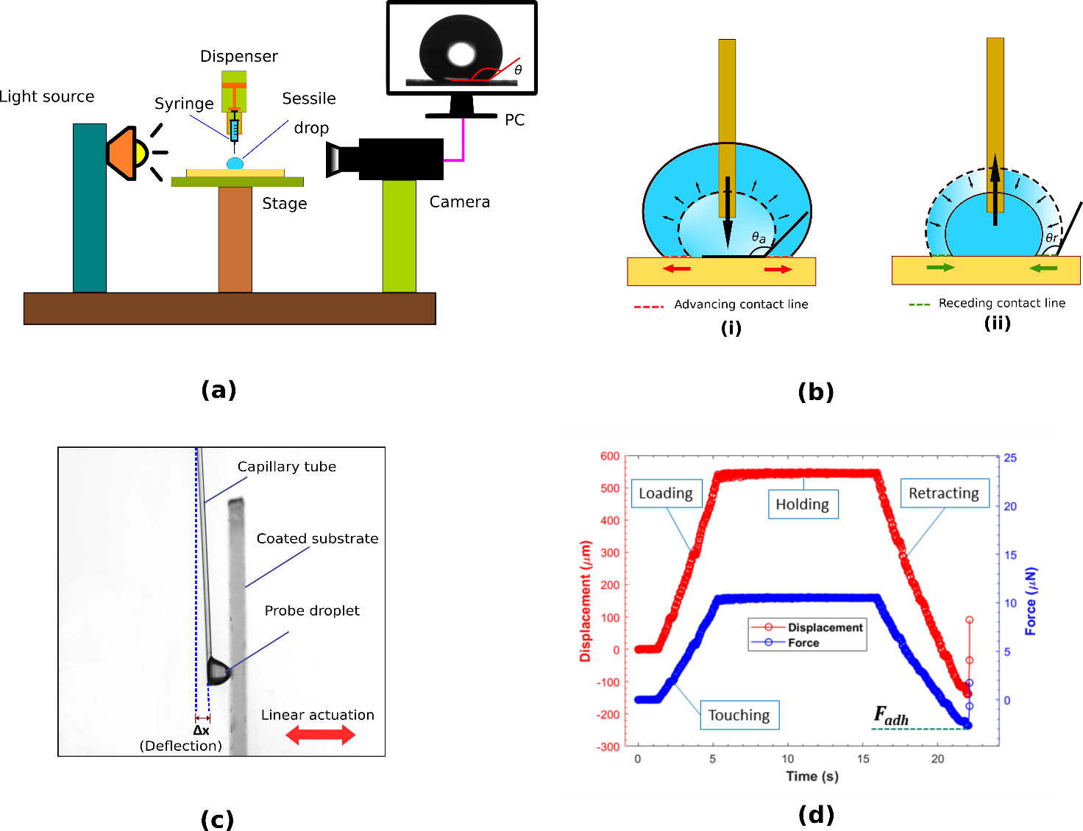
The adhesion measurement is based on the deflection of a polymeric cantilever similar to the droplet force apparatus (DFA)³⁰ and the one used recently in a separate work³² by the authors for measuring the friction and adhesion forces of microparticle doped aqueous suspensions. An acrylic capillary tube (Paradigm Optics Inc, WA, USA) with length L = 72 mm and external diameter d = 360 μm is used as the cantilever sensor with a stiffness constant k = 27.6 mN/m, calibrated separately (see supporting information, section S1 for calibration details). The probe droplet with a volume of 5μl is dispensed at the tip of cantilever using a micropipette. It is to be noted that a glass capillary tube of diameter 410μm was used in our earlier work with microparticles,³² which resulted in k = 305 mN/m. However, no significant difference in adhesion force measurements are observed between the two sets of cantilevers, elucidating the universality of the probing technique. The target hydrophobic surfaces were attached vertically on a motorized linear stage (Zaber Technologies Inc., BC, Canada) and translated with a velocity of 500μm/s. After smoothly touching the substrate and holding in the position for 10s, the stage is moved in the opposite direction, thereby deflecting the cantilever as shown in Figure 1(c) due to the adhesion of the droplet on the substrate. The deflection of cantilever tip from its mean position (Δx) is captured using a video camera (Photron FASTCAM Mini) at 60 frame per second with a strong backlight. Further, the video is analyzed using an open source video analysis program³⁸ from which the deflection with respect to time is extracted as shown in Figure 1(d). The entire measurement procedure can be segregated into four steps based on the typical displacement curve of the cantilever tip as shown in the Figure 1 (d). From this, the adhesion force is calculated as F_{adh} = kΔx_{max} where Δx_{max} is the maximum deflection of the cantilever before the droplet is detached from the surface (see Video S1 in the Supporting Information S9 for a visual demonstration of the measurement of F_{adh} from a typical experimental video and its analysis).
Figure 1. (a) The goniometry setup used for contact angle measurements, showing the sessile droplet and the static contact angle θ, (b)(i) Advancing contact angle (θ_{a}) (ii) Receding contact angle (θ_{r}), (c) The experimental setup for measuring adhesion force, showing the cantilever deflection Δx due to the adhesion of the probe droplet on the substrate, (d) Typical deflection profile over time and the estimated force showing the four steps involved in the procedure and the final value of adhesion F_{adh}.

We have used E. coli (K-12 Strain SMG 123 (PTA-7555), ATCC, Cedarlane, Canada) as the model microbe in our experiments. An overnight culture was grown in Lauryl Tryptose (LT) Broth (Catalog No. DF0241170, Difco), diluted in deionized (DI) water (Milli-Q, 18.2 MΩ cm, MilliPore Sigma, Canada) with a concentration of 35.6 g/l. More details on the bacterial culture could be found in section S2 of the supporting information. After culturing, the solution containing bacteria was centrifuged (VWR, Mississauga, Canada) at 5000rpm for 10 min and the supernatant was removed to get the E. coli in pellet form. Followed by washing in DI water twice, the pellet is then resuspended in three different base fluids which served as the stock solution for creating bacteria doped probe droplets. This ensured that any residue that might arise due to the presence of the culture media is completely removed during the adhesion experiments. We have used three different base liquid media in this study, namely, DI water, phosphate-buffered saline (PBS, 1X, pH 7.4, Catalog No. 10010-023, Gibco) and Lauryl Tryptose (LT) broth (with the same concentration as the one used for bacterial culture), to explore the dependency of the adhesion behavior on the suspending medium. These three base liquids are routinely used in biological experiments. Starting with the full concentration stock solution, a serial dilution process (more details in the supporting information, section S3) was followed with a dilution factor of 1/10 at each step to generate samples of sequentially reducing bacterial concentration with the same base fluid. An agar plate counting reveals that the concentration of the bacteria in the undiluted (full concentration) stock solution is 8.2 × 10⁶ CFU/ml (see supporting information, section S4). The dilution is limited to four steps in the present study as beyond this concentration, negligible number of bacterial colonies are observed in agar plating.
In order to understand of the physico-chemical mechanisms inherent to a live bacterial strain in comparison to dead bacteria (akin to microparticle suspension), bacterial colony were incapacitated where fresh sets of full concentration stock solutions with different base fluids containing E. coli were treated with 70% isopropyl alcohol (IPA, Fisher Scientific). A live/dead assay test (BacLight Kit, Invitrogen) was conducted on the samples to quantify the percentage of live and dead bacteria in the bacterial suspension (see section S5 in the supporting information for detailed protocol). For non-IPA treated samples, an average 72.3% bacteria were live. However, after IPA treatment, the percentage dropped down to 0, providing a visual confirmation that IPA solution indeed killed all the bacteria in the solution. This was also confirmed by agar plating, where no colony formation was observed in the IPA treated sample after incubation. In the present work, the bacterial signature is compared against inert polystyrene latex microparticles with a nominal diameter of 1μm (Magsphere Inc., Pasadena, CA, USA). These microparticles have a length scale comparable to that of E. coli³⁹ (~ few μm). The microparticle suspension is subsequently diluted in DI water in varying concentration from 0 to 5% (w/v). A detailed physical and chemical characteristics and scanning electron microscopy (SEM) images of these microparticles are available at manufacturer’s website.⁴⁰ For E.coli, for both the live and dead state, the characteristics are well reported in the literature.^{41–44}
In this study we used two types of surfaces with two different repellent coatings, namely, S1 (Glaco, Soft99, Japan) and S2 (Glass Protect-SH, SiO2 International, Canada), both were coated on clean glass slides (Catalog No. 12-550-A3,Fisher Scientific, Canada). While S1 was spray coated, S2 was dip coated and both were heated thereafter at 60⁰ C for 1 hour. Both coatings formed transparent hydrophobic surfaces with static contact angle, θ measured as 126° ± 1.6° and 151° ± 1.9° for S1 and S2, respectively. Please refer to the supporting information, section S6 for surface characterization data using SEM and atomic force microscopy (AFM).

Results & Discussion
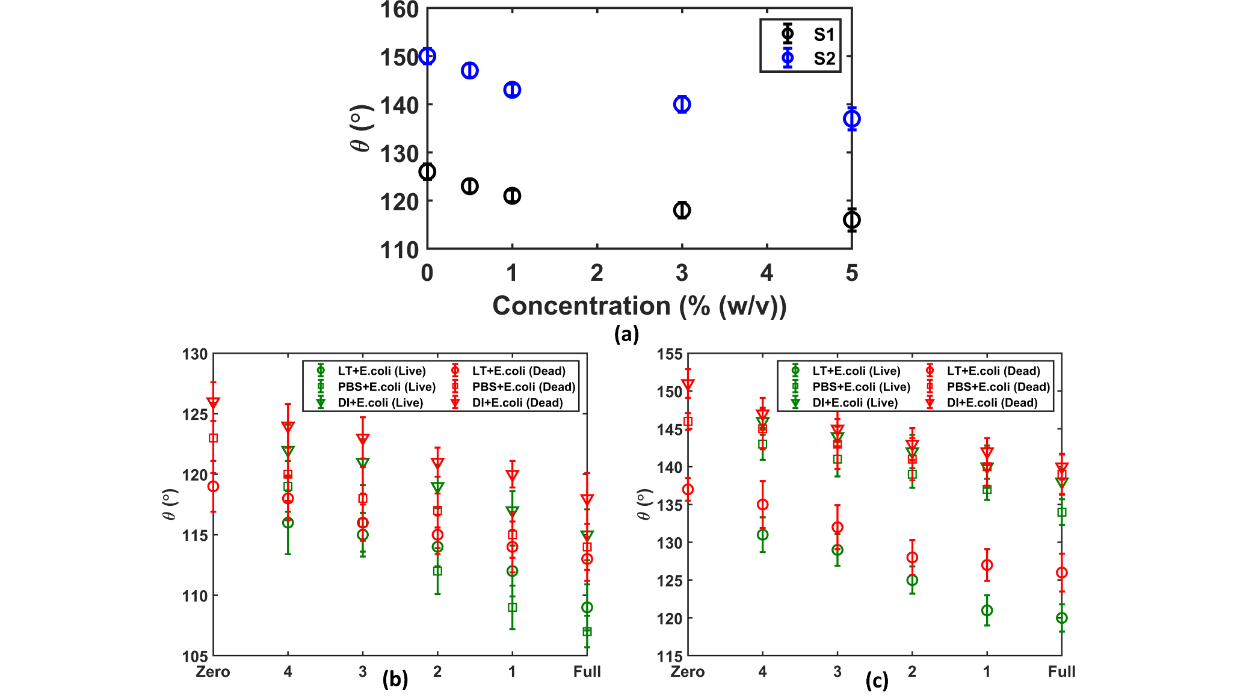
Figure 2. Static contact angle (θ) values for all probe-liquid and target surface combination - (a) represents θ values on S1 and S2 for varying microparticle concentration in the probe droplet, with DI water as base medium while (b) & (c) report θ values with varied bacterial (E. coli ) concentration in the probe droplet, for both dead and live bacterial cells as dopants and with three different base media, namely LT, PBS and DI water. (b) represents the static contact angle data on surface S1 while (c) corresponds to surface S2. In both (b) and (c) Zero and Full on the X (concentration) axis correspond to undoped base liquid and stock solution, while 4, 3, 2, 1 represent 10000, 1000, 100 & 10-fold dilution respectively from the stock solution i.e., increase in bacterial count from 8.2 × 10² CFU/ml to 8.2 × 10⁵ CFU/ml in multiples of 10.

Figure 2 shows the contact angle (CA) values for both microparticles as well as bacteria doped droplet with varied concentration for all three base liquids and two target surfaces. S2 showed a higher CA compared to S1 for all the cases, indicating a higher degree of hydrophobicity, which was also confirmed from the Attenuated Total Reflectance Fourier Transform Infrared (ATR-FTIR) spectra (see section S7 in the supporting information for further details) of the surfaces. The FTIR spectra of S2 indicates presence of C-F bonds on the surface, which contributes to a lower surface energy and consequently, higher hydrophobicity⁴⁵.
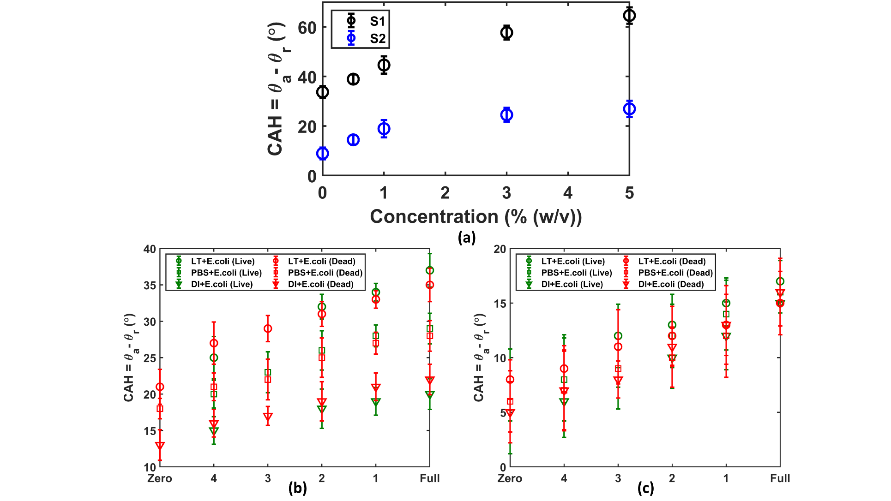
As can be seen in Figure 2(b) and 2(c), probe droplets with DI water as a base medium showed a higher static contact angle followed by that of PBS and LT, on both the target surfaces. Also, the probe droplet with live bacteria as dopant always showed lesser static contact angle than its dead counterpart for the same bacterial concentration, base medium and target surface. Moreover, an overall decreasing trend of θ with increasing bacterial concentration is observed which bears qualitative similarity with the experimental observation for microparticle laden droplet reported in Figure 2(a). It gives a preliminary indication that the presence of more bacteria within the probe droplet enhances surface wetting.
Figure 3. Contact angle hysteresis (CAH) values for all probe-liquid and target surface combination - (a) represents CAH values on S1 and S2 for varying microparticle concentration in the probe droplet, with DI water as base medium while (b) & (c) report CAH values with varied bacterial (E. coli ) concentration in the probe droplet, for both dead and live bacterial cells as dopants and with three different base media, namely LT, PBS and DI water. (b) contains the CAH data on surface S1 while (c) corresponds to surface S2. In both (b) and (c) Zero and Full on the X (concentration) axis correspond to base liquid (with no doping) and stock solution, while 4, 3, 2, 1 represent 10000, 1000, 100 & 10-fold dilution respectively from the stock solution, i.e., increase in bacterial count from 8.2 × 10² CFU/ml to 8.2 × 10⁵ CFU/ml in multiples of 10.
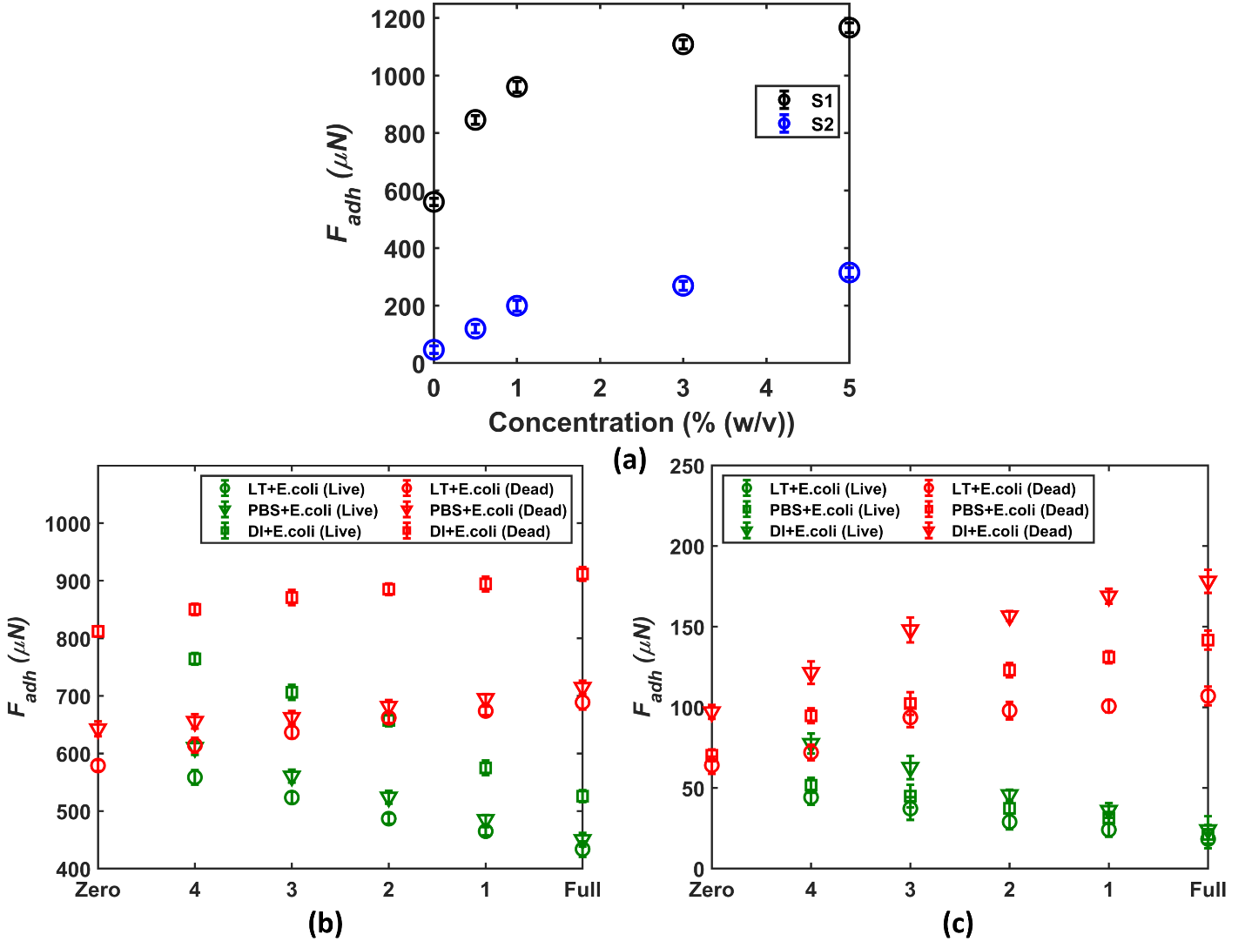
Figure 3 shows the contact angle hysteresis values for all the studied cases. The general observation is that the CAH increases with increase in doping concentration on all studied surface-probe liquid combination. The increasing trend of CAH indicates a stickier droplet-surface contact with increase in doping concentration, which is consistent with the wetting signature obtained from static contact angle measurements. The observed trend of contact angle hysteresis for microparticles is consistent with previously reported literature^{19,32}. It is to be noted here that there are several overlaps and crossovers between the experimentally observed trends for live and dead bacterial droplets. And unlike Figure 2, where probe droplet containing dead bacteria always showed a higher static contact angle than its live counterpart, no such generalizable criteria could be established for CAH, making CAH based conclusive distinction between live and dead bacterial suspensions impossible.
Figure 4. Adhesion force (F_{adh}) measurement for all probe-liquid and target surface combination - (a) represents F_{adh} values on S1 and S2 for varying microparticle concentration in the probe droplet, with DI water as base medium while (b) & (c) report F_{adh} values with varied bacterial (E.coli ) concentration in the probe droplet, for both dead and live bacterial cells as dopants and with three different base media, namely LT, PBS and DI water. (b) represents the static contact angle data on surface S1 while (c) corresponds to surface S2. In both (b) and (c) Zero and Full on the X (concentration) axis correspond to undoped base liquid and stock solution, while 4, 3, 2, 1 represent 10000, 1000, 100 & 10-fold dilution respectively from the stock solution, i.e., increase in bacterial count from 8.2 × 10² CFU/ml to 8.2 × 10⁵ CFU/ml in multiples of 10.

Figure 4 reports the adhesion force measurements, and here interestingly, there is a stark contrast in the concentration dependence of adhesion force between dead and live bacterial suspension. As can be seen in Figure 4(a), for microparticle suspension, F_{adh} increased with increasing doping concentration, which is in-line with our observation reported in a recent work.³² However, a decrease in the adhesion force is observed as the bacterial concentration is increased when the probe droplet contains live bacterial cells, for all the studied base liquids and target surface combination, as could be seen in Figure 4(b) & 4(c). On the contrary, with dead bacteria as dopant, we see an increase in adhesion force with increasing doping concentration, which is similar to the observed trend for microparticle suspension (as shown in Figure 4(a)). This is a direct indication that the viability and possible motility of bacterial cells are responsible for reduced adhesion. This happened despite the fact that around 30% of the bacteria within the stock solution was not active. As illustrated in Figures 2 & 3 through contact angle measurements, probe droplet showed qualitatively similar dependence on doping concentration, where for all the studied droplet-surface combination, an increase in concentration corresponds to a lower static contact angle and a higher contact angle hysteresis. This qualitative similarity in wetting signature might give a false indication that perhaps microparticle suspension is an appropriate surrogate for probing bacterial adhesion. However, our framework enables direct measurement of the adhesion response, which unambiguously indicates that despite resemblance in wetting signature, the adhesion behavior is indeed significantly different between live and dead bacteria. Although there is some qualitative resemblance between dead bacteria and microparticle suspension, probe droplets doped with live bacterial cells exhibit a completely different adhesion signature, owing to the bacterial viability and motility, which clearly can not be replicated using inert microspheres. Contextually, it is to be noted here that presence of nutrient residue (from the culture medium) in the probe droplet can create a nutrient gradient, causing chemotactic movement of bacteria inside the droplet. This movement can have unwanted implication on the ensuing adhesion behavior. However, we have thoroughly washed the cultured bacteria with DI water twice before resuspending them in the base medium, which ensures complete removal of nutrient residues before preparation of the stock solutions. Further, the extremely low Reynolds number flow (~10⁻⁵) for the bacteria¹⁰ makes any rapid chemotactic movement improbable unless there are strong advective currents within the droplet.

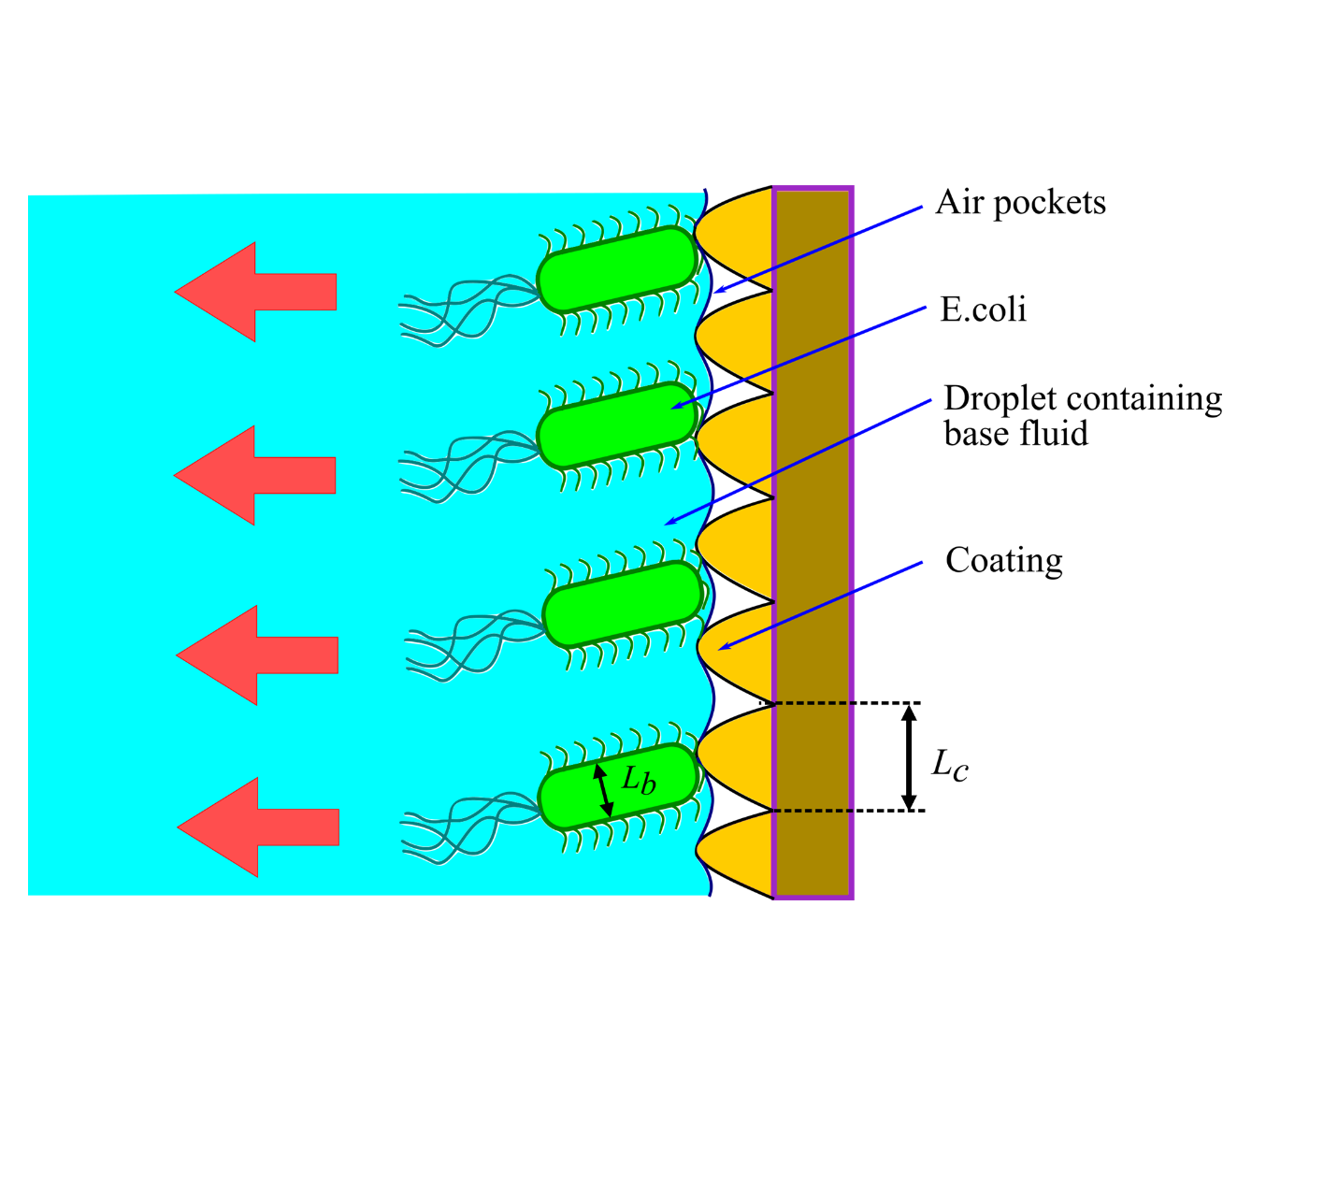
Figure 5. Proposed mechanism for depinning of the bacteria from a structured superhydrophobic surface. The diameter of the bacterial cells (L_{b}) is comparable with the roughness length scale (L_{c}). The arrows indicate the preferential direction of bacterial mobility in presence of structured superhydrophobic surface.
Based on the trend in the adhesion measurements, a mechanism is proposed here consisting of the motility driven depinning of the E. coli from the surface, as shown in Figure 5. Due to the roughness enabled hydrophobicity of the coated surfaces, which in turn is responsible for the Cassie-Baxter state of wetting, the pinning sites are already limited. The comparable size of the bacteria aids in augmenting this further, thereby leading to an early detachment of the droplet. Previous works have shown that for higher contact time with a given surface, the bacteria favours adhesion and growth.^{46,47} However, in the early stage of adhesion with short contact time (as in the present case), structural unfavorability of bacterial attachment on the surface becomes more important, leading to low adhesion force.
A direct comparison of bacteria and microparticles in terms of concentration used in the solution for the respective measurements, be it the contact angle or the adhesion force, is not straightforward, however from an electrostatic perspective, both have negative charges on its surface and is expected to interact with the surface in a similar way. The advantageous consequence is that we can now rule out that the surface charge is responsible for this enhanced depinning from the coated surface, then the microparticles should also have behaved in a similar way. As dead bacteria and the microparticles show a similar trend, the probable cause for this anomaly must be attributed to motility of the live bacteria.
It is to be noted here that culture-to-culture variance can alter the adhesion signature as different cultures may have different initial viability (percentage of live and dead bacteria), which is a key contributor to the ensuing dynamics, as we have identified earlier. As a precaution, we have always compared results from the same stock solution, which ensures the same parental identity and thereby eliminates the possibility of culture-to-culture variation. However, in order to establish the generality of experimental observations, we have also monitored the key quantities of interest (namely, percentage of live/dead bacteria, static and dynamic contact angle and adhesion force) across different cultures, where we maintained same culture conditions but cultured them separately as different aliquots. Our investigation confirmed that there was no significant difference across different aliquots, which reaffirms the generality of the conclusions. Details are presented in section S8 of the supporting information.
We emphasize that the results from contact angle-based study should complement that of adhesion experiments. The present study aims to delineate the limitations of goniometry over direct adhesion signature while dealing with bioactive samples like bacteria. Especially high values of contact angle for repellent surfaces, the image based static angle measurements cannot be relied upon in its entirety .^{48,49} The next viable estimate is the dynamic contact angle measurements based on the hysteresis the contact line, which again suffers the limitations from imaging artefacts while determining the incipient contact line movement.³⁷ Apart from reaffirming the non-unique interpretations of a regular goniometry, the adhesion based approach opens up a possibility of sensing and detecting the presence of bacteria (i.e., live versus dead), without any biochemical agents and time-consuming plating or gene sequencing. Further, the adhesion signature using the current experimental set-up can be quantified with reasonable accuracy and confidence level, which unlike AFM, does not demand sophisticated infrastructure and operational expertise.

Conclusion
We have presented the salient aspects of bacterial adhesion over highly repellent hydrophobic surfaces. We show that contact angle based optical goniometry provides an incomplete (and consequently inconclusive) description of the ensuing interfacial interaction between bacterial droplets and repellent surfaces. Apart from the imaging uncertainties (typically arising at high contact angle), wetting signature only captures on the behavior of the three-phase contact line and does not reveal any information on the contact surface underneath the droplet which is directly responsible for the adhesion behaviour. We report that despite qualitative similarity in concentration dependence of static as well as dynamic contact angle between microparticle suspension and bacterial (both live and dead) loads, the adhesion behavior exhibit a completely contrasting dependence on doping concentration, where unlike dead bacteria and inert microparticles, motility of live bacteria contributes to reduction in adhesion force with increase in concentration. A simple force-based adhesion measurement, as illustrated here, can elaborate the true nature of these interactions, which gives a clear indication that the bacterial viability and motility plays a crucial role in governing the adhesion behavior. We test with the most common fluids in biochemical experiments with both dead and live conditions and compare the outcome with the inert microparticle suspension to conclude that despite similar length scale, inert microparticles are not suitable surrogates for living bacterial cells.
Supporting Information
Calibration of the cantilever; serial dilution of bacterial solution; bacterial culture; agar plate counting of bacterial colonies; Live/Dead assay; surface characterization; Fourier Transform Infrared (FTIR) spectroscopy of the coated surface; culture invariance of experimental observations
Video of adhesion measurement (Video S1)

Acknowledgements
The authors would like to thank SiO2 International Inc. for graciously providing the hydrophobic coatings used in this work. We thank Dr. Dan Daniel, IMRE, A*STAR, Singapore for kindly providing us with the acrylic capillary tubes used in this study. The authors thankfully acknowledge Prof. Tong Leung, Dr. Nina Heining and Dr. Joseph P Thomas, Department of Chemistry, University of Waterloo for their assistance in the surface characterization of the coatings at the Waterloo Advanced Technology Laboratory (WATLab). The authors additionally acknowledge useful suggestions and imaging help from Dr. Snehasish Mondal during cantilever calibration. We also thank Dr. Naga Siva Kumar Gunda for helpful discussions. This work was supported by S.K.M.’s Alliance Grant ALLRP 551068-20 from the Natural Sciences and Engineering Research Council (NSERC) of Canada and University of Waterloo Start-up grant. S.M. additionally acknowledges financial support from the Waterloo Institute for Nanotechnology, University of Waterloo in the form of Nanofellowship 2020.

References
(1) Phillips, R.; Kondev, J.; Theriot, J.; Garcia, H. Physical Biology of the Cell; Garland Science, 2012, p. 17.
(2) Blount, Z. D. The Natural History of Model Organisms: The Unexhausted Potential of E. Coli. Elife 2015, 4, e05826.
(3) Hennes, M.; Tailleur, J.; Charron, G.; Daerr, A. Active Depinning of Bacterial Droplets: The Collective Surfing of Bacillus Subtilis. Proc. Natl. Acad. Sci. U. S. A. 2017, 114 (23), 5958–5963.
(4) Monds, R. D.; O’Toole, G. A. The Developmental Model of Microbial Biofilms: Ten Years of a Paradigm up for Review. Trends Microbiol. 2009, 17 (2), 73–87.
(5) Zhang, Y.; Buchholz, F.; Muyrers, J. P. P.; Stewart, A. F. A New Logic for DNA Engineering Using Recombination in Escherichia Coli. Nat. Genet. 1998, 20 (2), 123–128.
(6) Jang, J.; Hur, H.-G.; Sadowsky, M. J.; Byappanahalli, M. N.; Yan, T.; Ishii, S. Environmental Escherichia Coli: Ecology and Public Health Implications—a Review. J. Appl. Microbiol. 2017, 123 (3), 570–581.
(7) Pajoumshariati, S. R.; Azizi, M.; Zhang, S.; Dogan, B.; Simpson, K. W.; Abbaspourrad, A. A Microfluidic-Based Model for Spatially Constrained Culture of Intestinal Microbiota. Adv. Funct. Mater. 2018, 28 (48), 1805568.
(8) Jo, B. H.; Seo, J. H.; Kang, D. G.; Cha, H. J.; others. Engineered Escherichia Coli with Periplasmic Carbonic Anhydrase as a Biocatalyst for CO2 Sequestration. Appl. Environ. Microbiol. 2013, 79 (21), 6697–6705.
(9) López, H. M.; Gachelin, J.; Douarche, C.; Auradou, H.; Clément, E. Turning Bacteria Suspensions into Superfluids. Phys. Rev. Lett. 2015, 115 (2), 28301.
(10) Purcell, E. M. Life at Low Reynolds Number. Am. J. Phys. 1977, 45 (1), 3–11.
(11) Hasan, J.; Crawford, R. J.; Ivanova, E. P. Antibacterial Surfaces: The Quest for a New Generation of Biomaterials. Trends Biotechnol. 2013, 31 (5), 295–304.
(12) Nosonovsky, M.; Bhushan, B. Superhydrophobic Surfaces and Emerging Applications: Non-Adhesion, Energy, Green Engineering. Curr. Opin. Colloid Interface Sci. 2009, 14 (4), 270–280.
(13) Palacio, M. L. B.; Bhushan, B. Bioadhesion: A Review of Concepts and Applications. Philos. Trans. R. Soc. A Math. Phys. Eng. Sci. 2012, 370 (1967), 2321–2347.
(14) Tian, X.; Shaw, S.; Lind, K. R.; Cademartiri, L. Thermal Processing of Silicones for Green, Scalable, and Healable Superhydrophobic Coatings. Adv. Mater. 2016, 28 (19), 3677–3682.
(15) Simpson, J. T.; Hunter, S. R.; Aytug, T. Superhydrophobic Materials and Coatings: A Review. Reports Prog. Phys. 2015, 78 (8).
(16) Deng, X.; Mammen, L.; Butt, H.-J.; Vollmer, D. Candle Soot as a Template for a Transparent Robust Superamphiphobic Coating. Science (80-. ). 2012, 335 (6064), 67–70.
(17) Majhy, B.; Iqbal, R.; Sen, A. K. Facile Fabrication and Mechanistic Understanding of a Transparent Reversible Superhydrophobic-Superhydrophilic Surface. Sci. Rep. 2018, 8 (1), 1–11.
(18) Iqbal, R.; Majhy, B.; Sen, A. K. Facile Fabrication and Characterization of a PDMS-Derived Candle Soot Coated Stable Biocompatible Superhydrophobic and Superhemophobic Surface. ACS Appl. Mater. Interfaces 2017, 9 (36), 31170–31180.
(19) Waghmare, P. R.; Mitra, S. K. Contact Angle Hysteresis of Microbead Suspensions. Langmuir 2010, 26 (22), 17082–17089.
(20) Iqbal, R.; Majhy, B.; Shen, A. Q.; Sen, A. K. Evaporation and Morphological Patterns of Bi-Dispersed Colloidal Droplets on Hydrophilic and Hydrophobic Surfaces. Soft Matter 2018, 14 (48), 9901–9909.
(21) Zhang, X.; Wang, L.; Levänen, E. Superhydrophobic Surfaces for the Reduction of Bacterial Adhesion. RSC Advances. 2013, pp 12003–12020.
(22) Li, H.; Liu, Z.; Li, C.; Feng, Q.; Liu, Y.; Li, Q.; Dong, Z.; Wang, Y.; Jiang, L. Efficient Spreading and Controllable Penetration of High-Speed Drops on Superhydrophobic Surface by Vesicles. J. Mater. Chem. A 2020, 8 (34), 17392–17398.
(23) Iqbal, R.; Shen, A. Q.; Sen, A. K. Understanding of the Role of Dilution on Evaporative Deposition Patterns of Blood Droplets over Hydrophilic and Hydrophobic Substrates. J. Colloid Interface Sci. 2020, 579, 541–550.
(24) van Loosdrecht, M. C. M.; Lyklema, J.; Norde, W.; Zehnder, A. J. B. Bacterial Adhesion: A Physicochemical Approach. Microb. Ecol. 1989, 17 (1), 1–15.
(25) Malte, H. The DLVO Theory in Microbial Adhesion. Colloids Surfaces B Biointerfaces 1999, 14 (1–4), 105–119.
(26) Busscher, H. J.; Weerkamp, A. H.; van Der Mei, H. C.; van Pelt, A. W.; de Jong, H. P.; Arends, J. Measurement of the Surface Free Energy of Bacterial Cell Surfaces and Its Relevance for Adhesion. Appl. Environ. Microbiol. 1984, 48 (5), 980–983.
(27) Absolom, D. R.; Lamberti, F. V.; Policova, Z.; Zingg, W.; van Oss, C. J.; Neumann, A. W. Surface Thermodynamics of Bacterial Adhesion. Appl. Environ. Microbiol. 1983, 46 (1), 90–97.
(28) De Gennes, P.-G.; Brochard-Wyart, F.; Quéré, D. Capillarity and Wetting Phenomena: Drops, Bubbles, Pearls, Waves; Springer Science & Business Media, 2013, p. 17.
(29) Daniel, D.; Timonen, J. V. I.; Li, R.; Velling, S. J.; Kreder, M. J.; Tetreault, A.; Aizenberg, J. Origins of Extreme Liquid Repellency on Structured, Flat, and Lubricated Hydrophobic Surfaces. Phys. Rev. Lett. 2018, 120 (24), 244503.
(30) Daniel, D.; Chia, A. Y. T.; Moh, L. C. H.; Liu, R.; Koh, X. Q.; Zhang, X.; Tomczak, N. Hydration Lubrication of Polyzwitterionic Brushes Leads to Nearly Friction- and Adhesion-Free Droplet Motion. Commun. Phys. 2019, 2 (1), 1–7.
(31) Daniel, D.; Lay, C. L.; Sng, A.; Jun Lee, C. J.; Jin Neo, D. C.; Ling, X. Y.; Tomczak, N. Mapping Micrometer-Scale Wetting Properties of Superhydrophobic Surfaces. Proc. Natl. Acad. Sci. 2019, 116 (50), 25008–25012.
(32) M, K. R.; Misra, S.; Mitra, S. K. Friction and Adhesion of Microparticle Suspensions on Repellent Surfaces. Langmuir 2020, 36 (45), 13689–13697.
(33) Yuan, Y.; Hays, M. P.; Hardwidge, P. R.; Kim, J. Surface Characteristics Influencing Bacterial Adhesion to Polymeric Substrates. RSC Adv. 2017, 7 (23), 14254–14261.
(34) Meinders, J. M.; van der Mei, H. C.; Busscher, H. J. Deposition Efficiency and Reversibility of Bacterial Adhesion under Flow. J. Colloid Interface Sci. 1995, 176 (2), 329–341.
(35) Beloin, C.; Houry, A.; Froment, M.; Ghigo, J. M.; Henry, N. A Short-Time Scale Colloidal System Reveals Early Bacterial Adhesion Dynamics. PLoS Biol. 2008, 6 (7), 1549–1558.
(36) van Loosdrecht, M. C. M.; Norde, W.; Lyklema, J.; Zehnder, A. J. B. Hydrophobic and Electrostatic Parameters in Bacterial Adhesion - Dedicated to Werner Stumm for His 65th Birthday. Aquat. Sci. 1990, 52 (1), 103–114.
(37) Huhtamäki, T.; Tian, X.; Korhonen, J. T.; Ras, R. H. A. Surface-Wetting Characterization Using Contact-Angle Measurements. Nat. Protoc. 2018, 13 (7), 1521–1538.
(38) Brown, D. Tracker Free Video Analysis and Modeling Tool for Physics Education. Open Source Phys. comPADRE, USA 2012.
(39) Reshes, G.; Vanounou, S.; Fishov, I.; Feingold, M. Cell Shape Dynamics in Escherichia Coli. Biophys. J. 2008, 94 (1), 251–264.
(40) Magsphere Inc, Pasadena, C. 91107; U.S.A. Uniform polystyrene latex particles http://www.magsphere.com/Products/Polystyrene-Latex-Particles/polystyrene-latex-particles.html (accessed Dec 24, 2020).
(41) Li, R.; Goswami, U.; King, M.; Chen, J.; Cesario, T. C.; Rentzepis, P. M. In Situ Detection of Live-to-Dead Bacteria Ratio after Inactivation by Means of Synchronous Fluorescence and PCA. Proc. Natl. Acad. Sci. 2018, 115 (4), 668–673.
(42) Ni, X.-Y.; Liu, H.; Wang, C.; Wang, W.-L.; Xu, Z.-B.; Chen, Z.; Wu, Y.-H.; Hu, H.-Y. Comparison of Carbonized and Graphitized Carbon Fiber Electrodes under Flow-through Electrode System (FES) for High-Efficiency Bacterial Inactivation. Water Res. 2020, 168, 115150.
(43) Gopinath, V.; Priyadarshini, S.; Loke, M. F.; Arunkumar, J.; Marsili, E.; MubarakAli, D.; Velusamy, P.; Vadivelu, J. Biogenic Synthesis, Characterization of Antibacterial Silver Nanoparticles and Its Cell Cytotoxicity. Arab. J. Chem. 2017, 10 (8), 1107–1117.
(44) Huo, Z.-Y.; Li, G.-Q.; Yu, T.; Feng, C.; Lu, Y.; Wu, Y.-H.; Yu, C.; Xie, X.; Hu, H.-Y. Cell Transport Prompts the Performance of Low-Voltage Electroporation for Cell Inactivation. Sci. Rep. 2018, 8 (1), 1–10.
(45) Dalvi, V. H.; Rossky, P. J. Molecular Origins of Fluorocarbon Hydrophobicity. Proc. Natl. Acad. Sci. U. S. A. 2010, 107 (31), 13603–13607.
(46) Crick, C. R.; Ismail, S.; Pratten, J.; Parkin, I. P. An Investigation into Bacterial Attachment to an Elastomeric Superhydrophobic Surface Prepared via Aerosol Assisted Deposition. Thin Solid Films 2011, 519 (11), 3722–3727.
(47) Ellinas, K.; Kefallinou, D.; Stamatakis, K.; Gogolides, E.; Tserepi, A. Is There a Threshold in the Antibacterial Action of Superhydrophobic Surfaces? ACS Appl. Mater. Interfaces 2017, 9 (45), 39781–39789.
(48) Butt, H. J.; Roisman, I. V.; Brinkmann, M.; Papadopoulos, P.; Vollmer, D.; Semprebon, C. Characterization of Super Liquid-Repellent Surfaces. Curr. Opin. Colloid Interface Sci. 2014, 19 (4), 343–354.
(49) Liu, K.; Vuckovac, M.; Latikka, M.; Huhtamäki, T.; Ras, R. H. A. Improving Surface-Wetting Characterization. Science (80-. ). 2019, 363 (6432), 1147–1148.

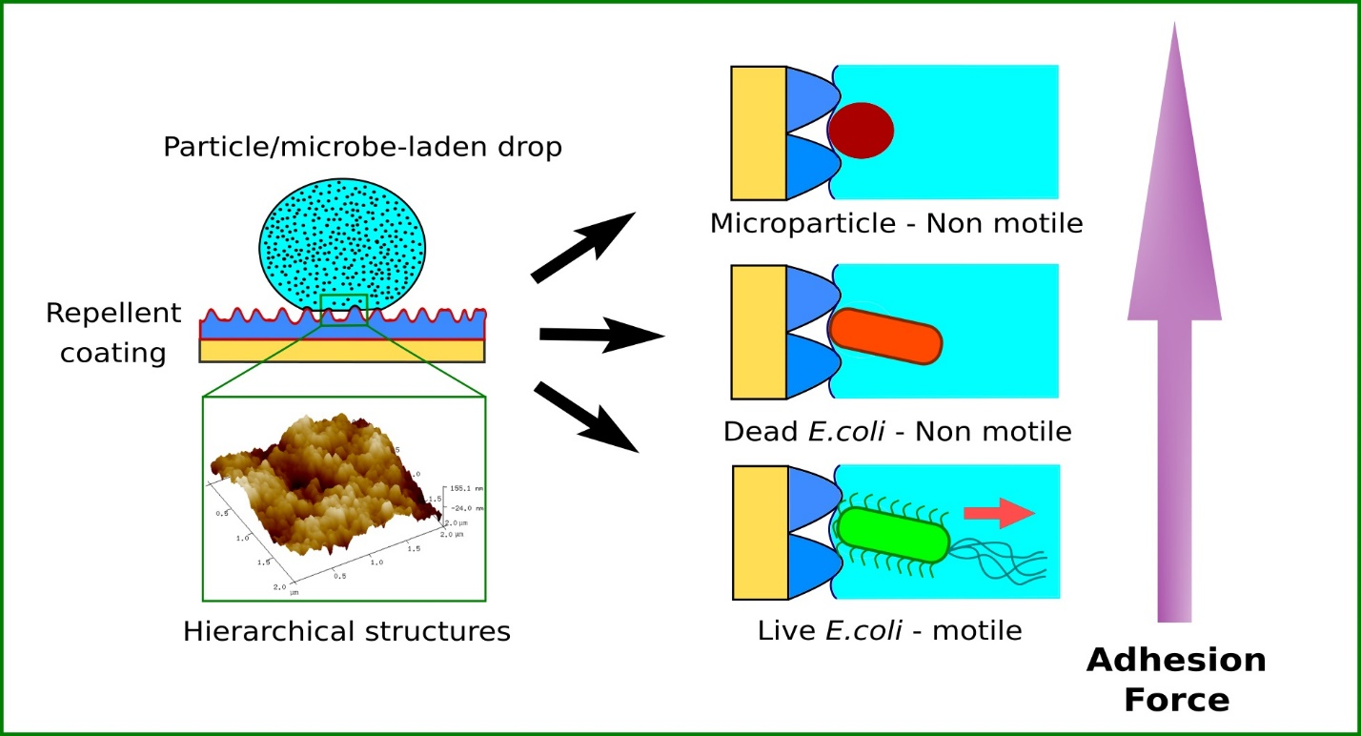
TOC Graphic

