Friction and Adhesion of Microparticle Suspension on Repellent Surfaces
Kiran Raj M, Sirshendu Misra, Sushanta K. Mitra*
Micro & Nano-scale Transport Laboratory, Waterloo Institute for Nanotechnology, Department of Mechanical and Mechatronics Engineering, University of Waterloo, 200 University Avenue West, Waterloo, Ontario N2L 3G1, Canada

Abstract
With the recent advancements in the development and application of repellent surfaces, both in air and under liquid medium, accurate characterization of repellence behavior is critical in understanding the mechanism behind many observed phenomena and to exploit them for novel applications. Conventionally, the repellence behavior of a surface is characterized by optical measurement of the dynamic contact angle of the target (to be repelled) liquid on the test surface. However, as already established in literature, optical measurements are prone to appreciable error, especially for repellent surfaces with high contact angle. Here, we present an alternative, more accurate force-based characterization method of both friction and adhesion forces of microparticle laden aqueous droplets over various repellent surfaces, where the force signature is captured by probing the surface with a droplet of the test liquid mounted at the tip of a flexible cantilever and then tracking the deflection of the tip of the cantilever as the probe droplet interacts with the surface. A systematic investigation of response of repellent surfaces towards droplets with different microparticle concentration revealed the dependency and sensitivity of measured adhesion and friction signature towards particle concentration. A comparison with theoretical estimate from optical goniometry highlights the deviation of the theoretical data from experimentally measured values and further substantiates the need of such a force-based approach for accurate characterization of repellence behavior.

Introduction
Understanding the phenomena of adhesion is of vital importance in a spectrum of applications especially bioengineering and surface science.¹ The interaction of bacteria and pathogens with a given substrate is critical towards our understanding of how mitigation strategies can be designed to kill, repel and dislodge the harmful bio-agents from surfaces.² Towards the understanding of this interaction, it is important to first characterize the adhesion force between the substrate and a model system. Typically, the microbes have a characteristics length scale of few microns, therefore, here we aim to elucidate the interaction between a target substrate and bio-agents by measuring the adhesion force between micro-particle laden drops and the substrate.
Repellant surfaces have garnered considerable attention in the past decade. With the origin in biomimetics and termed it accordingly as the lotus leaf effect, it led to the development of a plethora of engineered surfaces known as ‘superhydrophobic’ (SHP) or that with extreme water repellency.³ However, an accurate estimation of the relevant properties like the surface energy has always been a challenge.⁴ Among the methods of surface characterization like Wilhemy plate method, du Noüy ring method and capillary rise method, the contact angle measurement is the most commonly used one, but not without complications.⁵ Simple to carry out, the results depend crucially on the accuracy of image acquisition and its processing.^{6,7} A more reliable estimate is the dynamic contact angle, which takes into account the contact line movement.⁸ This method gives the contact angle hysteresis (CAH), conventionally given as the difference in the advancing (ϴ_{a}) and receding contact angle (ϴ_{r}). All of the imaging based techniques falter at extremely high contact angles primarily owing to the difficulty and uncertainty in detecting the baseline.⁶ This is where the precision of force based techniques finds relevance.⁹ They can be deflection based like Atomic Force Microscope (AFM)¹⁰ or piezoelectric sensors¹¹ or microelectronic balance systems.¹² Nonetheless, they all require expensive instrumentation and complicated procedures to yield the final result.
Recent attempts have been focused on quantifying both adhesion and friction with cantilever-based sensors and by skilfully tuning the existing framework of tools like AFM. Daniel et al., have used capillary tubes as cantilevers to measure the dissipative forces when a droplet attached to the capillary is bought in contact with repellent surfaces, which translates at a fixed velocity.⁹ By attaching a microlitre sized droplet of the test liquid on the cantilever and then using the droplet to probe the surface response, detailed mapping can be carried out.¹³ They have studied the three main class of liquid repellent surfaces with varying physical mechanisms at the contact line: micro/nanostructures showing the lotus-leaf effect, polymeric brush grafted surfaces and lubricated surfaces. They found that the dissipative force is independent of the velocity of droplet movement on superhydrophobic surfaces, but it depends non-linearly with velocity for polymer brush grafted and lubricated surfaces. The results were also corroborated with the observations from optical interferometry. The same study was extended to underliquid systems^{14,15} where a thin liquid film exists between the droplet and the solid surface and the forces involved are a function of the non dimensional capillary number (ratio of viscous force to surface tension force).¹⁶ However, they have not investigated how particle laden drops can affect the adhesion and friction behavior.
When the constitution of the droplet is not homogenous and consists of another phase as micro/nanoparticles, it can affect the dynamics of wetting significantly.^{17,18} The introduction of microparticles can affect the fundamental interaction of the fluid with the solid surface due to a number of aspects like adsorption, agglomeration and the internal convection and particle-particle interactions.^{17,19,20} The interfacial interaction of a particle laden droplet with a solid surface gives rise to a wide range of interesting physical phenomena, among which evaporation is a major one. In evaporating particle laden droplets with pinned contact line, radially varying rate of evaporation induces a capillary flow directed towards the contact line which drags the suspended particles outward, ultimately leaving behind a ring like stain along the contact line after the drop is evaporated (the so-called coffee stain effect).²¹ By appropriately tuning the size, volume fraction of suspended particles and the structure and wettability of the underlying surface, this aggregation process can be controlled to produce self assembled micro/nanoscale structures in varied geometrical arrangements.^{22–29} Such evaporation driven colloidal self assembly from particle laden suspension has garnered extensive interest in scientific community because of its practical relevance including its potential in creating photonic bandgap crystals,^{30,31} applicability in metamaterials research,^{32–35} its mixed implication in inkjet printing and others.^{36,37}Additionally, with suitable modification, this system involving microparticle laden droplets can be extended to asses the response of non-living surfaces towards active pathogenic loads, which finds direct relevance in the present novel coronavirus pandemic scenario. One way to understand the role of microparticles in the ensuing interfacial dynamics is to study the CAH of particle laden droplets on the target surface. Effect of microparticle concentrations on the CAH has been investigated over hydrophobic glass surfaces.³⁸ However, the impact of particle concentrations has not been studied systematically for repellent surfaces.³⁹
As evident from existing literature, understanding the interaction between particle laden drops and a given repellant surface is still an ongoing research direction. Fundamental to this understanding is the ability to experimentally measure the force signature (namely, the adhesion and friction forces) as the microparticle laden droplet comes in contact with the target substrate. To investigate such interactions which consists of forces in the range of micro/nanonewtons, complex equipment like AFM⁴⁰ or highly sensitive force sensors¹¹ are often needed. Here, we have attempted to address this challenge with the aid of a simple instrumentation, circumventing the use such sophisticated tools. Droplet interaction experiments are conducted with an in-house developed experimental setup that combines the simplicity of a capillary tube-based cantilever sensor with the accuracy of high-resolution image acquisition and processing. Imaging based techniques are exploited in the analysis for the time tracking of the displacement and force signature with high spatiotemporal resolution, yielding a cost-effective and rapid tool to decipher such force and wetting signatures.

Experimental
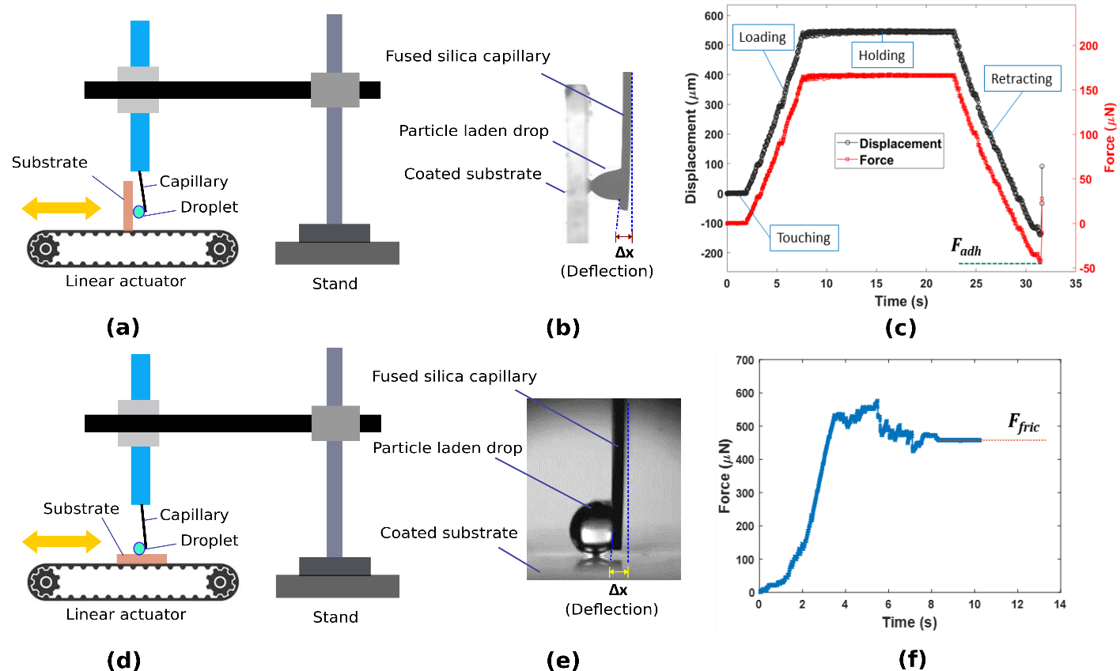
Figure 1. (a) Experimental setup showing the linear stage on which the test surface is held vertically. The droplet is dispensed at the tip of the cantilever which is aligned vertically with a stand. (b) Photograph of the droplet detaching from the surface and the deflection of the cantilver Δx. (c) Typical displacement curve and the force curve showing the steps involved in the adhesion measurement and the point corresponding to F_{adh}. (d) Experimental setup in which the sample is held horizontally to measure the friction. (e) Photograph of the deflection due friction between the droplet and the substrate (f) Typical force curve for friction measurent and the final plateau region gives F_{fric}.
The adhesion measurement setup consists of in-house made instrumentation as shown in Figure 1 (a). A fused silica capillary tube (Polymicro Capillary Tubing, Molex, AZ, USA) with length L = 70mm and external diameter d = 410μm (see Fig. 1(b)) is used as a cantilever sensor with a stiffness constant k = 305 mN/m (see Supporting Information (SI), Section S1 for calibration details). A similar experimental system has been used investigate the adhesion of underliquid droplets on polyzwitterionic brushes.⁴¹ A 5μl droplet is dispensed at the tip of cantilever manually with a micropipette. The glass slides with coating was fixed vertically over a linear motor stage (Zaber Technologies Inc., BC, Canada) and was translated at a velocity U = 0.5mm/s. The entire process is captured using a video camera (Photron FASTCAM Mini) at 60fps with a strong LED backlight. Video analysis is carried out using an open source video analysis platform⁴² from which the deflection profile of the cantilever tip (Δx) with respect to time is extracted. Based on this, adhesion measurement consists of four steps – (i) touching, where the droplet is made the first contact with the substrate (ii) loading where the substrate is pushed against the droplet for a distance of 500μm (iii) holding where droplet stays on the substrate for 15s and (iv) retracting where the substrate is translated in the opposite direction at a velocity U = 0.5mm/s. These events are shown in the typical displacement curve in Figure 1 (c) (see Video S1 in Supporting Information (SI)) from which, the force acting on the cantilever can be easily estimated as F = kΔx and is also depicted in the same figure. At the end of the retraction step, the droplet is detached from the substrate when the maximum deflection achieved (Δx_{max}). Then, adhesion force is calculated as F_{adh} = kΔx_{max} as shown in Figure 1 (c). The detachment is fairly quick and the inertia on the cantilever results in an overshoot of Δx from the mean position. For measuring friction, the same setup is used with the exception that the substrate is held horizontally against the droplet dispensed on the cantilever as shown in Figure 1(d & e) and was translated at a velocity of U = 0.5 mm/s. Here again, the temporal variation of the cantilever deflection (Δx) is recorded as shown in Figure 1(f) and is converted into the force using F = kΔx as shown in Figure 1(f). After an initial peak similar to the static friction between two solid surfaces, the curve attains a steady state force which is taken as the friction force F_{fric}. It should be noted that though the deflection of the cantilever is recorded against time during the experiment, the value of F_{adh} and F_{fric} corresponds to a point and a steady state value, respectively, in the curve.
An important consideration while conducting this experiment would be to ensure that the adhesion between the probing droplet and the target surface is lower than that between the probing droplet and the cantilever, as otherwise the probing droplet might get detached from the cantilever tip and get deposited on the target surface in the retraction phase of adhesion measurement cycle. On the other hand, we will also need to ensure that the probing droplet does not spread on the cantilever surface and therefore a hydrophilic cantilever would not work either. One way to ensure this is to use a moderately hydrophobic cantilever tip (with a static water contact angle 70º-100º) to probe superhydrophobic surfaces with typical water contact angle higher than 140º. Applying a thin polydimethylsiloxane (PDMS) coating on the surface of the capillary helps in this regard. Another important aspect is to choose the outer diameter of the capillary tube and droplet volume accordingly so that the surface tension force at the tip of the capillary can sustain the weight of the probing droplet. For our chosen capillary tube with outer diameter 410μm, we could stably attach probing droplets with volume 10 µL or lower. However, droplets bigger than 10 µL in volume tend to detach from the tip due to gravity.
Figure 2. SEM images of (a) S1 (b) S2 (c) S3 coatings on glass surface. Scale bar represents 1μm
We used three coatings to fabricate repellent surfaces on glass slide: Soot (S1), commercially available single part spray (Glaco - ‘Soft99’, S2) and a double part spray (Rust Oleum- ‘NeverWet’, S3). All glass slides were sonicated in ethanol and then rinsed in deionized (DI) water and dried with nitrogen gas before coating. For S1 (soot), we kept the glass slide over a flame for 5 min to allow soot to deposit onto the glass slide and then baked at 100⁰C for 30min. In the last decade, candle soot inspired repellent coatings have been extensively explored^{43–47} in literature because of the possibility of creating excellently stable, omniphobic surfaces. The fractal like assembly of nanoscopic soot particles helps sustain a Cassie-Baxter state with a typical water contact angle higher than 150º. For S2, the spray was applied on the glass slide twice with a 30 min interval and cured in ambient temperature for 4 hours. For S3, the base and top coatings were applied on a glass slide with 30 min interval and cured in ambient temperature for 4 hours. Scanning Electron Microscopic (SEM) images, shown in Figure 2 elucidates the presence of hierarchical micro/ nanostructures, which is responsible for the superhydrophobicity. All the three coatings are well established in literature as structured superhydrophobic surfaces with a very high static contact angle and fairly durable for normal operating conditions, if not extreme.^{43,48,49} Prepared samples were safely kept in a vacuum desiccator before the experiments to avoid contamination. Contact angle was measured using a goniometer (Holmarc Opto-Mechatronics, Kerala, India) by systematic characterization using a 3μl droplet on these substrates, dispensed quasi-statically using a needle dispenser. For dynamic contact angle measurements, the probe liquid is first slowly infused and then withdrawn from the test surface using a dispensing needle tip at a flowrate of 0.5 μl/min connected to a syringe pump (Chemyx, Stafford, TX) and the contact line movement is captured for both the growing as well as shrinking phase of the probe droplet. Subsequently, the contact angles at these phases are extracted using ImageJ which gives ϴ_{a} and ϴ_{r} respectively. We used polystyrene latex particles with nominal diameter of 1μm (Magsphere Inc., Pasadena, CA, USA), diluted in deionised (DI) water as the working fluid. The concentrations of these microparticles were varied from 0 (no particles) to 5% (w/v) and their interfacial tension (IFT) values were measured with pendant drop method⁵⁰ (see SI, Section S2).

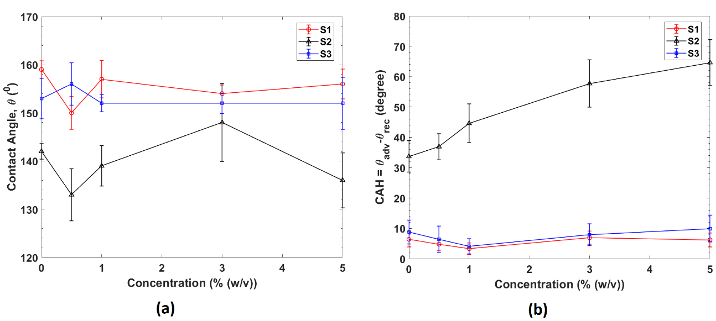
Results & Discussion
Figure 3. (a) Static contact angle (θ) and (b) Contact angle hysteresis for different concentration of the microparticles in aqueous solution for the three repellent surfaces studied.
The static contact angle gives an outline of the wetting characteristics based on the equilibrium state of the three-phase contact line. Within the range of experiment, the static contact angle remained almost independent of the concentration for all the substrates as shown in Figure 3(a). This occurred despite the reduction in the interfacial tension with increase in the concentration of the microparticles. S2 showed a smaller contact angle compared to S1 and S3, pointing to a reduced repellency for the same concentration of the microparticles. For the dynamic contact angle measurements expressed in the form of contact angle hysteresis ($CAH={θ_{a}}-θ_{r}$)) as shown in Figure 3(b) for S2, it is observed that CAH is monotonously increasing with the concentration. A similar increase in CAH was observed for microbead suspensions over a hydrophilic glass surface ($θ$ < 90⁰) with the increase in volume fraction of the microparticles.³⁸ For S1 and S3, the CAH is minimal and shows no variation with respect to a change in the concentration. This shows the importance of dynamic characterization additional to the static contact angle measurement while dealing with repellant surfaces as the behavior of the surface while approaching a previously unwet surface (advancing stage) and receding from an already wet surface (receding stage) are different. Further, the dynamics involved in the very process of dispensing a sessile droplet may cause errors if not operated correctly.⁸
We estimated the friction force acting on the droplet during the contact line motion using Furmidge’s relation as⁵¹
$F_{th}=2aγ_{LV}(cos{θ_{r}}-\cos{θ_{a}}),$ (1)
where a is base radius and $γ_{LV}$ is the surface tension and is plotted in Figure 4(a). F_{th} is almost invariable for S1 and S3 with the change in the concentration of the microparticles and the values obtained are comparable to that reported for structured superhydrophobic surfaces using a cantilever based force sensor (~ 5μN).⁹ However for S2, it shows a linearly increasing behavior. The friction force obtained from the cantilever-based measurement (F_{fric}), is plotted in Figure 4(b), which shows an increasing trend with an increase in the concentration of microparticles for S2 an S3 and a plateau for S1 after the initial rise. To validate our force estimation, we have also measured the tilting angle required for a droplet of chosen volume to start sliding down the surface of interest. The recorded tilt angle was then used in conjunction with the drop size to indirectly estimate the friction force, which is equal to the component of gravity acting along the inclined surface just at the moment when the droplet starts sliding down. For the surface-droplet combination with the lowest friction force (pure water droplet on S1), the calculated average friction from sliding angle data was 27.55 µN while our force apparatus registered an average value of 36.78 µN for a 10 µL droplet. This deviation of ca. 25% is within acceptable accuracy considering the base value in itself is very small. For further details on the sliding angle measurement, please refer to section S3 in the supporting information.
Figure 4. (a) Friction force from Furmidge equation (F_{th}) and (b) Friction (F_{fric}) and Adhesion force (F_{adh}) from for different concentration of the microparticles in aqueous solution for the three repellent surfaces studied. The inset shows values for S1 and S3 for low concentrations.

It is to be noted here that F_{th} estimated using the optically measured dynamic contact angle values differ significantly from the experimentally obtained F_{fric} values using the cantilever-based droplet force apparatus. This arises due to the well-known difficulty^{6,52} in determining baseline of the droplet from the shadow images of contact angle goniometer, which significantly affects the accuracy of measured of contact angle data in superhydrophobic surfaces (contact angle > 150°). For a nominal static contact angle of 162°, an error as small as 1 pixel in fixing the baseline of the droplet can result in an uncertainty of 5° in contact angle measurement.⁶ To illustrate its impact on the calculated value of F_{th}, let us assume an instance where the advancing contact angle is 162° and the receding contact angle is 157°. Now, if the receding angle is measured as 152° (an underprediction of 5°) due to the aforementioned error in accurate determination of the base line, the value of Δcosθ $(=cos{θ_{r}}-\cos{θ_{a}})$ experiences a 123% increment, which, assuming there is no other sources of error, directly corresponds to an error of 123% in the calculated value of friction force. Another responsible factor behind this difference is the possibility of local pinning of probing droplets on the target surface during friction measurement, which gives to a higher measured friction. This is more pronounced in case of S2 (Glaco coating – the one that consistently shows the highest friction and adhesion force among all the three coatings) where the surface contains random agglomeration of nanoscopic structures, as can be seen in the SEM image in Figure 2 (b). Similar observation with Glaco surface coating has earlier been reported by previous researchers^{53,54} as well. Such agglomerations act as local pinning sites, which contribute to a higher absolute friction and adhesion force as well as a higher difference between experimentally obtained data and the theoretical estimates using Furmidge’s equation. Further, Furmidge’s equation rely on the contact line motion and thus the energy dissipation at the vicinity of the three-phase contact line is considered. This is analogous to the Landau-Levich-Derjaugin (LLD) law for estimating the thickness of lubricant film between a drop and a solid surface, where the dissipation is considered only over the rim for a small width.¹ The above mentioned arguments substantiates the requirement of force-based measurement techniques, like the one reported here, for direct evaluation of adhesion and friction characteristics of super-repellent surfaces where the optically captured contact angle signature can be a source of significant uncertainty.
Now, let us look at the second force estimate from our experiments: F_{adh} plotted along with F_{fric} in Figure 4(b). For F_{adh}, the entire droplet surface that encountered the solid surface (circular area with radius a) contributes to the force measurement and thus in the deflection of the cantilever. It is perceived as the resistance to a disengagement in the normal direction while the experimentally measured frictional force in the present context (F_{fric}) is considered as the resistance to detachment in the lateral direction of the substrate. Even though both adhesion and friction correspond to the energy dissipation at the contact line, they differed in their magnitudes. It is clear from Figure 4(b) that F_{fric} is lower than F_{adh} for all coatings and concentrations. This maybe attributed to the fundamental difference in the way adhesion and friction contribute to the dissipation at the solid-liquid interface. Adhesion is measured by forceful complete removal of a test droplet from the surface while friction correspond to lateral migration of droplet, where the droplet always maintains contact with the surface (for a visual demonstration, refer to the actual experimental videos in SI, Section S7). While probing on the surface, adhesion measurement is confined to the area of contact (with radius a) whereas friction is extended over a strip with a width a.
Another observation is that F_{fric} flattened with respect to the concentration at a lower value than F_{adh}. A 20% reduction in the interfacial tension (see SI, Figure S2(b)) due to the increased concentration of the particles has resulted in about more than 100% increase in F_{adh}. For structured superhydrophobic surfaces, F_{fric} is a function of the solid surface fraction (φ) and is independent of the contact line velocity.⁹ A number of theories has been proposed towards the functional relationship with φ based on the energy considerations of the capillary bridges formed over the micro/nanostructures and their rupture.^{55–58} It should be noted that F_{th} based on the Furmidge relation considers an ideal flat surface without any roughness or impurities on the surface (φ = 1). In the present case, φ cannot be quantified accurately as the coating process is mostly uncontrolled on this aspect and it is only ensured that the fractal structures are formed on the substrate, leading to a Cassie-Baxter state of wetting.¹ This is verified through roughness measurement and reflection interference contrast microscopy (RICM) with the particle laden droplet over it for S2, the surface that offers the highest adhesion force to the oncoming droplets among all the tested substrates (see SI, Section S4 for details). The topological mapping of S2 was carried out using an Atomic Force Microscopy (AFM) as shown in Figure 5(a). It shows the random micro/nano structures that are responsible for the Cassie-Baxter state of wetting and the consequent superhydrophobicity.⁵⁹ This is further elucidated by means RICM observation as shown schematically in Figure 5(b). Figure 5(c) illustrates the change in reflected intensity signal from the same observation area before (Figure 5(c-i)) and after (Figure 5(c-ii)) a microparticle laden (5% w/v) water droplet is placed on the surface. The observed interference rings in Figure 5(c-ii) confirm formation of air pockets underneath the dispensed droplet, resulting in a Cassie - Baxter wetting state.
In our experiments, we also observed that F_{fric} was independent of the contact line velocity U (see SI, Section S5). From a measurement perspective, F_{adh} and F_{fric} are directly measured from the cantilever deflection while F_{th} is obtained from image analysis of both contact radius and the contact angles, making it more prone to appreciable errors in the case of highly repellant surfaces like the ones used in the present study. Contextually, it is to be noted here that the directly measured friction values using our force sensor provides a true representation of the actual response of the surface towards the oncoming droplet and therefore is more reliable than the theoretical estimate using Furmidge’s equation.
Figure 5. (a) AFM image showing the random roughness on the surface with the heights of the micro/nano features (b) Schematic of the RICM setup to probe at the location of the liquid-coating interface (c) RICM micrograph of (i) The sample without any water droplet on the surface (ii) The same position as in (i) with a droplet sitting over as shown in (b), clearly revealing the interference fringes corresponding to the capillary bridges formed between the micro/nanostructures. Scale bar represents 50μm
To understand the role of any force component due to the sedimentation of the particles with time along the contact line (coffee-ring effect), experiments are conducted by systematically varying the holding time (the time of direct contact of the droplet with the test surface) of the probing droplet on the test surface. It did not affect the adhesion force as shown in Figure 6 for a time interval up to 5 min even when we used a probe droplet with 5% (w/v) microdroplet concentration (the highest concentration used in the present study). It is to be noted that the substrates being highly repellant, the droplet is completely detached from the surface once the maximum deflection point of the cantilever is reached during the measurement of F_{adh}, without leaving any residues on the surface. In the case of hydrophilic substrates like normal quartz glass, the droplet is partially detached and splits into daughter droplets on the substrate, and thus the force measured will correspond to the separation force, which is also associated with formation of a new interface.^{12,60} Further, we also confirmed that the chemical inhomogeneities were not significant by conducting FTIR (Fourier-transform infrared spectroscopy) measurements over random locations across the sample (see SI, Section S6), which confirms acceptable spatial uniformity of the measured interaction signature.
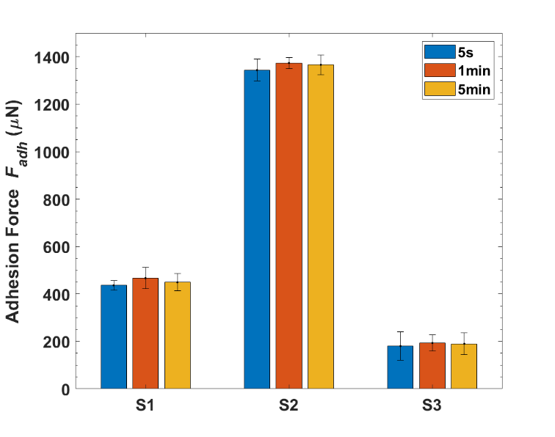
The results presented here shows that F_{adh} and F_{fric} can be a reliable estimate to classify different repellant surfaces. For a better accuracy and spatial averaging, AFM will definitely yield finer measurements,¹³ however customization of such an expensive instrument is not practical for most research groups. The present setup offers the simplicity in construction, data collection and analysis with minimal infrastructure and investment. With controlled vertical rastering, an adhesion map maybe constructed for repellent surfaces. Several factors can potentially introduce errors in the present system like localized variation in the concentration within the droplet, agglomeration of the microparticles and improper placing of the droplet on the cantilever. Further, the sole dependence on the bending of the cantilever as the measurement mechanism may lead to errors due to fatigue and variation in the k value over time. Nevertheless, it is useful in capturing the fundamental repellence signature, can help differentiating between seemingly similar repellent surfaces with similar static contact angle values and can also be used as a generic interfacial force measuring apparatus.
Figure 6. Adhesion force (F_{adh}) measured for different holding times over the substrates for a concentration of 5% (w/v).

Conclusion
We have investigated the frictional and adhesion characteristics of microparticle laden drops over repellent surfaces utilizing a simple yet efficient experimental setup. We have shown that the direct force measurements using droplet attached to a cantilever mechanism is more reliable than a regular optical goniometry for surfaces having high contact angle values where the inherent difficulties in optically imaging the solid-liquid interface and the challenges associated with the dispensation of the probe liquid significantly compromise the accuracy of measurements. Three coatings with different physicochemical properties but similar static water contact angles were investigated using the cantilever-based setup. Further, using the same setup, we were able to quantify the differences in the magnitudes of these forces for spherical polymeric microparticle laden water droplets. Based on the framework laid in this study, future structured investigations targeted at probing the molecular origin and nature of the interaction forces (contribution of van der Waals forces, capillary adhesion, steric effects etc.) between particle laden suspensions and solid surfaces could be developed. This study also provides a foundation towards development of rapid and cost-effective techniques to investigate the mechanism of interaction between surfaces and droplets with active bacterial or viral loads to evaluate the efficiency of antimicrobial/antiviral coatings and to understand the physics of their attachment to specific materials and fabrics, provided appropriate consideration given to account for the viability and motility of the live agents.

Acknowledgements
The authors would like to thank Prof. Tong Leung and Dr. Joseph P Thomas, Department of Chemistry, University of Waterloo for their assistance in the surface characterization of the coatings at the Waterloo Advanced Technology Laboratory (WATLab). We also thank Dr. Naga Siva Kumar Gunda for his advice and helpful suggestions during this work.
This work was supported by S.K.M.’s Alliance Grant ALLRP 551068 – 20 from the Natural Sciences and Engineering Research Council (NSERC) of Canada and University of Waterloo Start-up grant. SM additionally acknowledges financial support from the Waterloo Institute for Nanotechnology, University of Waterloo in the form of Nanofellowship 2020.

References
(1) De Gennes, P.-G.; Brochard-Wyart, F.; Quéré, D. Capillarity and Wetting Phenomena: Drops, Bubbles, Pearls, Waves; Springer Science & Business Media, 2013.
(2) Song, H.; Ahmad Nor, Y.; Yu, M.; Yang, Y.; Zhang, J.; Zhang, H.; Xu, C.; Mitter, N.; Yu, C. Silica Nanopollens Enhance Adhesion for Long-Term Bacterial Inhibition. J. Am. Chem. Soc. 2016, 138 (20), 6455–6462.
(3) Nosonovsky, M.; Bhushan, B. Superhydrophobic Surfaces and Emerging Applications: Non-Adhesion, Energy, Green Engineering. Curr. Opin. Colloid Interface Sci. 2009, 14 (4), 270–280.
(4) Neumann, A. W.; Good, R. J. Techniques of Measuring Contact Angles. In Surface and colloid science; Springer, 1979; pp 31–91.
(5) Kwok, D. Y.; Neumann, A. W. Contact Angle Measurement and Contact Angle Interpretation; 1999; Vol. 81.
(6) Liu, K.; Vuckovac, M.; Latikka, M.; Huhtamäki, T.; Ras, R. H. A. Improving Surface-Wetting Characterization. Science (80-. ). 2019, 363 (6432), 1147–1148.
(7) Srinivasan, S.; McKinley, G. H.; Cohen, R. E. Assessing the Accuracy of Contact Angle Measurements for Sessile Drops on Liquid-Repellent Surfaces. Langmuir 2011, 27 (22), 13582–13589.
(8) Huhtamäki, T.; Tian, X.; Korhonen, J. T.; Ras, R. H. A. Surface-Wetting Characterization Using Contact-Angle Measurements. Nat. Protoc. 2018, 13 (7), 1521–1538.
(9) Daniel, D.; Timonen, J. V. I.; Li, R.; Velling, S. J.; Kreder, M. J.; Tetreault, A.; Aizenberg, J. Origins of Extreme Liquid Repellency on Structured, Flat, and Lubricated Hydrophobic Surfaces. Phys. Rev. Lett. 2018, 120 (24), 244503.
(10) Sullan, R. M. A.; Churnside, A. B.; Nguyen, D. M.; Bull, M. S.; Perkins, T. T. Atomic Force Microscopy with Sub-PicoNewton Force Stability for Biological Applications. Methods 2013, 60 (2), 131–141.
(11) Liimatainen, V.; Vuckovac, M.; Jokinen, V.; Sariola, V.; Hokkanen, M. J.; Zhou, Q.; Ras, R. H. A. Mapping Microscale Wetting Variations on Biological and Synthetic Water-Repellent Surfaces. Nat. Commun. 2017, 8 (1), 1–7.
(12) Sun, Y.; Li, Y.; Dong, X.; Bu, X.; Drelich, J. W. Spreading and Adhesion Forces for Water Droplets on Methylated Glass Surfaces. Colloids Surfaces A Physicochem. Eng. Asp. 2020, 591 (November 2019), 124562.
(13) Daniel, D.; Lay, C. L.; Sng, A.; Jun Lee, C. J.; Jin Neo, D. C.; Ling, X. Y.; Tomczak, N. Mapping Micrometer-Scale Wetting Properties of Superhydrophobic Surfaces. Proc. Natl. Acad. Sci. 2019, 116 (50), 25008–25012.
(14) Waghmare, P. R.; Das, S.; Mitra, S. K. Drop Deposition on Under-Liquid Low Energy Surfaces. Soft Matter 2013, 9 (31), 7437–7447.
(15) Mitra, S.; Mitra, S. K. Symmetric Drop Coalescence on an Under-Liquid Substrate. Phys. Rev. E 2015, 92 (3), 33013.
(16) Daniel, D.; Chia, A. Y. T.; Moh, L. C. H.; Liu, R.; Koh, X. Q.; Zhang, X.; Tomczak, N. Hydration Lubrication of Polyzwitterionic Brushes Leads to Nearly Friction-and Adhesion-Free Droplet Motion. Commun. Phys. 2019, 2 (1), 1–7.
(17) Vafaei, S.; Borca-Tasciuc, T.; Podowski, M. Z.; Purkayastha, A.; Ramanath, G.; Ajayan, P. M. Effect of Nanoparticles on Sessile Droplet Contact Angle. Nanotechnology 2006, 17 (10), 2523–2527.
(18) Sefiane, K.; Skilling, J.; MacGillivray, J. Contact Line Motion and Dynamic Wetting of Nanofluid Solutions. Adv. Colloid Interface Sci. 2008, 138 (2), 101–120.
(19) Kendall, K.; Kendall, M.; Rehfeldt, F. Adhesion of Nanoparticles. In Adhesion of Cells, Viruses and Nanoparticles; Springer Netherlands: Dordrecht, 2010; Vol. 53, pp 169–193.
(20) Du, S.; Kendall, K.; Toloueinia, P.; Mehrabadi, Y.; Gupta, G.; Newton, J. Aggregation and Adhesion of Gold Nanoparticles in Phosphate Buffered Saline. J. Nanoparticle Res. 2012, 14 (3).
(21) Deegan, R. D.; Bakajin, O.; Dupont, T. F.; Huber, G.; Nagel, S. R.; Witten, T. A. Capillary Flowas the Cause of Ring Stains Fromdried Liquid Drops.Pdf. Nature 1997, 389 (23), 827–829.
(22) Fan, F.; Stebe, K. J. Assembly of Colloidal Particles by Evaporation on Surfaces with Patterned Hydrophobicity. Langmuir 2004, 20 (8), 3062–3067.
(23) Hosein, I. D.; Liddell, C. M. Convectively Assembled Asymmetric Dimer-Based Colloidal Crystals. Langmuir 2007, 23 (21), 10479–10485.
(24) Harris, D. J.; Hu, H.; Conrad, J. C.; Lewis, J. A. Patterning Colloidal Films via Evaporative Lithography. Phys. Rev. Lett. 2007, 98 (14), 148301.
(25) Marin, A. G.; Gelderblom, H.; Lohse, D.; Snoeijer, J. H. Order-to-Disorder Transition in Ring-Shaped Colloidal Stains. Phys. Rev. Lett. 2011, 107 (8), 85502.
(26) Velev, O. D.; Lenhoff, A. M.; Kaler, E. W. A Class of Microstructured Particles through Colloidal Crystallization. Science (80-. ). 2000, 287 (5461), 2240–2243.
(27) Dinsmore, A. D.; Hsu, M. F.; Nikolaides, M. G.; Marquez, M.; Bausch, A. R.; Weitz, D. A. Colloidosomes: Selectively Permeable Capsules Composed of Colloidal Particles. Science (80-. ). 2002, 298 (5595), 1006–1009.
(28) Manoharan, V. N.; Elsesser, M. T.; Pine, D. J. Dense Packing and Symmetry in Small Clusters of Microspheres. Science (80-. ). 2003, 301 (5632), 483–487.
(29) Marín, Á. G.; Gelderblom, H.; Susarrey-Arce, A.; van Houselt, A.; Lefferts, L.; Gardeniers, J. G. E.; Lohse, D.; Snoeijer, J. H. Building Microscopic Soccer Balls with Evaporating Colloidal Fakir Drops. Proc. Natl. Acad. Sci. 2012, 109 (41), 16455–16458.
(30) Vlasov, Y. A.; Bo, X.-Z.; Sturm, J. C.; Norris, D. J. On-Chip Natural Assembly of Silicon Photonic Bandgap Crystals. Nature 2001, 414 (6861), 289–293.
(31) Busch, K.; John, S. Photonic Band Gap Formation in Certain Self-Organizing Systems. Phys. Rev. E 1998, 58 (3), 3896.
(32) Van Blaaderen, A.; Ruel, R.; Wiltzius, P. Template-Directed Colloidal Crystallization. Nature 1997, 385 (6614), 321–324.
(33) Jiang, P.; Bertone, J. F.; Hwang, K. S.; Colvin, V. L. Single-Crystal Colloidal Multilayers of Controlled Thickness. Chem. Mater. 1999, 11 (8), 2132–2140.
(34) Hosein, I. D.; Lee, S. H.; Liddell, C. M. Dimer-Based Three-Dimensional Photonic Crystals. Adv. Funct. Mater. 2010, 20 (18), 3085–3091.
(35) Stebe, K. J.; Lewandowski, E.; Ghosh, M. Oriented Assembly of Metamaterials. Science (80-. ). 2009, 325 (5937), 159–160.
(36) Park, J.; Moon, J. Control of Colloidal Particle Deposit Patterns within Picoliter Droplets Ejected by Ink-Jet Printing. Langmuir 2006, 22 (8), 3506–3513.
(37) Kuang, M.; Wang, L.; Song, Y. Controllable Printing Droplets for High-Resolution Patterns. Adv. Mater. 2014, 26 (40), 6950–6958.
(38) Waghmare, P. R.; Mitra, S. K. Contact Angle Hysteresis of Microbead Suspensions. Langmuir 2010, 26 (22), 17082–17089.
(39) Brannon-Peppas, L. Recent Advances on the Use of Biodegradable Microparticles and Nanoparticles in Controlled Drug Delivery. Int. J. Pharm. 1995, 116 (1), 1–9.
(40) Alessandrini, A.; Facci, P. AFM: A Versatile Tool in Biophysics. Meas. Sci. Technol. 2005, 16 (6), R65.
(41) Daniel, D.; Chia, A. Y. T.; Moh, L. C. H.; Liu, R.; Koh, X. Q.; Zhang, X.; Tomczak, N. Hydration Lubrication of Polyzwitterionic Brushes Leads to Nearly Friction- and Adhesion-Free Droplet Motion. Commun. Phys. 2019, 2 (1), 1–7.
(42) Brown, D. Tracker Free Video Analysis and Modeling Tool for Physics Education. Open Source Phys. comPADRE, USA 2012.
(43) Deng, X.; Mammen, L.; Butt, H. J.; Vollmer, D. Candle Soot as a Template for a Transparent Robust Superamphiphobic Coating. Science (80-. ). 2012, 335 (6064), 67–70.
(44) Sahoo, B. N.; Nanda, S.; Kozinski, J. A.; Mitra, S. K. PDMS/Camphor Soot Composite Coating: Towards a Self-Healing and a Self-Cleaning Superhydrophobic Surface. RSC Adv. 2017, 7 (25), 15027–15040.
(45) Iqbal, R.; Majhy, B.; Sen, A. K. Facile Fabrication and Characterization of a PDMS-Derived Candle Soot Coated Stable Biocompatible Superhydrophobic and Superhemophobic Surface. ACS Appl. Mater. Interfaces 2017, 9 (36), 31170–31180.
(46) Sahoo, B. N.; Gunda, N. S. K.; Nanda, S.; Kozinski, J. A.; Mitra, S. K. Development of Dual-Phobic Surfaces: Superamphiphobicity in Air and Oleophobicity Underwater. ACS Sustain. Chem. Eng. 2017, 5 (8), 6716–6726.
(47) Majhy, B.; Iqbal, R.; Sen, A. K. Facile Fabrication and Mechanistic Understanding of a Transparent Reversible Superhydrophobic--Superhydrophilic Surface. Sci. Rep. 2018, 8 (1), 1–11.
(48) Vakarelski, I. U.; Patankar, N. A.; Marston, J. O.; Chan, D. Y. C.; Thoroddsen, S. T. Stabilization of Leidenfrost Vapour Layer by Textured Superhydrophobic Surfaces. Nature 2012, 489 (7415), 274–277.
(49) Zhao, X.; Khandoker, M. A. R.; Golovin, K. Non-Fluorinated Omniphobic Paper with Ultralow Contact Angle Hysteresis. ACS Appl. Mater. Interfaces 2020, 12 (13), 15748–15756.
(50) Berry, J. D.; Neeson, M. J.; Dagastine, R. R.; Chan, D. Y. C.; Tabor, R. F. Measurement of Surface and Interfacial Tension Using Pendant Drop Tensiometry. J. Colloid Interface Sci. 2015, 454, 226–237.
(51) Fumridge, C. G. L. Studies At Phase Interfaces I. the Sliding of Liquid Drops on Solid Surfaces and a Theory for Spray Retention. J. Colloid Sci. 1962, 17, 309–324.
(52) Vuckovac, M.; Latikka, M.; Liu, K.; Huhtamäki, T.; Ras, R. H. A. Uncertainties in Contact Angle Goniometry. Soft Matter 2019, 15 (35), 7089–7096.
(53) Lv, C.; Hao, P.; Yao, Z.; Niu, F. Departure of Condensation Droplets on Superhydrophobic Surfaces. Langmuir 2015, 31 (8), 2414–2420.
(54) Bourrianne, P.; Lv, C.; Quéré, D. The Cold Leidenfrost Regime. Sci. Adv. 2019, 5 (6), 1–6.
(55) Reyssat, M.; Quéré, D. Contact Angle Hysteresis Generated by Strong Dilute Defects. J. Phys. Chem. B 2009, 113 (12), 3906–3909.
(56) Gao, L.; McCarthy, T. J. Contact Angle Hysteresis Explained. Langmuir 2006, 22 (14), 6234–6237.
(57) Extrand, C. W. Model for Contact Angles and Hysteresis on Rough and Ultraphobic Surfaces. Langmuir 2002, 18 (21), 7991–7999.
(58) Butt, H.-J.; Gao, N.; Papadopoulos, P.; Steffen, W.; Kappl, M.; Berger, R. Energy Dissipation of Moving Drops on Superhydrophobic and Superoleophobic Surfaces. Langmuir 2017, 33 (1), 107–116.
(59) Bhushan, B.; Jung, Y. C. Natural and Biomimetic Artificial Surfaces for Superhydrophobicity, Self-Cleaning, Low Adhesion, and Drag Reduction. Prog. Mater. Sci. 2011, 56 (1), 1–108.
(60) Samuel, B.; Zhao, H.; Law, K. Y. Study of Wetting and Adhesion Interactions between Water and Various Polymer and Superhydrophobic Surfaces. J. Phys. Chem. C 2011, 115 (30), 14852–14861.

