Arborescent Poly(L-glutamic acid)s as Standards to Study the Dense Interior of Polypeptide Mesoglobules by Pyrene Excimer Fluorescence

Timothy Hall, Greg Whitton, Remi Casier, Mario Gauthier,* Jean Duhamel*

Institute for Polymer Research, Waterloo Institute for Nanotechnology, Department of Chemistry, University of Waterloo, 200 University Avenue West, Waterloo, ON N2L 3G1, Canada

* To Whom correspondence should be addressed.
E-mail: jduhamel@uwaterloo.ca, gauthier@uwaterloo.ca

ABSTRACT
A series of arborescent poly(L-glutamic acid)s of generations 0 to 3 (PGA(GY) with Y = 0 – 3) were randomly labeled with 1-pyrenemethylamine to yield several Py-PGA(GY) constructs with pyrene contents ranging between 2.5 and 22 mol%. The density (ρ) of the interior of the PGA(GY) samples was estimated in N,N-dimethylformamide (DMF) and dimethyl sulfoxide (DMSO) by conducting gel permeation chromatography and dynamic light scattering experiments to determine their molar mass and hydrodynamic diameter, respectively. It was determined that ρ increased with the generation number from PGA(G1) to PGA(G2), which promoted more contacts between the pyrene labels. The increase in the number of pyrene–pyrene contacts was quantified with the parameter N_{blob} obtained by analysis of the fluorescence decays for the Py-PGA(GY) samples in DMF and DMSO. In the analysis, N_{blob} represented the number of structural units, i.e. glutamic acid residues, comprised inside the volume probed by an exited pyrene, referred to as a blob. Inside a blob, pyrene excimer formation (PEF) could occur upon diffusive encounters between an excited and a ground-state pyrene label. It was found that N_{blob} increased with the generation number, and larger N_{blob} values were retrieved in DMSO as compared to DMF, because the oligo(L-glutamic acid) (OGA) side chains in the PGA(GY) samples underwent partial loss of helicity in DMSO, which increased their hydrodynamic volume and forced the side chains closer to each other, thus resulting in more pyrene–pyrene contacts and larger N_{blob} values. The trends observed for N_{blob} in DMF as a function of the generation number could be correlated theoretically with the degree of polymerization of the OGA side chains used to prepare the PGA(GY) samples and their internal density ρ. The good agreement found between the theoretical and experimental N_{blob} values confirm that pyrene is an excellent probe to study the complex interior of partially structured polypeptides.
INTRODUCTION
The ability of proteins to reproducibly convert a linear one-dimensional sequence of amino acids into a complex three-dimensional structure has been at the root of a long standing scientific effort to understand the underlying physical principles controlling protein folding. One of the recent developments in the field has been the realization that folding occurs locally and cooperatively within segments of a polypeptide referred to as foldons, that are made of N_{Foldon} = 20 ± 10 amino acids (aa).⁻ The existence and size of foldons have been established by NMR and MS proton exchange experiments performed on partially folded proteins. Most importantly, the use of foldons reduces dramatically the time required for a protein to fold as compared to the folding time (τ_{F}) for a hypothetical pathway where each aa of an N aa-long protein would be allowed 1 ps to sample any one of three possible conformations. This hypothetical pathway would result in τ_{F} values given by 3^{N}×1 ps, which are larger than the age of the Universe (~10¹⁰ years) for any protein with N larger than 61 aa’s. In contrast, a 60 aa-long protein made of three 20 aa-long foldons would fold on a much more reasonable time scale, with a τ_{F} value equal to (N/N_{Foldon})×3^{NFoldon}×1 ps = 10.6 ms. Since proteins must fold over a time scale much shorter than the lifespan of living organisms, the realization that the infinitely long folding times required for the systematic exploration of the entire conformational space of a polypeptide are impossible has been attributed to Cyrus Levinthal, and is referred to as Levinthal’s paradox., In fact, foldons have been presented as the only logical means to rationalize why proteins fold on much shorter time scales of milliseconds to seconds. Consequently, the characterization of foldons has been the subject of intense research efforts.
A recent investigation confirmed a suggestion made earlier that the size and dynamics of polypeptide blobs determined by Fluorescence Blob Model (FBM) analysis of the fluorescence decays acquired for polypeptides randomly labeled with the fluorescent dye pyrene were identical with those reported for foldons characterized through NMR and MS proton exchange experiments. In fact, foldons and blobs are conceptually identical since each term describes the length scale within a polymer coil over which encounters between aa’s located inside the same foldon or blob can lead to specific interactions between them. This result led to the postulate that blobs and foldons are similar entities.¹⁰ This conclusion was reached by applying FBM analysis to the decays of poly(L-glutamic acid) and poly(D,L-glutamic acid) chains randomly labeled with pyrene to yield a series of Py-PLGA and Py-PDLGA constructs, respectively. Within the FBM framework, the displacement of an excited pyrene label covalently attached to a macromolecule is confined to a subvolume of the polymer coil described as a blob because its mobility, during the few hundreds of nanoseconds while it remains excited, is restricted by the polymeric backbone to which it is bound. In N,N-dimethylformamide (DMF), the number of aa’s constituting a blob were found to equal 10 and 21 for the completely unfolded Py-PDLGA and the fully helical Py-PLGA constructs, respectively.¹⁰ Considering a blob size of 10 aa’s for PDLGA, the equivalent folding time τ_{F} calculated from the relationship 3¹⁰×1 ps was 59 ns, in good agreement with the inverse of the rate constant for excimer formation inside a blob, namely k_{blob}⁻¹ = 70 (± 12) ns. These results were in support of the equivalence between blobs and foldons, but the Py-PLGA and Py-PDLGA constructs used in these earlier experiments also constituted examples of linear polypeptides that were isolated in solution and adopted α−helical and fully unfolded conformations, respectively. Such conditions are far from those experienced by the segments of a polypeptide in a molten globule preceding the final stages of the folding pathway, where folded and partially folded polypeptide segments are expected to coexist in a crowded environment. In a molten polypeptide globule, the coexistence of folded and partially folded secondary structures constitutes a highly crowded environment that would be more representative of the conditions encountered during the NMR and MS proton exchange measurements.^{1-5,9},
In an effort to mimic experimental conditions in our fluorescence experiments that would approach those encountered in a molten polypeptide globule, a series of arborescent (dendritic graft) poly(L-glutamic acid)s of generations 0 – 3 (PGA(GY), with Y = 0 – 3 for generations G0 – G3) were randomly labeled with 1-pyrenemethylamine to yield a series of Py-PGA(GY) constructs. Arborescent polymers have crowded polymeric interiors confining linear polymer segments within a well-defined macromolecular volume.⁻ Consequently, they afford a unique experimental means to mimic the crowded environment encountered within a molten polypeptide globule, by generating globular macromolecules with a well-defined internal density. A grafting onto approach was used to prepare a series of arborescent poly(γ-benzyl L-glutamate) (PBG(GY) with Y = 0 – 3 for G0 – G3) which were then deprotected to prepare the Py-PGA(GY) constructs. The oligo(γ-benzyl L-glutamate) (OBG) segments used for the synthesis of the PBG(GY) samples were obtained by ring-opening polymerization of γ-benzyl L-glutamic acid carboxyanhydride. Partial deprotection of the OBG segments afforded free carboxylic acids that could be coupled by standard peptide chemistry methods with the N-terminus of the OBGs to produce a comb-branched PBG(G0) sample. The higher generation PBG(GY) samples with Y = 1 – 3 were obtained by additional cycles of partial deprotection and coupling with short OBGs. The procedure developed for the preparation of the PBG(GY) samples has been described in detail in an earlier publication (see Figure 1). It resulted in highly branched macromolecules with a branching functionality approaching 300 for PBG(G3), while maintaining a narrow molecular weight distribution (MWD) (M_{w}/M_{n} < 1.1) for all generations.¹⁶

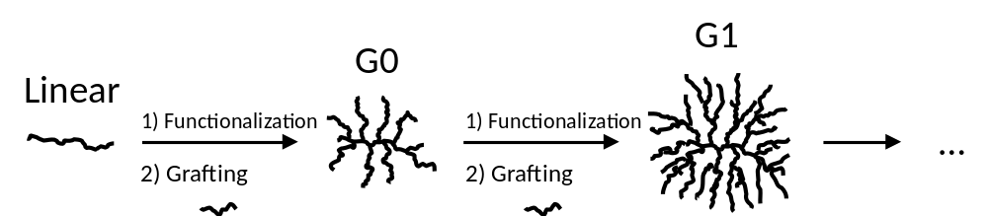
Figure 1. Schematic representation of the synthetic steps involved in the preparation of the globular arborescent PGAs.

The PBG(GY) samples were fully deprotected and labeled with pyrene to yield the Py-PGA(GY) constructs used in this study. Their MWD was characterized by gel permeation chromatography, while dynamic light scattering (DLS) measurements provided information on their internal density which could be related to the average separation distance (d_{h-h}) between the OGA helices inside the PGA(GY) constructs. Surprisingly good agreement was obtained between d_{h-h} and the expected increase in pyrene-pyrene contacts enabled by the proximity of the OGA helices inside the PGA(GY) molecular volume. This confirms the ability of the dye pyrene to accurately probe the proximity of different structural motifs inside the crowded interior of complex macromolecules, in addition to quantitatively describing the internal dynamics and structure of macromolecules in solution, which make it an excellent probe to study polypeptide mesoglobules.

EXPERIMENTAL
Chemicals: All reagents were purchased from Sigma-Aldrich and used as received unless otherwise stated. DMF used for the synthesis was dried over calcium hydride overnight before distillation under reduced pressure. Doubly distilled deionized water obtained from a Millipore Milli Q UF Plus (Bedford, MA) system was used. Spectra/Por dialysis bags were purchased from Spectrum.
Preparation of Poly(l-glutamic acid) Sodium Salt (PGNa): The PGNa samples were prepared from a series of PBG(GY) arborescent polymers whose synthesis was described earlier.¹⁶ The parameters describing their characteristic features are provided in Table 1. The deprotection of the benzyl groups, conducted in a similar manner for all the PBG(GY) samples, is described in more details for PBG(G3). In a 25 mL round bottom flask, PBG(G3) (0.5 g, 2.3 mmol benzyl glutamate units) was dissolved in 5 mL of trifluoroacetic acid and 0.5 mL of HBr solution in acetic acid (33% HBr by weight; 8.7 mmol HBr) was added with stirring. After 3 hours, 5 mL of anhydrous diethyl ether was added to induce precipitation, followed by 5 mL of acetone to partially solubilise the product. The slurry was then added drop-wise to 150 mL of diethyl ether with stirring. The polymer was recovered by suction filtration and washed three times with 10 mL portions of acetone. The polymer was further purified by suspension in 10 mL of acetone, sonication for 5 min, and suction filtration. The resulting chalky white solid was dissolved in 3 mL of DMF and 3 mL of 1 N aqueous NaOH, and dialyzed against H₂O in a regenerated Spectra/Por cellulose bag (Spectrum) with a 1000 MW cut-off for 6 hours. The solid (0.2 g) was recovered by lyophilisation of the solution collected from the dialysis bag. ¹H NMR analysis confirmed the absence of benzylic resonances at 5.0 and 7.3 ppm.

Table 1. Characteristics of arborescent PBG samples of successive generations.¹⁶
Generation | Graft polymers |  | Side chains |  | Branching functionality | D_{h} (nm)*
Generation | M_{n} (g·mol⁻¹) | M_{w}/M_{n} | M_{n}^{NMR} (g·mol⁻¹) | X_{n} | Branching functionality | DMF | DMSO
OBG† | 3.60×10³ | 1.09 | - | - | -
G0 | 5.30×10⁴ | 1.04 | 6600 | 30 | 6.6
G1 | 1.33×10⁵ | 1.06 | 4000 | 18 | 28 | 9.6 | 14.9
G2 | 4.86×10⁵ | 1.03 | 3900 | 17 | 124 | 12.6 | 20.7
G3 | 1.06×10⁶ | 1.03 | 3900 | 17 | 289 | 24.0 | 33.5
†M_{n} calculated using a number-average degree of polymerization (X_{n}) of 16 determined from ¹H NMR spectroscopy. * With 0.05% LiCl.
Coupling of PMA with PGNa: Covalent attachment of 1-pyrenemethylamine (PMA) to the PGA(GY) samples was performed by using carbodiimide coupling as outlined in Scheme 1. PMA was obtained by neutralizing 0.5 g of 1-pyrenemethylamine hydrochloride (0.5 g) with 50 mL of 1 N NH₄OH aqueous solution. The resulting PMA was extracted into hexane (6 × 50 mL washes), dehydrated over NaOH pellets (0.5 g), and finally dried under vacuum.
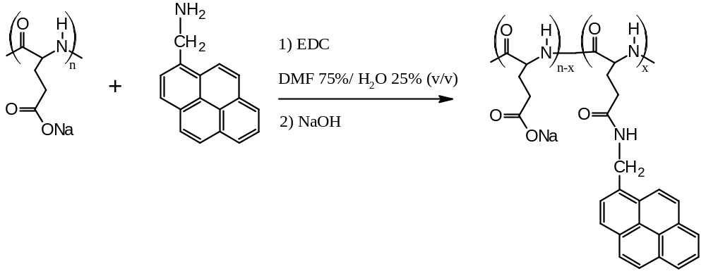
Scheme 1. Labeling reaction of poly(l-glutamic acid) sodium salt with PMA.
As an example of a labeling reaction, PGNa(G3) (11.3 mg, 7.510⁻⁴ mol glutamate units) was dissolved in 0.5 mL water, followed by PMA (1.77 mg, 7.6 10⁻⁶ mol), and the drop-wise addition of 2.5 mL dry DMF. After stirring for 10 min N-(3-dimethylaminopropyl)-N′-ethylcarbodiimide hydrochloride (EDC) (1.67 mg, 8.710⁻⁶ mol, 1.2 molar equivalents with respect to PMA) was added. After 5 hours the solution was acidified with 0.2 mL of 1 M HCl and the solvent was evaporated under a stream of air. The residue was dissolved in 4 mL of 1 M NaOH and unreacted PMA was removed by liquid-liquid extraction using hexane aliquots (7 × 4 mL). The aqueous solution was dialyzed for 15 hours in a 1000 MW cut-off bag immersed in 200 mL methanol, to further remove any unreacted pyrene, and then against 1 L of water (Milli Q doubly distilled). After changing the water bath 4 times within 8 hours, the content of the dialysis bag was freeze-dried on a Labconco Freezone 6 apparatus. The product, Py-PGNa(G3) (7.2 mg), was obtained as a white solid with 6.6% of the structural units labeled.
Acidification and Pyrene Content Determination: The pyrene content of the labeled Py-PGA(GY) samples was determined from the absorbance A at 344 nm of a Py-PGA(GY) solution in DMF of known massic concentration (m). Dividing A by the product ε×l×m, where l is the cell path length (1 cm) and ε is the molar extinction coefficient of 1-pyrenylmethylacetamide in DMF at 344 nm (ε = 39,000 mol⁻¹·L·cm⁻¹), the pyrene content, λ_{Py}, expressed in moles of pyrene per gram of PGNa(GY) sample, was obtained. Converting the pyrene content to the molar fraction (x) of glutamate units labeled with PMA was achieved with Equation 1, where M_{Py} (340 g/mol) and M_{GNa} (151 g/mol) are the molar mass of 1-pyrenemethylglutamide and sodium glutamate, respectively.
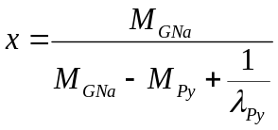 (1)
In a specific case given as an example of the procedure applied, Py-PGNa(G3) (2.31 mg) was converted to Py-PGA(G3) by dissolution in 5 mL of water and the addition of HCl (0.8 mL, 1 N) drop-wise with stirring to induce the precipitation of Py-PGA(G3). The acidified solution was lyophilized to yield a coarse white powder. The residue was dissolved in DMF (3.28 g) and a portion of this solution (0.517 g) was further diluted with DMF (4.41 g) such that the resulting absorbance at 344 nm equalled 1.16. A pyrene content corresponding to λ_{Py}= 414 μmol∙g⁻¹ or 6.6 mol% was obtained, and the sample was assigned the label Py(6.6)-PGA(G3). The Py(100x)-PGA(GY) sample nomenclature specifies the pyrene content, (100x in mol %), and the generation number (GY) of the PGA construct.
Gel Permeation Chromatography (GPC) Analysis: The absence of free (non-bound) PMA contaminant in the pyrene-labeled samples was verified with a Waters GPC instrument consisting of a Waters 501 HPLC pump, a Jordi H2O X-stream MB (LS) 250 mm × 10 mm linear column, and an Agilent 1100 Series fluorescence detector, using DMF as eluent at a flow rate of 1 mL/min at room temperature. Since PMA was found to adsorb on the GPC column, the Py-PGA(GY) solutions were prepared with a 2.5×10⁻⁶ M pyrene concentration to minimize interactions between the column and the Py-PGA(GY) constructs. Peak distortion was nevertheless observed for constructs labeled with higher pyrene contents (Figures S5 and S6), suggesting that they still interacted with the GPC column. However since no fluorescence signal was observed in the GPC traces of the Py-PGA(GY) samples at an elution volume corresponding to free PMA, these experiments demonstrated that the fluorescence of the Py-PGA(GY) solutions emanated solely from pyrene labels covalently attached to the arborescent polymers. Unfortunately, the extremely low Py-PGA(GY) concentrations used resulted in no signal from the differential refractive index and light scattering detectors, thus preventing the application of GPC analysis to determine the absolute molecular weight distribution of the Py-PGA(GY) constructs.
UV-Visible Spectrophotometry: UV-Vis absorption measurements were carried out on a Varian Cary 100 Bio spectrophotometer and were baseline-corrected. Solutions with an absorbance between 0.8 and 1.3 at 344 nm (pyrene absorption maximum) were prepared to ensure accurate absorbance measurements.
Nuclear Magnetic Resonance Spectroscopy: ¹H NMR spectra were acquired for the PGA(GY) samples on a Bruker 500 MHz spectrometer at a concentration of 5 mg/mL in DMF-d₇ or in DMSO-d₆. The spectra were calibrated using characteristic solvent peaks at 8.0 ppm and 2.5 ppm in DMF-d₇ and in DMSO-d₆, respectively.
Laser Light Scattering: A Brookhaven BI-200SM laser light scattering goniometer equipped with a BI-9000AT digital autocorrelator and a HeNe laser operating at 636 nm was used for the dynamic light scattering (DLS) experiments. The sample concentration was 10 mg/mL, with 0.5 mg/mL LiBr (0.05% w/v) added to minimize aggregation. The experiments were carried out at 25 ºC, with measurements at seven angles between 60º and 150º to establish a linear relationship between the inverse of the correlation time and the square of the scattering vector (q). More information about the DLS experiments can be found in the Supporting Information (SI).
Steady-State Fluorescence: A Photon Technology International LS-100 instrument with an Ushio UXL-75Xe Xenon arc lamp and a PTI 814 photomultiplier was used to record the steady-state fluorescence spectra. All the Py-PGA(GY) solutions had a pyrene concentration of 2.5×10⁻⁶ M, corresponding to massic Py-PGA(GY) concentrations ranging between 2 and 33 mg/L depending on their pyrene content (λ_{Py}). The solutions were degassed under a gentle flow of nitrogen for 30 min before acquiring the fluorescence spectra, which were analyzed to obtain the excimer-to-monomer fluorescence intensity (I_{E}/I_{M}) ratio using the integrated fluorescence intensity signal from 500 to 530 nm and from 372 to 378 nm for the excimer (I_{E}) and the monomer (I_{M}), respectively.
Time-Resolved Fluorescence Decays: The degassed solutions prepared for steady-state fluorescence measurements were excited at 344 nm, by adjusting the excitation monochromator of an IBH 5000F time-resolved fluorometer with a NanoLED source having a maximum intensity at 333 nm. Decays were acquired at 375 and 510 nm for the pyrene monomer and excimer, respectively, by the Time-Correlated Single Photon Counting (TCSPC) technique. All decays were collected over 1,024 channels with a minimum of 20,000 counts at the peak maximum. Depending on the sample, a decay acquisition time per channel of either 1.02 or 2.04 ns/channel was used with a repetition rate of 1 MHz or 500 kHz, respectively. Cut-off filters of 370 and 490 nm were used to block potential scattered light leaking through the detection system during the acquisition of the pyrene monomer and excimer fluorescence decays, respectively.
Fluorescence Decay Analysis: The monomer and excimer fluorescence decays obtained for the Py-PGA constructs were fitted globally according to the Fluorescence Blob Model (FBM) using Equations S7 and S8 given in the SI, respectively. According to the FBM, an excited pyrene covalently attached to a macromolecule probes a finite volume, referred to as a blob, while it remains excited. The blob is defined as a unit volume that is used to divide each macromolecule into a cluster of blobs, among which the pyrene labels are randomly attached onto the macromolecule and distribute themselves randomly according to a Poisson distribution. Excimer formation can occur through dynamic or static pathways. The dynamic pathway is a sequential process whereby an excited and a ground-state pyrene diffuse toward each other inside a blob with a rate constant k_{blob}. These excited pyrene labels are referred to as the species Py_{diff}*. When the pyrene labels are close to each other, the excited pyrene species Py_{diff}* turns into the species Py_{k2}*, indicating that the pyrene labels rearrange rapidly with a large rate constant k₂ to form an excimer. An excimer may also be formed by the encounter of two pyrene labels that are either well (E0*) or poorly (D*) stacked and emit with a natural lifetime that is short (τ_{E0}) or long (τ_{D}), respectively. Analysis using the FBM also yields the average number <n> of pyrene labels per blob, which can be employed to determine the number N_{blob} of structural units encompassed inside the volume of a blob. As such, N_{blob}, defined by Equation S24 in the SI, provides a measure of the local density inside the polymeric construct, a denser construct resulting in larger N_{blob} values. The FBM was described in numerous reviews and the reader is directed to these documents for further information.,

RESULTS
The PGA(GY) samples used in this study were obtained by removal of the benzyl groups of PBG(GY) samples in a mixture of trifluoroacetic acid, HBr and acetic acid. The product was precipitated several times in acetone before dialysis in a 1:1 mixture of DMF and 1 N NaOH aqueous solution, yielding about 200 mg of PGNa(GY) salt. After acidification of PGNa(GY) to PGA(GY), the ¹H NMR spectrum for PGA(GY) was acquired in DMF-d₆ and compared with that for the original PBG(GY) sample. An example of ¹H NMR spectra obtained for PBG(G2) and its corresponding PGA(G2) derivative is shown in Figure S1. The peaks at 7.3 and 5.0 ppm in the top spectrum, corresponding to the benzylic protons of the side-groups, are essentially absent in the bottom spectrum, indicating successful acidolysis.
Information about the dimensions of the PGA(GY) samples was obtained with dynamic light scattering measurements. The angular dependence of the distribution functions depicted in Figure 2A for PGA(G3) in DMSO indicates that there was no aggregation. The position of the peak maxima in Figure 2A yielded the average correlation time τ, whose inverse Γ=1/τ was plotted in Figure 2B as a function of q², calculated according to Equation S4. Γ increased linearly with q² as predicted by Equation S3. The good linearity observed in Figure 2B demonstrates that sample PGA(G3) was uniform in size. This implies that the low sample dispersity of the PBG constructs listed in Table 1¹⁶ was unaffected by the acidolysis of PBG to PGA.
The complete results for the DLS measurements of PGA in DMF and DMSO are presented as SI. Based on the histograms for the correlation times shown in Figures S10 and S13, sample PGA(G1) was found to self-assemble into larger aggregates. However it should be pointed out that the histograms shown in Figures 1A and S9-S13 are based on the light scattering intensity, which is extremely sensitive to the presence of large particles. Analysis of the autocorrelation function for PGA(G1) based upon particle numbers rather than the scattering intensity resulted in a minuscule contribution from the large aggregates. Thus, these aggregates represent a very small fraction of the particle population present in solution, with negligible effects on the average size measurements for the individual polymers. Furthermore, polymeric aggregates should not affect the fluorescence measurements, as these probe the macromolecules locally, on a length scale similar to the length of an OGA side chain used to prepare the PGA(GY) samples, much smaller than the size of the whole PGA(GY) samples and their aggregates.
A) | B)
Figure 2. A) Distribution functions for the time decay rate of scattered light intensity by PGA(G3) in DMSO measured at 150^{ο}, 135^{ο}, 120^{ο}, 105^{ο}, 90^{ο}, 75^{ο}, and 60^{ο} (from top to bottom). B) Plot for the relaxation rate of scattered light intensity as a function of q² to determine the diffusion coefficients of PGA(G3) in DMSO.
The hydrodynamic diameters for the PGA(GY) samples obtained in DMF and in DMSO are summarized in Table 2. The size of the G1 and G2 PGA constructs in DMF was smaller than in DMSO. This result is consistent with what had been observed for the PBG(GY) series (Table 1).¹⁶ These trends can be rationalized from the knowledge that whereas PGA in DMSO is expected to adopt a loose helical conformation, it adopts an α-helical conformation in DMF.^{10,}, Consequently, the α−helical conformation in DMF of the OGA side chains in the PGA(GY) samples likewise led to a more compact conformation for the arborescent PGA(GY) molecules. However the D_{h} value for PGA(G3) was slightly larger in DMF than in DMSO, contrary to the expectations based on the trends observed for the G1 and G2 PGA samples. Steric crowding due to the high branching functionality of PGA(G3) is suspected to have prevented some side chains from adopting a dominantly α-helical conformation, a conformation similar to that of the partially helical side chains in DMSO. As a consequence, the size of the PGA(G3) molecules became similar in DMF and in DMSO. In contrast, the PBG(G3) sample in DMF had a smaller D_{h} in DMF than in DMSO, suggesting that most side chains of PBG(G3) remained α-helical in DMF.¹⁶ This difference in behaviour between the PBG(G3) and PGA(G3) samples may be due to π-π staking of the PBG benzyl ester substituents, which might stabilize the α-helical conformation within the dense interior of the PBG(G3) molecules.
Table 2. Hydrodynamic diameter of arborescent PGA samples in DMF and in DMSO, with 0.05% LiBr added.
Generation | Diameter (nm)
 | DMF | DMSO
G1 | 11.0 | 16.4
G2 | 15.4 | 20.7
G3 | 31.2 | 30.3

After labeling the PGA(GY) samples with different amounts of 1-pyrenemethylamine, the fluorescence spectra of the Py-PGA(GY) samples were acquired in DMF and in DMSO. These are shown in Figure 3A and B for the Py-PGA(G3) series in DMF and in DMSO, respectively. The spectra exhibit sharp fluorescence bands for the pyrene monomer between 370 and 410 nm, and a broad structureless emission centered at about 480 nm for the excimer. An increase in pyrene content favored diffusive encounters between the pyrene labels, which resulted in increased pyrene excimer formation.
The main difference between the fluorescence spectra obtained in DMF and in DMSO is the relative intensity of the pyrene excimer fluorescence, which is much higher in DMF. At first glance, reduced excimer formation could be attributed to the high viscosity of DMSO (η = 1.987 mPa.s at 25 ºC) as compared to DMF (η = 0.784 mPa.s at 25 ºC), if excimer formation took place by diffusive encounters between two pyrene labels. However, the negative effect that the larger viscosity of DMSO might have on the efficiency of PEF was mitigated by the fact that the probability for two pyrene labels to form an excimer upon encounter had been found to be 53% larger in DMSO compared to DMF. This was established by applying the Birks scheme to determine the rate constant (k₁) of excimer formation for 1-pyrenemethylacetamide in DMF and DMSO found to equal 1.55 (±0.02)×10⁹ and 9.4 (±0.2)×10⁸ M⁻¹.s⁻¹, respectively.²² Although DMSO was more than twice more viscous than DMF, the k₁ values obtained in DMF and DMSO were comparable in magnitude. This result implied that the probability of forming excimer upon encounter of two 1-pyrenemethylacetamide molecules was much higher in DMSO than in DMF. The main consequence of this finding was that PEF was expected to be comparable in both solvents, despite the large solvent viscosity difference between DMF and DMSO. Furthermore, differences in fluorescence quantum yield for the pyrene monomer and excimer in DMF and in DMSO would also affect their respective fluorescence intensities. Consequently, the direct comparison of fluorescence intensities is best limited to a given solvent. The comparison of fluorescence data among different solvents is best achieved with time-resolved fluorescence measurements, which are much less sensitive to differences in solvent properties. The results from the lifetime measurements will be discussed later. Fluorescence spectra were acquired for all the Py-PGA(GY) constructs in DMF and in DMSO, to determine their I_{E}/I_{M} ratios. These are plotted in Figure 4 as a function of λ_{Py}, expressed in μmol of pyrene per gram of polymer.
A) | B)
Figure 3. Steady-state fluorescence spectra for sample Py-PGA(G3) in A) DMF and B) DMSO. The pyrene contents (top to bottom) are 12.6, 11.4, 10.9, 9.4, 8.1, 6.6, 5.4, and 4.0 mol %.
The trends obtained in DMF and in DMSO are similar, the I_{E}/I_{M} ratios increasing with λ_{Py}. The Py-OGA constructs yielded the least excimer, even as compared with I_{E}/I_{M} ratios obtained earlier for a series of linear Py-PGA samples with a degree of polymerization (X) of 800.¹⁰ The short OGA chains (16 aa’s) compartmentalized the pyrene labels inhomogeneously among different chains, resulting in a large fraction of OGAs bearing a single pyrene label that could not form excimer. This was not the case for the Py-PGA constructs with an X value of 800, making it much more difficult to isolate the pyrene labels and resulting in I_{E}/I_{M} ratios closer to those obtained for the generation G0 and G1 PGAs, both having an M_{n} value close to the linear PGA sample. Besides the obvious influence of the difference in chain length between OGA and PGA, the efficiency of PEF increased with generation number, with the G2 and G3 arborescent PGAs yielding the largest I_{E}/I_{M} ratios. The large size of the PGA(GY) samples ensured that, given a sufficiently high pyrene content, all the pyrene labels could form excimer, with pyrene labels either on the same OGA strand or on another OGA strand within the same arborescent polymer molecule. This latter path for PEF was promoted by the highly branched structure of the PGA(GY) molecules, resulting in more efficient PEF with increasing generation number.
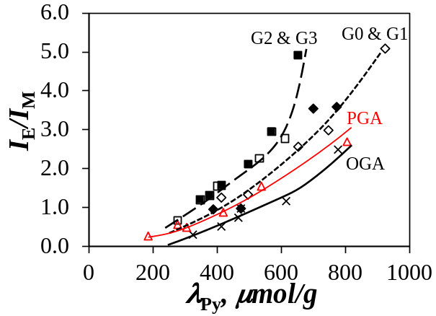 | 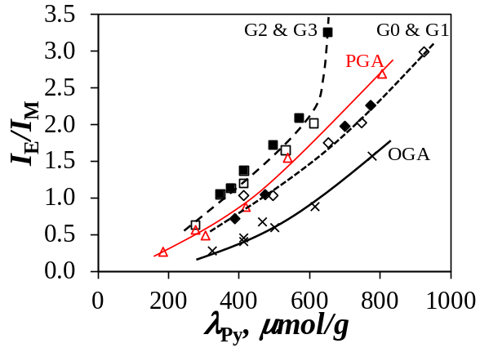  B)  A)
Figure 4. Plots of I_{E}/I_{M} versus pyrene content for (×) OGA, () PGA, () G0, () G1, () G2, and () G3 in A) DMF and B) DMSO. The lines serve as guide to the eyes.
While the fluorescence spectra provided the average intensity emitted by the different pyrene species present in solution, the analysis of the time-resolved fluorescence decays could isolate their individual contributions. This represents a major advantage of time-resolved fluorescence over steady-state fluorescence, since the different pyrene species described in the Experimental section affect the fluorescence signal of the pyrene monomer and excimer in very different ways. The monomer and excimer fluorescence decays for the Py-PGA(GY) samples were fitted globally to the FBM using Equations S1 and S2, respectively. The fits were good, yielding χ² values that were lower than 1.3, residuals and autocorrelation of the residuals randomly distributed around zero. An example of such a fit is shown in Figure S14 for Py(6.6)-PGA(G3) in DMF. All the parameters retrieved from the decay analyses are listed in Tables S1-S30 in the SI.
As discussed for the analysis of the I_{E}/I_{M} ratios presented in Figure 4, one of the key parameters expected to affect the I_{E}/I_{M} ratio is the size of the substrate labeled with pyrene. In particular, OGA stood out among the other polymers because its small size (M_{n} = 2,100 g/mol, equivalent to 16 glutamic acid units) generated a large population of isolated pyrene labels. This hypothesis was easily confirmed through FBM analysis of the fluorescence decays yielding the molar fraction f_{free}, calculated from Equation S23, of isolated pyrene labels (Py_{free}*). As shown in Figure 5, f_{free} for Py-OGA was by far the largest among all the pyrene-labeled substrates. For all polymers, f_{free} decreased with increasing pyrene content, as the attachment of more pyrene labels decreased the average contour length separating two pyrene moieties, thus reducing the probability of finding isolated pyrene labels. The PGA sample with M_{n} = 103 K, comparable to PGA(G1) (M_{n} = 78 K), yielded a similar profile for f_{free} in Figure 5. The higher generation G2 and G3 PGAs had the lowest f_{free} values, certainly because their larger size and highly branched structure enhanced PEF.
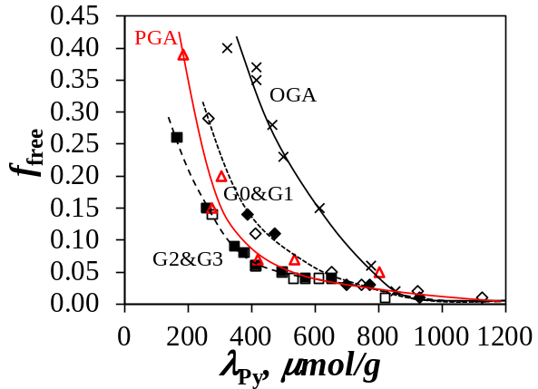 | 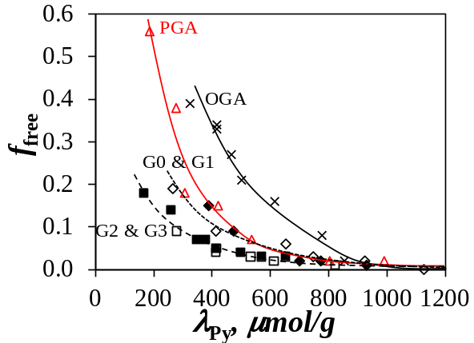  B)  A)
Figure 5. Plots of f_{free} as a function of pyrene content for the different pyrene-labeled constructs in A) DMF and B) DMSO. The symbols used are the same as in Figure 4.
The application of Equation S26 to the FBM parameters listed in Tables S1 – S30 yielded N_{blob}, the number of glutamic acids encompassed within the volume of a blob, and within which two pyrene labels could form excimer. Within experimental error, the N_{blob} values shown in Figure 6 remained constant with the pyrene content, demonstrating that pyrene-labeling of the PGA(GY) constructs did not affect their chain conformation. The N_{blob} values were averaged and plotted as a function of the branching functionality in Figure 7. The parameter N_{blob} provides a measure of the average spacing between two pyrene labels capable of PEF inside the macromolecules. Interestingly, N_{blob} obtained for OGA (14.4 ± 1.3 in DMF and 14.3 ± 1.4 in DMSO) was lower than N_{blob} determined earlier for PGA (20.3 ± 1.6 in DMF and 17.7 ± 1.3 in DMSO).¹⁰ As will be demonstrated quantitatively later, this discrepancy is attributed to chain end effects that are prevalent for the short OGA segments, and inexistent for the much longer PGA chains. An N_{blob} value of 14 for OGA is also lower than X = 16 for OGA, which is a reasonable outcome since the N_{blob} value should be lower than the degree of polymerization of the macromolecules under study.
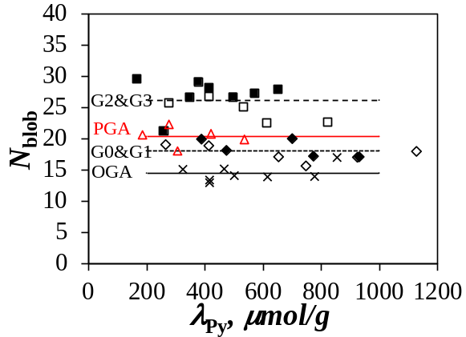  B)  A) | 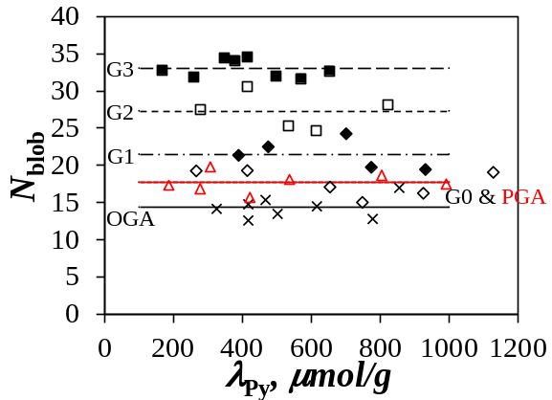
Figure 6. Plots for N_{blob} as a function of the pyrene content for linear (×), arborescent G0 (), G1 (), G2 (), and G3 () PGA in A) DMF and B) DMSO. The symbols used are the same as in Figure 4.
The decrease in N_{blob} observed for PGA from DMF to DMSO has been attributed to a partial loss of helicity experienced by PGA in DMSO. Based on the strong molar ellipticity observed for the Py-PGA constructs in DMSO, and the fact that a fully unfolded PGA chain has an N_{blob} value of 10 ± 1 in both DMF and DMSO, the N_{blob} value of 18 found for Py-PGA was interpreted as indicating that PGA had only partially lost its helical conformation. This result implied that the PGA helix must be somewhat expanded in DMSO as compared to DMF.¹⁰ This conclusion had two consequences. First, pyrene labels randomly distributed at the surface of a PGA helix were, on average, separated by longer distances making it more difficult for them to contact and form excimer, thus resulting in a decrease in N_{blob} for linear PGA from 21 in DMF relatively to 18 in DMSO.¹⁰ The second consequence was that the effect on N_{blob} was opposite for the PGA(GY) samples. The formation of looser OGA helices in DMSO brought the pyrene labels on different OGA strands closer to each other, allowing more contacts between pyrene labels, which led to higher N_{blob} values in DMSO for the higher generation PGA(GY) samples as compared to DMF, where the OGA strands inside the PGA(GY) samples were expected to form tighter and more compact α−helices.
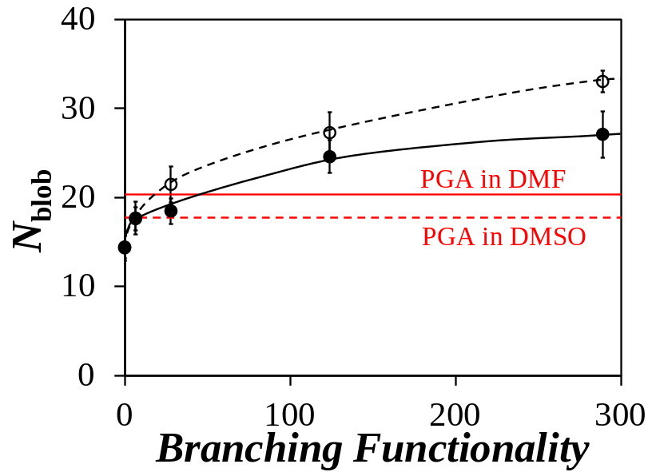
Figure 7. Plot for N_{blob} as a function of the branching functionality for the PGA(GY) samples in () DMF and () DMSO. The N_{blob} values are shown as continuous and dashed red lines in DMF and in DMSO, respectively.
Beside loosening of the OGA helices helping to bring the pyrene groups closer to each other, branching of the PGA(GY) samples also led to an increase in N_{blob}. The increased branching functionality of successive generations of the samples reduced the average distance between the OGA side chains, thus favoring pyrene-pyrene contacts and resulting in a larger N_{blob} values. Not surprisingly, Figure 7 appears to reflect an increase in N_{blob} with the branching functionality.

DISCUSSION
The analysis of the trends shown in Figure 7 suggests that the larger N_{blob} values observed for increasing branching functionality reflects increased pyrene-pyrene contacts resulting from a higher local density of structural motives, namely the OGA helices constituting the PGA(GY) constructs. The increase in local concentration of structural motives induced by PGA(GY) samples of higher branching functionalities is similar to what would be expected to occur during folding of a protein, where structural motives are brought in contact with each other. However the advantage of dealing with arborescent PGA(GY) constructs versus a folding protein is that the increase in helix density can be correlated with relatively well-defined parameters, such as the number-average molecular weight (M_{n}) and the hydrodynamic diameter (D_{h}) of the PGA(GY) samples.¹⁶
Relevant parameters pertaining to the PGA(GY) samples, summarized in Table 3, can be combined to provide a measure of the density (ρ) of the interior of the PGA(GY) samples of generations 1 – 3, by simply dividing the molar mass of the samples through their hydrodynamic volume as shown in Equation 2, where N_{A} is Avogadro’s number. The density of the constructs was found to increase from 0.19 to 0.25 g.mL⁻¹ as the generation number increased from 1 to 2, before decreasing to 0.07 g.mL⁻¹ for the PGA(G3) sample. The 4-fold decrease in density from PGA(G2) to PGA(G3) was expected based on the fact that both M_{n} and D_{h} doubled. However this
Table 3. Number-average molecular weight (M_{n}), dispersity (Ð), average density, inter-helix distance (d_{h-h}), value of N_{blob} for isolated OGA helices, increase in N_{blob} induced by inter-helical pyrene-pyrene contacts, expected N_{blob}, and experimentally observed N_{blob}.
Generation Number | M_{n}  kg·mol⁻¹ | Ð | D_{h}  nm | Polymer Density* g·cm⁻³ | Helix-Helix Distance**  d_{h-h}, nm | ΔN_{blob}† | Side Chain  X | Added Side Chains | <N_{blob}>‡ | <N_{blob}>  +  ΔN_{blob} | Measured <N_{blob}>
OGA | 2.1 | 1.09 | - |  |  | 0 | 16 | 1.0 | 14.8 | 14.8 | 14.2 ± 1.2
G0 | 31.2 | 1.04 | - |  |  | 0 | 30 | 7.5 | 18.3 | 18.3 | 17.2 ± 1.3
G1 | 78.3 | 1.06 | 11.0  (± 0.6) | 0.19 | 3.1 ± 0.3 | 0 | 18 | 20.0 | 17.4 | 17.4 | 18.3 ± 1.5
G2 | 286 | 1.03 | 15.4  (± 0.5) | 0.25 | 2.7 ± 0.2 | 5.9 | 17 | 90.5 | 15.8 | 21.8 | 24.6 ± 2.0
G3 | 624 | 1.03 | 31.2  (± 0.5) | 0.07 | 5.3 ± 0.3 | 0 | 17 | 147.2 | 15.5 | 15.5 | 27.7 ± 0.6
*Calculated using Equation 2.
**Calculated using Equation 4.
† Determined from Figure 9 using Equation 3.
‡ Calculated using Equation 6.
result also suggests an heterogeneous interior for PGA(G3), with a dense PGA(G2) core (density of 0.25 g.mL⁻¹) surrounded by a corona having a much lower density. In other words, this analysis suggests that PGA(G3) should be regarded as a heterogeneous sample having an interior with a high density of helical motives.

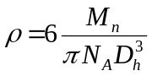 (2)

To correlate the increase in N_{blob} (ΔN_{blob}) observed as a function of the branching functionality in Figure 7 with the increase in density between PGA(G1) and PGA(G2) reported in Table 3, an array of hexagonally close-packed (HCP) helices was generated using HyperChem with a set inter-helix distance (d_{h-h}). This analysis focused on the results obtained in DMF, where PGA is known to adopt a well-defined α−helical conformation.²⁰ First, a PLGA helix was constructed with 32 glutamic acids using the built-in alpha helix conformation parameters (Phi = −58 °, Psi = −47 °, and Omega = 180 °), and the helix axis was aligned with the z-axis. This helix was referred to as the primary helix occupying the center of the HCP lattice (black helix in Figure 8A). The six other helices surrounding the primary helix in Figure 8A had their axis located at a distance d_{h-h} from the axis of the primary helix, at angles θ defined in Figure 8B (θ = 0, 60, 120, 180, 240, and 300º). In addition to the position of the surrounding helices defined by the coordinates (d_{h-h} and θ), the relative orientation of the surrounding helices was considered by defining an angle φ in Figure 8C. The 14th GA residue from the N-terminus on the primary helix of the glutamate side chains was then modified to include a 1-pyrenemethylamide moiety pointing along the y-axis. A second pyrene was then systematically added at a time along the glutamic acid residues of a secondary helix. It was then allowed to come in contact with the reference pyrene, by conducting molecular mechanics optimization (MMO) to determine the extent of carbon-carbon (C-C) overlap between the two pyrene pendants. The C-C overlap was determined as follows: The helix backbone was prevented from moving during MMO, by constraining the atoms via the ‘FIX ATOMS’ constraint. Restraints were then placed on the pyrene rings, such that the pyrene pendants could be brought together in a planar manner to achieve a 3.4 Å distance between the pyrene labels. A typical placement of restraints were between the carbons located at the top (carbon C7) and bottom (carbon C2) of the pyrene molecules. The MMO used a Fletcher-Reeves Conjugate gradient in vacuo with a termination condition set to a RMS gradient of 0.1 kcal·Å⁻¹·mol⁻¹. The optimization was considered successful when the planes of the pyrene pendants were parallel to each other with no bends present in their plane. Once the optimization was completed with the above requirements met, the C-C overlap of the pyrene labels was determined by highlighting the pyrene on the primary helix, arranging it so that its plane would be parallel to the plane of the computer screen, and counting the number of carbons of the pyrene on the secondary helix that fell within the frame of the reference pyrene on the primary helix. A C-C overlap of 7 or more atoms was expected to result in PEF, and the corresponding structural units were included in the calculation of ΔN_{blob}.^{10,-} This procedure was repeated for φ values of 0, 60, 120, and 180°, at θ values of 0, 60, 120 and 180°, and d_{h-h} distances of 3.0, 2.8, and 2.6 nm. For a d_{h-h} distance of 2.4 nm only φ = 180° was considered, as it was deemed to be sufficiently representative of additional pyrene-pyrene contacts (see Figure S17). The increase in N_{blob} for each distance d_{h-h} was taken as the average number of residues for which a C-C overlap greater than or equal to 7 was achieved for each position. The θ values of 60 and 120° were counted twice in this average, to account for additional helix positions at θ = 240 and 300°. Additional details about the procedures are provided in the SI.
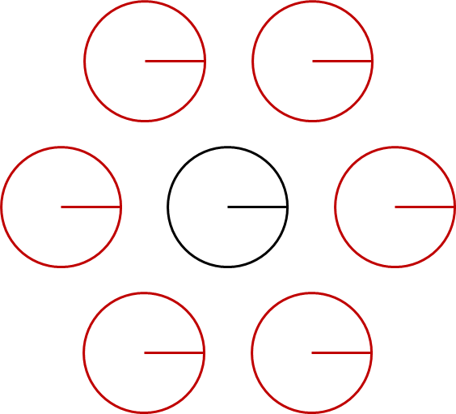  A) | 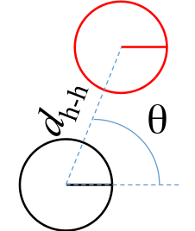  B) | 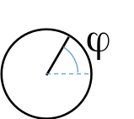 | 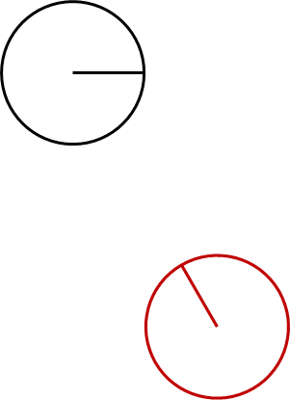  C)  D)
Figure 8: Top-down representation of the HCP packing of helical chain segments for A) a central helix (black) surrounded by the six outer helices (red) (φ = 0°; θ = 0, 60, 120, 180, 240, 300°), where θ and φ are defined in B) and C), respectively. D) The orientation of the red secondary helix relatively to the black primary helix is given by the set of coordinates (d_{h-h}, θ = 300º, ϕ = 120º).
The increase in N_{blob} resulting from a decrease in inter-helix distance d_{h-h} was referred to as ΔN_{blob} and was plotted as a function of d_{h-h} in Figure 9. The trend shown in Figure 9 indicates that OGA helices whose axes are separated by more than 3.0 nm could not generate pyrene-pyrene contacts that would result in PEF. Only shorter inter-helix distances resulted in an increase in N_{blob}. The trend in ΔN_{blob}-versus-d_{h-h} shown in Figure 9 was fitted with a 4th-order polynomial whose expression is given in Equation 3, relating the expected increase in N_{blob} with a given inter-helix distance.

(3)

Since PGA helices cannot expand in height, or they would no longer be α−helices, the density of the helix array shown in Figure 7 could only be reduced by increasing the inter-helix distance. The density of the matrix could then be approximated by considering the volume of a cylinder centered on the axis of the primary helix in Figure 8A and with radius d_{h-h}, so that the circumference of the cylinder would bisect the center of the outer secondary helices. As a first approximation, the number of helices (N_{h}) in the cylinder would then equal (6/2+1 =) 4 for HCP packing. The density (ρ) of the array of helices would then be given by the mass of N_{h} glutamic acids of molar mass (M_{GA} = 129 g.mol⁻¹) located in a disk of diameter d_{h-h} and height Δh (= 0.54 nm/residue for an α−helix). Rearranging the expression for ρ as a function of d_{h-h} yielded Equation 4. Using the density of the PGA(GY) samples in DMF given in Table 3 yielded the expected distance d_{h-h} from Equation 4, which was then introduced into Equation 3 to predict the corresponding increase in N_{blob} due to inter-helix contacts.
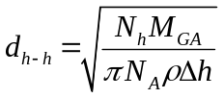 (4)

Figure 9: Plot of ΔN_{blob} as a function of for pyrene pairs with a C-C overlap greater than 6 atoms as a function of distance separating the helices in a hexagonal close packed arrangement. The dotted line represents an empirical fourth order polynomial (Equation 4) used to interpolate the increase in N_{blob} as a function of the helix-helix distance within a d_{h-h} range of 2.4 – 3.0 nm.

The resulting ΔN_{blob} values are listed in Table 3. They suggest that in DMF, no inter-helix contact took place in samples PGA(G0) and PGA(G1). At a first glance, this result somewhat contradicts the observation that N_{blob} increased from 14.2 ± 1.2 for OGA to 17.2 ± 1.3 for PGA(G0) and to 18.3 ± 1.5 for PGA(G1) in Figure 7. As it turns out, the increase in N_{blob} observed for the lower generation constructs was not due to an increase in density of structural motives, but rather to differences in the X value of the OGA side chains (Table 3) used in the grafting reactions to prepare the PGA(GY) samples. For instance, the OGA side chains (X = 30) used to build PGA(G0) were almost twice as large as the OGA substrate (X = 16) onto which the side chains were grafted. To this end, Equation 5 was derived in the SI to account for chain end effects induced by OGAs having different degrees of polymerization. Equation 5 uses the parameter N_{o}, representing the maximum number of glutamic acid (GA) units separating the GA residue with the reference pyrene label attached (position #1) from the other pyrene label attached along an OGA α−helix at a position N_{o} + 1, still able to provide good overlap and the formation of an excimer. The parameter N_{o} was found to equal 11 for α−helical OGA in DMF,¹⁰ indicating that two pyrene labels attached on an OGA α−helix with an X value of 12 or less can always form an excimer, thus leading to the conclusion that N_{blob} = X when X < N_{o} + 1. For larger X values, Equation 5 should be used.

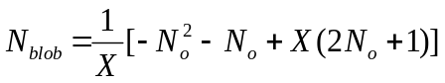 (5)

Based on Equation 5, the N_{blob} value for α−helical OGAs with an X value of 16 and 30 would equal 14.8 and 18.6, close to the experimentally obtained values of 14.2 ± 1.2 and 17.2 ± 1.3, respectively. Consequently, the increase in N_{blob} observed from OGA to PGA(G0) was certainly not due to increased density, but simply to the larger degree of polymerization of the OGA side chains used to prepare PGA(G0). The influence that the degree of polymerization of the side chains has on N_{blob} leads to the conclusion that the X value of each OGA side chain used in successive grafting reactions to produce a final PGA(GY) sample must be taken into account to predict the N_{blob} value of a given construct. This was achieved in Equation 6.

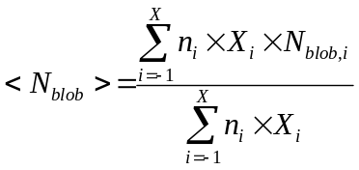 (6)

In Equation 6, n_{i} represents the number of side chains having a degree of polymerization X_{i}, with an associated N_{blob,i} value calculated using Equation 5, that are attached in the i^{th} grafting reaction used to prepare the PGA(GY) sample with X = 0 – 3. The index i = −1 in Equation 6 refers to linear OGA with X =16, used as a substrate to prepare PGA(G0). The similarity between the <N_{blob}> values obtained experimentally and from Equation 6 (Table 3) for OGA, PGA(G0), and PGA(G1) suggests that ΔN_{blob} took a zero-value for these constructs as was inferred from their inter-helix distance (d_{h-h}) determined from their density.
The quantity <N_{blob}> + ΔN_{blob}, where <N_{blob}> and ΔN_{blob} were calculated with Equations 6 and 3, respectively, was plotted in Figure 10 as a function of the N_{blob} values obtained experimentally for the PGA(GY) constructs in DMF. Rather good agreement was observed up to the PGA(G2) sample. As mentioned earlier, the density of the PGA(G3) sample was heterogeneous, making it impossible to relate the experimental N_{blob} values to the density of this construct. The experimental N_{blob} value of 27.7 obtained for PGA(G3) indicates that ΔN_{blob} = 12.2, which would correspond to a d_{h-h} value of 2.61 nm and a density of 0.26 g.mL⁻¹, similar to the density of PGA(G2). This suggests that during the labeling reaction, 1-pyrenemethylamine may be targeting the GA-rich region of the PGA(G3) sample, corresponding to the dense PGA(G2) core. In contrast, the D_{h} value obtained by DLS corresponds to the overall size of the PGA(G3) sample and does not reflect differences in local density inside the macromolecules.
G3
G2
G1
G0
OGA
Figure 10. Plot of <N_{blob}> + ΔN_{blob} vs experimental N_{blob} for the arborescent PGA molecules in DMF.

CONCLUSIONS
The experiments described in this report demonstrated that PEF between pyrene labels randomly attached onto fully (in DMF) and partially (in DMSO) structured oligopeptide segments constituting the interior of PGA(GY) samples responds effectively to the size and density of the oligopeptide segments used to prepare the PGA(GY) samples. This is an important achievement, as it demonstrates that PEF can be applied to characterize the size and density of structural motives found not only in the interior of PGA(GY) samples, but also in other environments such as the interior of polypeptide mesoglobules similar to those encountered during the folding of a protein. In fact, this study indicates that PEF could serve to monitor the increase in local density experienced by a polypeptide as it folds in solution.
Another aspect that should not be overlooked is the fact that highly branched polypeptides can be viewed as relatively well-defined biological standards that can serve in a quantitative manner to benchmark the response of PEF, or other spectroscopic techniques, to changes in macromolecular density. This new line of study would represent another application for these macromolecular constructs, besides the oft-cited elusive goal of employing them for drug delivery.

ACKNOWLEDGEMENTS
The authors are indebted to the Natural Sciences and Engineering Research Council of Canada (NSERC) for financial support.

SUPPORTING INFORMATION
Detailed information on the analysis of the DLS autocorrelation functions and the FBM analysis of the fluorescence decays, ¹H NMR spectra for the PBG(G2) and PGA(G2) samples, GPC traces for the PGA(GY) samples, DLS histograms for the PGA(GY) samples, example of decay fit, parameters retrieved from FBM analysis of the decays, additional information on the MMO and calculation of N_{blob} as a function of X.

REFERENCES

. Panchenko, A. R.; Luthey-Schulten, Z.; Cole, R. The Foldon Universe: A Survey of Structural Similarity and Self-Recognition of Independent Folding Units. J. Mol. Biol. 1997, 272, 95-105.
. Bai, Y.; Sosnick, T. R.; Mayne, L.; Englander, W. E. Protein Folding Intermediates: Native-State Hydrogen Exchange. Science 1995, 269, 192-197.
. Walters, B. T.; Mayne, L.; Hinshaw, J. R.; Sosnick, T. R.; Englander, S. W. Folding of Large Protein at High Structural Resolution. Proc. Natl. Acad. Sci. 2013, 110, 18898-18903.
. Hingorani, K. S.; Gierasch, L. M. Comparing Protein Folding in Vitro and in Vivo: Foldability Meets the Fitness Challenge. Curr. Opin. Struct. Biol. 2014, 24, 81-90.
. Hu, W.; Walters, B. T.; Kan, Z. Y.; Mayne, L.; Rosen, L. E.; Marguse, S.; Englander, S. W. Stepwise Protein Folding at Near Amino Acid Resolution by Hydrogen Exchange and Mass Spectrometry. Proc. Natl. Acad. Sci. 2013, 110, 7684-7689.
. Naganathan, A. N.; Muñoz, V. Scaling of Folding Times with Protein Size. J. Am. Chem. Soc. 2005, 127, 480-481.
. Levinthal, C. Are there Pathways for Protein Folding. J. Chim. Phys. 1968, 65, 44-45.
. Levinthal, C. How to Fold Graciously. Spectroscopy in Biological Systems. Proceedings University of Illinois Bulletin 1969, University of Illinois Press, Urbana, IL, pp 22-24.
. Englander, S. W.; Mayne, L. The Nature of Protein Folding Pathways. Proc. Natl. Acad. Sci. 2014, 111, 15873-15880.
. Casier, R.; Duhamel, J. Pyrene Excimer Fluorescence as a Direct and Easy Experimental Means to Characterize the Length Scale and Dynamics of Polypeptide Foldons. Macromolecules 2018, 51, 3450-3457.
. Farhangi, S.; Duhamel, J. Long Range Polymer Chain Dynamics Studied by Fluorescence Quenching. Macromolecules 2016, 49, 6149-6162.
. Naiyer, A.; Hassan, M. I.; Islam, A. ; Sundd, M.; Ahmad, F. Structural Characterization of MG and Pre-MG States of Proteins by MD Simulations, NMR, and Other Techniques. J. Biomol. Struct. Dyn. 2015, 33, 2267-2284.
. Gauthier, M. Arborescent Polymers and Other Dendrigraft Polymers: A Journey into Structural Diversity. J. Polym. Sci. Polym. Chem. Ed. 2007, 45, 3803-3810.
. Voit, B. I.; Lederer, A. Hyperbranched and Highly Branched Polymer Architectures – Synthetic Strategies and Major Characterization Aspects. Chem. Rev. 2009, 109, 5924-5973.
. Carlmark, A.; Hawker, C.; Hult, A.; Malkoch, M. New Methodologies in the Construction of Dendritic Materials. Chem. Soc. Rev. 2009, 38, 352-362.
. Whitton, G.; Gauthier, M. Arborescent Polypeptides from γ-Benzyl L-Glutamic Acid. J. Polym. Sci. Polym. Chem. 2013, 51, 5270-5279.
. Mathew, A.; Siu, H.; Duhamel, J. A Blob Model to Study Chain Folding by Fluorescence. Macromolecules 1999, 32, 7100-7108.
. Duhamel, J. Polymer Chain Dynamics in Solution Probed with a Fluorescence Blob Model. Acc. Chem. Res. 2006, 39, 953-960.
. Duhamel, J. New Insights in the Study of Pyrene Excimer Fluorescence to Characterize Macromolecules and their Supramolecular Assemblies in Solution. Langmuir 2012, 28, 6527-6538.
. Matsumoto, M.; Watanabe, H.; Yoshioka, K. Electric and hydrodynamic properties of polypeptides in solution. II. Conformation of Poly(L-glutamic acid) in Various Organic Solvents. Biopolymers 1970, 9, 1307-1317.
. Yamaoka, K.; Ueda, K. Reversing-Pulse Electric Birefringence of (Glu)n. Part 2. Reversing-Pulse Electric Birefringence Study of Helical Poly(alpha-L-glutamic acid) in N,N-Dimethylformamide with Emphasis on a New Data Analysis for Polydisperse System. J. Phys. Chem. 1982, 86, 406-413.
. Hall, T. Study of Arborescent Poly(L-glutamic acid) by Pyrene Excimer Formation. MSc. Thesis, University of Waterloo, Waterloo, ON, Canada, 2012.
. Lakowicz, J. R. Principles of Fluorescence Spectroscopy 2nd Ed., Kluwer Academic/Plenum Publishers, NY, 1999, p241.
. Duhamel, J.; Kanagalingam, S.; O’Brien, T.; Ingratta, M. Side-Chain Dynamics of an α−Helical Polypeptide Monitored by Fluorescence. J. Am. Chem. Soc. 2003, 125, 12810-12822.
. Ingratta, M.; Duhamel, J. Effect of Side-chain Length on the Side-chain Dynamics of α−Helical Poly(L-glutamic acid) as Probed by a Fluorescence Blob Model. J. Phys. Chem. B 2008, 112, 9209-9218.
. Li, L.; Duhamel, J. Conformation of Pyrene-Labeled Amylose in DMSO Characterized with the Fluorescence Blob Model. Macromolecules 2016, 49, 7965-7974.
. Svenson, S. The Dendrimer Paradox – High Medical Expectations but Poor Clinical Translation. Chem. Soc. Rev. 2015, 44, 4131-4144. Table of Content 