New Approaches to Characterize Polymeric Oil Additives in Solution Based on Pyrene Excimer Fluorescence
This is the peer reviewed version of the following article: J. Polym. Sci., Part B: Polym. Phys. 2017, 55, 7–18, which has been published in final form at https://doi.org/10.1002/polb.24256. This article may be used for non-commercial purposes in accordance with Wiley Terms and Conditions for Self-Archiving.

Solmaz Pirouz, Jean Duhamel
Institute for Polymer Research, Waterloo Institute for Nanotechnology, Department of Chemistry, 200 University Avenue West, Waterloo, ON N2L 3G1, Canada
Correspondence to: Jean Duhamel (E-mail: jduhamel@uwaterloo.ca)
ABSTRACT
Pyrene derivatives have been used to label maleated polyolefins employed as engine oil additives such as maleated ethylene propylene copolymers or polyisobutylene terminated at one end with a succininic anhydride. Pyrene excimer fluorescence (PEF) could then be applied to probe the behavior of the pyrene-labeled polyolefins (PyLPOs) in solution. These experiments take advantage of the fact that the fluorescence intensity of the excimer reflects both the internal dynamics and local pyrene concentration of PyLPOs. In particular, this review describes new methodology that was recently implemented to characterize the complex fluorescence signal emitted by PyLPOs by using steady-state and time-resolved fluorescence. This methodology enables one to gain quantitative information about the conformation, level of clustering of the succinic pendants along a maleated polyolefins, and aggregation of polyolefins in solution. Such information is relevant to scientists aiming to characterize polymeric oil additives used in engine oil.
KEYWORDS: Polyolefins, engine oil additives, pyrene excimer fluorescence

INTRODUCTION
The main purpose of engine oils is to create a lubricating layer between the moving parts of engines. Since base oil alone cannot meet all requirements of engine oils, performance-enhancing additives are purposely added to the oil formulation to improve engine efficiency and durability.^{1,2} These additives include dispersants, detergents, viscosity index improvers (VIIs), pour point depressants (PPDs), antiwear agents, and antioxidants.¹ Oil additives in a formulation vary in quantity depending on the specific requirements of an engine oil. The composition of a typical engine oil is shown in Table 1. A brief overview of the specific role of the different engine oil additives listed in Table 1 is provided hereafter.
Dispersants represent the most important family of chemical additives found in engine oils and they have been used since the 1950s.⁴⁻⁶ They work by dispersing oil-insoluble combustion by-products such as soot and sludge generated during the normal operation of the engine. Without dispersants, soot and sludge formation would cause wear and filter plugging. Like dispersants, detergents have been used since the 1940’s by the engine oil industry.⁵ Detergents are polar organometallic oil soluble bases which can cling onto the surface of particles. They are composed of an oil-soluble tail, called the substrate, and a negatively charged head group associated with a metal counterion. They serve two principal functions. First, they lift any deposits off the different surfaces of the engine due to their strong affinity toward these deposits while their oil-soluble tail maintains them in solution. Secondly, detergents neutralize any acids formed during the oil combustion by chemically reacting with them to form harmless chemicals, thus reducing corrosion.⁷

Table 1. Concentration of the main additives used in engine oil formulations.³
Material | Weight (%) | Material | Weight (%)
Base Oil | 71.5-96.2 | Antioxidant/Wear | 0.1-2.0
Metallic Detergent | 2-10 | Viscosity Index Improver | 0.1-3.0
Ashless Dispersant | 1-9 | Pour Point Depressant | 0.1-1.5

Beside the deposits left on engine surfaces and the acids generated in the oil, another major chemical that is detrimental to the performance of oil is wax. The problem with any lubricating oil containing some wax is that the wax crystallizes at very low temperatures, thus preventing the oil from flowing. Adding PPDs to the oil improves the low temperature performance of the oil by disrupting or preventing the formation of the waxy crystalline network.^{8,9} VIIs are another type of oil additives which are incorporated into the oil to reduce the inherent drop in viscosity that is observed with increasing temperature.¹ Without VIIs, the oil would be too thin at high temperature to properly coat the engine parts which would result in a loss of lubrication. At low temperatures, the oil would be too viscous to flow, thus failing to provide the protective lubrication necessary for the frictionless motion of the engine parts. In summary, VIIs are designed to counteract the reduction in oil viscosity observed at high engine temperatures without excessively increasing the viscosity of the oil at lower temperatures.
Chemicals that deposit onto the engine surfaces often exhibit acid functionalities that are usually the result of oxidation of the oil hydrocarbons from exposure to oxygen at high temperature. Antioxidants have been shown to decrease the oxidation rate of the oil and prevent soot/sludge formation.¹ Finally, a last family of important oil additives consists of antiwear agents which form a protective coating on the metal surfaces of the engine parts and can have an antioxidant effect on the oil as well.¹ Organosulfur and organophosphorus compounds, such as organic polysulfides, phosphates, dithiophosphates, and dithiocarbamates are the most commonly used antiwear agents.^{1,7}
Among the long list of oil additives presented so far, PPDs, VIIs, and oil dispersants are the only additives that are polymeric in nature and this review describes how fluorescence of the dye pyrene can be applied to characterize pyrene-labeled polyolefins (PyLPOs) employed as engine oil additives. Following the Introduction, the second section reviews the different polymeric oil additives focusing mostly on oil dispersants, pour point depressants (PPDs), and viscosity index improvers (VIIs). The third part of this review presents briefly the main photophysical features of pyrene-labeled macromolecules (PyLMs) and some of the recent developments made for their analysis. The fourth section describes the application of these concepts to study the behavior of PyLPOs whose non-fluorescent analogues are used as oil additives.
POLYMERIC OIL ADDITIVES
Pour Point Depressants
Two major problems are encountered with lubricating oils at very low temperatures. First, below a certain temperature, the engine oil can no longer flow freely. This temperature is known as the pour point. Second, any lubricating oil containing a small amount of wax forms crystalline networks at very low temperatures, which prevent the oil to flow.^{9,10} Even though most of the wax is removed during base oil refining, a small amount of wax still remains in the oil. These waxes are composed of asphaltenes which vary in molecular weight and chemical composition. Asphaltenes have a heterogeneous molecular structure with a distribution of aromatic nuclei. They readily aggregate to form colloidal particles, a process that increases the oil viscosity and the probability for wax crystallization.¹¹ In most cases, an engine generates sufficient shear to disrupt the wax network and allow the oil to flow. However, wax aggregation decreases the engine durability and lifetime, and is an important problem for cold start-up. PPDs are oil additives that ensure the free flow of oil and prevent the formation of waxy crystalline networks at low temperatures.⁸⁻¹⁰ Adding small amounts of PPDs can lower the pour point temperature by up to 30 ºC. Addition of PPDs does not prohibit crystallization but simply redirects the crystal growth patterns in a manner that results in the formation of smaller wax crystals.¹² For example, alkyl-substituted aromatic PPDs adsorb onto wax crystals to inhibit their growth while PPDs having a comb structure are designed to co-crystallize with wax crystals.⁸ PPDs enable a smoother car start-up, decrease engine wear, and increase engine life.
There are a number of factors that must be considered when selecting a polymer to be used as a PPD. The primary requirement is that the polymer must be soluble in engine oil over a wide range of temperatures that covers normal engine operation. Since the polymer solubility and its interactions with the oil and other oil additives are affected by temperature, the added polymer must remain compatible with the other species in the oil over the desired temperature range. The selected polymers also need to withstand the violent mechanical shear they are subjected to in the engine.^{12,13} For example, high molecular weight polymers are more effective as PPDs but they are also less soluble. Furthermore, the shear generated by an engine will cleave high molecular weight polymers resulting in the formation of lower molecular weight molecules. This means that when formulating a given PPD for a particular application, selection of a polymer having an appropriate molecular weight is necessary to ensure that the oil remains stable, even after going through numerous extreme temperature cycles.⁹
Different PPDs may be necessary for a same application as product specifications change over time. A list of the best known PPDs include ethylene-based polyolefins with alkyl side chains,⁸ vinyl-acetate copolymers,¹² poly(alkylphenol formaldehyde sulphonate)s,¹⁴ hexa-triethanolamine oleate esters,¹¹ poly(alkyl methacrylate)s,⁹ and copolymers of olefins and maleic anhydride that were post-modified with alcohols or alkyl amines to yield ester, amide, or succinimide functionalities.¹⁵ Viscosity measurements, cross-polarized light microscopy, and differential scanning calorimetery (DSC) can be used to investigate the efficiency of PPDs.¹¹⁻¹³
Oil Dispersants
Dispersants are designed to improve engine performance, decrease fuel consumption, and decrease pollution emission. The dispersants are used to disperse the oil-insoluble combustion by-products that circulate back into the engine oil and ensure that the oil flows freely. Sludge and soot are two of the most obvious by-products. Engine soot or ultrafine particles (UFPs) are mostly composed of carbon, but may contain some hydrogen and oxygen, and traces of nitrogen, sulfur, and metals.¹⁶ These particles, which are typically formed by the incomplete oxidation of fuel during ignition, are smaller than 100 nm in diameter and used to be released into the air with the exhaust gases.¹⁷ Since releasing UFPs from engines into the air can cause air pollution, governmental regulations were issued that aimed to reduce UFP emission.¹⁸ To this end, car manufacturers circulate the exhaust gas back into the oil, thus increasing the concentration of UFPs in the oil. In turn, an increase in UFP concentration leads to UFP aggregation and an increase in the viscosity of the oil. UFP aggregation is induced by the polar groups that are generated on their surface during engine operation. In apolar oil, UFPs aggregate into large particles (LPs, d_{LP} = ~1 µm) to minimize their polar surface exposure to the apolar oil. LPs can cause sludge formation resulting in oil blockage and engine failure. Therefore, dispersants are added to the engine oil to prevent UFP aggregation and in turn sludge formation.⁴
Dispersants are typically composed of a polar head group and an oil-soluble apolar tail. Metallic and ashless dispersants are two types of commonly used oil additives.⁴ The polar core of the dispersant is expected to adsorb onto the surface of the UFPs whereas the apolar tail stabilizes the particles in the oil. Dispersants can reduce UFP aggregation via a steric or electrostatic mechanism. Metal-containing dispersants have a good dispersancy capacity but the presence of metals can lead to the production of insoluble solids during engine operation which have a composition similar to that of ashes generated in a wood fire. These solid precipitates actually add to the sludge problem. The other type of dispersant is referred to as ashless dispersant. Unlike metallic dispersants, ashless dispersants do not leave any solid deposits in the engine. The most common types of ashless dispersants are Mannich type, succinate ester, and succinimide dispersants (Figure 1).⁴
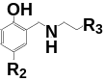A) | 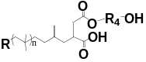B) | 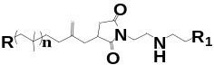C)
Figure 1. Chemical structure of A) Mannich type, B) succinate ester, and C) succinimide dispersants.
Mannich type dispersants are synthesized in the presence of alkylphenol, formaldehyde, and a polyamine (Figure 1A).⁴ The second group of ashless dispersants known as succinic esters are produced by the reaction of polyisobutylene terminated at one end with a succinic anhydride moiety (PIBSA) with alcohol (Figure 1B). The last and most common group of dispersants are the succinimide dispersants (Figure 1C). They were initially developed by Le Suer and Stuart in 1966.¹⁹ The preparation of a polyisobutylene succinimide dispersant (PIBSI) begins by using cationic polymerization to generate a short PIB terminated by a double bond²⁰ followed by an Alder-ene reaction between the terminal double bond and maleic anhydride at high temperature to yield PIBSA. PIBSA can further react with a polyamine in a 1:1 or 1:2 polyamine:PIBSA ratio to produce mono-PIBSI (m-PIBSI) and bis-PIBSI (b-PIBSI) dispersants, respectively.²¹⁻²³
In the case of PIBSI dispersants, increasing the number of secondary amines in the polyamine core results in a stronger binding onto UFPs, but decreases the compatibility of PIBSI dispersants with other oil additives and engine parts. For example, engine seals play an important role in engine design because they prevent oil leakage. Fluoroelastomers are commonly used as engine seals, due to their good thermal stability and oxidation resistance. However, these materials are sensitive to the basicity of the oil due to dehydrofluorination.⁴ The amines used to prepare the PIBSI dispersants make the oil more basic and consequently increase the probability of engine seal degradation. The basicity of the oil can be reduced through post-modification of the PIBSI-dispersants with ethylene carbonate or boric acid.^{24,25} This discussion illustrates how the incorporation of oil dispersants into an engine oil formulation requires that numerous factors be carefully considered to allow optimal engine cleanliness while providing acceptable seal compatibility.
Viscosity Index Improvers
VIIs have been added to motor oils since the 1940s to reduce the decrease in viscosity experienced by a liquid subject to an increase in temperature. VIIs are polymers with high molecular weight, typically in the 50,000 to 500,000 g.mol^{1} range.^{1,2}6 Without VIIs, the oil would be too thin at high temperature to properly coat the moving parts of the engine which would no longer be lubricated. At low temperatures, the oil would be too viscous to flow, which would prevent the motion of the engine parts. VIIs are designed to counteract the reduction in oil viscosity observed at high engine temperatures without excessively increasing the viscosity of the oil at lower temperatures. VIIs play an important role in increasing the oil performance by improving engine parts cleanliness and seal durability and better controlling deposits formation on engine surfaces and viscosity increase due to soot formation.
Semicrystalline polyolefins have been shown to be efficient VIIs. Crystalline sequences within a VII crystallize at low temperature and form dense crystalline microdomains resulting in polymer coils having small hydrodynamic volumes (V_{h}). Increasing the temperature melts the crystalline microdomains, allows the polymers to swell, and results in a higher V_{h} for the polymer coils. Since the viscosity of the solution depends on the volume fraction of the solution that is occupied by the polymer coils, expansion of the polymer coils leads to a viscosity increase as shown in Figure 2.
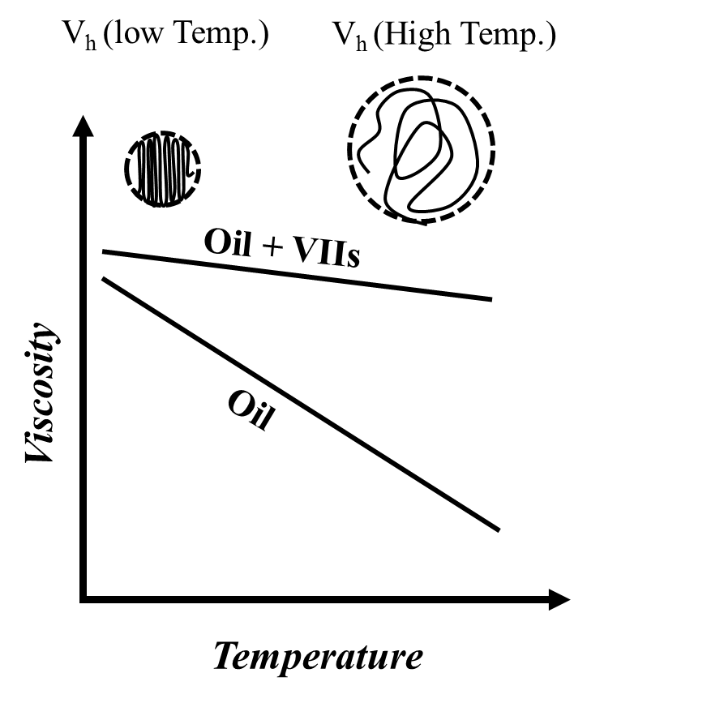
Figure 2. Expected change in oil viscosity in the absence and presence of VIIs.
Therefore, the decrease in engine oil viscosity with increasing temperature is moderated by the expansion of the polymer coil following the melting of the crystalline microdomains. The main consequence of these counteracting phenomena is that, addition of a VII to an oil ensures that the engine oil viscosity does not change significantly as a function of temperature during the operation of the engine. Synthetic polymers, such as alkyl methacrylate copolymers, olefin copolymers, and hydrogenated styrene-diene copolymers have been used as VIIs.7

CHARACTERIZATION OF OIL ADDITIVES
The oil industry has been using different polymers as engine oil additives to make their oils perform consistently all year round under low and high temperature conditions. However, when these polymers are exposed to the extreme chemical and physical stresses encountered in an engine, chain cleavage can occur, causing partial or total loss of their functions. The durability of these polymeric additives depends on internal parameters such as the chemical structure and molar ratio of the co-monomers used to prepare a polyolefin, as well as on external factors such as engine type and operation temperature, to name but a few.
For example, the thickening experienced by a solution of VII or PPD increases with the molecular weight of the polymer. However higher molecular weight polymers are more sensitive to shear thinning and chain cleavage. Both effects result in a loss of lubrication at high temperature which causes higher friction and consequently greater damage to the engine, a not so desirable outcome. Consequently the optimal chain length for a polyolefin used as a VII or PPD requires balancing the detrimental effect of chain scission and shear thinning with the desirable effect of increased viscosity.
Depending on the application, the oil additives may need to be evaluated for their ability to provide dispersancy and oxidation stability, maintain a relatively constant oil viscosity at low and high temperatures, minimize chain cleavage under high shear and in the presence of other oil additives, and form lubricating films having proper thickness. Over the years, several techniques have been applied to assess the effectiveness of these synthetic polymers as oil additives. These techniques include viscosity, cross-polarized light microscopy, light scattering (LS), carbon nuclear magnetic resonance (¹³C NMR), Fourier transform infrared spectroscopy (FTIR), gel permeation chromatography (GPC), differential scanning calorimetry (DSC), and fluorescence measurements.¹ Among these characterization techniques, only fluorescence can be used to characterize polymeric oil additives at the molecular level over a broad range of concentrations and temperatures. In particular, the study of excimer formation between pyrene labels covalently attached onto polymeric oil additives has been instrumental in their characterization at the molecular level. The pyrene excimer fluorescence-based techniques that were developed for that specific purpose are briefly described hereafter.
PYRENE EXCIMER FLUORESCENCE (PEF)
Pyrene excimer florescence (PEF) is vividly illustrated in Figure 3 when comparing the fluorescence spectrum of solutions of 1-pyrenemethyl succinimide (PyMeSu) and of a maleated EP copolymer labeled with 1-pyrenemethylamine (PMA-EP) having a pyrene concentration of 3.6×10⁻⁵ M in tetrahydrofuran (THF) and 1.1×10⁻⁵ M in toluene, respectively. THF was selected as a solvent due to its transparency at wavelengths lower than 300 nm to acquire the absorption spectrum of PyMeSu in Figure 3A. The PMA-EP sample being insoluble in THF was characterized in toluene in Figure 3B. Upon excitation at 343 nm into the S₂-electronic state of pyrene (see Figure 3A), Py-MeSu fluoresces at wavelengths larger than 360 nm. At a concentration of 3.6×10⁻⁵ M, an excited PyMeSu is unable to form an excimer because it decays back to the ground-state before having had a chance to encounter a ground-state pyrene. In this case, only the fluorescence of the pyrene monomer with its sharp peaks between 370 and 410 nm is observed in the fluorescence spectrum. But for Py-EP, the much higher local PyMeSu concentration inside the polymer coil enables pyrene excimer formation as illustrated from the broad featureless emission appearing at 480 nm in Figure 4B.
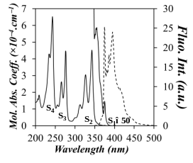 | 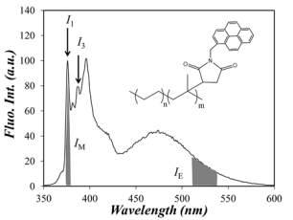
Figure 3. A) Absorption (____) and fluorescence emission (- - - -) spectra of 1-pyrenemethyl-succinimide (Py-MSI) in THF. ([Py-MeSu] = 3.6×10⁻⁵ M, λ_{ex} = 343 nm for the emission spectrum). B) Steady-state fluorescence spectrum in toluene of a pyrene labeled amorphous EP copolymer containing 108 μmol of pyrene per gram of polymer. ([Py-EP] = 0.1 g.L⁻¹, λ_{ex} = 344 nm).
The amount of excimer being produced can be estimated qualitatively by integrating the fluorescence band corresponding to the 0-0 transition of pyrene at 375 nm and the emission of the excimer between 500 and 530 nm to yield the fluorescence intensities I_{M} and I_{E} whose ratio I_{E}/I_{M} is a direct reflection of the efficiency of pyrene excimer formation. For instance, since a flexible backbone or a collapsed polymer coil would promote pyrene-pyrene encounters in a PyLM, the fluorescence spectrum of such a PyLM would yield a large I_{E}/I_{M} ratio. As it turns out, the I_{E}/I_{M} ratio under good solvency conditions for the pyrene labels is proportional to the product k_{diff}×[Py]_{loc} where k_{diff} is the rate constant of pyrene excimer formation by diffusive encounters and [Py]_{loc} is the local pyrene concentration in the polymer coil. Whereas the I_{E}/I_{M} ratio reflects intramolecular excimer formation at low PyLM concentration, excimer formation can also occur intermolecularly at high polymer concentration. An increase in the I_{E}/I_{M} ratio with increasing polymer concentration reflects an increase in [Py]_{loc} and is usually taken as an indication of the existence of intermolecular interactions between PyLMs.²⁸
Scheme 1 provides a simple description of the process of pyrene excimer formation. Irradiation of a solution of PyLMs results in the excitation of some pyrene monomers that can either fluoresce with their natural lifetime τ_{M} or form an excimer upon encounter with a ground-state pyrene. The excimer can then fluoresce with its natural lifetime τ_{E0}. Although pyrene excimer dissociation is possible, it is usually considered negligible at temperatures lower than 35 ºC.²⁹⁻³¹
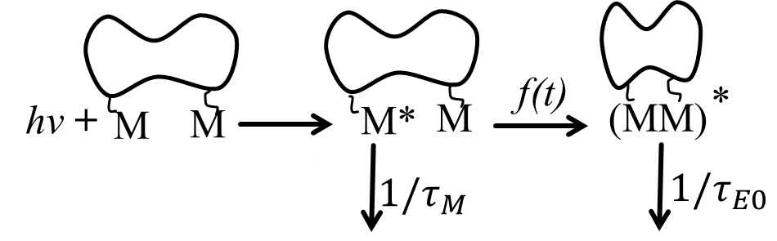
Scheme 1. Excimer formation between pyrene groups covalently attached onto a macromolecule.
In many instances, excimer formation in a PyLM must be described by a “time-dependent rate constant” referred to as f(t) in Scheme 1. The time-dependency of f(t) results from the distribution of chain contour lengths separating every two pyrenes covalently attached onto a macromolecule.²⁹⁻³¹ Since a single contour length yields a single rate constant of excimer formation, a distribution of contour lengths yields a distribution of rate constants with the shorter and longer contour lengths yielding larger and smaller rate constants. Consequently, pyrene labels separated by a short distance form excimer rapidly at early times whereas at longer times, only those pyrenes separated by longer distances form excimer with a much smaller rate constant, hence the need for a “time-dependent rate constant”. Monodisperse linear chains bearing a pyrene label at each end exhibit a single contour length, and only in this situation does f(t) simplifies down to a single, non time-dependent, rate constant (f(t) = k_{diff}). But any of the other more common pyrene-labeling schemes applied for macromolecules results in a distribution of rate constants represented by the function f(t). The past 20 years have seen an explosion in the number of mathematical means that have been made available to describe f(t) quantitatively. These advances have led to the establishment of the Fluorescence Blob Model (FBM),³² the sequential model,³³ and the Model Free Analysis (MFA).³⁴ These models have been presented in three recent reviews²⁹⁻³¹ and the readers are directed toward these documents for further information.
Interestingly, many of these recent developments in the analysis of fluorescence decays of PyLMs originated from the insight gained from the study of pyrene-labeled EP copolymers and PIBSA used as VII and dispersants in the oil additive industry. In turn, these analytical developments have provided new means to characterize oil additives based on pyrene excimer fluorescence (PEF) using both steady-state and time-resolved fluorescence. These advances in the characterization of polymeric oil additives by PEF are now described.
CHARACTERIZATION OF POLYMERIC OIL ADDITIVES BY PEF
Inspired by the development spearheaded by the Winnik group in Toronto in the 1980’s of applications based on the use of PEF to probe polymer behaviour in solution, Jao then at Texaco led a team of researchers who pyrene-labeled an EP copolymer to monitor its behaviour in solution by using fluorescence.³⁵ Being familiar with the chemistry employed to prepare the dispersants used in the oil additive industry, they maleated the EP copolymer and reacted the succinic anhydride groups with 1-pyrenebutyrylhydrazine (PBH). In 1992, they reported the first example of fluorescence spectra acquired with a pyrene-labeled EP copolymer (Py-EP) in two apolar solvents, namely methylcyclohexane and tetrahydronaphthalene (tetralin).³⁵ One interesting feature about the PBH-EP copolymer was that the remaining hydrazine proton could H-bond with carbonyls (see Figure 4A). The concentration regime where pyrene excimer formation occurred intramolecularly was determined from the sharp breakpoint in a plot of I_{E}/I_{M} versus polymer concentration.
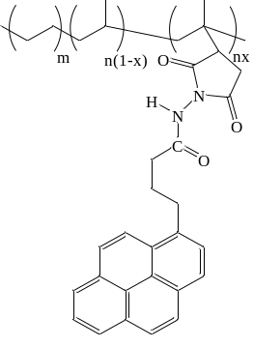  A) | 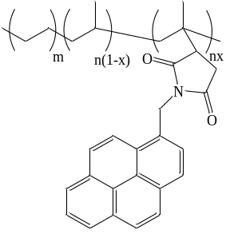  B)
Figure 4. Chemical structure of the maleated EP copolymers reacted with A) 1-pyrenebutyryl-hydrazine (PBH) and B) 1-pyrenemethylamine (PMA).
Following this early study, research on the behaviour of Py-EPs in solution was taken on by the Winnik and Fendler laboratories in Toronto and Syracuse, respectively. This work led to two important observations. The first and most important was that the spacers shown in Figure 4 and used to covalently attach pyrene to the EP backbone promoted strong interactions in apolar hydrocarbons like hexane or methylcyclohexane. Starting with an amorphous EP copolymers containing 60 mol% ethylene that was maleated and reacted with 1-pyrenemethylamine (PMA) to yield PMA-EP, Nemeth et al. measured the hydrodynamic diameter (D_{h}) of this Py-EP sample as a function of polymer concentration.³⁶ In apolar hexane (dielectric constant (ε) = 1.89), D_{h} showed a dramatic increase with polymer concentration while the increase was much less pronounced in more polar THF (ε = 7.5). The level of pyrene aggregation obtained by measuring the peak-to-valley ratio or P_{A} value, taken as the ratio of the absorbance at the ~344 nm maximum over that of the ~334 nm valley (see Figure 3A),³⁷ also confirmed that pyrene aggregation was strong for PMA-EP in hexane but practically absent in THF. This conclusion was reached from the knowledge that a P_{A} value larger or smaller than 3 is indicative of the absence or presence of pyrene aggregates in solution, respectively. Similar observations were made by Jao et al. by comparing the excitation and emission fluorescence spectra and the rise time in excimer fluorescence decays of a PBH-EP sample in apolar methylcyclohexane and THF.³⁸ The excitation spectra of PBH-EP were red-shifted in methylcyclohexane but showed hardly any shift in THF. Changing the excitation wavelength from 340 nm where the pyrene monomers absorb to 350 nm where the pyrene aggregates mostly absorb led to a more than two-fold increase in the I_{E}/I_{M} ratio in methylcyclohexane whereas a similar shift in excitation wavelength changed the I_{E}/I_{M} ratio by less than 10% in THF. The excimer decays of the PBH-EP sample showed a pronounced rise time of 5.4 ns and 17.2 ns in methylcyclohexane and THF, respectively. The time scale over which an excimer is formed reflects the level of pyrene aggregation, where instantaneous excimer formation indicates that the pyrene labels are pre-associated whereas excimer formation by diffusive encounters between pyrene labels as described in Scheme 1 results in delayed excimer formation reflected by a rising component in the excimer decay. Consequently, the short rise time observed in methylcyclohexane for the excimer decay of PBH-EP indicated that the pyrene groups leading to excimer formation where much closer to each other than in THF. All these observations^{36,38} supported the claim that apolar aliphatic solvents induced strong pyrene aggregation for both PMA-EP and PBH-EP.
The second conclusion of these early studies was that the simple models describing the kinetics for excimer formation between pyrene labels attached at the two ends of a monodisperse chain^{39,40} did not apply to Py-EPs in solution and that quantitative analysis of the monomer and excimer fluorescence decays acquired with the Py-EP samples required a re-think of the models used to fit the fluorescence decays. The inadequacy of these early fitting routines was routed in the fact that the Py-EP copolymers did not have a narrow molecular weight distribution and that their labeling followed the distribution of succinic anhydride pendants generated during the maleation of the EP sample. In turn, this led to a distribution of rate constants for pyrene excimer formation resulting in the “time-dependent rate constant” f(t) introduced in Scheme 1. Considering that all models dealing with pyrene excimer formation could take into account no more than two rate constants of excimer formation due to resolution issues in the analysis of multiexponential fluorescence decays,³⁰ a wide conceptual gap needed to be bridged to conduct a quantitative analysis of the fluorescence decays acquired with Py-EPs.
The first attempt to quantitatively analyze the fluorescence decays of PBH-EP in solution took advantage of the resemblance of the monomer decays with those obtained for molecular pyrene dissolved in sodium dodecyl sulfate (SDS) micelles.⁴¹ Assuming that an excited pyrene can only diffuse within a small sub-volume of the polymer coil referred to as a blob while it remains excited, the polymer coil can be viewed as a cluster of blobs where the pyrene labels distribute themselves randomly according to a Poisson distribution (see Figure 5). The kinetics of pyrene excimer formation could then be handled in the same manner as for pyrene dissolved in surfactant micelles and this analysis model was called the Fluorescence Blob Model (FBM).⁴¹ In this first application of the FBM, exchange of ground state pyrenes between blobs was neglected. The fit of the fluorescence decays of PBH-EP in THF and methylcyclohexane was satisfactory but showed some imperfections in the residuals and autocorrelation function of the residuals. These imperfections were attributed to the fact that this early version of the FBM did not account for exchange of pyrenes among blobs. This feature was added in later versions of the analysis programs based on the FBM.^{30,32,42}
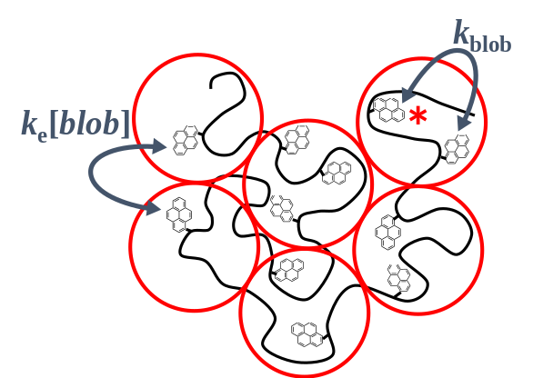
Figure 5. Schematic representation of the compartmentalization of the polymer coil into blobs where pyrene labels distribute themselves randomly according to a Poisson distribution. Encounter between an excited and a ground-state pyrene located inside a same blob take place with a rate constant k_{blob}. Exchange of ground-state pyrenes between blobs is described by the product k_{e}×[blob] where k_{e} is the exchange rate constant and [blob] is the local concentration of blobs inside the polymer coil.
The existence of a distribution of rate constants for pyrene excimer formation was duly recognized by Nemeth et al. who proposed a mathematical framework based on the use of a binomial function to handle f(t) in Scheme 1 for a Py-EP sample.⁴³ However while the FBM could be expressed by a relatively simple mathematical equation that could be applied to fit the fluorescence decays, no such expression was derived for the binomial function. Instead, the authors fitted the decays with a sum of three exponentials and used the contribution to the fluorescence decays of those excited monomers that did not form excimer and emitted with their natural lifetime τ_{M} to find the probability that a backbone unit be labeled with pyrene. The recovered probability was reasonable, but the study did not provide much additional information in terms of description of polymer chain dynamics. Furthermore, the absence of a mathematical equation to fit the entire fluorescence decays meant that the validity of the binomial distribution of rate constants for pyrene excimer formation still remains to be demonstrated. To this date, the FBM provides the only mathematical equation that can be used to fit globally the fluorescence decays of the pyrene monomer and excimer of randomly labeled macromolecules.³⁰
The first global FBM analysis of the monomer and excimer fluorescence decays acquired with a PBH-EP sample in THF and hexane was attempted in 2001.⁴⁴ Despite the addition of exchange of pyrene labels between blobs, the fits of the decays were poor in hexane showing strong deviations in the residuals at the early times. These deviations were attributed to the presence of pyrene aggregates where excimer formation occurred on a fast time scale. This observation led to the proposal that excimer formation took place as a sequence of two successive steps. Molecularly separated pyrene labels would diffuse slowly toward each other in the first step controlled by a rate constant k_{blob} as shown in Figure 5, but their encounter would be driven by the polar linker which would lead to the aggregation of the pyrene labels resulting in their efficient excimer formation with a large rate constant k₂ (k₂ >> k_{blob}) in a second step. This sequential approach for the process of excimer formation in solutions of PBH-EP proved highly successful resulting in excellent decay fits.⁴⁴ In these experiments, k₂ and k_{blob} were found to equal 2.1 (± 0.2) ×10⁸ s⁻¹ and 2.1 (± 0.4) ×10⁷ s⁻¹, respectively. Most importantly, the molar fraction (f_{agg}) of aggregated pyrenes could be determined quantitatively and was found to equal 0.68 (± 0.07) in hexane but only 0.34 (± 0.04) in THF, thus reflecting the strong level of aggregation induced by the succinimide moieties in hexane.
The studies of pyrene excimer formation in Py-EP solutions resulted in two important outcomes for the modeling of pyrene excimer formation. The first was the introduction of the FBM that provided a new means to handle the complex distribution of rate constants for excimer formation in randomly labeled polymers. The second was the realization that excimer formation between pyrene labels attached onto a macromolecule takes place in a sequential manner with a first slow diffusive step controlled by backbone motion that brings the two pyrenes close to each other followed by a rapid rearrangement of the pyrene labels to form an excimer. The validity of these concepts was further confirmed by studying pyrene excimer formation for oligoisobutylenes terminated at one end with a succininic anhydride unit (PIBSA) and labeled with either PBH or PMA to yield PBH-PIBSA and PMA-PIBSA, respectively.⁴⁵ In these experiments where excimer formation occurred intermolecularly, the slow diffusion of the terminal pyrenyl groups in solution could be well-approximated by a single rate constant which represented a major simplification compared to the distribution of rate constants that needed to be handled for solutions of Py-EP copolymers where excimer formed intramolecularly. The molar fraction of aggregated pyrenes was determined quantitatively and is shown in Figure 6 as a function of pyrene concentration. The effect that the H-bonding capability of PBH-PIBSA has on its intermolecular association in hexane is clearly illustrated in Figure 6 where f_{agg} remained larger than 0.6 over the entire concentration range studied. PMA-PIBSA was found to aggregate also in hexane, but to a much lesser extent than PBH-PIBSA, since its succinimide group could not H-bond. In the case of PMA-EP in hexane, interactions between the pyrene groups are believed to be induced by the polar succinimide groups. In THF, little aggregation took place and the linker connecting pyrene to the EP backbone showed no effect on aggregation. The non-zero f_{agg} value obtained in THF is due to the presence of a small fraction of doubly-maleated PIBSA molecules which after pyrene labeling, form excimer intramolecularly even at very low pyrene concentration.
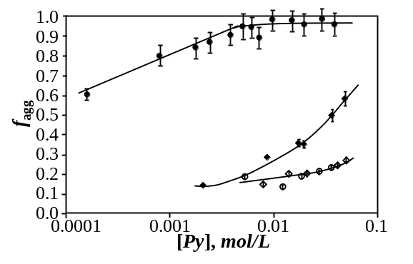Figure 6. Plot of f_{agg} versus pyrene concentration for PBH-PIBSA in hexane (●) and THF (○) and PMA-PIBSA in hexane () and THF ().⁴⁵
The ability to recover f_{agg} from the quantitative analysis of fluorescence decays was also applied to characterize the level of succinic anhydride clustering in a maleated EP copolymer.⁴⁶ Since clustering of associative pendants along a polymer leads to a stronger associative behaviour of the modified polymer in solution which is accompanied by a stronger rheological response, the level of clustering in modified EP copolymers is an important molecular parameter. In particular, the polymeric dispersants used by the oil additive industry bear pendants that are insoluble in an oil formulation and thus tend to aggregate in a manner that leads to a viscosity increase. Clustering of these pendants along the chain provides another parameter that affects the oil viscosity. To this end, Zhang et al. used two PMA-EP copolymers, with one copolymer having a more clustered distribution of succinic anhydride pendants than the other.⁴⁶ Fluorescence decay analysis for dilute PMA-EP solutions in THF yielded an f_{agg} value that increased from 0.34 ± 0.01 to 0.51 ± 0.00 as the level of clustering increased. The PMA-EP samples with a larger clustering of pyrene labels showed a stronger increase in viscosity with polymer concentration in hexane, thus demonstrating the effect that clustering had on the viscosity of a solution of modified EP copolymers.
The contribution of the carbonyl groups to polar aggregation of succinimide pendants in hexane was clearly demonstrated by Zhang and Duhamel by reducing the succinimide carbonyls of a PMA-EP sample with LiAlH₄ to generate pyrrolidine units.⁴⁷ The reduced PMA-EP sample in hexane formed much less excimer, its P_{A} value equaled 2.8 compared to 1.9 before reduction, and the excimer decay showed a risetime which was absent for the sample before reduction. Since a P_{A} value of 3 and higher indicates the absence of ground-state pyrene aggregates whereas a lower P_{A} value reflects pyrene aggregation,³⁷ the increase in P_{A} value from 1.9 to 2.8 after hydrogenation of the carbonyl groups was taken as evidence that reduction of the carbonyls led to a substantial decrease in pyrene aggregation. Similarly, the appearance of a rise time in the excimer decay after reduction of the succinimide carbonyls reflecting the delayed excimer formation described in Scheme 1 was another clear indication of the reduction in pyrene aggregation. Furthermore, the photophysical parameters retrieved with the reduced PMA-EP sample in hexane were similar to those obtained for the same sample in THF before reduction. These results demonstrated that the succinimide carbonyls contributed substantially to the aggregation of the succinimide pendants in apolar aliphatic solvents such as hexane or methylcyclohexane. While this conclusion was reasonable based on the chemical composition of the Py-EP samples, it complicated the study of EP copolymers in solution tremendously since their solution behaviour could be masked by the strong aggregation undergone by the succinimide pendants in aliphatic solvents. Indeed, strong aggregation of the succinimide pendants of a Py-EP sample would induce the efficient formation of pyrene excimer regardless of the behaviour of the EP backbone in solution. In these experiments, pyrene excimer formation would provide information on the association mechanism but not on the EP copolymer.
To remedy this problem, a series of experiments conducted on a PMA-EP sample in mixtures of toluene and hexane by Zhang and Duhamel established that the high level of association of a PMA-EP sample in hexane could be decreased to a similar level as that found in THF if apolar hexane (ε = 1.89) was substituted by toluene, another apolar solvent (ε = 2.38).⁴⁸ This observation opened the route for using PEF of Py-EP samples to characterize the behaviour of EP copolymers in solution. This conclusion was immediately taken advantage of to investigate whether PEF could be applied to probe the collapse undergone by the polymer coil of a semicrystalline EP copolymer at low temperature.⁴⁹ To this end, an amorphous and a semicrystalline EP copolymer having ethylene contents of, respectively, 60 and 80 mol% were maleated and reacted with PMA to yield PMA-EP(60) and PMA-EP(80). EP(80) had an interesting composition with a semicrystalline core flanked by two amorphous stretches. The fluorescence spectra of PMA-EP(60) and PMA-EP(80) were acquired at different temperatures. The I_{E}/I_{M} ratios were determined and plotted as a function of temperature in Figure 7. The I_{E}/I_{M}–vs–T profiles were complex exhibiting one break point at 25 ºC for all samples, and two additional breakpoints at −5 and −20 ºC for the semicrystalline EP copolymer. The breakpoint observed at 25 ºC was attributed to the inversion temperature observed in Steven-Ban plots when the excimer begins to dissociate before it has time to emit.⁵⁰ At temperatures lower than 25 ºC, excimer dissociation is negligible and I_{E}/I_{M} is directly proportional to the rate constant of excimer formation, which is itself inversely proportional to solvent viscosity. Consequently I_{E}/I_{M} increased with increasing temperature for PMA-EP(60) due to the decrease in solvent viscosity associated with an increase in temperature. The lower viscosity favors diffusive encounters between pyrene labels which results in a larger I_{E}/I_{M} ratio. The behaviour exhibited by the PMA-EP(60) sample in Figure 7 was typical of any PyLM in solution.
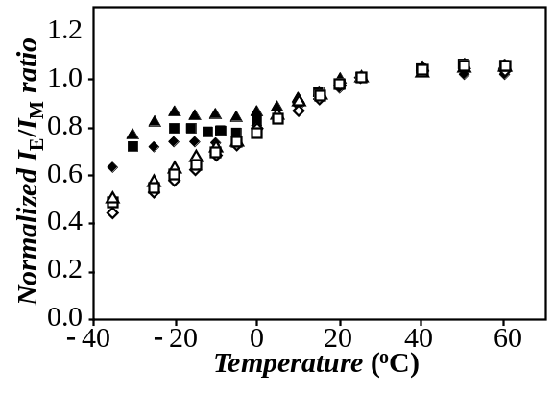
Figure 7. Normalized I_{E}/I_{M} ratio of Py-EPs plotted as a function of temperature at various concentrations in toluene (triangles, 0.02 g/L; squares, 0.1 g/L; diamonds, 2 g/L). Full and empty symbols are for PMA-EP(80) and PMA-EP(60), respectively.⁴⁹
What was unexpected in Figure 7 was the plateau region of the I_{E}/I_{M} ratio observed for PMA-EP(80) in toluene between −5 and −20 ºC. As it turned out, this plateau was due to an intramolecular collapse of the polymer coil induced by microcrystal formation as the solution temperature was lowered from −5 to −20 ºC. This reduction in polymer coil size as the temperature was decreased led to an increase in [Py]_{loc} which offset the viscosity-induced decrease in I_{E}/I_{M}. The collapse of the polymer coil was confirmed by conducting intrinsic viscosity measurements as a function of temperature which showed a drop in [η] in the same temperature range where I_{E}/I_{M} plateaued. Additional Fluorescence Resonance Energy Transfer (FRET) experiments demonstrated that the peculiar composition of EP(80) also enabled this polymer to form microcrystals intramolecularly even at polymer concentrations as high as 2 g.L⁻¹. The ability of EP(80) to form microcrystals intramolecularly was attributed to its microstructure where the amorphous overhangs would stabilize the microcrystals generated by the semicrystalline core of the polymer in solution.
The I_{E}/I_{M}–vs–T profiles shown in Figure 7 provided a clear indication of whether a polyolefin would generate microcrystals in solution. However, whereas the special microstructure of the EP(80) sample allowed it to undergo an intramolecular collapse with decreasing temperature, such behaviour was deemed highly unlikely for semicrystalline EP copolymers prepared by random copolymerization of ethylene and propylene. For such semicrystalline EP copolymers, the formation of microcrystals at lower solution temperature would indicate a worsening of the solvent quality toward the polymer which would be accompanied by an increase in intermolecular interactions. Since such associations would lead to the formation of polymer aggregates that would affect the viscosity of the solution, Pirouz et al. investigated whether pyrene excimer fluorescence could be applied to measure quantitatively the molar fraction (f_{inter}) of intermolecular interactions taking place in solution.^{51,52}
In their experiments, Pirouz et al. used an amorphous and a semicrystalline EP copolymer containing 60 and 78 mol% of ethylene monomer randomly distributed along the EP(60) and EP(78) backbones. The polymers were maleated and pyrene-labeled with PMA. Plots of I_{E}/I_{M}-vs-T were generated between −30 and +25 ºC for 10 g.L⁻¹ PMA-EP solutions in toluene as well as mixtures of 0.01 g.L⁻¹ PMA-EP and 10 g/L of the corresponding unlabeled EP copolymer in toluene. These plots are shown in Figure 8. The I_{E}/I_{M}-vs-T profiles obtained for the 10 g.L⁻¹ PMA-EP(60) solution and the mixtures containing 0.01 g.L⁻¹ of both PMA-EPs with an excess of the corresponding unlabeled EP copolymer showed a linear increase with increasing temperature over the entire temperature range. As in Figure 7 for the amorphous PMA-EP(60) sample, excimer formation was controlled by the solution viscosity that decreased with increasing temperature. By comparison, the 10 g.L⁻¹ PMA-EP(78) solution showed a much more complex behaviour as the solution temperature was increased, with I_{E}/I_{M} increasing first from −30 to −15 ºC, decreasing from −15 to 0 ºC, and increasing again from 0 to +25 ºC. In fact, the anomalous behaviour observed between −15 to 0 ºC in Figure 8 for PMA-EP(78) in toluene was similar to that found between −20 and −5 ºC in Figure 7 for PMA-EP(80),⁴⁹ another semicrystalline polymer. Intrinsic viscosity measurements as a function of temperature also confirmed that EP(78) underwent a collapse in the same temperature range where the I_{E}/I_{M} ratio behaved in an unexpected manner. As for EP(80), this behaviour was attributed to the formation of crystalline microdomains by EP(78) in toluene that would lead to an enhancement of [Py]_{loc} and thus of the I_{E}/I_{M} ratio. This feature of the I_{E}/I_{M}-vs-T profiles seems to be common for semicrystalline polymers randomly labeled with pyrene.^{49,51,52}
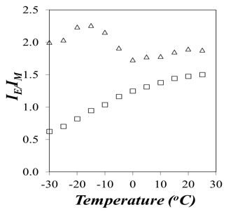  A) | 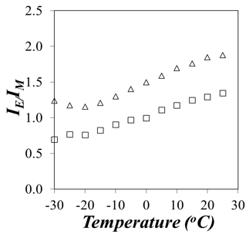  B)
Figure 8. I_{E}/I_{M} -vs-T. A) () PMA-EP(78) (10 g.L⁻¹), () mixture of PMA-EP(78) (0.01 g.L⁻¹) and EP(78) (10 g.L⁻¹). B) () PMA-EP(60) (10 g.L⁻¹), () mixture of PMA-EP(60) (0.01 g.L⁻¹) and EP(60) (10 g.L⁻¹). Solvent = toluene.^{51,52}

The four I_{E}/I_{M}-vs-T profiles showed in Figure 8 could be analyzed further to determine the molar fraction (f_{inter}) of intermolecular interactions taking place between pyrene pendants, and thus EP copolymers in solution. This was accomplished by taking advantage of the inherent dependency of the I_{E}/I_{M} ratio on [Py]_{loc} experienced by an excited pyrene attached to a polymer as shown in Equation 13.⁵³
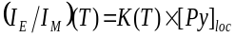 (13)
In Equation 13, K(T) is a function of the fluorescence quantum yields of the pyrene monomer and excimer and the rate constants for excimer formation and dissociation, all kinetic parameters that depend on temperature. But at a set temperature, K(T) is a constant that takes the same value whether the I_{E}/I_{M} ratio is acquired with a concentrated or a dilute solution. Taking this fact into account, solutions containing 10 g.L⁻¹ PMA-EP and a mixture of 0.01 g.L⁻¹ PMA-EP with 10 g.L⁻¹ EP yielded the ratios I_{E}/I_{M}(intra&inter) and I_{E}/I_{M}(intra) which were equal to K(T)×[Py]_{loc}(intra&inter) and K(T)×[Py]_{loc}(intra), respectively. This analysis of the I_{E}/I_{M} ratios led to the derivation of Equation 14 which was then applied to determine f_{inter}.
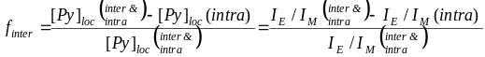(14)
Most interestingly, the complex temperature dependency of K(T) was eliminated from Equation 14 where K(T) canceled out. The four I_{E}/I_{M}-vs-T profiles shown in Figure 8 were processed according to Equation 14 to yield plots of f_{inter} as a function of temperature for the two PMA-EP(60) and PMA-EP(78) samples. Contrary to the complex behavior of the I_{E}/I_{M} trends observed in Figure 8, the f_{inter}-vs-T profiles shown in Figure 9 could be readily interpreted. The molar fraction f_{inter} remained constant with temperature for PMA-EP(60) as was expected for this amorphous polymer, but f_{inter} showed two clear-cut temperature regimes for PMA-EP(78). At temperatures lower than −5 ºC, f_{inter} equalled 0.62 ± 0.07 but it decreased to 0.23 ± 0.03 for temperatures greater than −5 ºC. The decrease in f_{inter} at higher temperature was a consequence of the melting of microcrystals involving several EP(78) chains and it demonstrated that for this EP copolymer, microcrystal formation took place intermolecularly in solution. Most importantly, the ability to use f_{inter} to quantify the level of intermolecular interactions between EP copolymers used as VIIs by the oil additive industry represented a major advance in the characterization of the behaviour of VIIs in solution. It can now be applied to probe the effect that different oil components have on each other in the intricate formulation of engine oils.
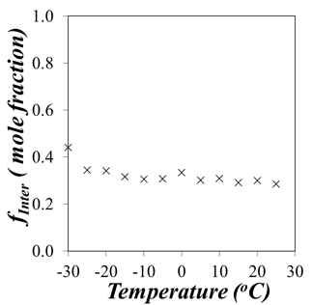  A) | 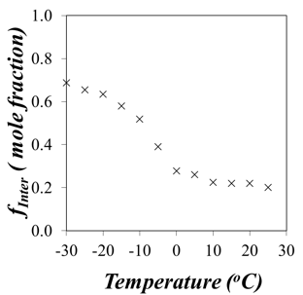  B)
Figure 9. Molar fraction f_{inter} of pyrene labeled EP copolymers forming excimer intermole-cularly in toluene for A) PMA-EP(60) and B) PMA-EP(78) at a concentration of 10 g.L⁻¹.^{51,52}
CONCLUSIONS
This review has highlighted how maleated polyolefins followed by their labeling with pyrene derivatives can be used to probe their behaviour in solution. For instance, reaction of a maleated EP copolymer with PBH results in a Py-EP copolymer that generates strong intermolecular associations via H-bonding in aliphatic solvents. Consequently, experiments conducted with PBH-EP samples provided information at the molecular level about the associative behaviour of modified EPs typically used as dispersants by the oil additive industry. These associations could be probed qualitatively from the study of the absorption, excitation, and emission spectra of Py-EP solutions or the rise time in the excimer decays. Models have also been proposed to gain quantitative information about the associative strength of a given PBH-EP sample in an aliphatic solvent by determining the molar fraction f_{agg} obtained through the quantitative global analysis of the pyrene monomer and excimer fluorescence decays.
On the other hand, the reaction of PMA with a maleated EP yielded a Py-EP that did not form H-bonds. However the succinimide moieties used to connect the pyrene label to the EP backbone were polar enough to induce intermolecular associations in apolar aliphatic solvents like hexane or methylcyclohexane. Fortunately these strong polar interactions appeared to vanish in apolar toluene. As a result, the study of PMA-EP samples in toluene provided information about the behaviour of EP copolymers in solution. Taking advantage of the direct relationship that exists between the I_{E}/I_{M} ratio and [Py]_{loc}, information about the level of intermolecular interactions that are being generated between polymers in solution could be quantified from the molar fraction f_{inter}. f_{inter} was shown to increase markedly when the solution temperature reached the point where a semicrystalline EP copolymer would form crystalline microdomains in solution. For amorphous EP copolymers, f_{inter} remained constant as a function of temperature.
The advances for the characterization of polyolefins in solution described in this review demonstrate how pyrene excimer fluorescence can be used effectively to probe a variety of behaviours encountered by Py-EP samples in solution. It provides a powerful analytical means to investigate both quantitatively and qualitatively polymer-polymer interactions in solution and seems to be particularly well-suited to study the solution behaviour of polyolefins used by the oil additive industry.
ACKNOWLEDGEMENTS
The authors are indebted to Imperial Oil, DSM, Afton, and NSERC for generous support.
REFERENCES AND NOTES
- Z. Pawlak, In Tribochemistry of lubricating oils; Elsevier: Poland, 2003; Vol. 45.
- A. M. Nassar, N. S. Ahmed, R. S. Kamal, A. A. Abdel Azim, E. El-Nagdy, Petrol. Sci. Tech. 2005, 23, 537-546.
- P. Salino, P. Volpi, Ann. Chim. 1987, 16, 145.
- L. R. Rudnik, In Lubricant Additives: Chemistry and Application; E. A. Barbadsz, G. D. Lamb, G. D. Eds.; CRC Press, Boca Raton: Florida, 2003; pp 458-490.
- R. M. Mortier, F. F. Malcolm, S. T. Orszulik, In Chemistry and Technology of Lubricants; Springer: London, 2009.
- T._C. Jao, C. A. Passut, In Handbook of Detergents: Part D: Formulation; M. S. Showell, Ed.; CRC Press, Boca Raton: Florida, 2006.
- T.-C. Jao, C. A. Passut, In Handbook of Detergents; G. Broze, Ed.; CRC Press, New York, 1999.
- W. J. Heilman, B. E. Wilburn, USP 5188724, 1993.
- W. V. Horne, Ind. Eng. Chem. 1949, 41, 952-959.
- H. H. Naga, W. M. Azim, M. M. Ahmed, J. Chem. Tech. Bio. 1985, 35, 241-247.
- A. Hafiz, T. Khidr, J. Petr. Sci. Eng. 2007, 56, 296-302.
- L. Fang, X. Zhang, J. Ma, B. Zhang, Ind. Eng. Chem. Res. 2012, 51, 11605-11612.
- H. Horowitz, Ind. Eng. Chem. 1958, 50, 1089-1094.
- N. El Mehbad, J. Power Ener. Eng. 2013, 1, 90-94.
- R. L. Cravey, S. L. Mead, USP 7942941, 2011.
- A. D. H. Clague, J. B. Donnet, T. K. Wang, J. C. M. Peng, Carbon 1999, 37, 1553-1565.
- M. R. Gwinn, V. Vallyathan, Environ. Health Perspect. 2006, 114, 1818-1825.
- J. Farnlund, C. Holman, P. Kageson, Eur. Env. News Info. Service 2001, 10, 1-22.
- W. M. Le Suer, G. R. Norman, USP 3172892, 1967.
- G. Odian, In Principles of Polymerization; Wiley: New York, 2004.
- R. H. Wollenberg, S. Rafael, F. Plavac, USP 4612132, 1986.
- A. Tomlinson, T. N. Danks, D. M. Heyes, S. E. Taylor, D. J. Moreton, Langmuir 1997, 13, 5881-5893.
- E. S. Forbes, E. L. Neustadter, Tribology 1972, 5, 72-77.
- J. J. Harrison, C. Novara, USP 5112507, 1992.
- R. H. Wollenberg, S. Rafael, F. Plavac, USP 4802893, 1989.
- M. Smeeth, H. Spikes, S. Gunsel, Tribol. Trans. 1996, 39, 726-734.
- S. Tanveer, R. Prasad, R. Indian J. Chem. Technol. 2006, 13, 398.
- V. Vangani, J. Duhamel, S. Nemeth, T.-C. Jao, Macromolecules 1999, 32, 2845-2854.
- J. Duhamel, Polymers 2012, 4, 211-239.
- J. Duhamel, Langmuir 2012, 28, 6527-6538.
- J. Duhamel, Langmuir 2014, 30, 2307-2324.
- A. K. Mathew, H. Siu, J. Duhamel, Macromolecules 1999, 32, 7100-7108.
- S. Lee, J. Duhamel, Macromolecules 1998, 31, 9193-9200.
- H. Siu, J. Duhamel, J. Phys. Chem. B 2005, 109, 1770-1780.
- T.-C. Jao, M. K. Mishra, I. D. Rubin, Macromol. Reports 1992, 29, 283-292.
- S. Nemeth, T.-C. Jao, J. H. Fendler, Macromolecules 1994, 27, 5449-5456.
- F. M. Winnik, Chem. Rev. 1993, 93, 587-614.
- T.-C. Jao, K. M. Mishra, I. D. Rubin, J. Duhamel, M. A. Winnik, J. Polym. Sci. Part B Polym. Phys, 1995, 33, 1173-1181.
- M. A. Winnik, Acc. Chem. Res. 1985, 18, 73-79.
- S. Farhangi, J. Duhamel, accepted for publication in Macromolecules 2016.
- J. Duhamel, A. Yekta, M. A. Winnik, T.-C. Jao, M. K. Mishra, I. D. Rubin, J. Phys. Chem. 1993, 97, 13708-13712.
- J. Duhamel, Acc. Chem. Res. 2006, 39, 953-960.
- S. Nemeth, T.-C. Jao, J. H. Fendler, J. Polym. Sci.: Part B Polym. Phys. 1996, 34, 1723-1732.
- V. Vangani, J. Drage, J. Mehta, A. K. Mathew, J. Duhamel, J. Phys. Chem. B 2001, 105, 4827-4839.
- A. K. Mathew, J. Duhamel, J. Gao, Macromolecules 2001, 34, 1454-1469.
- M. Zhang, J. Duhamel, M. Van Duin, P. Meessen, Macromolecules 2004, 37, 1877-1890.
- M. Zhang, J. Duhamel, Eur. Polym. J. 2008, 44, 3005-3014.
- M. Zhang, J. Duhamel, Macromolecules 2005, 38, 4438-4446.
- M. Zhang, J. Duhamel, Macromolecules 2007, 40, 661-669.
- B. Stevens, M. I. Ban, Trans. Far. Soc. 1964, 60, 1515–1523.
- S. Pirouz, J. Duhamel, S. Jiang, A. Duggal, Macromolecules 2015, 48, 4620-4630.
- A. Duggal, J. Sheng, J. Duhamel, S. Pirouz, USP 20160317, 2016.
- C. Cuniberti, A. Perico, Eur. Polym. J. 1980, 16, 887-893.

AUTHOR BIOGRAPHIES ((author photos and biography text up to 75 words))


AUTHOR BIOGRAPHIES ((author photos and biography text up to 75 words))
Jean Duhamel was trained as a Chemical Engineer from the Ecole Nationale Supérieure des Industries Chimiques in Nancy (France). In 1989, he obtained his PhD with Dr. André at the Institute National Polytechnique de Lorraine (France). After two post-doctoral stays in the laboratories of Profs. Winnik at the U. of Toronto (Canada) and Lu at the U. of Pennsylvania (USA), he joined the University of Waterloo (Canada) in 1996.

GRAPHICAL ABSTRACT
AUTHOR NAMES: Solmaz Pirouz and Jean Duhamel
TITLE New Approaches to Characterize Polymeric Oil Additives in Solution Based on Pyrene Excimer Fluorescence
TEXT ((up to 75 words, not the same as the abstract text, present tense, no personal pronouns, written for a non-specialist, see recent issue for examples))
Dyes are molecules whose fluorescence signal can be used to probe their local environment at the molecular level. This review describes how the fluorescence of the dye pyrene has been employed to probe at the molecular level the behavior of long chain molecules or polymers that are used to improve the efficiency of engine oils. These fluorescence experiments provide a means to better understand how these technologically important polymers function in oil.
GRAPHICAL ABSTRACT FIGURE 