Background information

Method overview
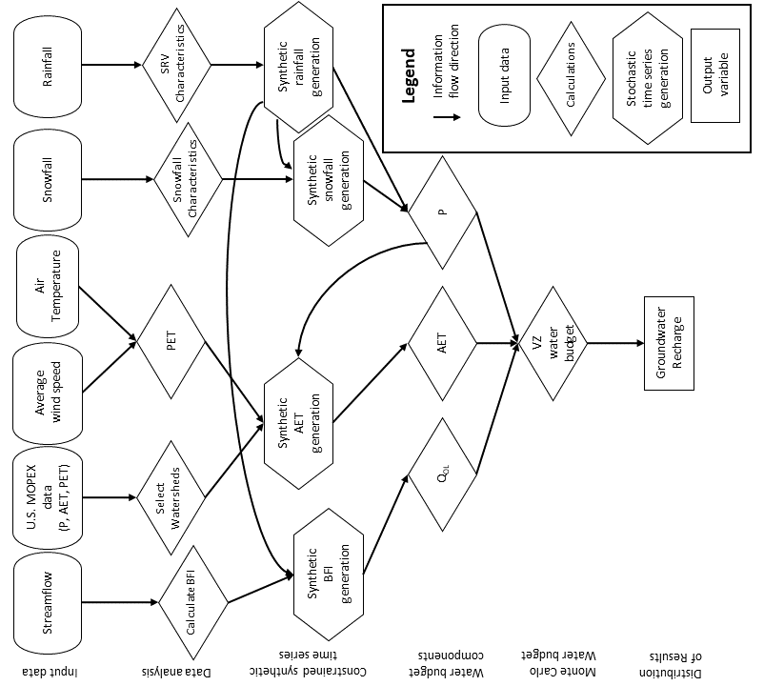
Figure S1.1: Flow chart outlining method to calculate SRV and AET contributions to groundwater recharge variability. Abbreviations: MOPEX – model parameter experiment, P – precipitation, AET – actual evapotranspiration, PET – potential evapotranspiration, BFI – (stream) baseflow index, SRV – spatiotemporal rainfall variability, Q_{OL} – overland flow component of streamflow, and VZ – vadose zone.

Filling gaps in the Roseville rainfall and snowfall time series
Missing daily rainfall and snowfall amounts in the Roseville Environment Canada weather data for the time period of 1973 to 2005 were filled in as described by AquaResource (2008). Values were estimated using: 1) data from nearby surrogate stations, and 2) long-term climatic relationships (ratios) of annual values between Roseville and each of the surrogate stations. Each long-term ratio (e.g., rain_{Roseville}/rain_{Surrogate}) was dependent upon the number of years of concurrent data. The estimates for Roseville were the product of a daily precipitation amount at a surrogate station and the ratio related to that station. A total of 60 days of missing rainfall and 31 days of missing snowfall were filled for 1973 to 2005 (based on gaps in the record from Government of Canada, 2019). Surrogate stations were selected in order of preference, and the station with highest preference that had data available on the missing day was chosen. The Preston Environment Canada weather station (6.9 km from the Roseville station) was primarily used as a surrogate station (AquaResource, 2008), and the resulting dataset was obtained from OMNR (2007).
Roseville precipitation data with missing values were obtained from Government of Canada (2019). Missing Roseville daily rainfall and snowfall data for the time period of 2006 to 2018 were estimated in the present study based on the same procedure that was described in AquaResource (2008) – i.e., observations at a nearby surrogate station were multiplied by the long-term rainfall or snowfall or total precipitation ratio between Roseville and the station. Different surrogate stations were used for this latter time period due to data availability. Daily minimum and maximum temperatures at the University of Waterloo (UW) weather station (Seglenieks, 2020) were used to estimate whether precipitation likely fell as rain (minimum daily temperature “Tmin” > 0°C) or snow (maximum daily temperature “Tmax” < 0°C) or both (Tmin < 0°C, Tmax > 0°C). Rainfall on 81 days was estimated to be 0 mm because Tmax < 0°C, and snowfall on 228 days was estimated to be 0 mm because of Tmin > 0°C. Rainfall data were preferentially filled in using data from the UW weather station (Seglenieks, 2020), and snowfall were preferentially filled in using the Waterloo-Wellington2 (WATWEL2) weather station (Government of Canada, 2020b). The Kitchener-Waterloo (KW) weather station (Government of Canada, 2020a) was used if either of the other two stations were also missing data, and also to estimate snowfall amounts when it was possible that both rainfall and snowfall occurred on the same day.
Snowfall was assumed to be 0 mm in a limited number of cases (14 days) where the surrogate stations were missing data. The UW weather station (15 km from the Roseville station) was used to fill in 323 daily rainfall amounts based on an average annual ratio of rain_{Roseville}/rain_{UW} of 0.826 derived for UW tipping bucket rainfall during the time period 2006 to 2018. Missing or erroneous daily tipping bucket rainfall values (88) at the UW station (18 days in Apr 2017, 18 days in Nov 2017, 16 days in Apr 2018; 7 days in May 2018, and 29 days in Aug 2018) were replaced with weighing gauge precipitation amounts from the same station. The WATWEL2 station (14 km from the Roseville station) was used to fill in 138 daily snowfall amounts based on a ratio (snow_{Roseville}/snow_{WATWEL2}) of 0.912 derived for annual snowfall for the time period 2006 to 2017. Snowfall amounts for time periods when the WATWEL2 data were unavailable (14 days) were filled in using total precipitation from the KW weather station (13 km from the Roseville station) for days with Tmax < 0°C. The ratio for P_{tot,Roseville}/P_{tot,KW} (where P_{tot} indicates total precipitation) that was derived and applied to estimate this daily snowfall was 0.813 for the time period from 2011 to 2018. Snowfall for 5 days with Tmin < 0°C and Tmax > 0°C, and where rainfall was filled in based on the UW station, was estimated based on the difference between the product of a P_{tot,Roseville}/P_{tot,KW} ratio of 1.13 times the KW total precipitation, and the rainfall amount filled in based on the UW station. Table S1.1 summarizes the filling of missing values.
Filling in the missing data in the Roseville rainfall and snowfall time series increased the average annual rainfall from 770 to 787 mm, the average annual snowfall from 136 to 139 mm, and total precipitation from 907 to 926 mm.

Table S1.1: Summary of missing precipitation values filled in at the Roseville weather station.
Precipitation type | No. of days | Surrogate station | Distance from Roseville (km) | Ratio | Comments
Rainfall | 81 | N/A | N/A | N/A | Assumed 0 mm. Tmax < 0°C
Snowfall | 228 | N/A | N/A | N/A | Assumed 0 mm. Tmin > 0°C
Snowfall | 14 | N/A | N/A | N/A | Assumed 0 mm. Surrogate stations missing data.
Rainfall | 323 | UW | 15 | 0.826 | -
Snowfall | 138 | WATWEL2 | 14 | 0.912 | -
Snowfall | 14 | KW | 13 | 0.813 | Tmax < 0°C
Snowfall* | 5 | KW | 13 | 1.13 | Tmin < 0°C,  Tmax > 0°C; ratio is for P_{tot}
* These days were estimated to have both rain and snow. Snowfall was estimated as:
snow = (P_{tot,KW} * ratio_{Ptot,KW}) - rain_{UW} x ratio_{UW,rain}

Fitting Roseville distributions of intervals between rainy days and rainfall amounts
Following the fill-in of missing data for the Roseville weather station, a best-fit curve for the probability distribution of the rainfall amounts was obtained using a mixed exponential function. Figure 3 shows the observed and modelled relative frequency distributions for rainfall depths. A non-linear solver function in GNU Octave (Eaton et al., 2024) was used to fit the data. In order to incorporate the mean value from the observed distribution into the fitting process, a point with an x-coordinate of 120 mm and a y-coordinate equal to a weighting factor (0.5) times the mean rainfall depth was added to the list of points shown in Figure 3. The weighting factor was used to scale the relative influence of the mean value point. The best-fit parameters for the mixed exponential distribution are shown in Table S1.2 along with the estimated mean value. The percent difference between the resulting mean value estimate from the distribution and the observed arithmetic mean value was < 1%.

Table S1.2: Best-fit parameters for a mixed exponential distribution describing observed rainfall.
Distribution | Mixed exponential model* |  |  |  | Observed mean value‡  (mm)
Distribution | p | β₁ | β₂ | Mean value†  (mm) | Observed mean value‡  (mm)
Rainfall amounts | 0.514 | 2.01 | 13.4 | 7.540 | 7.542
* Mixed exponential model (Li et al., 2013): $f\left(x\right)= \frac{p}{β_{1}}\exp\left(\frac{-x}{β_{1}}\right)+\frac{1-p}{β_{2}}exp\left(\frac{-x}{β_{2}}\right)$
† Mean value = p × β₁ + (1 - p) × β₂
‡ Arithmetic mean = sum of non-zero amounts / number of non-zero amounts

US MOPEX watersheds similar to Alder Creek

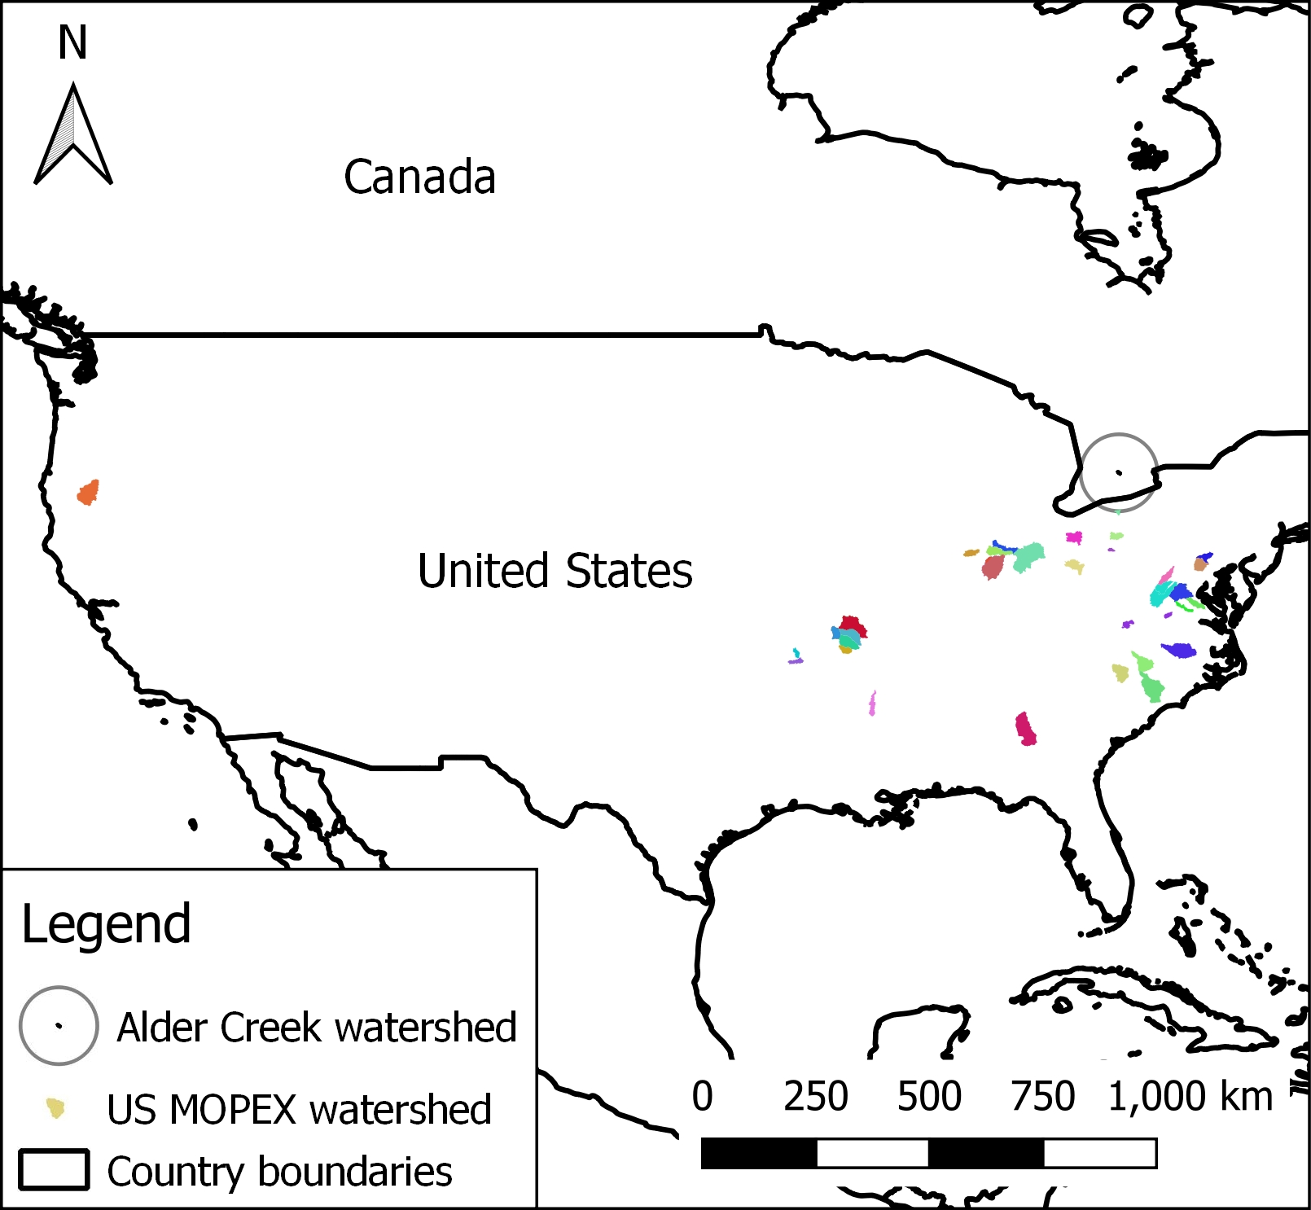
Figure S1.2: Locations of the 47 selected US MOPEX (Duan et al., 2006; Troch et al., 2018) watersheds, as well as the Alder Creek watershed (GRCA, 1998, Sandvik, 2009).

Baseflow indices

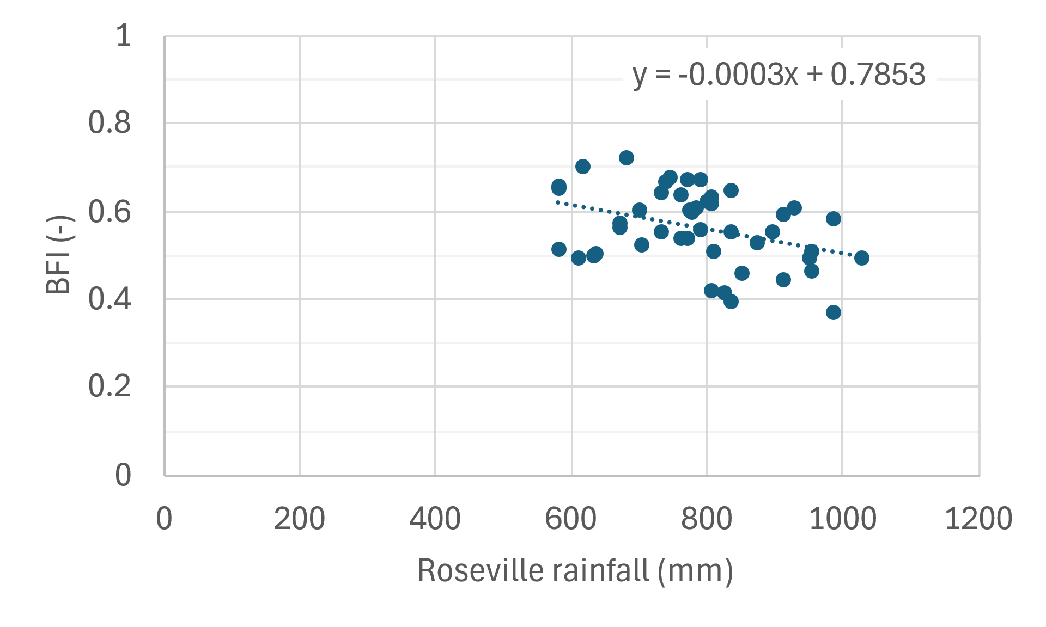
Figure S1.3: Relationship between annual BFI values estimated for the Water Survey of Canada’s New Dundee gauging station and Roseville annual rainfall (Barlow et al., 2014; Government of Canada, 2019; WSC, 2019).

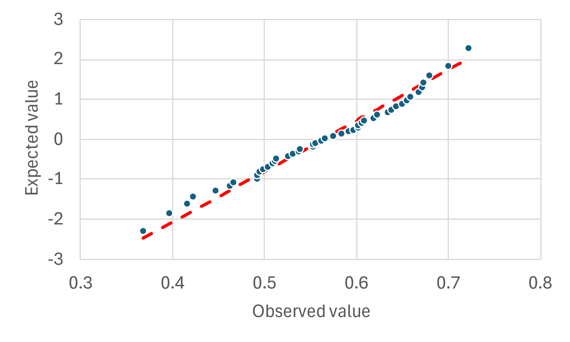
Figure S1.4: Expected vs observed values for normal distribution of differences from the trend line between BFI and rainfall (i.e., [BFI value] – [trend line BFI value] for a given annual rainfall amount). The data were derived from Barlow et al. (2014), Government of Canada (2019), and WSC (2019).

References
AquaResource Inc. (AquaResource), 2008. Technical Memorandum Re: MNR Climate Data Gap Filling Project – Data Review. Summary of Ontario Ministry of Natural Resources (MNR) precipitation data analysis. August 2008. AquaResource Inc., Breslau, ON, Canada. Obtained from Matrix Solutions Inc., controlled access.
Barlow, P.M., Cunningham, W.L., Zhai, T., and Gray, M., 2014. U.S. Geological Survey Groundwater Toolbox, a graphical and mapping interface for analysis of hydrologic data (version 1.0) – User guide for estimation of base flow, runoff, and groundwater recharge from streamflow data. U.S. Geological Survey Techniques and Methods, book 3, chap. B10, 27 p. https://doi.org/10.3133/tm3B10.
Eaton, J.W., Bateman, D., Hauberg, S., Wehbring, R., 2024. GNU Octave: A high-level interactive language for numerical computations. Edition 9 for Octave version 9.2.0. https://octave.org/support. (Accessed 11.10.2024.)
Duan, Q., Schaake, J., Andréassian, V., Franks, S., Goteti, G., Gupta, H.V., Gusev, Y.M., Habets, F., Hall, A., Hay, L., Hogue, T., Huang, M., Leavesley, G., Liang, X., Nasonova, O.N., Noilhan, J., Oudin, L., Sorooshian, S., Wagener, T., Wood, E.F., 2006. Model Parameter Estimation Experiment (MOPEX): An overview of science strategy and major results from the second and third workshops. J. Hydrol. 320, 3-17. https://doi.org/10.1016/j.jhydrol.2005.07.031.
Government of Canada, 2019. Historical Data: Rainfall, snowfall, and temperature data for the Roseville, ON, weather station [computer files]. Extracted from the Environment and Climate Change Canada Historical Climate Data web site, https://climate.weather.gc.ca/index_e.html. (Accessed 15.01.2019.)
Government of Canada, 2020a. Historical Data: Rainfall and snowfall data for the Kitchener/Waterloo weather station [computer files]. Extracted from the Environment and Climate Change Canada Historical Climate Data web site, https://climate.weather.gc.ca/index_e.html. (Accessed 16.11.2020.)
Government of Canada, 2020b. Historical Data: Rainfall and snowfall data for the Waterloo Wellington 2 weather station [computer files]. Extracted from the Environment and Climate Change Canada Historical Climate Data web site, https://climate.weather.gc.ca/index_e.html. (Accessed 12.11.2020.)
Grand River Conservation Authority (GRCA), 1998. Grand River Watershed data [computer file]. Subcatchment basins. Cambridge, Ontario: Grand River Conservation Authority. Contains Information made available under Grand River Conservation Authority’s Open Data Licence v2.0 (https://data.grandriver.ca/about-licensing.html). https://data.grandriver.ca/downloads-geospatial.html. (Accessed 29.03.2012).
Ontario Ministry of Natural Resources (OMNR), 2007. Daily weather data [computer file]. Digital Archive of Canadian Climatological Data. Obtained from Matrix Solutions Inc., Guelph, ON, Canada; controlled access. (Accessed 28.04.2016).
Sandvik, B., 2009. World borders dataset. GIS digital mapping data. http://thematicmapping.org/downloads/world_borders.php. (Accessed 13.10.2020).
Seglenieks, F., 2020. University of Waterloo weather station data archives [computer files]. Temperature and precipitation data – daily summaries (1998-2014) and 15 min data (2015 – 2018). Extracted from the Eric D. Soulis Weather Station web site, http://weather.uwaterloo.ca/data.html. (Accessed 09.10.2020).
Troch, P., Dwivedi, R., Neto, A.A.M., Liu, T., Roy, T., Valdés-Pineda, R., Durcik, M., Arciniega-Esparza, S., Breña-Naranjo, J.A., 2018. Data for the catchment-scale groundwater recharge and vegetation water use efficiency estimation. HydroShare, CC BY license (http://creativecommons.org/licenses/by/4.0/). http://www.hydroshare.org/resource/99d5c1a238134ea6b8b767a65f440cb7 (Accessed 23.08.2024).
Water Survey of Canada (WSC), 2019. Daily discharge data for Alder Creek near New Dundee (02GA030)[ON]. Extracted from the Environment and Climate Change Canada Historical Hydrometric Data web site, https://wateroffice.ec.gc.ca/mainmenu/historical_data_index_e.html. (Accessed 12.03.2019).

