APPENDIX A

Building of a PBPK model for lamotrigine in breastfeeding infants
Contents
1 Introduction 2
2 Methods and results 2
2.1 Modeling strategy 2
2.2 Adult IV model 3
2.2.1 IV model parameterization 3
2.3 Adult oral model 4
2.3.1 Oral model parameterization 4
2.4 Oral model evaluation 6
2.5 Population model 6
2.5 Scale adult model to infants 7
3 Discussion and conclusion 9
4 Figures 9
5 References 23

1 Introduction

Lamotrigine is a phenyltriazine anticonvulsant indicated for epilepsy as adjunctive therapy in those 2 years and older, and monotherapy in those 16 years and older (1). It is also indicated for bipolar disorder in patients 18 years and older as maintenance treatment to delay the time of occurrence of mood episodes for those taking standard therapy and experiencing acute mood episodes. Lamotrigine has a plasma half-life ranging from 22.8 to 59 hours with peak plasma concentrations occurring between 1.4 to 4.8 hours following administration (2, 3).

Lamotrigine is available as compressed tablets (25 mg, 100 mg, 150 mg, and 200 mg), chewable dispersible tablets (2 mg, 5 mg, and 25 mg), and orally disintegrating tablets (25 mg, 50 mg, 100 mg, and 200 mg). The tablet is available in immediate release (IR), sustained release (SR), and extended release (ER) formulations. Classified as a BCS Class 2 drug, lamotrigine has high permeability and low solubility. Its oral bioavailability is high at 98 ± 0.05% (4, 5).

The predominate route of lamotrigine elimination is through hepatic metabolism, with renal excretion accounting for <10% (6). The enzyme mainly responsible for its liver metabolism is UGT1A4, however, the role of further enzymes, UGT2B7 and UGT1A3, is less clear (7, 8). Total oral clearance (CL/F) was 0.44 mL/min/kg (range: 0.12-1.10 mL/min/kg) from healthy adults taking a single dose of lamotrigine (9). Following oral administration of 240 mg radiolabeled lamotrigine to 6 healthy volunteers, 94% of the drug and its metabolites were recovered in urine and 2% in the feces. The majority of radioactivity consisted of unchanged lamotrigine (7-10%) and its inactive metabolite, 2-N-glucuronide (76%) (5, 9, 10).

Studies in patients with epilepsy have shown a linear relationship between dose and lamotrigine plasma concentration at steady state, following doses of 50 to 350 mg twice daily (9). For ER formulations, an increase in systemic exposure to lamotrigine in healthy volunteers was dose proportional between 50 and 200 mg; however, at doses between 25 and 50 mg, the increase in exposure was less than dose proportional (1.6-fold increase in exposure due to a 2-fold increase in dose) (11).

This appendix reports the building of a pediatric physiologically-based pharmacokinetic (PBPK) model for lamotrigine.

2 Methods and results

2.1 Modeling software and strategy

PBPK modelling and simulation were performed using PK-Sim (version 8; Open Systems Pharmacology). The small molecule PBPK model structure includes fifteen organs connected through venous and arterial blood pools with each organ compartment divided into 4 sub-compartments (red blood cells, plasma, interstitial space, intracellular space).

Pediatric PBPK model development followed a typical method as described in Maharaj, Barrett (12). First, model parameters were optimized to describe systemic disposition in an adult based on the PK following IV administration. Once solidified, PK data following single dose oral administration was used for optimization of model parameters specific to oral absorption in an adult. Model evaluation was completed using PK data following multiple administration regimens. An adult population was then used to assess the appropriateness of the virtual individuals in capturing PK variability as compared to observed PK data. Extrapolation to the pediatric age range took into account changes in anatomy and physiology relevant to describe PK of the medication while leaving all drug specific parameter as used in the adult model. Evaluation of the pediatric model was completed using PK data from children directly administered lamotrigine. The final pediatric model was used to simulate the dose exposure relationship in breastfeeding infants.

2.2 Adult IV model

2.2.1 IV model parameterization

Table 1 presents the drug specific parameters of lamotrigine and the values used for the naïve model.

Table 1. Physicochemical properties and ADME of lamotrigine for IV model construction
 | Used in naïve model | Used in optimized model
Physicochemical properties
Lipophilicity (logP) | 1.19 (13, 14)  1.87 (ALOGPS) (15)  1.98 (ADMET Predictor) | 1.81
Fraction unbound in plasma (fu) | 0.45 (9) | 0.45
Molecular weight | 256.09 g/mol (2) | 256.09 g/mol
pKa | 5.7 (base) (9)  5.5 (base) (2) | 5.7
Water solubility | 0.17 mg/mL (9) | 0.17 mg/mL
ADME
Partition coefficient | Rodgers and Rowland  Schmitt  Berezkhovskiy  PK-Sim Standard | Rodgers and Rowland
Cell permeability | PK-Sim Standard | PK-Sim Standard
Total clearance (CL/F) | 0.44 (0.12 – 1.10) mL/min/kg (9) | 0.44 (0.12 – 1.10) mL/min/kg
Renal clearance (CL/F) | 0.043 ± 0.012 mL/min/kg (16) | 0.043 ± 0.012 mL/min/kg
UGT1A4 concentration | 1.0 µM | 1.0 µM
UGT1A4 specific clearance | 0 1/min | 0.029 1/min
UGT1A3 concentration | 1.0 µM | 1.0 µM
UGT1A3 specific clearance | 0 1/min | 0.0032 1/min
GFR fraction | 1.0 | 0.05

Table 2 presents the lamotrigine dataset used for building the IV model. Local optimization was carried out in PK-Sim using a Monte Carlo approach for exploring the parameter space.

Table 2. Pharmacokinetic dataset for lamotrigine IV model construction
Study | Dose and administration | Cohort | N | Age (years)ª | Weight (kg)ª
Yuen & Peck 1988 | 67.82 mg IV infusion over 30 min | European males (75%) and females | 8 | 27.5 [20-35]^{b} | 71 [59-83]^{b}
ªMean ± SD reported, or range in square brackets if SD not reported.
^{b}Mean not reported in study, therefore the median, an average of the range, or BMI of approximately 23 kg/m² was used instead.

First, a naïve model was set up for a mean male individual weighing 71 kg. Clearance was partitioned as renal and hepatic. GFR fraction was fixed to 0.05 to account for glomerular reabsorption (GFR <1) to reach a fraction excreted unchanged in urine of 7.33% (10). Each of four partition coefficient calculation methods (Table 1) were evaluated with optimization of logP and non-specific hepatic enzymatic clearance using the IV dataset. The Rodgers and Rowland method for predicting partition coefficients and logP was selected on the basis of visual model performance for curve shape (Table 1). The optimized logP was similar to published values (Table 1).

The optimized non-specific enzyme clearance was 0.033 1/min as is a function of more than one enzyme. In a study with 240 mg administered orally to man, 94% of the dose was found in urine with 10% excreted unchanged (17). The study proposed the following metabolites and their abundance in urine: 2-N-glucuronide (76%), 5-N-glucuronide (10%), 2-N-methyl glucuronide (0.14%), and other minor metabolites (4%) (17). However, a more recent study by Beck, Ohman (18) found 2-N-glucuronide as the main metabolite, noting the weak evidence supporting the presence of the further metabolites. Based on Beck, Ohman (18), 2-N-glucuronide was considered the sole metabolite by UGT1A4 and UGT1A3 (8). Although previous in vitro studies in human liver microsomes have determined the involvement of UGT2B7 in lamotrigine to 2-N-glucuronide metabolism (7), these results could not be replicated by Argikar and Remmel (8), suggesting that further studies are required to assess the involvement of UGT2B7. Clearance was partitioned according to 2-N-glucuronide formation by UGT1A4 (90%) and UGT1A3 (10%). These relative contributions were determined from in vitro studies (8) with appropriate scaling as performed by Ladumor, Thakur (14). The organ-specific expressions of UGT1A4 and UGT1A3 were informed by the Human Protein Atlas (https://www.proteinatlas.org/) and specifically Kaivosaari, Toivonen (19) and Nakamura, Nakajima (20), and Strassburg, Oldhafer (21), respectively.

The optimized values for the adult IV PBPK model are presented in Table 1. Figure 1 presents the outcome of the IV model optimization using the Yuen and Peck (5) dataset.

2.3 Adult oral model

2.3.1 Oral model parameterization

The same systemic parameters as developed for the mean male IV PBPK model were used for the model defining oral administration. Those drug/formulation-specific parameters needing definition included lamotrigine solubility, formulation dissolution and intestinal permeability. The oral PBPK model for each lamotrigine dose for which observed PK data was available was created using the same mean male as in the IV model. Lamotrigine water solubility was defined at 0.17 mg/mL at a reference pH of 7 and solubility gain per charge of 10 to describe pH-dependent solubility (22). Dissolution was defined based on a Weibull function (inputs of curve shape and dissolution half-time). Dissolution half-time was an optimized parameter for each study of the same dose whereas intestinal permeability was a globally optimized parameter and therefore the same for each oral PK study.

Table 3. Oral absorption parameters for lamotrigine oral model construction
 | Used in naïve model | Used in optimized model
Dissolution half-life IR 25 mg | 10 min | 11.39 min
Dissolution half-life IR 75 mg | 10 min | 30.93 min
Dissolution half-life IR 100 mg | 10 min | 2.95 min
Dissolution half-life IR 200 mg | 10 min | 43.97 min
Dissolution half-life IR 300 mg | 10 min | 10.36 min
Dissolution profile shape | 0.92 | 0.92
Water solubility | 0.17 mg/mL (9) | 0.17 mg/mL
Specific intestinal permeability | 1.503E-5 cm/min | 2.269 cm/min

Table 4 shows the PK datasets used for oral model building. All are single dose administrations. The datasets used for optimization of dissolution half-time and specific intestinal permeability included the drug in a compressed tablet, capsule form, and chewable/dispersible tablet. Lamotrigine chewable/dispersible tablets, whether administered as dispersed in water, chewed, or swallowed whole, were found to be equivalent to the compressed tablet form in terms of rate and extent of absorption (9). Therefore, the datasets from one dose, regardless of formulation type, were used together for optimization purposes.

Table 4. Pharmacokinetic dataset for lamotrigine oral model construction
Study | Dose and administration | Cohort | N | Age (years)ª | Weight (kg)ª
Berg 2017 | 25 mg PO IR tablet | White (86%) American males (57%) and females | 49 | 46 ± 16 | 80 ± 18
Ebert 2000 | 25 mg PO IR capsule | European males | 10 | 25 ± 4 | 74.4 [63-100]^{b}
Gidal 2003 | 25 mg PO IR tablet | American males (19%) and females | 28 | 34 ± 13 | 78 ± 23
Yuen & Peck 1988 | 75 mg PO capsule | European males (75%) and females | 8 | 27.5 [20-35]^{b} | 70.2 [59-83]^{b}
Birnbaum 2000 | 100 mg PO IR tablet | White American males | 12 | 40.8 ± 11.5 | 83.6^{b}
Birnbaum 2001 | 100 mg PO IR chewable/dispersible tablet | White American males (92%) and a female | 12 | 32.1 ± 7.1 | 81.0^{b}
Burger 2008 | 100 mg PO capsule | European males | 17 | 35 [19-54] | 77 [65-92]
Fillastre 1993 | 100 mg PO tablet | European males | 6 | 27 ± 9 | 69 ± 5
Marcellin 2001 | 100 mg PO solution | European males (33%) and females | 12 | 50 ± 8.9 | 71.2 ± 9.9
Srichaiya 2008 | 100 mg PO IR tablet | Southeast Asian males | 24 | 20.5 ± 1.3 | 62.5 ± 7.4
van Luin 2009 | 100 mg PO IR tablet | European males | 24 | 34 [20-52] | 79 [63-94]
Hermann 2003 | 200 mg PO IR tablet | White (60%) American males | 15 | 28 ± 8 | 72.7 ± 9
Incecayir 2007 | 200 mg IR chewable/dispersible tablet | European males (64%) and females | 14 | 23 ± 2 | 65.1^{b}
Wootton 1997 | 200 mg PO IR tablet | European males (55%) and females | 11 | 46 [35-57]^{b} | 73.6^{b}
Depot 1990 | 300 mg PO capsule | White American males | 8 | 28.5 [20-37]^{b} | 77.7 ± 9.7
The adult population model was derived from the grey-shaded studies.
ªMean ± SD reported, or range in square brackets if SD not reported.
^{b}Mean not reported in study, therefore the median, an average of the range, or BMI of approximately 23 kg/m² was used instead.

In vitro dissolution studies with lamotrigine IR tablets provided different dissolution half-times, ranging from 0.7-6.6 minutes when described with a Weibull function (23-25). Initially, dissolution half-time was set to 10 minutes. Given the variability in the observed Tmax likely due to the dissolution of the drug limited by low solubility, half-times were optimized individually per dosage. Optimization of specific intestinal permeability and the individual dissolution half-times was carried out using a Monte Carlo approach to explore the parameter space. The results are shown in Table 3. Dissolution half-time was not a value of interest for pediatric extrapolation since lamotrigine in breastmilk is in solution. This exercise was primarily a means to estimate intestinal permeability which is important in this pediatric context. Intestinal permeability was optimized to be very high and therefore is not rate limiting absorption. This is in line with its BCS II status.

A comparison of the observed PK from each study and the estimated plasma concentration vs. time profile following optimization are presented for each PK study in Figures 2–16. The aggregated results of the fits using the oral datasets is depicted in Figure 17 as model-fitted concentrations compared to observed concentrations. Calculated average fold error (AFE) was 0.95 and absolute AFE (AAFE) was 1.27 demonstrating almost no bias and good precision.

2.4 Oral model evaluation

The optimized oral model was then evaluated for predicting multiple-dose and steady state kinetics using the observed data from the studies presented in Table 5. Model performance for the evaluation is presented in Figures 18-20. The evaluation produced acceptable average fold error (AFE) and absolute AFE (AAFE) values of 1.04 and 1.13, respectively.

Table 5. Pharmacokinetic datasets for lamotrigine oral model validation
Study | Dose and administration | Cohort | N | Age (years)ª | Weight (kg)ª
Jann 2006 | 50 mg PO daily for 10 days | American males (86%) and females | 14 | 24.4 ± 2.4 | 78.9 ± 11.1
Gastrup 2016 | 100 mg PO daily for 8 days | European males | 10 | 25^{b} [22-32] | NR
Theis 2005 | 200 mg PO daily for 18 days | White (87%) European males | 13 | [19-54] | [80.2-83.2]
ªMean ± SD reported, or range in square brackets if SD not reported.
^{b}Reported as a median

2.5 Population model

To assess the ability of the model to reproduce PK variability following oral administration, adult virtual populations (n=100) were created. These virtual populations were built based on the sex, age and weight distributions of each clinical study used to evaluate PK variability as presented in Table 4. Variability was incorporated based on anatomical and physiological differences between people for relevant model parameters in the software. The exception was any user-defined proteins including UGT1A4 and UGT1A3. The reference concentration of these enzymes was modelled as a log normal distribution with mean of 1 and a standard distribution of 1.6, based on assessment outlined below. The results of the population simulations are shown in Figures 21–24 and demonstrate that overall, variability was well captured.

2.5 Scale adult model to infants

The oral adult model was scaled to children to predict breastfed infant exposure to lamotrigine from mothers taking the medication at steady state. All drug-specific inputs were kept the same as in the adult model. The anatomy and physiology were scaled to that of neonates at different ages. Growth and maturation of different processes (metabolic capacity, glomerular filtration rate, protein binding, body composition, and transporter expression) were accounted for, and realistic variability around anatomy and physiology were applied to give a virtual infant population.

The ontogeny profiles of UGT1A4 and UGT1A3 were modeled after in vitro studies by Badée, Qiu (26) and Miyagi and Collier (27). Enzyme activity levels were normalized to the adult activity and used to fit a Hill and linear function, for UGT1A4 and UGT1A3, respectively.

For UGT1A4, the Hill function was described by the following parameters: A = kPMA^{n}/(PMA^{n} + A_{0.5}^{n}), where A is normalized enzyme activity, PMA is postmenstrual age, k is the vertical transformation factor, n is the Hill coefficient, and A_{0.5} is postmenstrual age at 50% activity. To perform the Hill function fitting, an L1 regression method was used to minimize the sum of absolute error. To assess variability in activity, a virtual population (n=5,000) was created across postmenstrual ages (>0 to 77 years old) and following a mean calculation of A from the Hill function, a geometric standard deviation was applied to capture the observed variability. Variability was not found to be age dependent and was set at a standard deviation of 1.6. For UGT1A3, activity was not-age dependent. A population of size 5,000 was similarly created and A was given a geometric mean of 1 and geometric SD of 1.6. The final ontogeny profiles used and their associate variability along with the observed data are presented in Figures 25 and 26.

To verify the infant PBPK models, a population of children 1-6 years old were simulated with a single oral administration of 2 mg/kg. The results were compared with observed data from Vauzelle-KervroËDan, Rey (28) (capsules) and Chen, Casale (29) (chewable tablets) and are shown in Table 6 and Figure 27. Half-life was well predicted suggesting that the clearance to volume of distribution ratio was reasonable. AUC₀₋₄₈ predicted by the pediatric PBPK model (38.5 ± 11 ug*h/mL) was greater than the two studies (25.4 ± 6.8 and 27.4 ± 7.2 ug*h/mL). Based on a Tmax that may have been underpredicted, although not consistently, the absorption profile of the formulation seemed not to follow that in adults. The dose in breast milk is fully dissolved and therefore formulation effects are inconsequential. Based on a reasonable clearance to volume ratio and thus systemic PK, the pediatric PBPK model was deemed reasonable for use in the breastfeeding workflow.

Table 6. Infant PBPK model evaluation with mean infant data
Study | N | Age (years) | T_{max} (hrs) | C_{max} (ug/mL) | AUC₀₋₄₈ (ug*h/mL) | T_{1/2} (hrs)
Vauzelle-Kervroeden 1996 | 10 | 2.5 ± 1.4 | 6* | 1.11 ± 0.29 | 25.4 ± 6.8 | 21.9 ± 6.8
Patient 28 | 1 | 1.17 | 1.55 | 1.55 | 30.4 | 36.5
Patient 31 | 1 | 6 | 0.93 | 0.93 | 20.9 | 20.3
Chen 1999 | 4 | [3.8-5.9] | 4.5 ± 5.1 | 1.1 ± 0.37 | 27.4 ± 7.2 | 30.5 ± 5.6
This study | 100 | 3.4 ± 1.5 | 1.35 ± 0.47 | 1.91 ± 0.36 | 38.5 ± 11 | 21.6 ± 8.7
*Median value

3 Discussion and conclusion

The final lamotrigine PBPK model adequately describes the PK of lamotrigine in adults and children. The optimized IV and oral adult models produced AFE and AAFE values of 0.95 and 1.27, respectively. The oral models sufficiently predicted three pharmacokinetic datasets with adults administered multiple doses of lamotrigine. The evaluation produced acceptable AFE and AAFE values, 1.04 and 1.13, respectively. An evaluation of the pediatric PBPK model in children was supported by two small studies. Although there were no published studies in infants <1 years old, the results from this evaluation in 1-6 year olds provided insight on the model’s performance. Essentially, while the absorption kinetics appeared to be a function of the formulations used, the systemic PK appeared well estimated. As such, the pediatric model was deemed reasonable for use in the breastfeeding workflow.

4 Figures

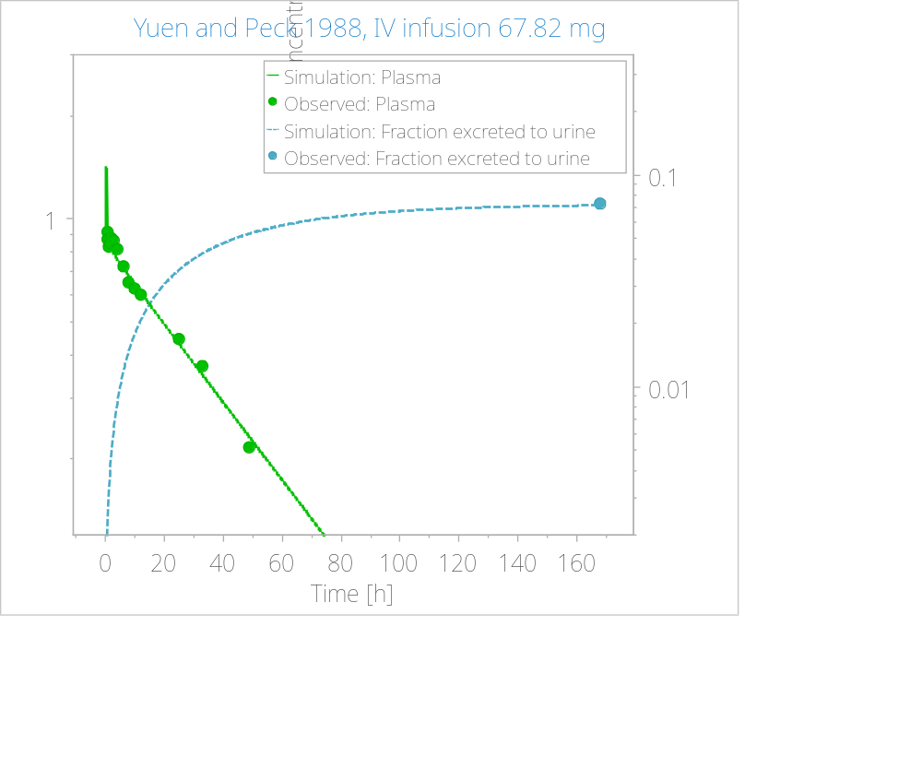
Figure 1. IV model optimization using Yuen & Peck 1988, 67.82 mg infusion dataset.

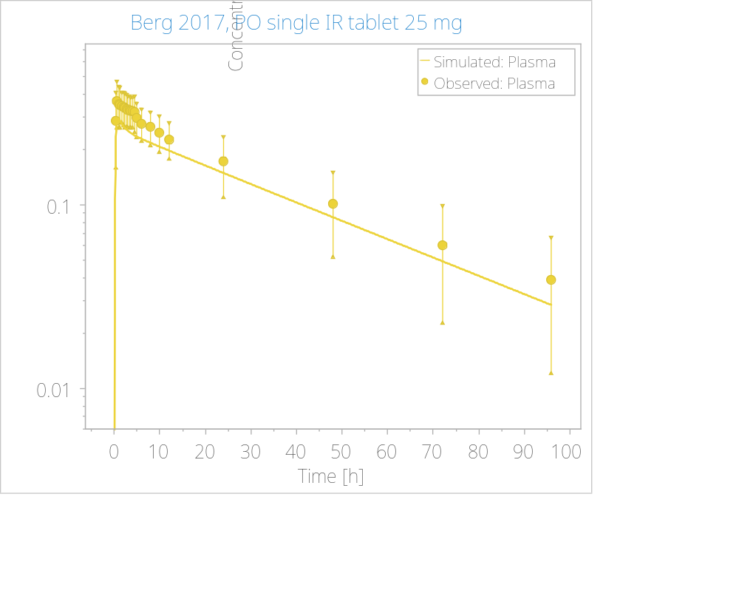
Figure 2. Oral model optimization using Berg 2017, 25 mg IR formulation single dose dataset.

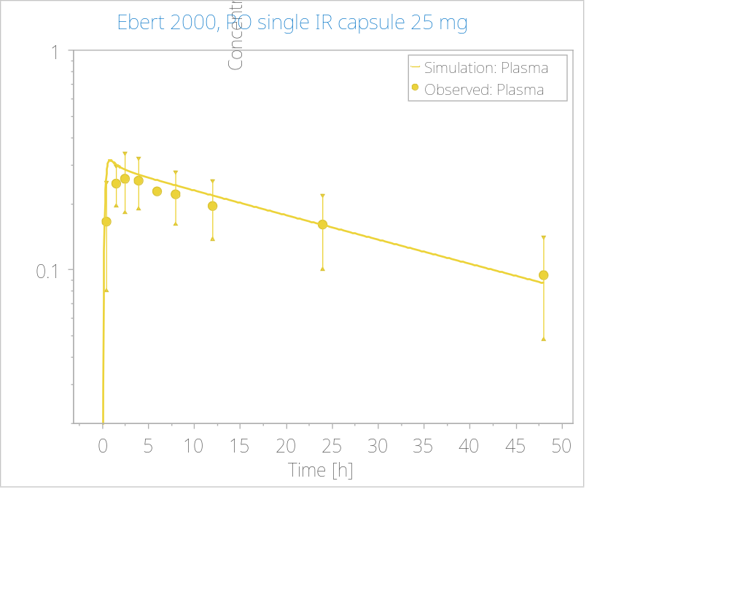
Figure 3. Oral model optimization using Ebert 2000, 25 mg IR formulation single dose dataset.

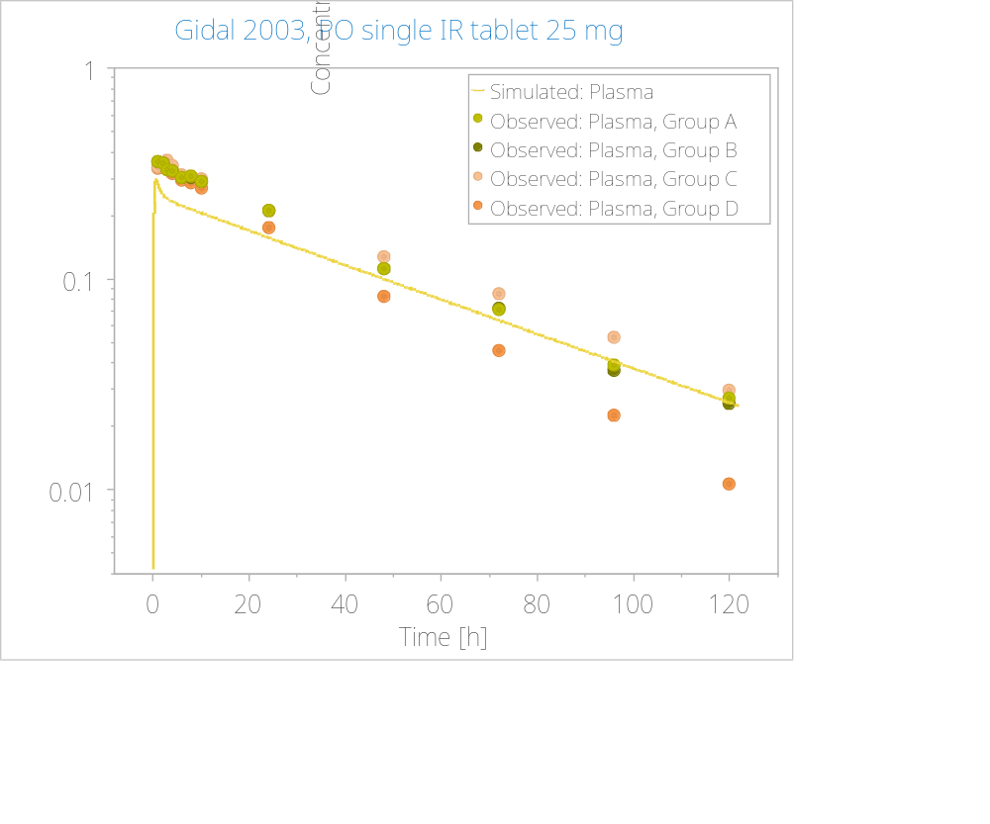
Figure 4. Oral model optimization using Gidal 2003, 25 mg IR formulation single dose dataset.

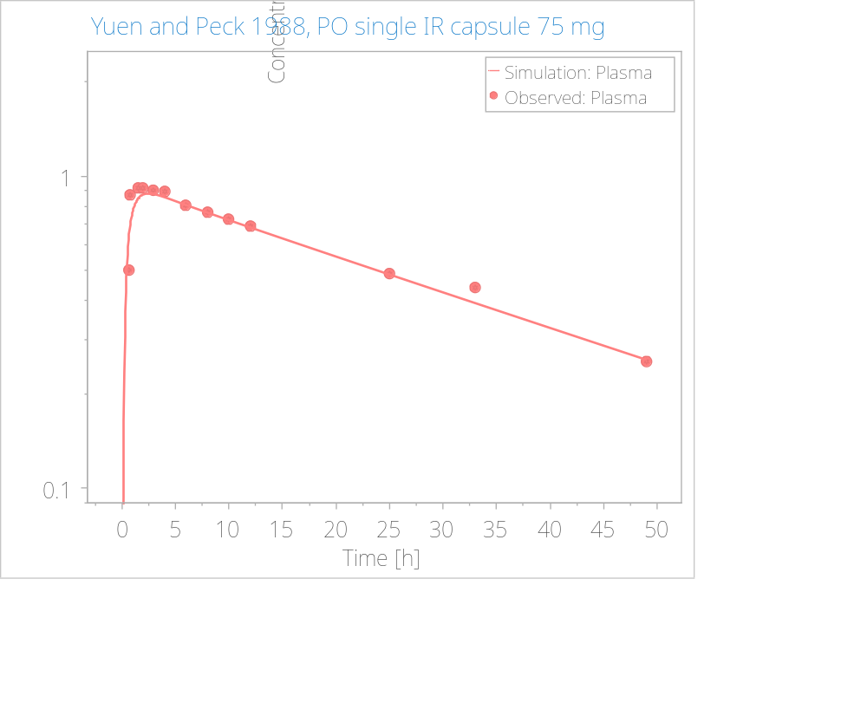
Figure 5. Oral model optimization using Yuen and Peck 1988, 75 mg IR formulation single dose dataset.

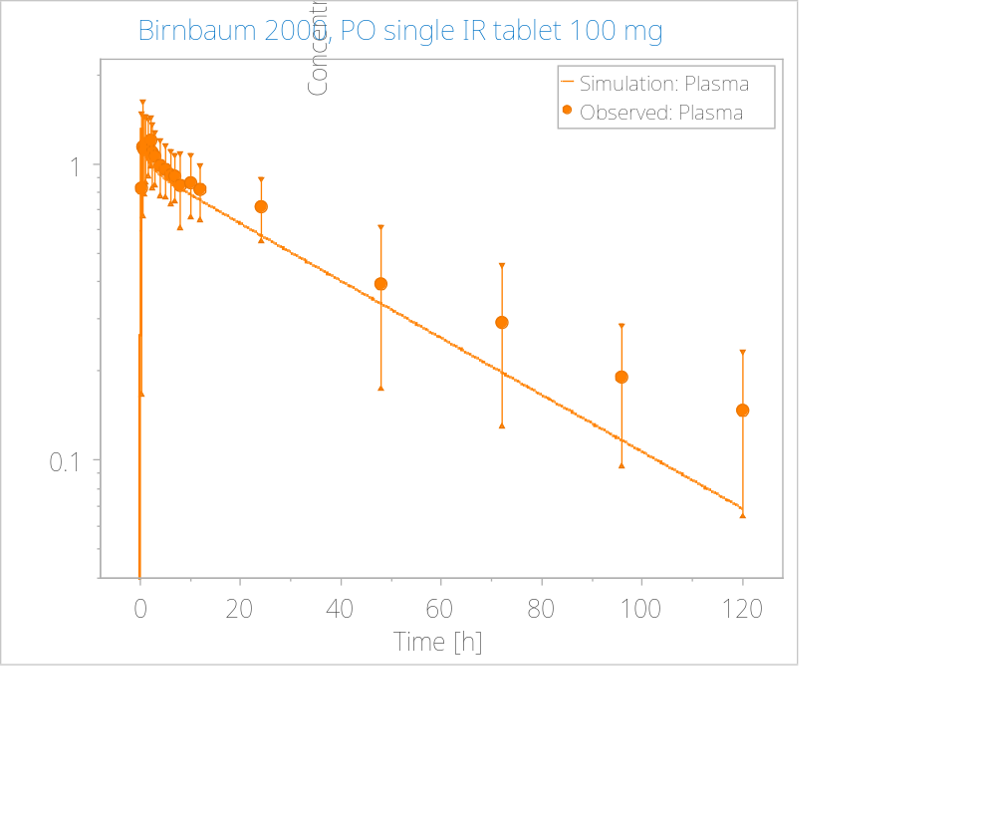
Figure 6. Oral model optimization using Birnbaum 2000, 100 mg IR formulation single dose dataset.

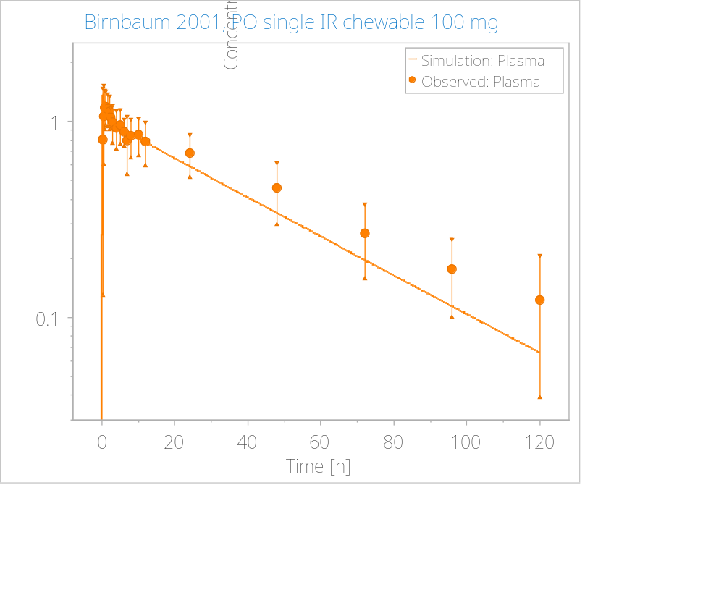
Figure 7. Oral model optimization using Birnbaum 2001, 100 mg IR formulation single dose dataset.

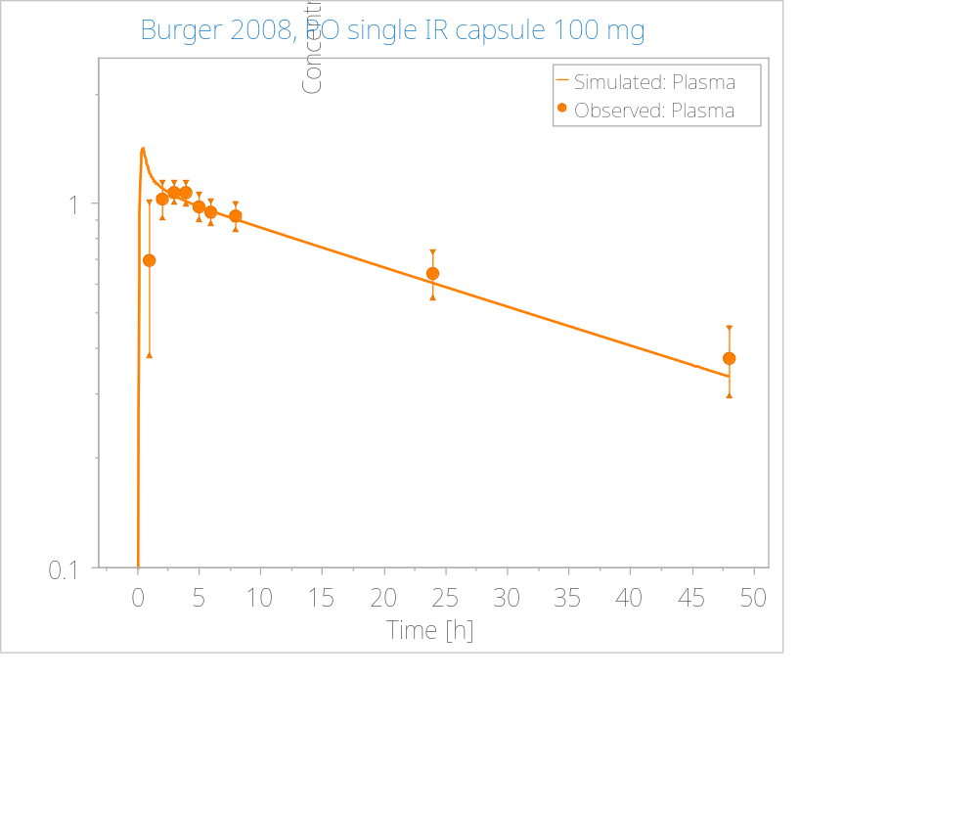
Figure 8. Oral model optimization using Burger 2008, 100 mg IR formulation single dose dataset.

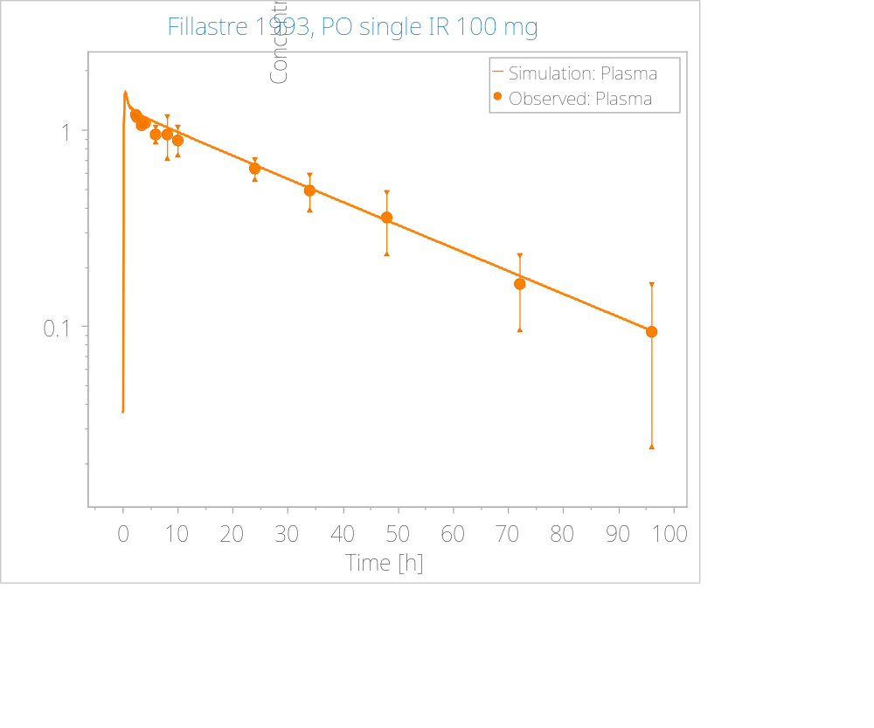
Figure 9. Oral model optimization using Fillastre 1993, 100 mg IR formulation single dose dataset.

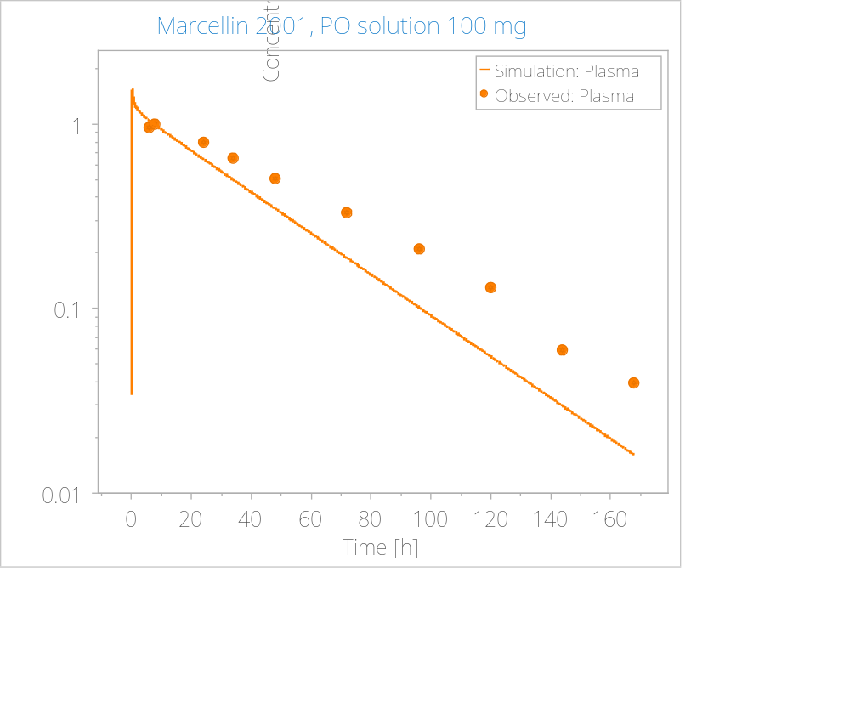
Figure 10. Oral model optimization using Marcellin 2001, 100 mg IR formulation single dose dataset.

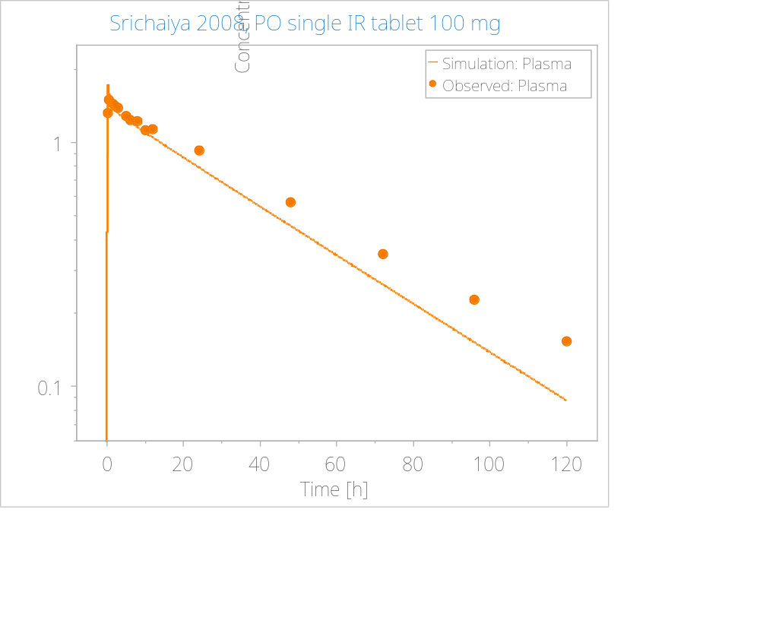
Figure 11. Oral model optimization using Srichaiya 2008, 100 mg IR formulation single dose dataset.

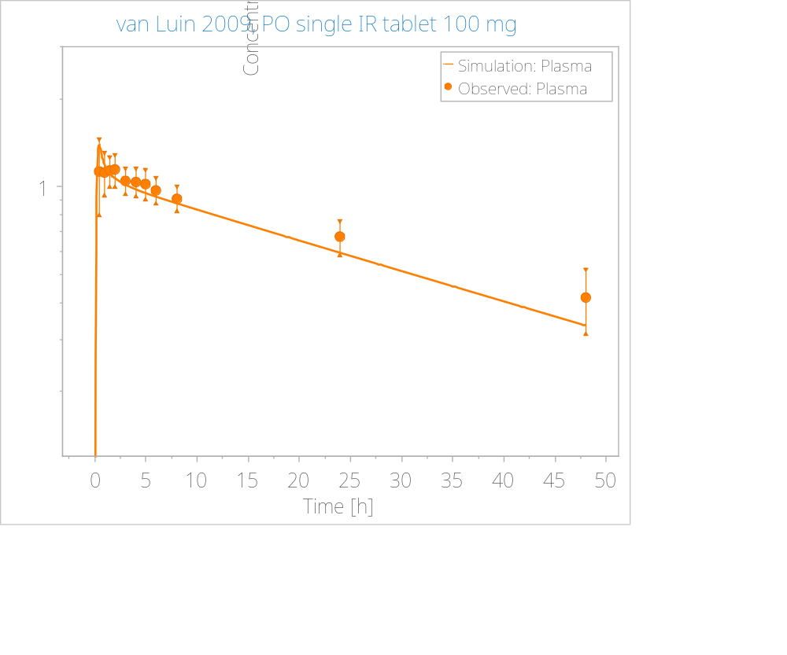
Figure 12. Oral model optimization using van Luin 2009, 100 mg IR formulation single dose dataset.

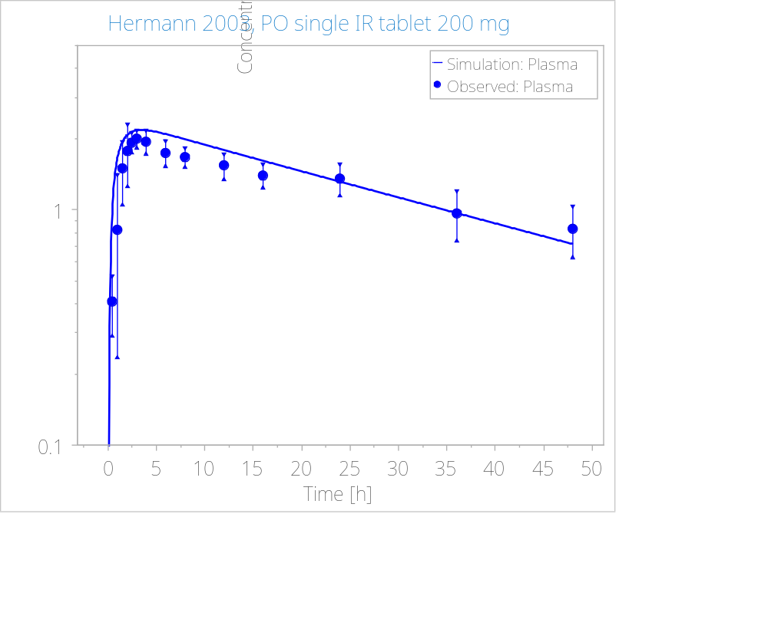
Figure 13. Oral model optimization using Hermann 2003, 200 mg IR formulation single dose dataset.

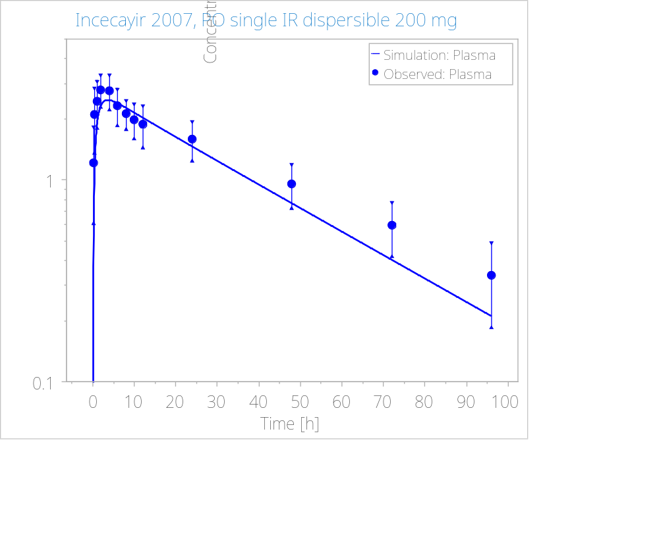
Figure 14. Oral model optimization using Incecayir 2007, 200 mg IR formulation single dose dataset.

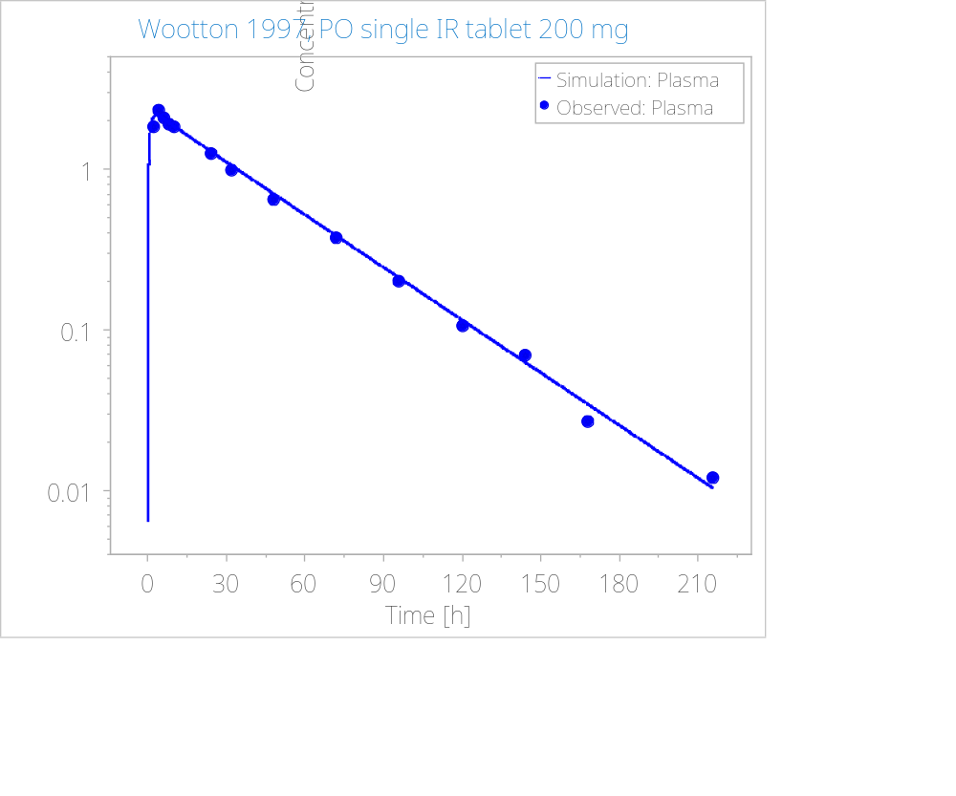
Figure 15. Oral model optimization using Wootton 1997, 200 mg IR formulation single dose dataset.

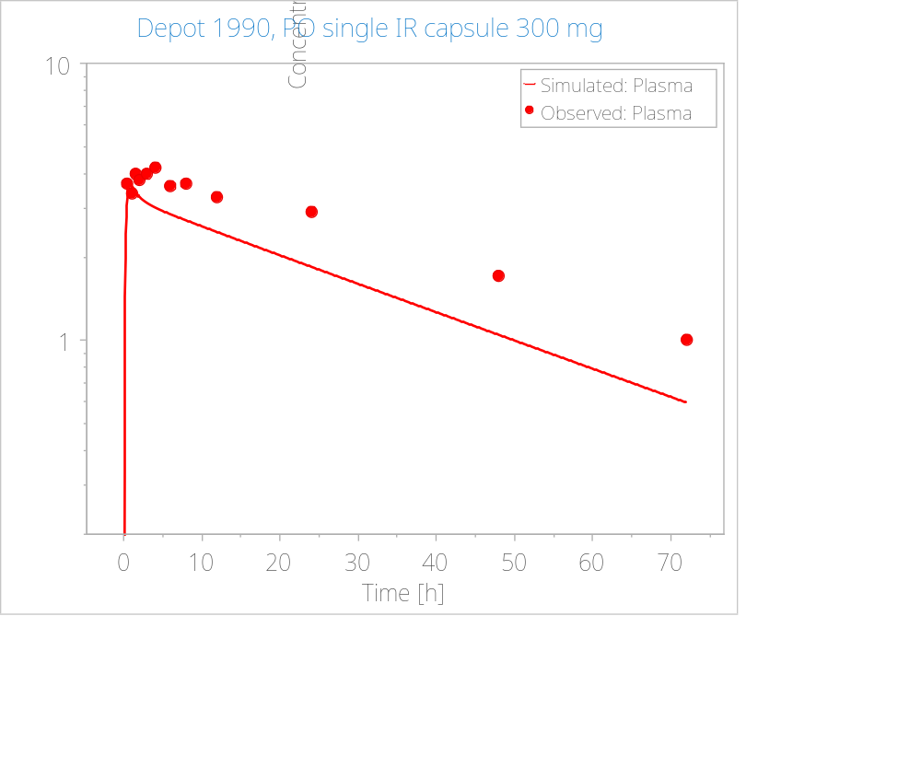
Figure 16. Oral model optimization using Depot 1990, 300 mg IR formulation single dose dataset.

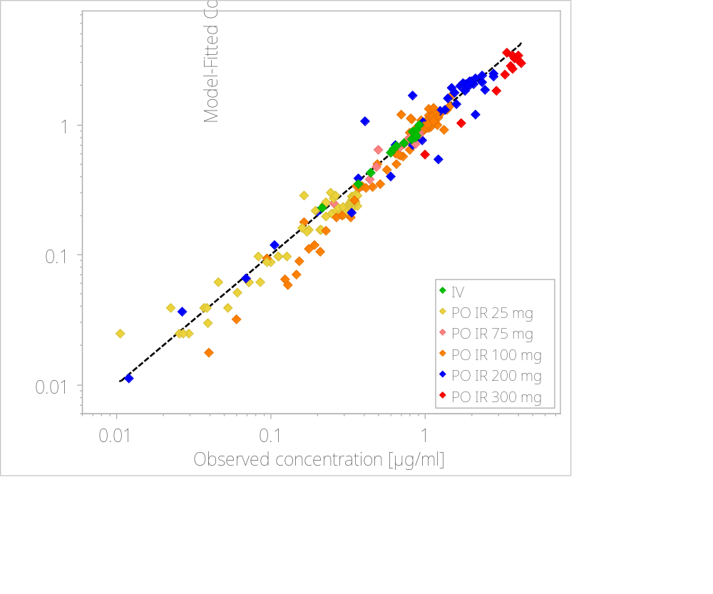
Figure 17. Model-fitted vs observed concentrations of all model-building PO datasets. Dashed line represents the line of identity. Calculated average fold error (AFE) was 0.95 and absolute AFE was 1.27.

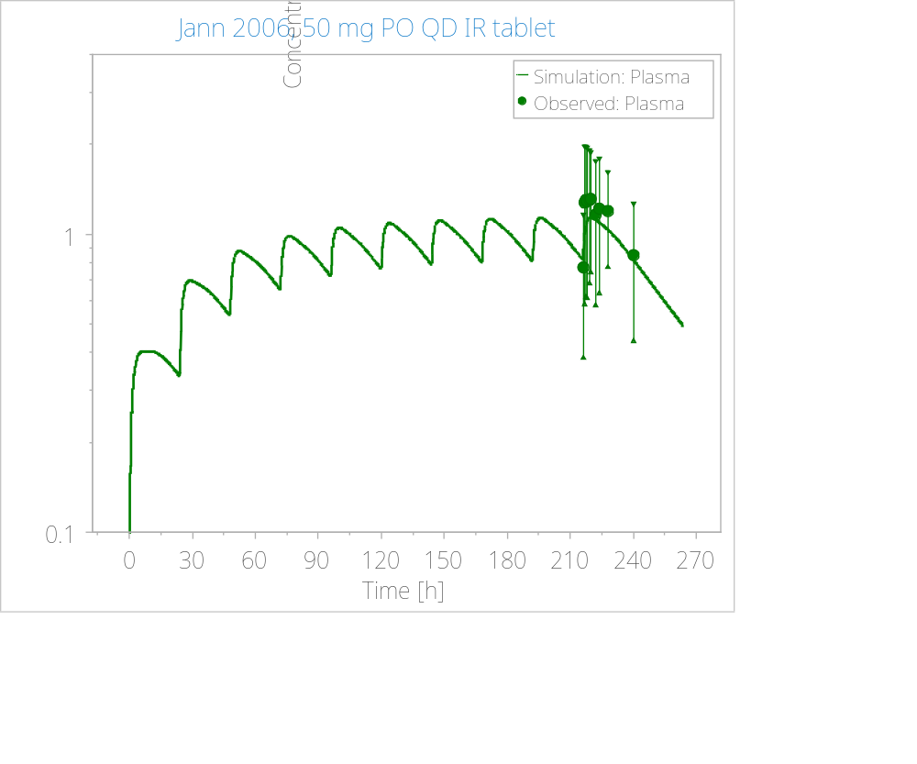
Figure 18. Simulation for model verification. Observed data reported as mean (circles) with standard deviation (error bars).

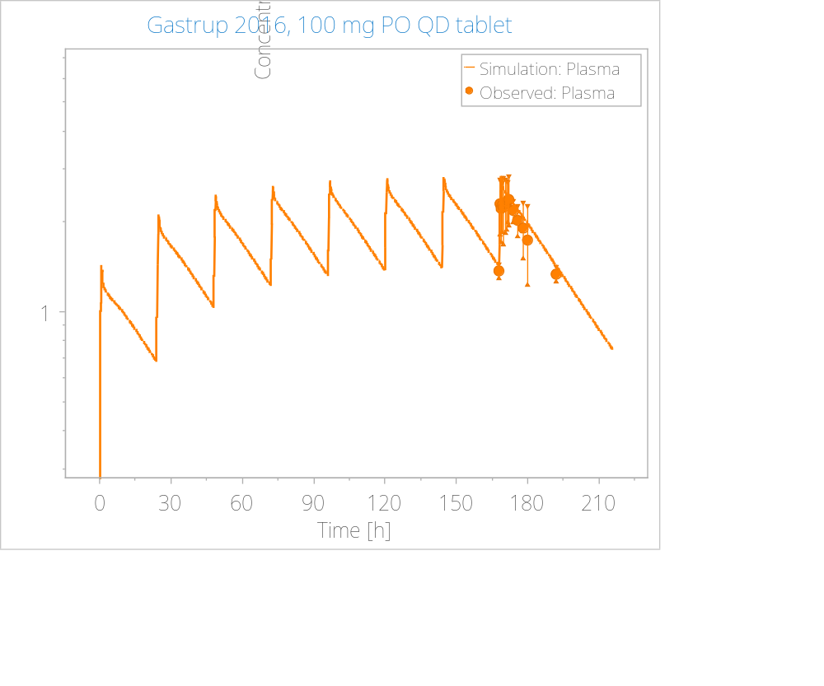
Figure 19. Simulation for model verification. Observed data reported as mean (circles) with standard deviation (error bars).

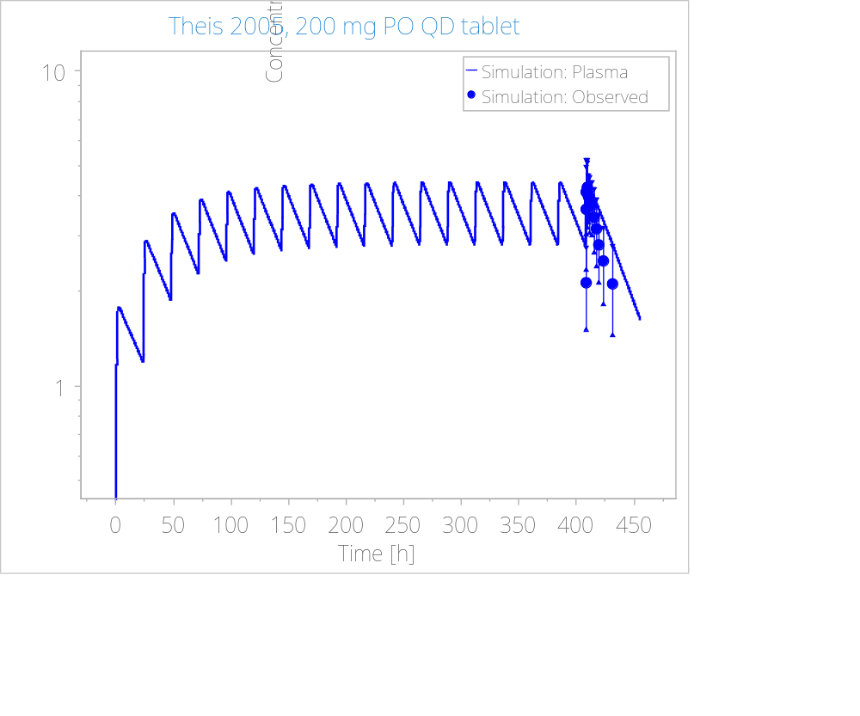
Figure 20. Simulation for model verification. Observed data reported as mean (circles) with standard deviation (error bars).

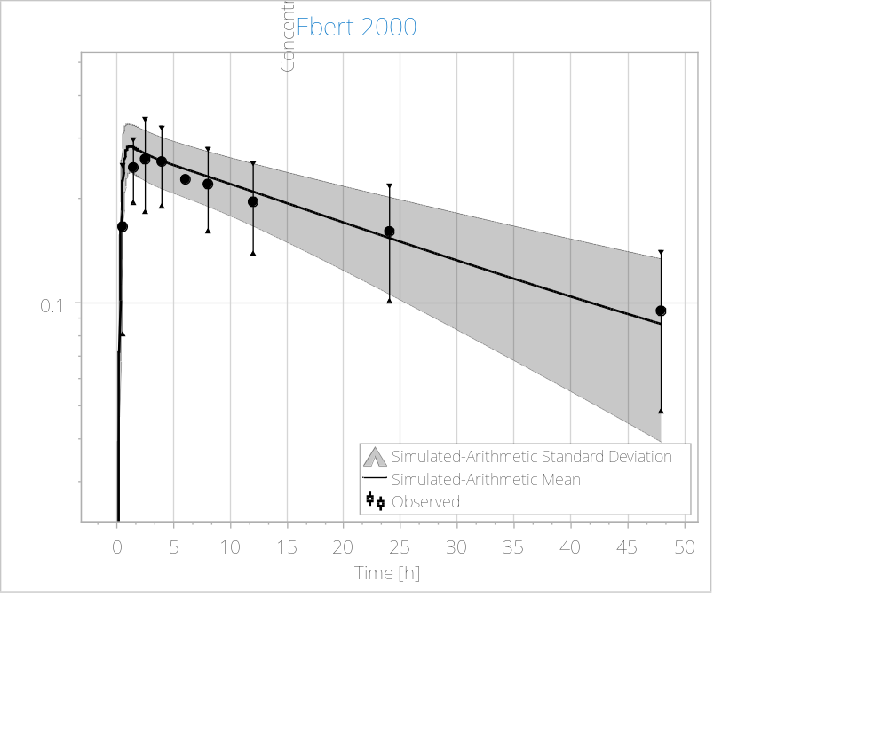
Figure 21. Adult population PBPK simulation (line = mean; gray shaded area = 90th prediction interval) compared to observed data from Ebert 2000.

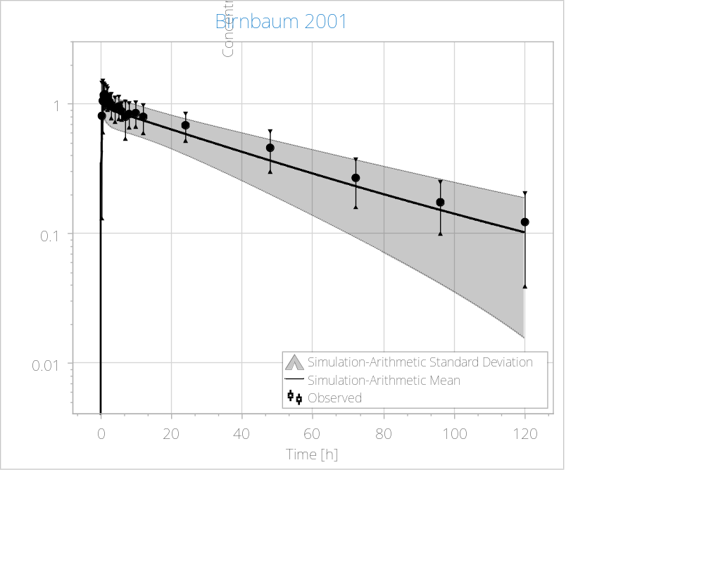
Figure 22. Adult population PBPK simulation (line = mean; gray shaded area = 90th prediction interval) compared to observed data from Birnbaum 2001.

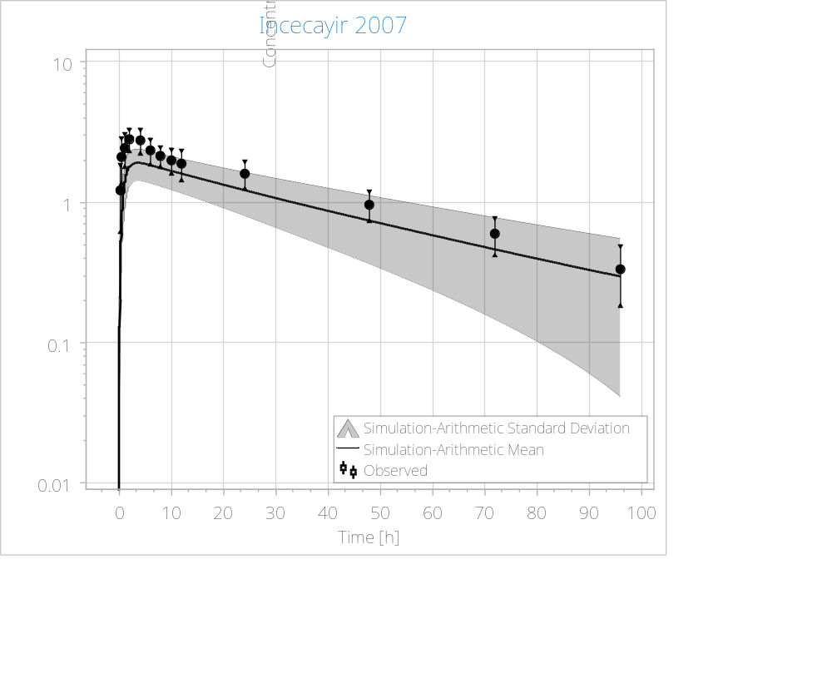
Figure 23. Adult population PBPK simulation (line = mean; gray shaded area = 90th prediction interval) compared to observed data from Incecayir 2007.

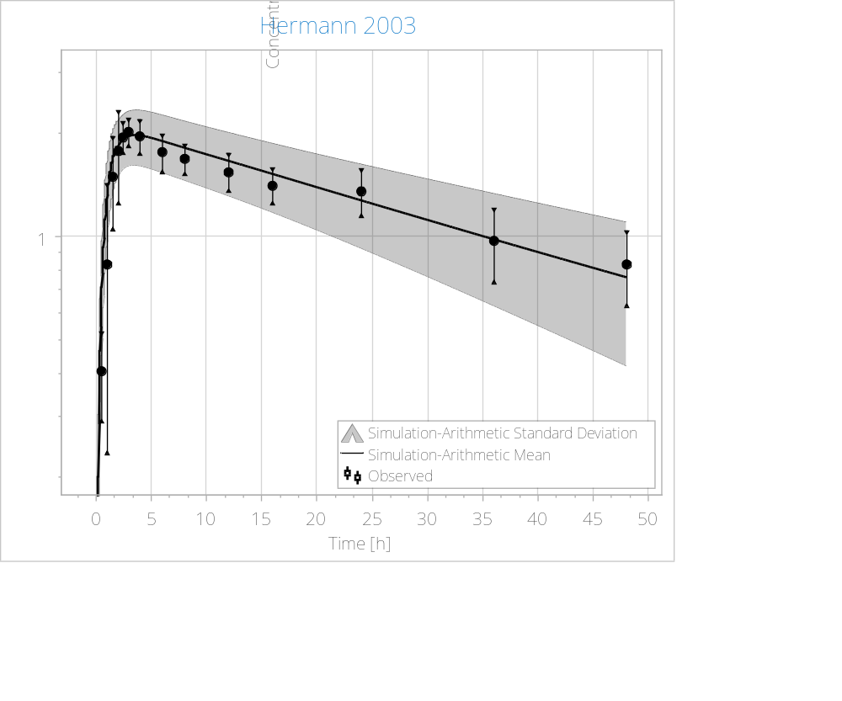
Figure 24. Adult population PBPK simulation (line = mean; gray shaded area = 90th prediction interval) compared to observed data from Hermann 2003.
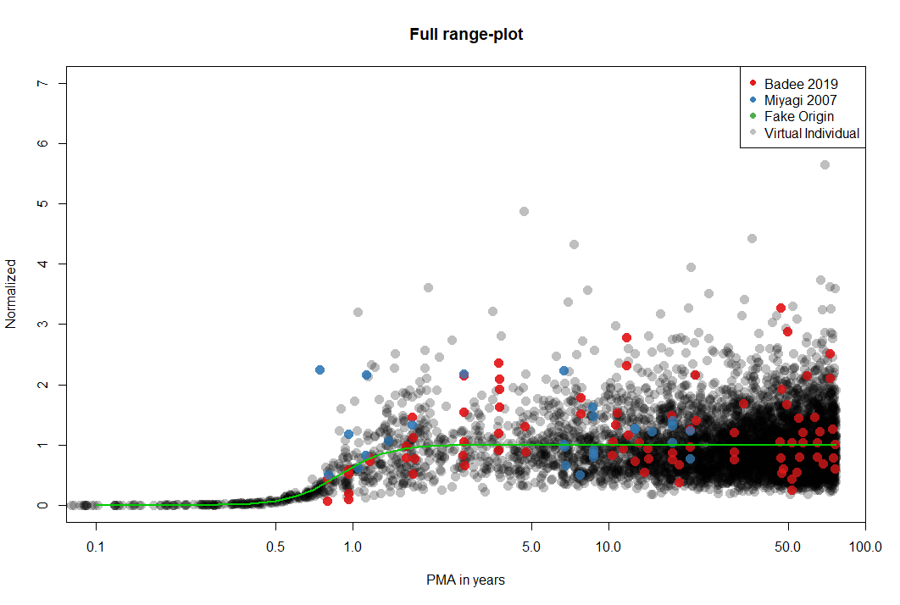
Figure 25. Ontogeny profile for UGT1A4 activity normalized to the adult value and described by a Hill function with the following parameters, mean ± SD: k = 1 ± 0.5 (lognormal), n = 4.54 ± 1.2 (lognormal), and A0.5 = 0.89 ± 0.05 (normal). PMA: postmenstrual age in years.

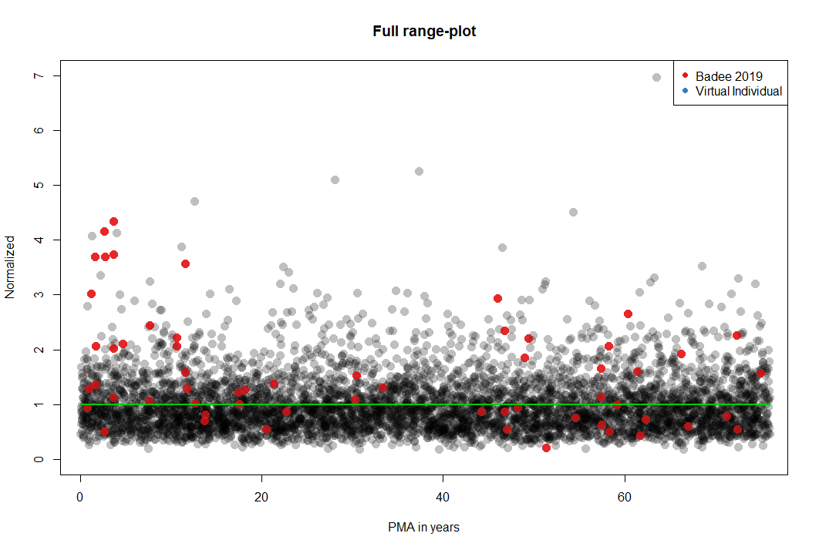
Figure 26. Ontogeny profile for UGT1A3 activity described by a linear function and not age-dependent. PMA: postmenstrual age in years.

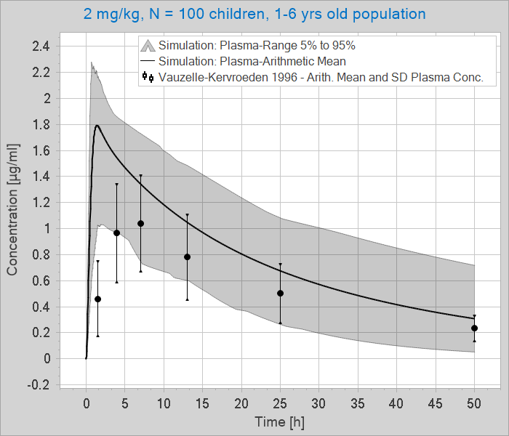
Figure 27. Child population PBPK simulation (line = mean; gray shaded area = 90th prediction interval) compared with the Vauzelle-Kervroeden 1996 dataset (2 mg/kg, N = 10, 2.5 ± 1.4 yrs old) for model verification.

5 References

1. U.S. Food & Drug Administration. LAMICITAL (Lamotrigine) Label. 2015.
2. Rambeck B, Wolf P. Lamotrigine clinical pharmacokinetics. Clinical pharmacokinetics. 1993;25(6):433-43.
3. Cohen AF, Land GS, Breimer DD, Yuen WC, Winton C, Peck AW. Lamotrigine, a new anticonvulsant: pharmacokinetics in normal humans. Clinical pharmacology and therapeutics. 1987;42(5):535-41.
4. Peck AW. Clinical Pharmacology of Lamotrigine. Epilepsia. 1991;32(s2):S9-S12.
5. Yuen WC, Peck AW. Lamotrigine pharmacokinetics: oral and IV infusion in man. Br J Clin Pharmacol. 1988;26:242P.
6. Milosheska D, Lorber B, Vovk T, Kastelic M, Dolžan V, Grabnar I. Pharmacokinetics of lamotrigine and its metabolite N-2-glucuronide: Influence of polymorphism of UDP-glucuronosyltransferases and drug transporters. British journal of clinical pharmacology. 2016;82(2):399-411.
7. Rowland A, Elliot DJ, Williams JA, Mackenzie PI, Dickinson RG, Miners JO. In vitro characterization of lamotrigine N2-glucuronidation and the lamotrigine-valproic acid interaction. Drug metabolism and disposition: the biological fate of chemicals. 2006;34(6):1055-62.
8. Argikar UA, Remmel RP. Variation in glucuronidation of lamotrigine in human liver microsomes. Xenobiotica; the fate of foreign compounds in biological systems. 2009;39(5):355-63.
9. Food and Drug Administration. LAMICITAL Label, Sponsor: GlaxoSmithKline. March 24, 2015.
10. Posner J, Cohen AF, Land G, Winton C, Peck AW. The pharmacokinetics of lamotrigine (BW430C) in healthy subjects with unconjugated hyperbilirubinaemia (Gilbert's syndrome). British journal of clinical pharmacology. 1989;28(1):117-20.
11. Food and Drug Administration. Clinical Pharmacology and Biopharmaceutics Review - Lamicital XR, Sponsor: GlaxoSmithKline. In: Research CfDEa, editor. 2009.
12. Maharaj AR, Barrett JS, Edginton AN. A workflow example of PBPK modeling to support pediatric research and development: case study with lorazepam. The AAPS journal. 2013;15(2):455-64.
13. Conner TM, Reed RC, Zhang T. A Physiologically Based Pharmacokinetic Model for Optimally Profiling Lamotrigine Disposition and Drug-Drug Interactions. European journal of drug metabolism and pharmacokinetics. 2019;44(3):389-408.
14. Ladumor MK, Thakur A, Sharma S, Rachapally A, Mishra S, Bobe P, et al. A repository of protein abundance data of drug metabolizing enzymes and transporters for applications in physiologically based pharmacokinetic (PBPK) modelling and simulation. Scientific Reports. 2019;9(1):9709.
15. Lamotrigine [Internet]. Available from: https://www.drugbank.ca/drugs/DB00555.
16. Wootton R, Soul-Lawton J, Rolan PE, Sheung CT, Cooper JD, Posner J. Comparison of the pharmacokinetics of lamotrigine in patients with chronic renal failure and healthy volunteers. Br J Clin Pharmacol. 1997;43(1):23-7.
17. Doig MV, Clare RA. Use of thermospray liquid chromatography-mass spectrometry to aid in the identification of urinary metabolites of a novel antiepileptic drug, Lamotrigine. Journal of chromatography. 1991;554(1-2):181-9.
18. Beck O, Ohman I, Nordgren HK. Determination of lamotrigine and its metabolites in human plasma by liquid chromatography-mass spectrometry. Therapeutic drug monitoring. 2006;28(5):603-7.
19. Kaivosaari S, Toivonen P, Hesse LM, Koskinen M, Court MH, Finel M. Nicotine glucuronidation and the human UDP-glucuronosyltransferase UGT2B10. Molecular pharmacology. 2007;72(3):761-8.
20. Nakamura A, Nakajima M, Yamanaka H, Fujiwara R, Yokoi T. Expression of UGT1A and UGT2B mRNA in human normal tissues and various cell lines. Drug metabolism and disposition: the biological fate of chemicals. 2008;36(8):1461-4.
21. Strassburg CP, Oldhafer K, Manns MP, Tukey RH. Differential expression of the UGT1A locus in human liver, biliary, and gastric tissue: identification of UGT1A7 and UGT1A10 transcripts in extrahepatic tissue. Molecular pharmacology. 1997;52(2):212-20.
22. Martins MT, Paim CS, Steppe M. Development of a dissolution test for lamotrigine in tablet form using an ultraviolet method. Brazilian Journal of Pharmaceutical Sciences. 2010;46:179-86.
23. Lalic M, Pilipovic A, Golocorbin-Kon S, Gebauer-Bukurov K, Bozic K, Mikov M, et al. Comparison of dissolution profiles and serum concentrations of two lamotrigine tablet formulations. Drugs in R&D. 2011;11(1):53-60.
24. Glaxo Group Limited, inventorSustained Release Formulations Comprising LamotrigineFebruary 12, 2004.
25. Vaithianathan S, Raman S, Jiang W, Ting TY, Kane MA, Polli JE. Biopharmaceutic Risk Assessment of Brand and Generic Lamotrigine Tablets. Molecular pharmaceutics. 2015;12(7):2436-43.
26. Badée J, Qiu N, Collier AC, Takahashi RH, Forrest WF, Parrott N, et al. Characterization of the Ontogeny of Hepatic UDP-Glucuronosyltransferase Enzymes Based on Glucuronidation Activity Measured in Human Liver Microsomes. Journal of clinical pharmacology. 2019;59 Suppl 1:S42-s55.
27. Miyagi SJ, Collier AC. Pediatric development of glucuronidation: the ontogeny of hepatic UGT1A4. Drug metabolism and disposition: the biological fate of chemicals. 2007;35(9):1587-92.
28. Vauzelle-KervroËDan F, Rey E, Cieuta C, Pariente-Khayat A, Pons G, D′Athis P, et al. Influence of concurrent antiepileptic medication on the pharmacokinetics of lamotrigine as add-on therapy in epileptic children. British Journal of Clinical Pharmacology. 1996;41(4):325-30.
29. Chen C, Casale EJ, Duncan B, Culverhouse EH, Gilman J. Pharmacokinetics of Lamotrigine in Children in the Absence of other Antiepileptic Drugs. Pharmacotherapy: The Journal of Human Pharmacology and Drug Therapy. 1999;19(4):437-41.

