Characterization of Snap-Cure Epoxy Resin under Tension and Compression Loading at Quasi-static, Intermediate and High Strain Rates

Yu Zeng¹, Duane Cronin¹, John Montesano ¹
¹Department of Mechanical & Mechatronics Engineering, University of Waterloo, 200 University Avenue West, Waterloo, ON N2L 3G1 Canada
yu.zeng@uwaterloo.ca, duane.cronin@uwaterloo.ca, john.montesano@uwaterloo.ca
Corresponding Author: John Montesano (john.montesano@uwaterloo.ca)

Declarations of conflict of interest: none

Abstract
The recent development of snap curing epoxy resins, low-cost reinforcement fabrics, and automated rapid processing technologies has led to increased usage of fiber-reinforced plastic (FRP) composite materials in high-volume production vehicles. For energy absorbing vehicle structures, characterizing the strain rate-dependent response and the local failure behaviour of the epoxy material is critical to assess the crashworthiness of these FRP materials. The current study investigated the deformation response of a three-part snap-cure epoxy resin under tensile and compressive loading over a range of strain rates (i.e., ${10}^{-4} to {10}^{3} s^{-1}$). The experimental results revealed that the tensile elastic modulus and the yield strength of the tested material increased notably over the range of strain rates investigated, while all the tensile specimens fractured in a brittle manner. In contrast, the compressive elastic modulus was not sensitive to the change in strain rates; however, the compressive yield strength increased significantly and was higher than the tensile yield strength at similar loading rates. This study provides an important data set for a snap-cure epoxy material while addressing a gap in the literature, which will support the development of a robust high-fidelity virtual multiscale-modeling framework aimed at predicting the impact performance of FRP materials.

Keywords: Snap-cure epoxy; strain rate-dependent deformation response; high strain rate characterization; FRP composite materials

1 Introduction

Owing to their high specific mechanical properties and excellent energy absorption characteristics, high-performance fiber-reinforced plastic (FRP) composite materials are regarded as a viable option for improving the fuel economy of light duty vehicles and increasing the range of future electric vehicles through vehicle mass reduction. Despite several advantages, FRP materials have not been widely integrated into the body-in-white (BIW) structures of high-volume production vehicles due to the inherently high cost and long cycle times of conventional FRP fabrication processes (Elmarakbi, 2014). The recent development of snap curing epoxy resins, low-cost reinforcement fabrics, and automated liquid composite molding processing technologies, such as high-pressure resin transfer molding (HP-RTM) (Cherniaev, et al., 2019) and liquid compression molding (LCM), provide a promising opportunity to increase usage of FRP materials in high-volume production vehicles. Advances in polymer chemistry have enabled a significant reduction in the cure times of epoxy resins, making the production speed of snap-cure resin-based FRP parts comparable to that of stamped steel (Malnati & Sloan, 2018). One niche application for these new FRP materials is for energy absorbing vehicle structures and vehicle crashworthiness, where assessing the material response under impact loads is crucial. It is known that the strain rate-dependent deformation response of FRP materials is governed by the rate-dependent properties and local failure phenomena of the matrix (Perry & Walley, 2022). To date, few studies focused on characterizing the constitutive behaviour of snap-cure epoxy resins have been reported (Morelle, et al., 2017). Assessing the strain rate-dependent deformation response of snap-cure epoxy materials is necessary for conducting virtual tests to capture the associated response of FRP materials.

Since Kolsky’s pioneering work on the characterization of the impact response of plastics (Kolsky, 1949), there have been many early studies on investigating the mechanical strain rate sensitivity of brittle or glassy polymers. Walley et al. (1989) reported the compressive response of several glassy polymers for a wide range of strain rates, showing notable strain rate-dependence in the plastic region, including the strain hardening response at large strains. Other early studies on glassy polymers were primarily focused on dynamic testing of thermoplastic materials due to the earlier development of the structural thermoplastics (e.g., Polymethylmethacrylate (PMMA)) (Chou, et al., 1973). Over the last 20 years the usage of epoxy materials has increased for structural applications, and the results of characterization efforts for epoxies at strain rates in the range of${ 10}^{-5} to {10}^{5} s^{-1}$ have been more widely reported. Chen et al. (2002) characterized the response of Epon 828/T-403 epoxy, showing that the strain rate-dependent behavior, particular in the plastic deformation region, was significant under tensile and compressive loading. Gilat et al. (2007) studied the strain rate sensitivity of E-862 and PR-520 epoxies at the strain rates of ${10}^{-5}{-10}^{3} s^{-1}$, demonstrating that the tensile strength at the highest strain rate considered increased by approximately 100% from the lowest strain rate case for both tested materials. The maximum shear strain for E-862 was found to decrease with increasing strain rate, while the maximum strain for PR-520 remained constant for all shear tests. Jordan et al. (2008) tested Epon 826/DEA epoxy at strain rates in the range ${10}^{-4}{-10}^{4} s^{-1}$, revealing a clear strain rate dependence for the plastic region under compression. It was reported that there was no notable difference in the elastic response of the tested material at different strain rates. Gerlach et al. (2008) characterized Hexcel RTM-6 epoxy at the strain rates of ${10}^{-3}{-10}^{4} s^{-1}$, showing a notable increase of yield and flow stress and elastic modulus with increasing strain rate under both tension and compression. A significant increase of failure strength and elastic modulus were also associated with the increase of strain rate under tension. Werner and Daniel (2014) characterized 3501-6 epoxy at strain rates in the range of ${10}^{-5}{-10}^{3} s^{-1}$ and demonstrated that the compressive stress-strain curves showed similar overall shape for all strain rates considered. It was found that only the nonlinear response was dependent on the strain rate, while the relation between the yield strength and strain rate followed a linear logarithmic equation. Tamrakar et al. (2018) tested DER 353 epoxy at the strain rates of ${10}^{-3}{-10}^{4} s^{-1}$, and the compression test results indicated that a noticeable increase of yield and flow stress was associated with the increase of strain rates, as well as a clear increase for elastic modulus.

In general, for most epoxies certain properties have been reported to exhibit strain rate-dependence, while the influence of strain rate on the post-yield response is typically pronounced. However, there are contradictory reports regarding the effect of strain rate on elastic modulus in both tension and compression. One of the potential reasons for this discrepancy is that in some studies dynamic force equilibrium or a constant strain rate was not achieved during intermediate and high-rate tests (not reported in most studies), which can lead to inaccurate data. Furthermore, most reported studies focused on characterizing moderately cross-linked epoxies (e.g., EPON and DER), which were based on the widely used DGEBA/F and cured with amine-based hardeners. These epoxies can exhibit ductile behaviour at room temperatures and low strain rate conditions. Few reported studies investigated the response of highly cross-linked epoxies (e.g., Gerlach et al. (2008)), which may exhibit distinct strain rate sensitivity. Snap-cure epoxy systems, which are more suitable for high-volume production environments such as for automobile structures, have not been characterized under dynamic loading conditions. Additionally, in most previous studies epoxy specimens were fabricated in the laboratory, lacking connection to the industrial manufacturing process (Cherniaev, et al., 2019).

A review of the literature has revealed a critical gap in reporting the results of characterization campaigns focused on the rate-dependent deformation behaviour of highly cross-linked snap-cure or rapid curing epoxies, particularly those fabricated using industrial fabrication processes. The objective of the current study was to characterize the tensile and compressive rate-dependent deformation behaviour of a three-part snap-cure epoxy material that is used for fabricating FRP composites. The epoxy material was fabricated using a rapid high-pressure resin transfer molding process, after which custom test specimens were cut and machined as required for each test setup. Specimens were tested using different tension and compression testing apparatus, where each setup was carefully calibrated to ensure that dynamic force equilibrium and a constant strain rate were achieved for all performed tests. The fracture surfaces of the tensile specimens were also investigated with an optical microscope to assess the influence of strain rate.

2 Background

2.1 Deformation response of cured epoxy
A representative stress-strain curve for a highly cross-linked epoxy material under quasi-static uniaxial compressive loading reveals four typical deformation stages (Fig. 1): I. elastic (linear elastic and viscoelastic); II. onset of plastic flow; III. strain-softening; and IV. strain hardening or re-hardening (Morelle, et al., 2017). The linear region of the first deformation stage typically only spans 1-2 % strain (Goldberg, et al., 2003). With increasing strain, the glassy polymer exhibits a nonlinear stress-strain response due to the increase of the nonlinear viscoelastic deformation or nonlinear elastic deformation (Chen, et al., 2002; HASAN & BOYCE, 1995). The deformation response of glassy polymers in this stage may be influenced by the strain rate and temperature (Morelle, et al., 2017). The onset of plastic flow occurs during the second deformation stage (Fig. 1, stage II). Distinct from the classical definition of a yield point for metallic materials, the yield point for a polymer can be defined as the point at which the stress does not increase with the increase of the strain (i.e., local stress maximum) (Brown, 1999). Many studies indicated that the yield behaviour of glassy polymers is largely affected by the hydrostatic pressure, strain rate, temperature in this stage (Morelle, et al., 2017; Gerlach, et al., 2008; Littell, et al., 2008). The third deformation stage constitutes strain softening (Fig. 1, stage III), where there is no general agreement on the governing mechanism. If strain-localization or necking occurs, the softening behaviour is associated with the evolution of the macroscopic shear bands (Morelle, et al., 2017). In many cases, micro-shear bands occur within the specimen rather than external macro-shear bands. In these situations, some researchers proposed that the yield and softening were determined by the initiation, evolution, and merger of the shear transformation zone (STZ) (Sindt, et al., 1996; Hasan & Boyce, 1995). Some researchers suggested that the rearrangement of the free volume is the cause of strain softening (Struik, 1991; Jatin, et al., 2014). The final deformation stage consists of material strain hardening (Fig. 1, stage IV), where the stress begins to rise with increasing strain. This phenomenon can be described by a rubbery elastic response of the entangled cross-linked molecular network, where the reorientation and stretching of the molecular chains are confined by the network (Haward & Thackray, 1968); (Hasan & Boyce, 1995; M.Arruda & C.Boyce, 1993; Klompen, et al., 2005). The material response in this stage is primarily affected by the cross-link density and secondly by the temperature and strain rate.

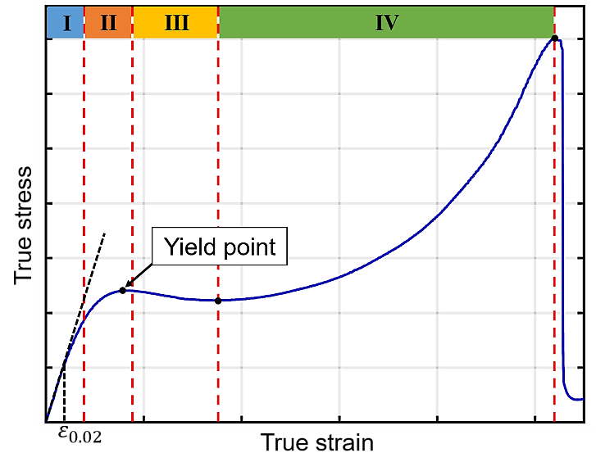
Fig. 1 A typical compressive stress-strain curve for highly cross-linked epoxy resins and many glassy polymers

The deformation rate, temperature, and hydrostatic pressure can influence the deformation behaviour of epoxy materials. Normally, for compressive deformation, the nonlinear elastic and plastic regions show strain rate dependence, and higher yield strengths are associated with higher strain rates (Fig. 2) (Werner & Daniel, 2014). The influence of temperature on the deformation response is opposite to that of strain rate, where lower yield strengths are related with higher temperatures (Fig. 2a) (Littell, et al., 2008; Boyce, et al., 1988). Unlike many crystalline materials in which shear deformations are independent of hydrostatic pressure, the shear stress-strain behaviour of most polymer materials can be significantly affected by their hydrostatic stress (ARGON, 2013). The presence of compressive normal stresses normally increases the elastic modulus and yield strength of the polymer materials (Fig.2b) (Pae & Bhateja, 1975). This pressure-dependent behaviour of deformation can be explained as that the compressive pressure can reduce the free volume of the polymer material, thus increasing the resistance to molecular mobility (PARRY & TABOR, 1974).

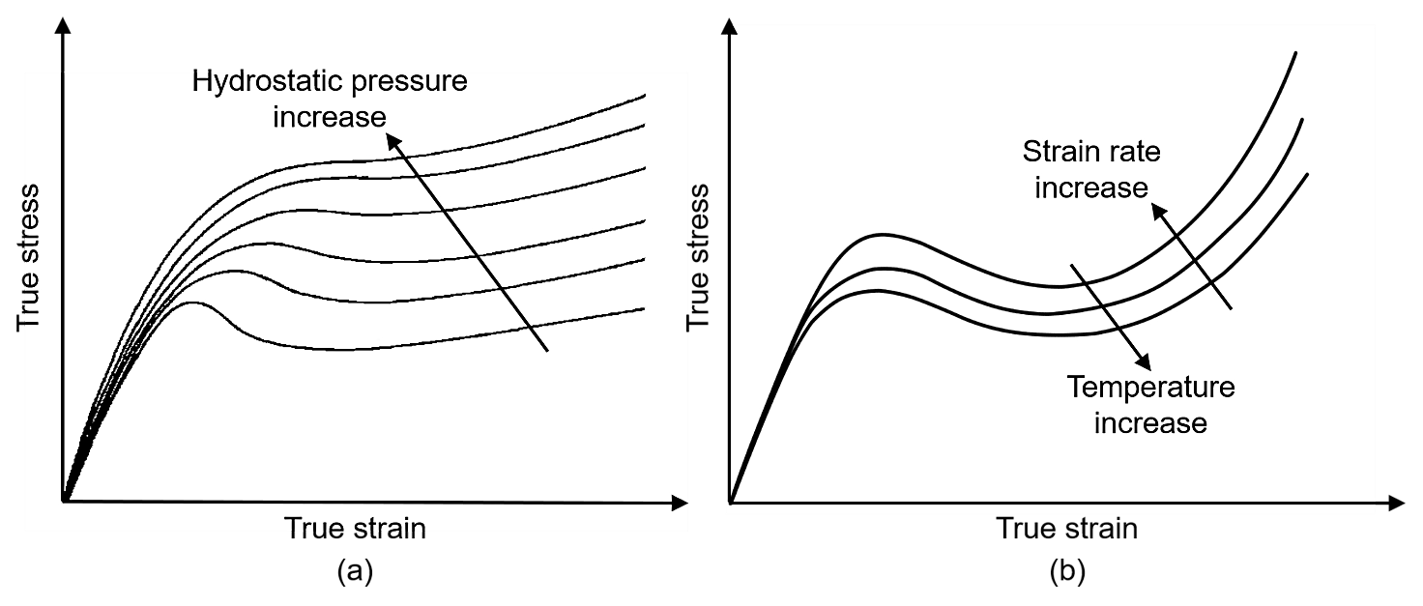
Fig. 2 Schematics of (a) strain rate- and temperature-dependent deformation response of glassy polymers under compressive loading; (b) Typical stress-strain curves at various hydrostatic pressures for a glassy polymer. Adapted from Pae and Bhateja (Pae & Bhateja, 1975)

2.2 Characterization techniques for epoxy materials across a wide range of strain rates

Different techniques and apparatus have been used to characterize the response of polymers at different applicable strain rates. For characterizing the tensile or compressive response of epoxies under quasi-static strain rates (< 10⁻¹ s⁻¹), commercially available servo-hydraulic and screw-driven testing machines are commonly used. The specimen geometries were typically cylindrical or rectangular dog-bone shape for tensile tests (Werner & Daniel, 2014; Gilat, et al., 2007) and cylindrical or rectangular blocks for compressive tests (Tamrakar, et al., 2018; Werner & Daniel, 2014). Characterizing the response of epoxy materials under intermediate strain rates (10⁻¹ - 10² s⁻¹) can be challenging since the frequency of experimental data acquisition can be close to the natural frequency of the loading device, which may cause signal oscillations (Siviour & Jordan, 2016; Mattucci, et al., 2012). The most widely used testing devices have been closed-loop drop weight hydraulic machines or hydraulic intermediate strain rate (HISR) apparatus. HISR apparatus are similar to conventional uniaxial testing machines where an engagement sleeve is accelerated to a predetermined constant velocity, which then impacts an engagement piston at the bottom of the stroke to deform the test specimen (Ouellet, et al., 2006). The geometries of the test specimens for intermediate strain rate tests are often the same as those used for quasi-static strain rate tests.

The split Hopkinson Pressure Bar (SHPB) or Kolsky bar has become a widely used testing apparatus for characterizing epoxies at high strain rates (10² - 10⁴ s⁻¹) (Chen, et al., 2002; Gerlach, et al., 2008; Jordan, et al., 2008). A typical SHPB apparatus consists of a transmitter bar, an incident bar, a striker bar, two strain gauges and a high-frequency data acquisition system. The two strain gauges located at the center of the transmitter and incident bars are used to record wave propagation during the test, including incident, reflected, and transmitted waves (Fig. 3). The waveforms along with their amplitude and timing are used for analyzing the material stress-strain behaviour (Gray III, 2000). The key assumption for the SHPB test analysis method is that the test specimen reaches dynamic force equilibrium after an initial transition period and deforms homogeneously. In general, a specimen reaches dynamic equilibrium once the impact wave has time to propagate in the specimen for more than four reflections before failure (Salisbury, 2001). A common technique to verify the dynamic force equilibrium is the one-wave versus two-wave method, where the forces on both ends of the test specimen measured from the incident and transmitter bars using the incident, reflected, and transmitted waves are compared (Gray III, 2000).

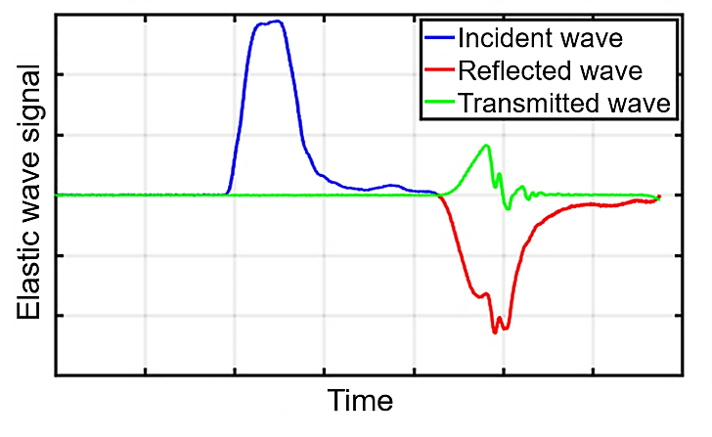
Fig. 3 A generic plot of the three elastic waveforms observed in the bars of a typical SHPB setup

Elastic wave propagation in the bars and tested material can be complex, inertial effects may also be notable, and capturing data at high sampling frequencies may pose additional difficulties. Different techniques were developed to meet the SHPB test requirements and to improve the quality of test results. First, the material and geometric impedance differences between the specimen and the bars (e.g., polymer specimens and steel bars) may result in a low transmitted signal and high reflected signal, which may affect the data accuracy and complicate data processing (Sligtenhorst, et al., 2006). Several methods have been used to address the low impedance issue, including using additional strain gauges or gauges with high sensitivity (Jordan, et al., 2008; Wasley, et al., 1969; Chen, et al., 2000), modifying the geometry of the bars and specimen (Tamrakar, et al., 2018; Chen, et al., 1999), pulse-shaping (Frew, et al., 2002; Frew, et al., 2005), and changing the material of the bars (Bacon, 1998; Salisbury, 2001; H.Zhao, et al., 1997). Secondly, the stress wave propagation in the bars can be dispersive, especially for a viscoelastic polymeric bar (Liu & Subhash, 2006; Sligtenhorst, et al., 2006; Salisbury & Cronin, 2009; Salisbury & Cronin, 2015). Several methods were reported to correct the wave dispersion for SHPB numerically (Liu & Subhash, 2006; Gorham, 2000) and experimentally (Benatar, et al., 2003; Bacon, 1998).

3 Material and test methodology

3.1 Material and specimen preparation
The material studied was a three-part rapid curing (snap-cure) low viscosity epoxy system, namely EPIKOTE™ 06150 (Hexion Inc.). The epoxy system comprised EPIKOTE™ Resin TRAC 06150 (blends of bisphenol-based glycidyl ethers), EPIKURE™ Curing Agent TRAC 06150 (aliphatic amine), and the internal mold release agent HELOXY™ Additive TRAC 06805.
Owing to the different testing apparatus required to characterize the mechanical properties of the cured epoxy material over a range of strain rates in tension and compression, three different specimen geometries were required (Table 1). Therefore, two processes were used to manufacture the epoxy material into flat panels and cylindrical samples, namely HP-RTM and a hand-cast method, respectively. Flat panels of the epoxy system (nominally 4 mm-thick and 900 mm × 550 mm in size) were fabricated using a full-scale HP-RTM setup described by (Cherniaev, et al., 2019). Quasi-static and intermediate strain rate tension dog-bone specimens were machined from the flat panels. Compression and high strain rate tensile tests required thicker sample geometries that were not achievable using the HP-RTM process. Solid cylindrical epoxy samples (∅16 × 55 mm) were cast by hand-mixing and open-air molding using a custom-built mold, and later machined to size.

Table 1 Summary of the material characterization tests performed in this study and specimen geometry
Test | Test frame | Frame displacement rate | Specimen geometry (mm)
Quasi-static strain rate tension | Small Servo-hydraulic  (MTS) | 0.0254 mm/s (0.001 in/s) | 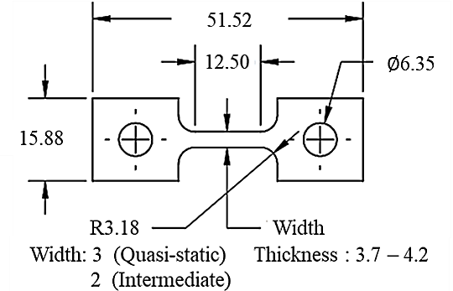
Quasi-static strain rate tension | Small Servo-hydraulic  (MTS) | 0.254 mm/s (0.01 in/s)
Intermediate strain rate tension | Hydraulic Intermediate Strain Rate (MTS) | 150 mm/s
Intermediate strain rate tension | Hydraulic Intermediate Strain Rate (MTS) | 1,000 mm/s
High strain rate tension | Tensile Polymeric Split-Hopkinson Pressure Bar | ~6,000 mm/s | 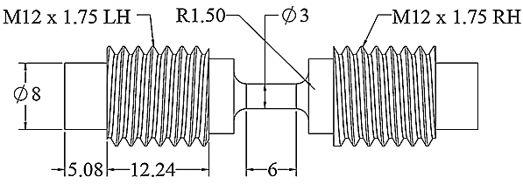
Quasi-static strain rate compression | Medium-scale Servo-hydraulic (MTS) | 0.01 mm/s | 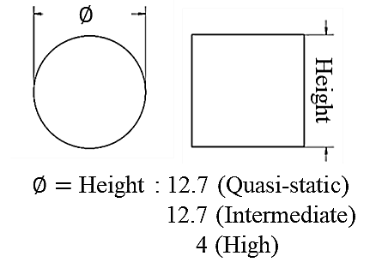
Quasi-static strain rate compression | Medium-scale Servo-hydraulic (MTS) | 0.1 mm/s
Intermediate strain rate compression | Medium-scale Servo-hydraulic (MTS) | 15 mm/s
High strain rate compression | Compressive polymeric split-Hopkinson pressure bar | ~2,200 mm/s

3.2 Dynamic Mechanical Analysis
Dynamic Mechanical Analysis (DMA) was performed to compare the glass transition temperature ($T_{g}$) of specimens fabricated using HP-RTM and hand-cast methods, thus providing an indirect means to compare the degree of cure. A DMA Q800 (TA Instruments, New Castle, Delaware) was used to conduct the DMA tests, while TA Universal Analysis software enabled analysis of the experimental data. A three-point flexural test with both strain and temperature sweeping were conducted to investigate the change of storage modulus and loss modulus of the samples over a range of temperatures. The DMA specimens were rectangular with the dimensions of 55 × 9.5 ×3.8 mm.

3.3 Mechanical Test Setup
Uniaxial tension and compression tests at different strain rates, applicable to automotive crashworthiness applications, were conducted to investigate the deformation response of the neat epoxy material. For quasi-static strain rate tests, speed of testing followed the ASTM standard D638. The speed of testing for intermediate strain rate tests were limited by the test machine, where strain rates between 1 s⁻¹ and 100 s⁻¹ were achieved. High strain rate tests were conducted in the range 100 s⁻¹ to 1000 s⁻¹ to represent the material deformation rate during an impact event.
3.3.1 Uniaxial Tensile Tests
All the tensile tests were carried out in a lab environment with a constant temperature (24 ± 1°C) and relative humidity (50 ± 5%). Quasi-static strain rate tensile tests were conducted on an MTS servo-hydraulic test frame with a 2,224 N (500 lb) capacity load cell (OMEGA LC412-500) and custom pin-loaded fixtures (Fig.4a). An MTS FlexTest SE controller was used, where two sets of uniaxial tensile tests were performed at a constant crosshead displacement rate (CCDR) of 0.0254 and 0.254 mm/s (Table 1). Intermediate strain rate tension tests were conducted on a hydraulic intermediate strain rate (HISR) apparatus with the pin-loaded fixtures (Fig. 4 b). An MTS 407 unit was used to control the loading process of the HISR and the applied force was measured by a piezoelectric force sensor (KISTLER 9341B) with a $±$30 kN range. The crosshead displacement rates were set to 150 and 1000 mm/s (Table 1). A minimum of five repeated tests were conducted for each strain rate considered, and additional trial tests were conducted to ensure that each test setup was appropriate. In addition, the fracture surface of the specimens was investigated with a KEYENCE opto-digital microscope equipped with a high-resolution zoom lens, VH-Z500R.
A custom-built Tensile Polymeric Split-Hopkinson Pressure Bar (T-PSHPB) apparatus was used to characterize the tensile properties of the studied epoxy material at a high strain rate (Fig. 4c). The T-PSHPB apparatus comprised polymethyl methacrylate (PMMA) bars to minimize the material impedance difference with the tested epoxy specimens. A hollow cylindrical striker bar loaded by four bungee cords impacted the flange of the incident bar to generate an elastic stress-wave to the system. The impact velocity of the striker bar was adjusted by changing the stretch length of the bungee cords, while a load cell (OMEGA LC412-1k) with 4,448 N (1,000 lb) capacity measured the applied load. A 32 N load was applied to the striker bar to accelerate the bar to a velocity of 6 m/s upon impact. The strain of the incident and transmitter bars was measured by two strain gauges (OMEGA SGD-7/1000-LY13) and two signal-conditioning amplifiers (Vishay 2210B). The test signals were recorded by National Instruments™ LabVIEW software.

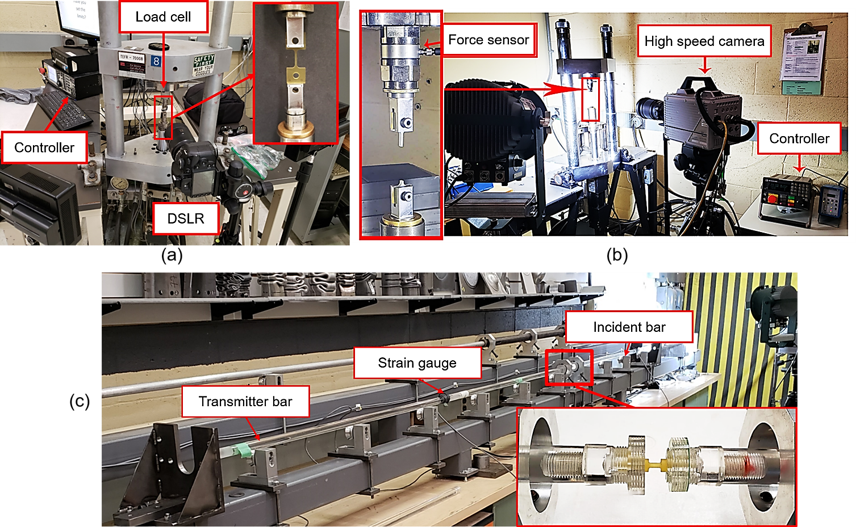
Fig. 4 Images of (a) the quasi-static tensile test setup; (b) the HISR setup; (c) the T-PSHPB apparatus

Specimen strain for the quasi-static and intermediate strain rate tension tests was determined using 2D digital image correlation (DIC). The gauge section of all specimens was painted with stochastic speckle pattern using latex-based spray paint. A Nikon D3200 Digital Single-lens Reflex (DSLR) camera was used to capture images of the specimen deformations during the quasi-static strain rate tests with a frame rate of 30 frames per second (FPS), while a Photron SA5 high-speed camera was used for the intermediate strain rate tests with a frame rate of 7,000 and 50,000 FPS. For post-processing of captured images, an industry-grade DIC software, GOM Correlate 2018, was used to calculate the strain of the specimen without using any strain filters. For the GOM setup, the subset sizes were 40 pixels for D3200 images (2,000 Pixels per inch (PPI)) and 23 pixels for SA5 images (500 PPI), while the step size was 8 pixels for D3200 images and 6 pixels for SA5 images. For the high strain rate tension tests, a point tracking technique was used instead of speckle patterns for DIC due to the cylindrical shape of the specimens. A Photron SAZ high-speed camera was used to capture the specimen deformation (frame rate of 480,000 FPS) for subsequent DIC analysis and to verify the calculated strain from the T-PSHPB system. For the GOM setup, the subset size was 11 pixels for SAZ images (350 PPI), while the step size was 5 pixels.
Yield strength of polymers can normally be determined as maximum stress (yield point) before the strain-softening stage. However, the yield point may not be identifiable for glassy polymers that exhibit a low elongation to break during tension tests. Different methods to define the tensile yield strength of polymers has been used in previous work, from 0.3% to 2% strain offset. In this study, a 0.3% offset of the elastic modulus slope line was used to define the yield stress since it is commonly accepted in the polymer technical community (Semeliss, et al., 1990).
3.3.2 Uniaxial Compression Tests
All compression tests were performed under a constant ambient temperature (24 ± 1°C) and relative humidity (50 ± 5%). The quasi-static and intermediate strain rate compression tests were conducted on a medium-scale custom-built servo-hydraulic test frame with a 88,964 N (20,000 lb) capacity load cell (Transducer Techniques SWP), flat platen fixtures, and an MTS 407 hydraulic controller (Fig.5a). To reduce specimen barreling during the compression tests, two carbide plates coated with white lithium grease were placed between the platens and the specimen to reduce surface contact friction. Three strain rates were used to characterize the compression properties of the epoxy material with this setup, two sets of quasi-static strain rate tests with 0.01 and 0.1 mm/s CCDR, and one set of intermediate strain rate tests with 15 mm/s CCDR (Table 1).
A compressive polymeric split-Hopkinson pressure bar (C-PSHPB) test apparatus was used to characterize the compressive properties of the epoxy material at a high strain rate (Fig. 5b). The compressed gas pressure applied to the striker bar was set to 20 psi to yield a striker bar impact velocity of 2.2 m/s. The strains of the incident and transmitter bars were measured by two strain gauges (Micro-Measurements CEA-13-250UW-120) and two signal-conditioning amplifiers (Vishay 2210B). The test signals were recorded by a National Instruments™ LabVIEW software.
The Photron SA5 cameras and GOM software used for the tension tests were also used for the quasi-static and intermediate strain rate compression tests. A Photron SAZ high-speed camera was also used to record specimen deformation during the high strain rate tests and to perform subsequent DIC analysis. A point tracking technique was used instead of applying a speckle pattern on the specimen surface to analyze the compressive deformation due to the cylindrical shape of the specimens. Data analysis for compression tests was similar to that used for the tension tests. Single-factor analysis of variance (ANOVA) was conducted to analyze the difference between the compressive elastic modulus at different deformation rates.
Fig. 5 Images of (a) the quasi-static and intermediate compression test setup; (b) the C-PSHPB apparatus
4. Results and Discussion

4.1 Dynamic mechanical analysis results
The DMA test results (Table 2) showed that the average storage modulus onset and tan delta peak $T_{g}$ values for the HP-RTM specimens were 3% higher when compared to the hand-cast specimens, which indicates that the HP-RTM specimens had a slightly higher degree of cure or crosslink density. This discrepancy may be a result of the difference in pressure applied to the specimens during curing. Nevertheless, the difference in the $T_{g}$ values between the two types of tested specimens was considered negligible, and their mechanical properties were deemed to be similar.
Table 2 $T_{g}$ for HP-RTM and hand-cast specimens (95% confidence interval (CI)) obtained using DMA
 | HP-RTM | Hand-Cast | % Diff.
Onset ${ T}_{g}$ ($C^{°}$) | 121.86$±0.05$ | 118.59$±0.91$ | 3%
Peak ${ T}_{g}$ ($C^{°}$) | 139.11$±0.12$ | 134.88$±0.95$ | 3%

4.2 Uniaxial Tensile Test Results
Two sets of tests with two different quasi-static strain rates ($3.3 ×{10}^{-4} s^{-1}$ and $3.5 ×{10}^{-3} s^{-1}$) measured by DIC were conducted. Experimental strain measurements showed that the major and minor strain distributions were uniform in the gauge section of the specimens during deformation (not shown). The stress-strain response of the epoxy was consistent for each repeated test, for each strain rate (Fig. 6a and b), revealing that the degree of cure and mechanical properties across the HP-RTM resin panels were uniform. The tensile response of the epoxy material demonstrated moderate ductility. For both quasi-static strain rates considered, the epoxy deformed elastically up to approximately 30 MPa or 1-2% strain. Thereafter, the epoxy plastically deformed reaching the peak stress at approximately 78 MPa or 7% strain, which was followed by moderate strain softening. The failure strain of the specimens varied from 7 to 10% strain, which was attributed to machining-induced defects that occurred during specimen fabrication.
In the intermediate strain rate range, uniaxial tensile tests were conducted at the two strain rates of $3.2 s^{-1}$ and $23.9 s^{-1}$. For both strain rates, the stress-strain response of the epoxy was consistent for all repeated tests (Fig. 6c and d). Overall, the response of the epoxy at intermediate strain rates demonstrated lower ductility when compared to the response measured during the quasi-static strain rate tests, with similar elastic deformation up to 1-2 % strain. All the specimens fractured during the plastic flow region, without reaching the strain-softening stage. There was notable variation in the failure strain of the specimens (from 4% to 9% strain), and the tests conducted with a strain rate of 3.2 $s^{-1}$ have notably low failure strains compared to the other quasi-static and intermediate strain rate tensile tests. The low failure strains may have been a result of the applied loading frequency, which was close to the natural frequency of the hydraulic loading device; this resonance issue was previously reported as a common challenge for an impact based intermediate strain rate apparatus (Jordan, et al., 2008).
The engineering stress-strain plots for the high strain rate tensile test reveal that the epoxy deformed in a linear elastic manner prior to failure, with an average strain at failure of ~3.7% (Fig. 6e). The stress-strain response and failure strains for the repeated tests were found to have good consistency. Note, only three repeated test results are reported here since they correspond to those where dynamic force equilibrium of the specimen was attained.

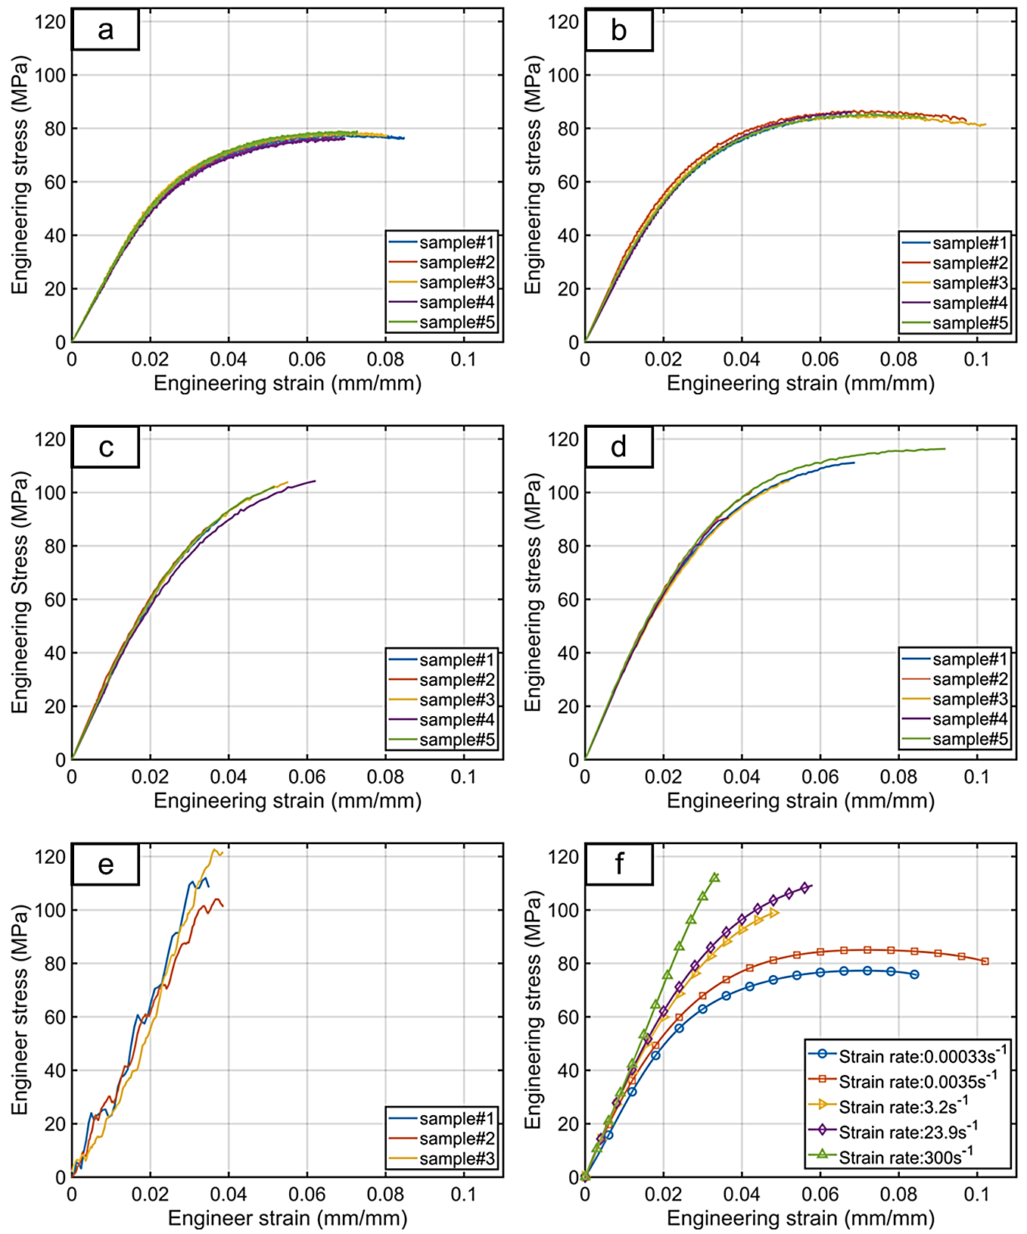
Fig. 6 Uniaxial tensile engineering stress-strain curves at the strain rates of: (a) 0.00033 s⁻¹, (b) 0.0035 s⁻¹, (c) 3.2 s⁻¹, (d) 23.9 s⁻¹, (e) 300 s⁻¹, and (f) Overall average curves

To assess dynamic force equilibrium for the T-PSHPB tests, two approaches were used, namely one-wave versus two-wave verification and a direct method employing DIC. The one-wave versus two-wave method compares the forces on both ends of the test specimen measured from the incident and transmitter bars, which should be equal for the duration of the test. The corresponding results for one of the T-PSHPB tests revealed that the specimen reached dynamic force equilibrium (Fig. 7). The direct approach involved measuring strain directly on the test specimen surface at various locations along its length to ensure that the specimen undergoes uniform deformation along the gauge section. In this study, the test specimens were divided into three sections (Fig. 8). DIC software was used to analyze the captured images and calculate the strain versus time for each section, which revealed that the specimen reached dynamic force equilibrium during the test. Furthermore, a good agreement was found between the strain calculated by the split Hopkinson pressure bar theory and that extracted from DIC (Fig. 9), thus verifying the accuracy of the theory. This is important for this tensile split Hopkinson-bar test because the fillets located at both ends of the gauge section of the dog-bone specimens (Table 1) might affect the strain calculation from the theory. These results also demonstrate that after an initial transition the test specimens were subjected to a constant strain rate for the duration of the tests.
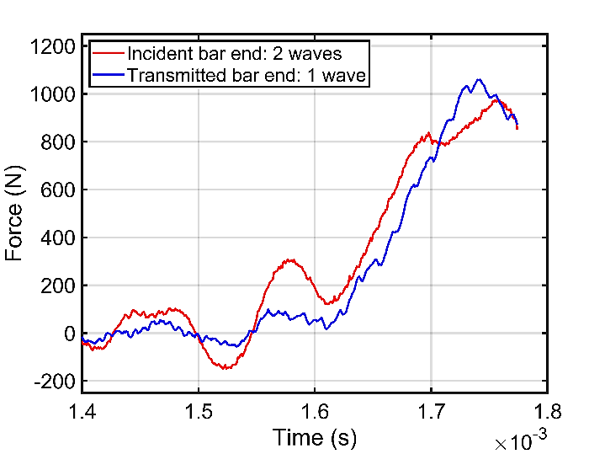
Fig. 7 The force-time profiles measured from the incident end (two-wave) and transmitter bars (one-wave) for the T-SHPB test
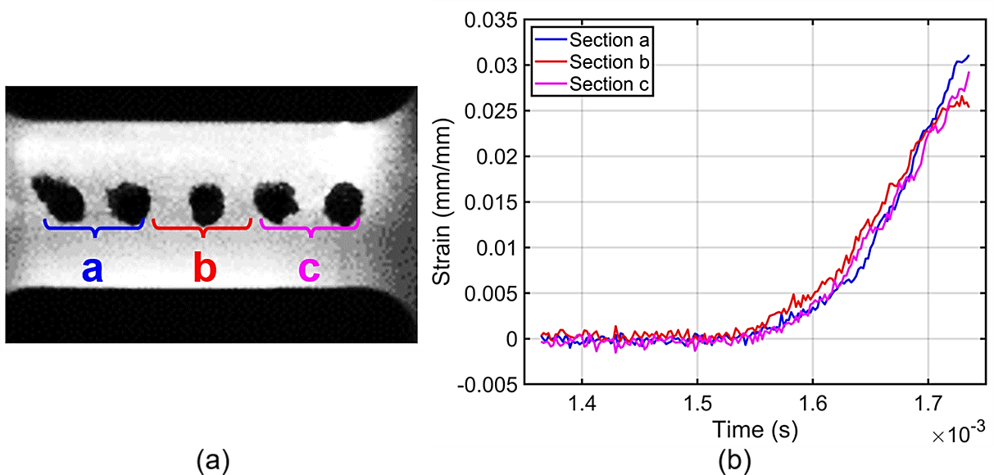
Fig. 8 (a) A gauge section image of the T-SHPB test specimen indicating three sections analyzed using DIC, and (b) strain-time plots for three indicated sections

Fig. 9 Strain profiles calculated by the test software and captured by the DIC method for the T-SHPB test

The average tensile stress-strain curves for all considered strain rates were combined to assess the strain rate-dependent response of the epoxy (Fig. 6f). The elastic modulus, tensile strength, 0.3% offset tensile strength and Poisson’s ratio were carefully determined based on the engineering stress and strain results, and a 95% confidence interval for each value was calculated (Table 3). The elastic modulus and 0.3% offset strength of the epoxy both increased with higher strain rates, while the Poisson’s ratio remained constant at 0.38 ± 0.04. The elastic modulus increased by 34% for high strain rate loading when compared to the quasi-static strain rate case, while the yield strength increased by 31% over the same range of strain rate.
As indicated in Fig.10 (a) and (b), the strain rate dependence of the tensile modulus and 0.3% offset strength roughly follows a linear logarithmic increment relation. These phenomenological-based relationships can be used to calibrate strain rate-dependent constitutive models, as was previously accomplished for other polymers (Gerlach, et al., 2008; Bai, et al., 2015).

Table 3 Summary of mechanical properties for tensile tests at different strain rates (95% CI)
Average strain rate | 0.00033 $s^{-1}$ | 0.0035 $s^{-1}$ | 3.2 $s^{-1}$ | 23.9 $s^{-1}$ | 300 $s^{-1}$
Elastic modulus  (GPa) | 2.70 ± 0.09 | 3.02 ± 0.23 | 3.12 ± 0.12 | 3.25 ± 0.08 | 3.57 ± 0.70
Tensile strength  (MPa) | 77.6 ± 1.8 | 85.8 ± 1.3 | 97.5 ± 16.1 | 104.6 ± 19.4 | 115.8 ± 20.0
0.3% offset strength  (MPa) | 47.2 ± 3.0 | 53.9 $±$ 4.1 | 70.9 ± 5.3 | 73.4 ± 4.5 | N/A
Poisson’s ratio | 0.39 ± 0.02 | 0.36 ± 0.04 | 0.38 ± 0.04 | 0.39 ± 0.02 | N/A

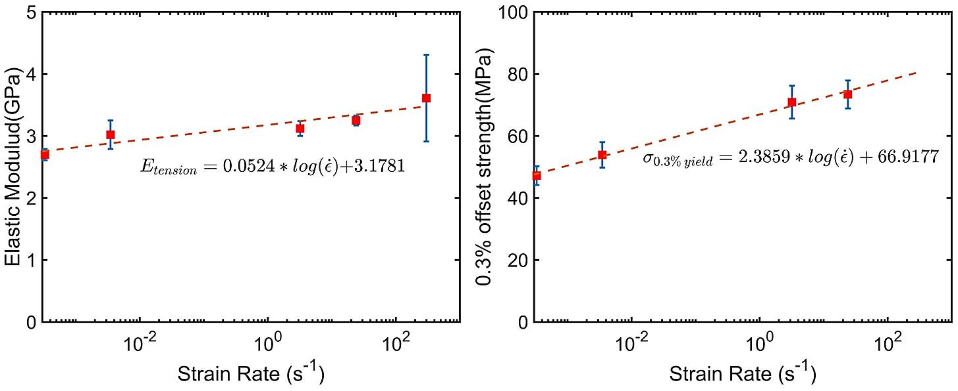
Fig. 10 Relation between mechanical properties and strain rate for tensile tests: (a) elastic modulus, and (b) 0.3% offset strength

4.3 Uniaxial Compression Test Results

Uniaxial compression tests were conducted at two different quasi-static strain rates ($8 ×{10}^{-4} s^{-1}$ and$8 ×{10}^{-3} s^{-1}$). For both deformation rates, the stress-strain response for all repeated tests was consistent prior to the yield point and during the strain softening stage, with evident scatter during the strain re-hardening stage (beyond 25% strain) (Fig. 11a and b). Strain re-hardening may be affected by variations in the crosslink network, including crosslink density, crosslink distributions, specimen defects, which was not observed during the tension tests. Overall, the stress-strain response of the epoxy material demonstrated typical ductile behaviour, in which elastic, plastic flow, strain softening, and strain re-hardening stages were observed. For both quasi-static strain rates considered, the epoxy deformed elastically up to approximately 1-2% strain. Thereafter, the inelastic deformation of the epoxy specimens was significant, reaching the yield point at approximately 7% strain. Beyond the yield point, the epoxy specimens deformed plastically in the strain range of 8 – 15%, leading to strain softening because of shear band relocation. In the final stage of the deformation process from approximately 15% until specimen failure at 45-55% strain, the stress continuously increased during strain re-hardening. All specimens fractured along the axial direction due to the tensile transverse strains induced by Poisson’s effect. The difference in failure strain was less than 6% between specimens for both strain rates.
In the intermediate strain rate range, the uniaxial compression tests were performed at one strain rate (1.56 s⁻¹) due to limitations with the test frame. From the corresponding DIC analysis, it was observed that the test frame cross-head speed reduced when some of the tested specimens attained compressive strains beyond 35%. Thus, the corresponding test results are presented up to a strain of 35%. Similar to the quasi-static strain rate tests, assessment of the engineering stress-strain response revealed that the specimens underwent similar deformation stages including elastic, plastic flow, strain softening, and strain re-hardening (Fig. 11c). During the deformation, the yield point was observed at approximately 10% strain, while the strain re-hardening began at 18% strain. The stress-strain response for all repeated tests was consistent prior to the yield point, whereas the post-yield behaviour beyond 10% strain shows minor scatter. The specimens ultimately fractured along their axial direction due to the tensile transverse strains induced by Poisson’s effect.
In the high strain rate regime, uniaxial compression tests were performed under one strain rate (approximately 550 s⁻¹) using the C-PSHPB. The engineering stress-strain response of the epoxy revealed that the yield point was attained at 13% strain (Fig. 11d). In contrast to the quasi-static and intermediate strain rate tests, strain softening and re-hardening were not significant. Three repeated tests were performed with minor scatter in the stress-strain response. The specimens fractured comminuted into small pieces at failure.

Fig. 11 Uniaxial compressive engineering stress-strain curves for the strain rates of: (a) 0.0008 s⁻¹, (b) 0.008 s⁻¹, (c) 1.56 s⁻¹, (d) 550 s⁻¹, and (e) total curves
To ensure accuracy of the compressive test data, specimen buckling and barreling were inspected using images captured during the tests. The side view of a cylindrical compression specimen during an intermediate strain rate compression test was checked, where no visible buckling was observed. Specimen barreling is not observed between 0 and -19 % strain, while there is minor barreling (with in 5% differences in diameter) in the strain re-hardening stage at approximately -35% strain (Fig.12), which may have contributed to the scatter observed in data. A one-wave versus two-wave method was used through the test software to verify that dynamic force equilibrium was achieved for the C-PSHPB tests (Fig. 13). To verify the calculation results of the software, the strain calculated by the test software was compared with the strain captured by the DIC method (Fig. 14), and a reasonably good agreement was found between the two results
Fig. 12 The barreling of a cylindrical specimen at the different strains during one intermediate strain rate compression test (1.56 s⁻¹)

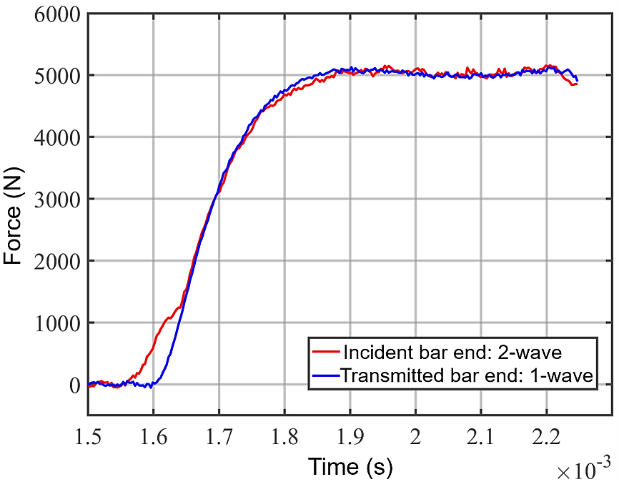
Fig. 13 The force-time profiles from the incident end (two-wave) and transmitter bars (one-wave) for a C-PSHPB tests
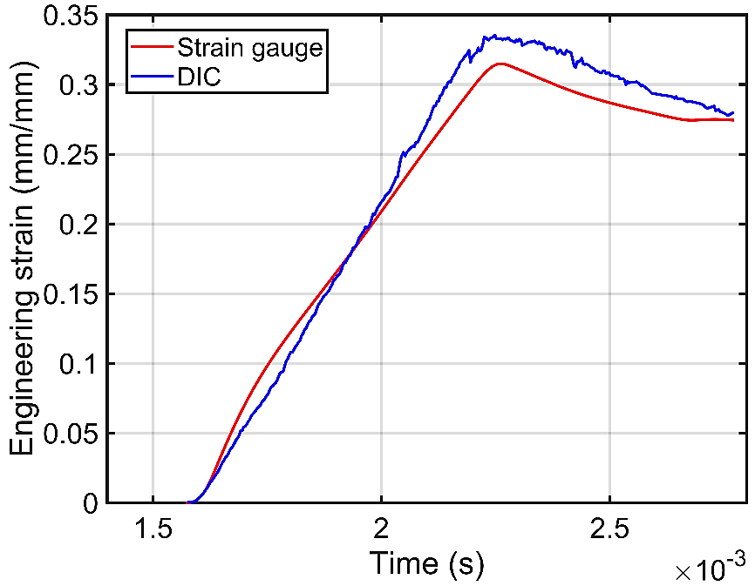
Fig. 14 A comparison of strain calculated by the test software and captured by the DIC method for a C-PSHPB test

The average compressive stress-strain curves for all considered strain rates were combined to assess the strain rate-dependent response of the epoxy (Fig. 11e). The overall stress-strain response is similar at different strain rates. The elastic modulus and the yield strength were carefully determined based on the engineering stress and strain results, and a 95% confidence interval for each value was calculated (Table 4). The elastic modulus was observed to have little change with increasing strain rate. Single-factor analysis of variance (ANOVA) showed that there were no statistically significant differences of the compressive elastic modulus between different strain rates ($F=1.03$ and$F_{crit}=4.10$). In contrast, increased yield strengths were associated with increased strain rates (Fig. 15). From the lowest quasi-static strain rate to the highest strain rate, the yield strength increases as much as 81%.

Table 4 Summary of mechanical properties for compression tests at different strain rates (95% CI)
Average strain rate | 0.0008 $s^{-1}$ | 0.008 $s^{-1}$ | 1.56 $s^{-1}$ | 550 $s^{-1}$
Elastic modulus  (GPa) | 2.84 $±$0.06 | 2$.85±$0.24 | 2$.87±$0.02 | 2$.89±$ 0.16
Yield strength  (MPa) | 1$13.1±1.7$ | 1$19.9±1.4$ | 1$46.1±4.1$ | 2$05.0±3.1$

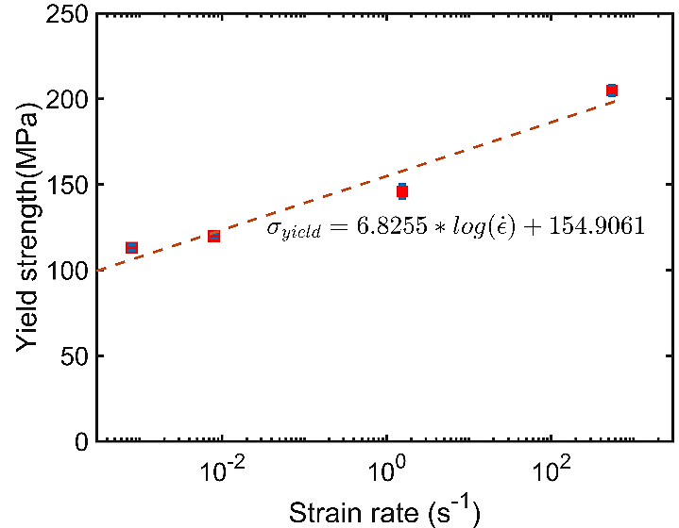
Fig. 15 Relation between yield strength and strain rate for compression tests

4.4 Summary of tension and compression results
A summary of all the tensile and compressive characterization results at different strain rates reveals some key features of the strain rate sensitivity for the studied epoxy (Fig. 16). First, the tensile and compressive stress-strain behaviour is clearly dissimilar because of the different exhibited failure strains and the post-yield responses. During compressive loading, the studied epoxy showed notable strain softening and strain re-hardening behaviour after yielding. The quasi-static tensile response also revealed strain softening, while strain re-hardening was not observed since the test specimens fractured prior to reaching this region. However, in the strain range of 0-10%, the general trend of the all the stress-strain curves (tension and compression) are similar at different strain rates. The similar trend of the stress-strain response is an important assumption for many elastic-plastic constitutive models because these models use a linear logarithmic relation to scale up the plastic stress-strain curve at the lowest strain rate to incorporate the strain rate effect. Second, the epoxy exhibited asymmetric yielding between tension and compression. The compressive yield strengths were noticeably higher than the tensile yield strengths at similar strain rates. As shown in Fig.16, for the quasi-static tests, the compressive yield strength is about 30% higher than the tensile value at similar strain rates (0.00033 s⁻¹ for tension versus 0.0008 s⁻¹ for compression). The difference of yield strengths between tension and compression indicates the presence of pressure dependence in this epoxy material, where the higher hydrostatic pressures in compression lead to higher yield strength. Third, the tensile elastic modulus was more sensitive to the change of strain rates than the compressive elastic modulus, which is in agreement with several previous studies (Tamrakar, et al., 2018; Gerlach, et al., 2008; Werner & Daniel, 2014). The linear elastic regions of the compressive stress-strain curves are almost overlapping, which indicates a small variation of the elastic modulus with strain rates. The linear elastic regions of the tensile stress-strain curves reveal that there was notable strain rate dependency on the tensile elastic modulus, with an increase in elastic modulus of 34% at the highest strain rate considered relative to lowest the quasi-static strain rate. During linear elastic deformation, the response of the epoxy material includes a nonlinear viscoelastic component due to minor intermolecular interaction and movement in the side groups. The viscoelastic component of deformation can be significantly influenced by the strain rate, as was the case for tension.

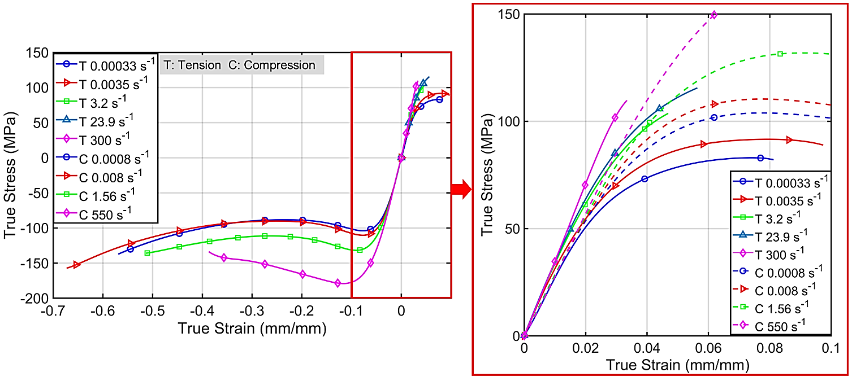
Fig. 16 Average true stress-strain plots for all the compressive and tensile tests at different strain rates and representative true stress-strain plots of all the compression and tensile tests at different strain rates (up to 10% strain)

4.5 Fracture Surface Investigation
All test specimens fractured due to tension. Tensile specimens for the lower quasi-static and high strain rate tests fractured in a typical brittle manner with the fracture surface oriented perpendicular to the loading direction. The compression specimens failed as a result of high tensile strains along the specimen radial direction caused by Poisson’s effect, resulting in fracture surfaces in planes parallel to the loading direction. The tensile specimens were chosen to investigate the fracture surfaces. Overall, all the tensile specimens fractured in a brittle manner without necking, with similar fracture pattern for all tested strain rates. This indicates that although the tensile stress-strain curves in Fig. 6 exhibit some degree of ductility, the epoxy was sufficiently brittle and the mechanisms leading to fracture do not change with strain rate. Fig.17 shows the typical fracture pattern observed, revealing that the crack propagation follows several well-known stages for thermosetting polymers: mirror-like, smooth with parabolas, hackle, and rough (Roulin-Moloney, 1989). The fracture process initiates at a local defect on the specimen surface, which may be a void or a machining mark. Thereafter, the crack propagates at a slow rate, creating a smooth and pattern-less surface, often call mirror-like stage (Fig.17a(i)). As the crack propagation speed increases with the increase of applied stress, parabolic patterns appear due to the formation of secondary crack (Fig.17a(ii)), referred to as smooth with parabolas stage. During the subsequent hackle stage, ellipse shape patterns are formed when the primary crack propagation speed increases as shown in Fig. 17a(iii). During the final stage, the abrupt fracture of the specimen creates rough surfaces and complex patterns (Fig.17a(iv)). Fig. 17b shows the fracture surface of the tensile specimen under dynamic loading. Comparing to the quasi-static strain rate tensile test, the fracture surface for the dynamic tensile test has similar patterns, but the mirror-like, smooth with parabolas and hackle stage areas are much smaller.
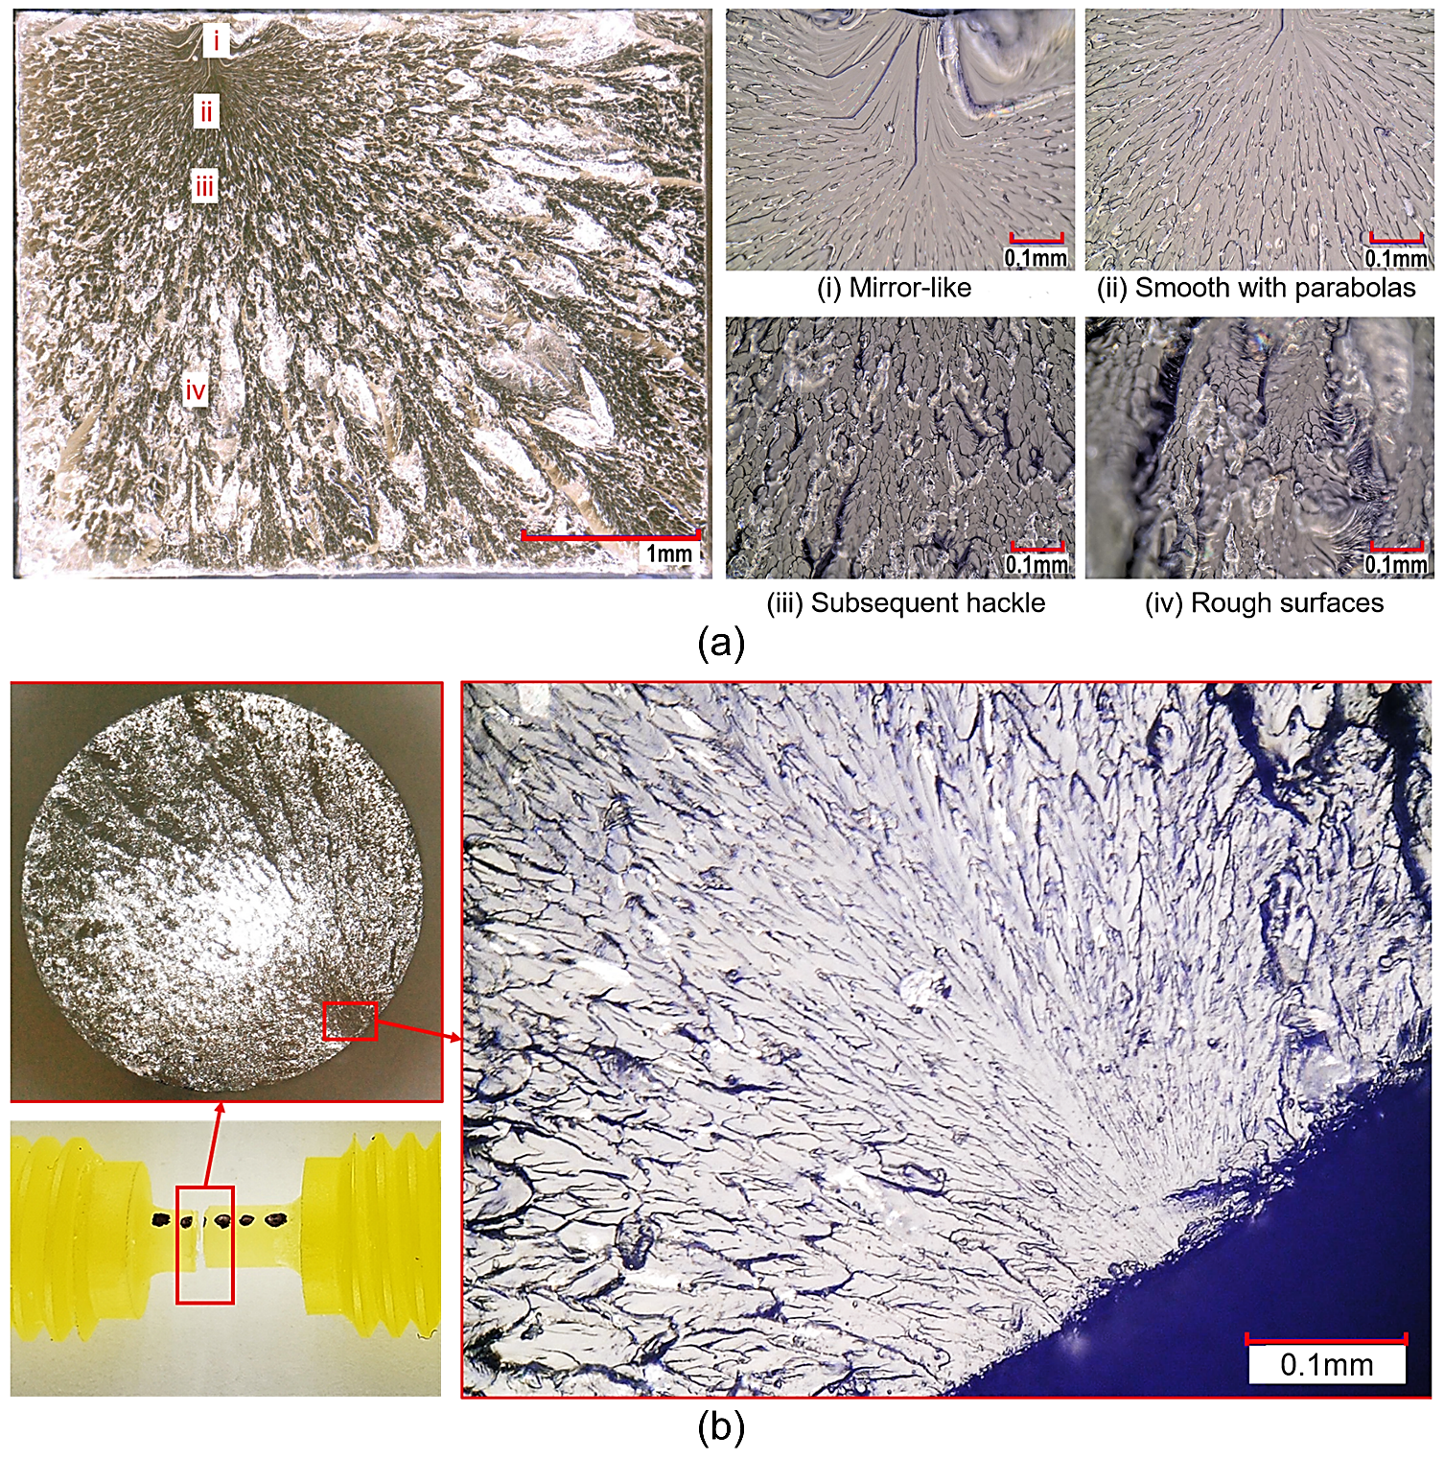
Fig.17 Fracture surface images for tensile test specimens at the strain rates of: (a) 0.00033 s⁻¹ and (b) 300 s⁻¹

5 Conclusions
This study characterized the mechanical response of a three-part snap-cure epoxy resin system designed for high volume automotive production. A series of uniaxial mechanical tests were conducted to characterize the strain rate-dependent tensile and compressive stress-strain behaviour of the epoxy material under a variety of strain rates, ranging from quasi-static to dynamic, which was the major component of this study.
The major findings for the mechanical characterization of the studied snap-cure epoxy are summarized as follows:
- The studied snap-cure epoxy exhibited a large deformation for compressive quasi-static strain rates, where the stress-strain response can be divided into different stages: elastic, plastic yield, strain softening, and strain re-hardening. These four deformation stages agree with other high cross-linked epoxies and many glassy thermoplastics at a temperature well below their$T_{g}$. The tensile and high strain rate compressive stress-strain behaviours showed different post-yield responses because of the different failure strains.
- The tensile elastic modulus increased by 34% over the range of strain rates investigated, demonstrated a strong strain rate dependence, while the compressive elastic modulus showed little difference over the tested strain rates.
- The tensile and compressive post-yield responses showed noticeable strain rate dependence, where yield strength increased by 31% and 81% over the range of strain rates investigated, respectfully.
- Pressure-dependent plastic deformation was identified by a difference in compression and tension yield strength. The compressive yield strength was 46% higher than the tensile yield strength at the similar quasi-static strain rates, attributed to the higher hydrostatic pressure in compression.
- Brittle fracture of all the tensile specimens was confirmed by the assessment of the fracture surfaces, where all the tensile specimens demonstrated similar fracture patterns at the tested strain rates.

Acknowledgements
This study was funded by the Natural Sciences and Engineering Research Council of Canada (NSERC) through Collaborative Research and Development Grant No. CRDPJ-507776-16, as well as the industrial sponsors Honda Development and Manufacturing of America LLC, Hexion Inc., Zoltek Corp. and Laval International.

References
A.Trautmann, C.R.Siviour, S.M.Walley & J.E.Field, 2005. Lubrication of polycarbonate at cryogenic temperatures in the split Hopkinson pressure bar. International Journal of Impact Engineering, 31(5), pp. 523-544.
Alger, M., 1996. Polymer Science Dictionary. London: Springer.
Argon, A. S., 1973. A theory for the low-temperature plastic deformation of glassy polymers. The Philosophical Magazine: A Journal of Theoretical Experimental and Applied Physics, 28(4), pp. 839-865.
ARGON, A. S., 2013. The Physics of Deformation and Fracture of Polymers. New York: Cambridge University Press.
B.J.Briscoe & R.W.Nosker, 1984. The influence of interfacial friction on the deformation of high density polyethylene in a split hopkinson pressure bar. Wear, 95(3), pp. 241-262.
Bacon, C., 1998. An experimental method for considering dispersion and attenuation in a viscoelastic Hopkinson bar. Experimental Mechanics, Volume 38, p. 242–249.
Bai, X. et al., 2015. High-fidelity micro-scale modeling of the thermo-visco-plastic behavior of carbon fiber polymer matrix composites. Composite Structures, Volume 134, p. 132–141.
Behzadi, S. & Jones, F. R., 2005. Yielding Behavior of Model Epoxy Matrices for Fiber Reinforced Composites: Effect of Strain Rate and Temperature. Journal of Macromolecular Science, Part B, Physics, 44(6), p. 993–1005.
Benatar, A., Rittel, D. & Yarin, A., 2003. Theoretical and experimental analysis of longitudinal wave propagation in cylindrical viscoelastic rods.. Journal of the Mechanics and Physics of Solids, Volume 51, p. 1413–1431.
Boyce, M. C., Parks, D. M. & Argon, A. S., 1988. Large inelastic deformation of glassy polymers. part I: rate dependent constitutive model.. Mechanics of Materials, 7(1), pp. 15-33.
Brown, R., 1999. Handbook of Polymer Testing: Physical Methods. New York: CRC Press.
Buckley, C. et al., 2001. Deformation of thermosetting resins at impact rates of strain. Part I: Experimental study. Journal of the Mechanics and Physics of Solids, Issue 49, p. 1517 – 1538.
Chen, W., Lu, F. & Cheng, M., 2002. Tension and compression tests of two polymers under quasistatic and dynamic loading. Polymer Testing, Issue 22, pp. 113 - 121.
Chen, W., Lu, F. & Zhou, B., 2000. A quartz-crystal-embedded split Hopkinson pressure bar for soft materials. Experimental Mechanics, Volume 40, pp. 1-6.
Chen, W., Zhang, B. & Forrestal, M. J., 1999. A split Hopkinson bar technique for low-impedance materials. Experimental Mechanics, Volume 39, pp. 81- 85.
Cherniaev, A., Zeng, Y., Cronin, D. & Montesano, J., 2019. Quasi-static and dynamic characterization of unidirectional non-crimp carbon fiber fabric composites processed by HP-RTM. Polymer Testing, pp. 365 - 375.
Chou, S., Robertson, K. & Rainey, J., 1973. The effect of strain rate and heat developed during deformation on the stress–strain curve of plastics. Experimental Mechanics, Volume 13, p. 422–432.
Ellis, B., Found, M. S. & Bell, J. R., 1996. Effects of cure treatment on glass transition temperatures for a BADGE–DDM epoxy resin. Journal of Applied Polymer Science, 59(10), pp. 1493-1505.
Elmarakbi, A., 2014. Overview of Composite Materials and their Automotive Applications. In: Advanced composite materials for automotive applications : structural integrity and crashworthiness. Chichester: John Wiley & Sons, pp. 3-28.
Fais, C., 2011. Lightweight automotive design with HP-RTM. Reinforced Plastics, pp. 29-31.
Follansbee, P., 1985. The Hopkinson Bar, Mechanical Testing. In: ASM Handbook. s.l.:American Society for Metals, p. 198–203.
Frew, D. J., Forrestal, M. J. & Chen, W., 2002. Pulse shaping techniques for testing brittle materials with a split hopkinson pressure bar. Experimental Mechanics, Volume 42, p. 93–106.
Frew, D. J., Forrestal, M. J. & Chen, W., 2005. Pulse shaping techniques for testing elastic-plastic materials with a split Hopkinson pressure bar. Experimental Mechanics, 45(2), pp. 186 - 195.
Gadhamshetty, V. et al., 2019. Advanced High-Strength Steel and Carbon Fiber Reinforced Polymer Composite Body in White for Passenger Cars: Environmental Performance and Sustainable Return on Investment under Different Propulsion Modes. ACS sustainable chemistry & engineering, 7(5), pp. 4951-4963.
Gerlach, R., Siviour, C. R., Petrinic, N. & Wiegand, J., 2008. Experimental characterisation and constitutive modelling of RTM-6 resin under impact loading. Polymer, 49(11), pp. 2728 - 2737.
Gilat, A., Goldberg, R. K. & Roberts, G. D., 2007. Strain Rate Sensitivity of Epoxy Resin in Tensile and Shear Loading. JOURNAL OF AEROSPACE ENGINEERING, 20(2), pp. 75-89.
Goldberg, R. K., Robertsa, G. D. & Gilat, A., 2003. Incorporation of mean stress effects into the micromechanical analysis of the high strain rate response of polymer matrix composites. Composites: Part B, Issue 34, p. 151–165.
Gorham, D. A., 2000. A numerical method for the correction of dispersion in pressure bar signals. Journal of Physics E: Scientific Instruments, 16(6), p. 477–479.
Gray III, G. T. (., 2000. Classic Split-Hopkinson Pressure Bar Testing. In: ASM Handbook Volume 8: Mechanical Testing and Evaluation. s.l.:ASM International, p. p462–476.
Grillet, A. C., Galy, J., Gérard, J.-F. & Pascault, J.-P., 1991. Mechanical and viscoelastic properties of epoxy networks cured with aromatic diamines. Polymer, 32(10), pp. 1885-1891.
H.Zhao, G.Gary & J.R.Klepaczko, 1997. On the use of a viscoelastic split hopkinson pressure bar. International Journal of Impact Engineering, 19(4), pp. 319-330.
Han E.H. Meijer, L. E. G., 2005. Mechanical performance of polymer systems: The relation between structure and properties. Progress in Polymer Science, Issue 30, pp. 915-938.
Hasan, 0. A. & Boyce, M. C., 1995. A Constitutive Model for the Nonlinear Viscoelastic Viscoplastic Behavior of Glassy Polymers. POLYMER ENGINEERING AND SCIENCE, 35(4), p. 331–344.
HASAN, 0. A. & BOYCE, M. C., 1995. A Constitutive Model for the Nonlinear Viscoelastic Viscoplastic Behavior of Glassy Polymers. POLYMER ENGINEERING AND SCIENCE, 35(4), p. 331–344.
Haward, R. N. & Thackray, G., 1968. The Use of a Mathematical Model to Describe Isothermal Stress-Strain Curves in Glassy Thermoplastics. Proceedings of the Royal Society of London. Series A, Mathematical and PhysicalSciences, 302(1471), pp. 453-472.
HEXION, 2015. Technical Data Sheet, Duisburg: Internal document.
J. Peirs, P. V. J. D., 2012. Novel Technique for Static and Dynamic Shear Testing. Experimental Mechanics, p. 729–741.
Jatin, Sudarkodi, V. & Basu, S., 2014. Investigations into the origins of plastic flow and strain hardening in amorphous glassy polymers. International Journal of Plasticity, Issue 56, pp. 139 - 155.
Jordan, J. L., Foley, J. R. & Siviour, C. R., 2008. Mechanical properties of Epon 826/DEA epoxy. Mechanics of Time-Dependent Materials, Issue 12, pp. 249-272.
Kirkaldy, D., 1863. Results of an experimental inquiry into the comparative tensile strength and other properties of various kinds of wrought iron and steel. Journal of the Franklin Institute, 75(6), pp. 397-404.
Klompen, E. T. J., Engels, T. A. P., Govaert, L. E. & Meijer, H. E. H., 2005. Modeling of the Postyield Response of Glassy Polymers: Influence of Thermomechanical History. Macromolecules, 38(16), pp. 6997-7008.
Kolsky, H., 1949. An investigation of the mechanical properties of materials at very high rates of loading. Proceedings of, Issue 62, p. 676–700.
Kuhn, H. & Medlin, D., 2000. ASM Handbook, Volume 8 : Mechanical Testing and Evaluation. s.l.:ASM International.
Lee, S. M., 1989. Reference Book for Composites Technology, Volume I. Lancaster: CRC Press.
Littell, J. D. et al., 2008. Measurement of Epoxy Resin Tension, Compression, and Shear Stress–Strain Curves over a Wide Range of Strain Rates Using Small Test Specimens. Journal of Aerospace Engineering, 21(3), pp. 162 -173.
Liu, Q. & Subhash, G., 2006. Characterization of viscoelastic properties of polymer bar using iterative deconvolution in the time domain. Mechanics of Materials, Volume 38, pp. 1105-1117.
Luis F. Trimino, D. S. C., 2016. Evaluation of Numerical Methods to Model Structural Adhesive Response and Failure in Tension and Shear Loading. Journal of Dynamic Behavior of Materials, pp. 122-137.
M.Arruda, E. & C.Boyce, M., 1993. Evolution of plastic anisotropy in amorphous polymers during finite straining. International Journal of Plasticity, 9(6), pp. 697-720.
Malnati, P. & Sloan, J., 2018. CompositesWorld. [Online]
Available at: https://www.compositesworld.com/articles/fast-and-faster-rapid-cure-epoxies-drive-down-cycle-times
[Accessed 11 05 2022].
Mattucci, S., Moulton, J., Chandrashekar, N. & Cronin, D., 2012. Strain rate dependent properties of younger human cervical spine ligaments.. J Mech Behav Biomed Mater., Volume 10, pp. 216-26.
Melick, H., L.E.Govaert & H.E.H.Meijer, 2003. On the origin of strain hardening in glassy polymers. Polymer, 44(8), pp. 2493-2502.
Morelle, X., 2015. Mechanical characterization and physics-based modeling of highly-crosslinked epoxy resin (Ph.D. dissertation), Louvain-la-Neuve: Université catholique de Louvain.
Morelle, X. P. et al., 2017. Mechanical characterization and modeling of the deformation and failure of the highly crosslinked RTM6 epoxy resin. Mechanics of Time-Dependent Materials, 3(21), pp. 419-454.
Ouellet, S., Cronin, D. & Worswick, M., 2006. Compressive response of polymeric foams under quasi-static, medium and high strain rate conditions. Polymer Testing, 25(6), pp. 731-743.
Pae, K. D. & Bhateja, S. K., 1975. The effects of hydrostatic pressure on the mechanical behavior of polymers.. Journal of Macromolecular Science, 13(1), p. 1–75.
PARRY, E. J. & TABOR, D., 1974. Pressure dependence of the shear modulus of various polymers. Journal of Materials Science, Volume 9, pp. 289 - 292.
Perry, J. I. & Walley, S. M., 2022. Measuring the Efect of Strain Rate on Deformation and Damage in Fibre-Reinforced Composites: A Review. Journal of Dynamic Behavior of Materials, Volume 8, p. 178–213.
Poulain, X. & A.A. Benzerga, R. G., 2014. Finite-strain elasto-viscoplastic behavior of an epoxy resin: Experiments and modeling in the glassy regime. International Journal of Plasticity, Issue 62, pp. 138 -161.
Roulin-Moloney, A. C., 1989. Fractography and failure mechanics of polymers and composites. London: Elsevier Applied Science.
Salisbury, C., 2001. "Spectral analysis of wave propagation through a polymeric Hopkinson Bar" M.S. thesis. Waterloo, Ontario, Canada: Department of Mechanical and Mechatronics Engineering, University of Waterloo.
Salisbury, C. & Cronin, D., 2015. Deformation Mechanics of a Non-linear Hyper-viscoelastic Porous Material, Part I: Testing and Constitutive Modeling of Non-porous Polychloroprene. Journal of Dynamic Behavior of Materials, Volume 1, p. 237–248.
Salisbury, C. P. & Cronin, D. S., 2009. Mechanical Properties of Ballistic Gelatin at High Deformation Rates. Experimental Mechanics, Volume 49, p. 829–840.
Semeliss, M., Wong, g. & Turtle, M., 1990. The Yield and Post-Yield Behavior High-Density Polyethylene, s.l.: NASA-Langley Research Center Grant No. NAG-I-974.
Senden, D. J. A., Dommelen, J. A. W. v. & Govaert, L. E., 2010. Strain hardening and its relation to bauschinger effects in. Journal of Polymer Science Part B: Polymer Physics, 48(13), p. 1483–1494.
Sindt, O., Perez, J. & Gerard, J. F., 1996. Molecular architecture-mechanical behaviour relationships in epoxy networks. Polyme, 37(14), pp. 2989-2997,.
Siviour, C. R. & Jordan, J. L., 2016. High Strain Rate Mechanics of Polymers: A Review. Journal of Dynamic Behavior of Materials, Volume 2, pp. 15-32.
Sligtenhorst, C. V., S.Cronin, D. & Brodland, G., 2006. High strain rate compressive properties of bovine muscle tissue determined using a split Hopkinson bar apparatus. Journal of Biomechanics, 39(10), pp. 1852-1858.
Song, B. et al., 2008. A Long Split Hopkinson Pressure Bar (LSHPB) for Intermediate-rate Characterization of Soft Materials. Experimental Mechanics, 48(6), p. 809–815.
Struik, L., 1991. Some problems in the non-linear viscoelasticity of amorphous glassy polymers. Journal of Non-Crystalline Solids, Volume 131-133, pp. 395-407.
Tamrakar, S. et al., 2018. Experimental Investigation of Strain Rate and Temperature Dependent Response of an Epoxy Resin Undergoing Large Deformation. Journal of Dynamic Behavior of Materials, Issue 4, pp. 114-128.
Urbaczewski‐Espuche, E. et al., 1991. Influence of chain flexibility and crosslink density on mechanical properties of epoxy/amine networks. Polymer Engineering and Science, 31(22), pp. 1572-1580.
Walley, S., Field, J., Pope, P. & Safford, N., 1989. A study of the rapid deformation behaviour of a range of polymers. Philosophical Transactions of the Royal Society of London, Volume 328, p. 1–33.
Wasley, R. J., Hoge, K. G. & Cast, J. C., 1969. Combined Strain Gauge—Quartz Crystal Instrumented Hopkinson Split Bar. Review of Scientific Instruments, 40(7), pp. 889-894.
Werner, B. & Daniel, I., 2014. Characterization and modeling of polymeric matrix under multi-axial static and dynamic loading. Composites Science and Technology, Issue 102, pp. 113-119.

