The consequences of high-flexion postures on arterial wave reflections
Aida Zaheer¹, Kimberly H. Peckett¹, Tania J. Pereira¹, Stacey M. Acker¹, and Jason S. Au¹
¹Department of Kinesiology and Health Sciences, University of Waterloo, Waterloo, Canada

RUNNING HEAD: Arterial wave reflection in high-flexion postures

Corresponding Author:
Jason S. Au, PhD, CSEP-CEP
University of Waterloo
Department of Kinesiology and Health Sciences
BMH 1104, 200 University Avenue West
Waterloo, ON, Canada, N2L 3G1
Telephone: 519-888-4567 x40522
Email: jason.au@uwaterloo.ca

Submitted to: Journal of Human Hypertension
Article type: Article

ABSTRACT
Although central wave reflections are critical for aortic pressure regulation, the control mechanisms involved in humans are understudied. This study investigated the impact of upper- and lower-limb high-flexion postures on central arterial wave reflections. Twenty-two healthy adults (11 females, aged 25 ± 3 years) underwent three randomized and counter-balanced positions to evaluate the effect on central wave reflection: supine legs and arms anatomical position; supine two legs bent and arms straight; and supine two arms bent and legs straight. Characteristic impedance, forward and backward pressure waves, and pulse characteristics were measured via the central pressure-flow relationship in the frequency domain at the end of each posture hold. Central diastolic blood pressure increased during arm flexion only (67 ± 9 mmHg vs. 62 ± 9 mmHg; p<0.01). Central systolic blood pressure, augmentation index, forward wave amplitude, reflected wave amplitude, central wave reflection magnitude, and characteristic impedance were unaffected by varying limb flexion positions (all p>0.05). Acutely bending the arms and legs did not influence central wave reflections, likely related to a minimal effect of conduit artery bending, versus microvascular involvement, as suggested in previous studies. These findings underscore the importance of identifying the specific vascular regions responsible for wave reflection generation and support the need to refine central pressure augmentation models to accurately localize the dominant sources of wave reflection in humans.
KEYWORDS: blood pressure, limb bending, augmentation pressure, body position
Summary Table:
What is known about topic:
- Central wave reflections are the sum of peripheral reflections from transitions in vascular impedance from discontinuities in the arterial circulation.
- Microvascular vasoconstriction and vasodilation can impact central wave reflection, but the contributions of large conduit artery discontinuities is unknown.

What this study adds:
- Large conduit artery discontinuities induced by limb high flexion positions do not impact central wave reflections.

INTRODUCTION
Pulsatile arterial hemodynamics, including arterial wave reflections, are important vascular properties that regulate blood pressure and left ventricular afterload (1). When the left ventricle ejects blood, forward-travelling pressure waves reach effective reflection sites from geometric discontinuities in the vascular tree and are reflected back towards the heart, generating backwards wave reflections (2). These forward and backward pressure waves merge throughout the arterial tree to form the characteristic arterial pressure wave. Stronger wave reflections have been reported to be elevated in select cardiovascular conditions independent of pulse wave velocity (3), and are related to microvascular damage, increased arterial stiffness, as well as other cardiometabolic risk factors worsening cardiovascular prognosis (4-6). Additionally, central arterial wave reflection can independently predict incident cardiovascular disease and heart failure (7).
While there is epidemiological relevance for the role of arterial wave reflections on cardiovascular health, the regulatory underpinnings of wave reflections in humans remain unclear. Previous work has established that the body size and shape across species are important determinants of arterial pressure wave contours due to variations in the spatial distribution of muscle mass across different body shapes. For instance, in the kangaroo with highly developed muscular groups in the lower body and a small upper body, the reflections from their upper body arteries appear too weak to modify the effects of strong wave reflections arising from the lower body (8), whereas in humans, there are evident modifications of wave reflections from both the upper and lower body (8). Previous work has also shown that in humans, lower body dynamic exercise decreases pulse wave reflection magnitude (9), presumably due to expected microvascular vasodilation in the exercising muscle, which reduces resistance and reflection magnitude independent of changes in forward pressure (9). In line with these findings, we have previously demonstrated that peripheral heating can reduce wave reflection, presumably due to local vasodilation of the skeletal muscle microvasculature (10). It is unknown, however, whether manipulations of the larger conduit arteries would similarly impact peripheral resistance and wave reflection. It is conceivable that arterial ‘kinks’ due to vessel curvatures may create discontinuities in the arterial tree, particularly at high-flexion joint locations, transiently increasing the magnitude of the reflected wave. Indeed, previous literature has observed that exposure to prolonged high-flexion leg positions increases vascular dysfunction (11) and wave reflection pressure (12, 13). These high-flexion positions have been thought to contribute to higher incident and reflected wave pressures during prolonged sedentary behaviour (14), though this has not been explicitly tested.
The study aims to elucidate how certain limb positions, characterized as high-flexion positions introducing bending in conduit arteries, impact the amplitude and timing of central arterial wave reflections. We hypothesize that a double-leg high flexion position will augment arterial wave reflection compared to unbent and double-arm flexion due to the increased size of the peripheral skeletal muscle bed.

MATERIALS AND METHODS
Participants: Twenty-two young (aged 18-35 years), healthy adults without pre-existing cardiovascular conditions were recruited. Exclusion criteria included current cigarette smoking, a history of chronic disease or illness, current medication use that could impact cardiovascular responses, and any hormonal disorders or instabilities (i.e., amenorrhea, menopause, or pregnancy). Considering the postures held in the current study, participants were excluded if they were unable to comfortably hold the position or had any limb injury or amputation within the last 6 months. The sample size was estimated using a Monte Carlo simulation-based approach using the Superpower tool (15). The simulation was designed as a one-way repeated measures ANOVA to detect a 0.05 AU difference in wave reflection coefficient with a pooled common standard deviation of 0.05 AU (partial η² = 0.3423), based on previous expected magnitudes of responses from our lab (10, 16). With 22 participants, the analysis was adequately powered (>80%) to detect a main effect of limb bending with a two-tailed α = 0.05.
Study design: All participants arrived for their study visit having refrained from caffeine for 6 hours, alcohol and vigorous physical activity for 12 hours, and fasted for 4 hours prior to the start time. Following 15 minutes of supine rest to allow for instrumentation, participants held the following positions for 5 minutes in a randomized and counter-balanced unblinded order: supine legs and arms in the anatomical position (baseline); supine two arms bent and legs straight (AB); and, supine two legs bent and arms straight (LB) (Figure 1). Outcome measures were taken at the end of each posture hold while the posture was maintained.
Limb Bending: For the double leg-bending condition, participants laid supine with both legs in a tucked position (knees to chest, ankles to thighs) and with arms outstretched. Both feet were placed flat on a block, and the angles of the hip and knee flexion on both sides were measured using a goniometer. Participants were asked to bend their legs to their maximum range of motion while maintaining comfort and only engage postural muscles for support. A similar procedure was followed for double arm-bending, where the arms were tucked (elbows to sides and hands to clavicles), and elbow and shoulder flexion angles were measured. Participants were instructed to bend their arms to their maximal comfortable range and only engage postural muscles for support.
Central wave reflection: Central pressure and flow data were coordinated using the NIHem USB-II workstation (Cardiovascular Engineering Inc.; Norwood, MA, USA), which uses a combined ausculatory/oscillometric method for blood pressure measurement, a fingertip applanation tonometer for pressure waveform assessment, and integrates with external ultrasounds for Doppler signal import. Brachial artery blood pressure was acquired supine in the right arm in triplicate for the SLA, LB, and AB conditions, ensuring measurement variability did not exceed 5 mmHg. Right common carotid pressure wave was measured for 10 seconds using arterial applanation tonometry as an approximation of aortic pressure. Waveforms were maximized for amplitude and scored for feature quality. Echocardiography (M5 phased array probe, Vivid S70N; GE HealthCare, Milwaukee, WI, USA) was used to determine aortic root diameter in the parasternal long axis and left ventricular outflow tract blood velocity in the apical four-chamber view. Aortic root diameter was assumed not to change throughout the duration of the protocol. Pulse wave and blood flow signals were ECG-gated and aligned to the R-wave for further analysis. Characteristic impedance (Z_{C}) was calculated as the average of the 4th to 10th harmonics of the pressure-flow relationship in the frequency domain. Forward and backward pressure (P_{f} and P_{b}, respectively) were derived from Z_{C}, and a ratio of P_{f} to P_{b} was used to determine central relative wave reflection magnitude (RM). Reflected wave transit time (RWTT) was calculated as the time delay between P_{f} and P_{b} when the pressure wave crosses zero. All central wave reflection parameters were calculated by the NIHem USB-II workstation. Augmentation index was estimated via a ratio of augmented pressure to central pulse pressure and normalized to 75 bpm (AIx@75bpm).
Statistical analyses: All statistical comparisons were performed with RStudio (v4.3.0). Data were screened for normality using visual inspection of Q-Q plots and sphericity using Mauchly’s test. A one-way repeated measures ANOVA was used to assess differences in blood pressure or central wave reflection (i.e., P_{f}, P_{b}, RM) in the various flexion postures (i.e., SLA, AB, or LB), using post hoc Bonferroni-adjusted paired Student’s t-tests to evaluate significant effects. The type I error rate was set a priori at α=0.05.

RESULTS
Central hemodynamics: Participant characteristics split by sex are reported in Table 1, including the flexion joint angles during the posture manipulations. All participants had normal resting cardiovascular function and completed the protocol. Central diastolic blood pressure increased from baseline to AB positioning only, from 62 ± 9 mmHg to 67 ± 9 mmHg (p < 0.01, η² = 0.06), while central systolic blood pressure was unaffected (p = 0.24, η² = 0.01). The arms and legs were elevated from the heart in the AB and LB positions, respectively, which may have influenced the measured diastolic blood pressure. Brachial diastolic blood pressure was similarly elevated in AB compared to baseline (p<0.01). Heart rate did not differ between positions (p = 0.90).
Central wave reflection: Neither arm nor leg flexion positions changed Pf (Figure 2A), Pb (Figure 2B), or RM (Figure 2C), compared to baseline (all p > 0.31). RWTT did not change between flexion positions (p = 0.19, η² = 0.03; Table 2). Similarly, Z_{C} was not different from baseline during arm or leg flexion (p = 0.82, η² = 0.003). There was no influence of either limb flexion positions on AIx@75bpm (p = 0.56; Table 2).

DISCUSSION
In this study, we sought to investigate whether large conduit artery bending, introduced by high flexion positions in the arms and legs, would have a measurable impact on central wave reflection. The main findings of the current study are that neither arm nor leg bending influenced central wave reflections. Contrary to our hypothesis, lower limb flexion did not affect wave reflections compared to supine rest or upper limb flexion despite engaging a larger muscle mass and having a higher number of artery-arteriole transition zones. Our findings suggest that changes in peripheral resistance due to manipulations of a microvascular network, rather than large artery bending, likely play a larger role in dictating central wave reflections.
It has been established that peripheral resistance plays a large role in the timing and magnitude of wave reflections (17). Based on this knowledge, we hypothesized that the bending of large conduit arteries may contribute to augmented wave reflections by introducing a sizable reflection point in the large vessel, as opposed to the microvascular arteriolar network as per the majority of previous work (9, 10). Such large artery geometry has previously been shown to influence central wave reflection in patients with ‘Gothic arch’ type aortic coarctation repair, characterized by an angulated aortic arch, versus a more rounded post-repair phenotype (18). Our findings did not support our initial hypothesis, as bending of large peripheral conduit arteries did not influence central wave reflections. Even with acute elbow and knee flexion angles of 39deg and 59deg, respectively, which approximate a ‘Gothic aortic arch’ angle, it is likely that such peripheral resistance changes to conduit arteries are not as effective in modulating the central waveform compared to either aortic arch deformations, or significant microvascular involvement. Previous other experimental studies offer support for the control of wave reflection intensity through hemodynamic manipulation of peripheral resistance. Davis et al. 2011 (19) found that active standing increases peripheral resistance and decreases wave reflections due to altered pressure distribution along leg arteries and the aorta, thereby affecting local arterial diameters and compliance. Athaide et al. 2023 (9) found that peripheral limb heating reduced wave reflections regardless of which limbs (upper or lower) were heated, presumably due to a localized microvascular vasodilatory response. Similarly, Stock et al. 2021 (10) found that the vasoactive response induced by exercise decreased reflection magnitude during lower-body exercise. Finally, Heffernan, Lefferts et al. 2013 (14) found that introducing external compression of the calf increases wave reflection in a dose-dependent manner, related to increasing retrograde shear. In contrast to the above studies, we induced an isolated manipulation of peripheral vessels whereby the microvasculature was left relatively unaffected by the limb bending condition. Given that the microvascular network is a primary controller of peripheral resistance, we suggest that bending of large conduit arteries does not induce a comparable magnitude of resistance to induce similar changes in wave reflection.
While this study provides valuable insight into how limb positioning influences wave reflection characteristics, limitations to the protocol should be noted. During the trials, the participants’ arms and legs were elevated in the AB and LB positions, respectively, despite the participants lying in a supine position. As a result, there may have been changes to the hydrostatic component of transmural pressure, thereby affecting wave reflections (20); however, this would likely have increased wave reflection rather than concealed an effect. Given the study findings, it is unlikely that we created severe enough restriction to induce limb ischemia during maximal limb flexion, although it would have been beneficial to include measures of downstream perfusion (e.g., oxygenation, distal blood velocity) to report the severity of arterial bending. Notably, the limb flexion positions were held at maximally tolerated passive flexion, without active muscle involvement. This study also focused on central hemodynamics but did not quantify blood flow or vessel diameters in the flexed limbs. Blood pooling significantly increases during prolonged sitting (12, 13, 21-23), and accounting for changes in limb blood volume or quantifying limb blood velocity may have provided greater insight into haemodynamic mechanisms by which limb flexion influences pulse wave velocities and pulse pressures. We also did not power the study to identify sex-based differences despite recruiting equal numbers of males and females. Females tend to have a shorter arterial tree, which may alter wave reflections due to proximity between the heart and wave reflection site. Another limitation to consider is that the acute (5 minute) flexion period may not have been sufficient to evoke a cardiovascular response, particularly as blood pressure stabilizes in only 50% of individuals after 5 minutes of rest, increasing to 90% after 25 minutes (24). The short acclimatization windows may have lent some of the variation within the current dataset, which could be masking subtle differences between positions. However, we used an initial resting period and a randomized cross-over design to limit the carry-over effects of prolonged supine rest on the order of interventions. Given the potential compounding effect of prolonged sedentary behaviour and bent limb postures, future research should consider the effects of longer bouts of limb flexion on cardiovascular hemodynamics and wave reflection properties.
In conclusion, limb bending of the arms or legs did not alter the magnitude or timing of reflected waves, suggesting that geometric changes to large conduit arteries have minimal influence on central wave reflections. These findings underscore the importance of identifying the specific vascular regions responsible for wave reflection generation and support the need to refine central pressure augmentation models to accurately localize the dominant sources of wave reflection in humans.

DATA AVAILABILITY
Data are available upon reasonable request to the authors.
REFERENCES
1. Nichols WW, Denardo SJ, Wilkinson IB, McEniery CM, Cockcroft J, O'Rourke MF. Effects of arterial stiffness, pulse wave velocity, and wave reflections on the central aortic pressure waveform. J Clin Hypertens (Greenwich). 2008;10(4):295-303.
2. O'Rourke MF, Yaginuma T. Wave reflections and the arterial pulse. Arch Intern Med. 1984;144(2):366-71.
3. Steinberg RS, Udeshi E, Dickert N, Quyyumi A, Chirinos JA, Morris AA. Novel Measures of Arterial Hemodynamics and Wave Reflections Associated With Clinical Outcomes in Patients With Heart Failure. J Am Heart Assoc. 2023;12(6):e027666.
4. Haidar MA, van Buchem MA, Sigurdsson S, Gotal JD, Gudnason V, Launer LJ, et al. Wave Reflection at the Origin of a First-Generation Branch Artery and Target Organ Protection: The AGES-Reykjavik Study. Hypertension. 2021;77(4):1169-77.
5. Mitchell GF, Parise H, Benjamin EJ, Larson MG, Keyes MJ, Vita JA, et al. Changes in arterial stiffness and wave reflection with advancing age in healthy men and women: the Framingham Heart Study. Hypertension. 2004;43(6):1239-45.
6. Mitchell GF. Arterial Stiffness and Wave Reflection: Biomarkers of Cardiovascular Risk. Artery Res. 2009;3(2):56-64.
7. Chirinos JA, Kips JG, Jacobs DR, Jr., Brumback L, Duprez DA, Kronmal R, et al. Arterial wave reflections and incident cardiovascular events and heart failure: MESA (Multiethnic Study of Atherosclerosis). J Am Coll Cardiol. 2012;60(21):2170-7.
8. Avolio AP, Nichols WW, O'Rourke MF. Exaggerated wave reflection in the kangaroo simulates arterial counterpulsation. Am J Physiol. 1984;246(2 Pt 2):R267-70.
9. Stock JM, Chirinos JA, Edwards DG. Lower-body dynamic exercise reduces wave reflection in healthy young adults. Exp Physiol. 2021;106(8):1720-30.
10. Athaide CE, Cohen JN, Stevens KA, Robertson AD, Au JS. Heating-induced peripheral limb microvascular vasodilation reduces arterial wave reflection. Journal of Applied Physiology. 2023;134(5):1232-9.
11. Shivgulam ME, O'Brien MW, Wu Y, Liu H, Petterson JL, Schwartz BD, et al. Sitting knee-flexion angle does not influence endothelial-dependent vasodilation in laboratory or free-living conditions. Vasc Med. 2024:1358863X241238702.
12. Credeur DP, Miller SM, Jones R, Stoner L, Dolbow DR, Fryer SM, et al. Impact of Prolonged Sitting on Peripheral and Central Vascular Health. Am J Cardiol. 2019;123(2):260-6.
13. Evans WS, Stoner L, Willey Q, Kelsch E, Credeur DP, Hanson ED. Local exercise does not prevent the aortic stiffening response to acute prolonged sitting: a randomized crossover trial. J Appl Physiol (1985). 2019;127(3):781-7.
14. Heffernan KS, Tarzia BJ, Kasprowicz AG, Lefferts WK, Hatanaka M, Jae SY. Self-reported sitting time is associated with higher pressure from wave reflections independent of physical activity levels in healthy young adults. Am J Hypertens. 2013;26(8):1017-23.
15. Lakens D, Caldwell AR. Simulation-Based Power Analysis for Factorial Analysis of Variance Designs. Advances in Methods and Practices in Psychological Science. 2021;4(1):2515245920951503.
16. Athaide CE, Robertson AD, Devries MC, Au JS. Seated Elliptical Exercise, But Not Periodic Standing, Alleviates Sitting-Induced Changes to Arterial Wave Reflections. Med Sci Sports Exerc. 2024;56(5):953-62.
17. Xiao H, Butlin M, Tan I, Avolio A. Effects of cardiac timing and peripheral resistance on measurement of pulse wave velocity for assessment of arterial stiffness. Sci Rep. 2017;7(1):5990.
18. Ou P, Celermajer DS, Raisky O, Jolivet O, Buyens F, Herment A, et al. Angular (Gothic) aortic arch leads to enhanced systolic wave reflection, central aortic stiffness, and increased left ventricular mass late after aortic coarctation repair: evaluation with magnetic resonance flow mapping. J Thorac Cardiovasc Surg. 2008;135(1):62-8.
19. Davis SC, Westerhof BE, van den Bogaard B, Bogert LW, Truijen J, Kim YS, et al. Active standing reduces wave reflection in the presence of increased peripheral resistance in young and old healthy individuals. J Hypertens. 2011;29(4):682-9.
20. Pucci G, Battista F, Anastasio F, Sanesi L, Gavish B, Butlin M, et al. Effects of gravity-induced upper-limb blood pressure changes on wave transmission and arterial radial waveform. J Hypertens. 2016;34(6):1091-8.
21. Shvartz E, Gaume JG, White RT, Reibold RC. Hemodynamic responses during prolonged sitting. J Appl Physiol Respir Environ Exerc Physiol. 1983;54(6):1673-80.
22. Shvartz E, Reibold RC, White RT, Gaume JG. Hemodynamic responses in orthostasis following 5 hours of sitting. Aviat Space Environ Med. 1982;53(3):226-31.
23. Moinuddin A, Stone K, Turner L, Paterson C, Hall N, Daykin A, et al. The impact of uninterrupted sitting on central and peripheral cardiovascular function in pre-menopausal and post-menopausal women. Eur J Appl Physiol. 2024;124(10):3021-9.
24. Mahe G, Comets E, Nouni A, Paillard F, Dourmap C, Le Faucheur A, et al. A minimal resting time of 25 min is needed before measuring stabilized blood pressure in subjects addressed for vascular investigations. Sci Rep. 2017;7(1):12893.

AUTHOR CONTRIBUTION
AZ, KP, SA and JA were involved in the conceptualization and initial drafting of the project. AZ, KP and TP were involved in the data curation, formal analysis, and investigation of the manuscript. J.A. was involved in the funding acquisition, resources, software, and supervision of the manuscript. All authors were involved in the methodology, project administration, visualization, and writing of the manuscript.

FUNDING
This work was funded by the Natural Sciences and Engineering Research Council of Canada (RGPIN-2021-02563).

ETHICAL APPROVAL
Ethics approval: This study received ethics clearance from the University of Waterloo Research Ethics Committee (ORE #45481) and adhered to the recommendations outlined in the Declaration of Helsinki for human participants, except for registration in a database. All participants provided written informed consent prior to engaging in any study protocols. Consent was obtained to publish participant photos in Figure 1.

COMPETING INTERESTS
The authors declare there are no competing interests.
FIGURE LEGENDS
FIGURE 1: Supine body positions including A) supine legs and arms in the anatomical position (baseline); B) supine two arms bent and legs straight; and C) supine two legs bent and arms straight.
FIGURE 2: Forward pressure (P_{f}, A), backwards pressure (P_{b}, B), and reflection magnitude (RM, C) at supine baseline, arms bent (AB) or legs bent (LB) positions. The upper and lower box borders represent the 25th and 75th percentiles. The solid centerline represents the median response. Individual data points are represented by individual lines.

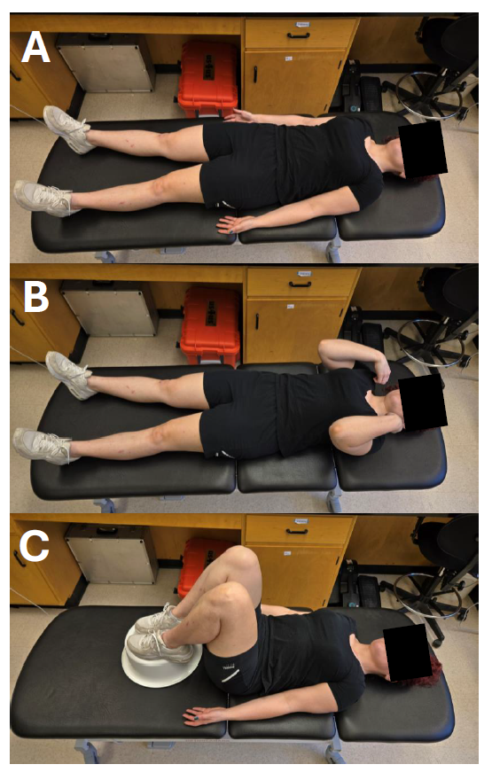
FIGURE 1
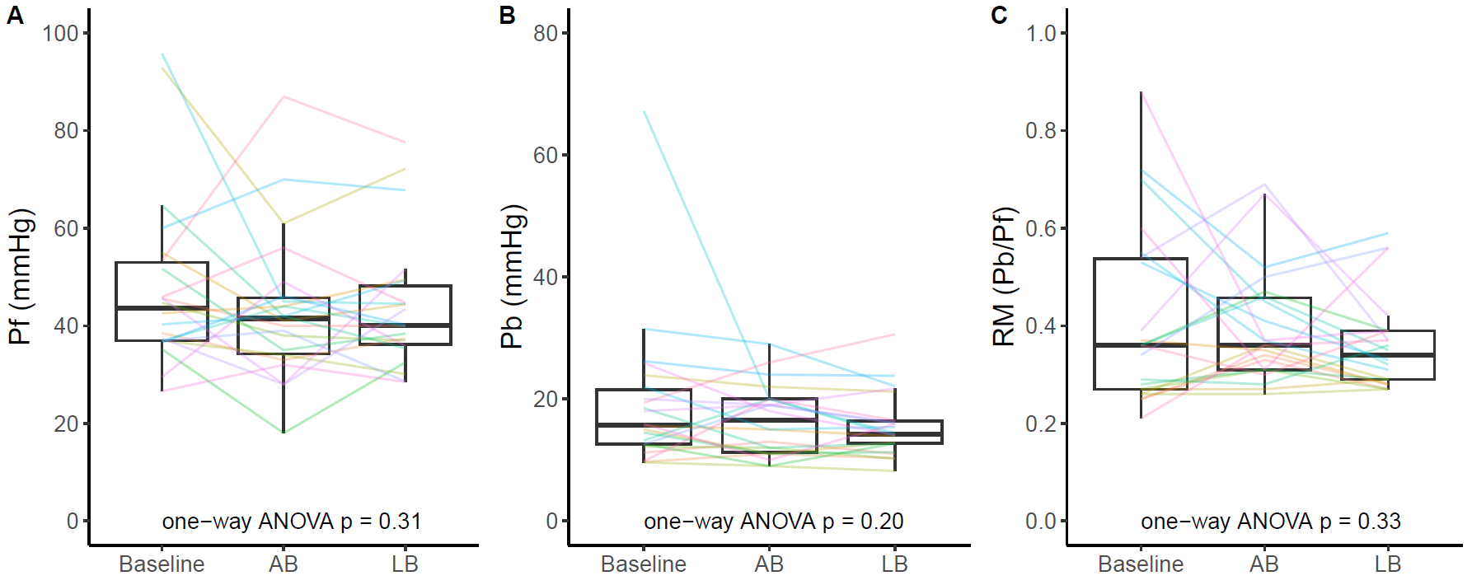
FIGURE 2
Table 1: Participant characteristics split by sex.
Variable | Female | Male
n | 11 | 11
Age (yr) | 25 ± 3 | 26 ± 3
Body mass (kg) | 62 ± 9 | 81 ± 8
Height (cm) | 165 ± 5 | 179 ± 5
Hip joint angles in flexion (°) | 88 ± 2 | 86 ± 2
Knee joint angle in flexion (°) | 124 ± 7 | 119 ± 4
Shoulder joint angle in flexion (°) | 91 ± 8 | 92 ± 7
Elbow joint angle in flexion (°) | 143 ± 8 | 139 ± 4
Values are means ± SD. Joint angles averaged between left and right sides.

Table 2: Hemodynamics during different conditions.
 | Baseline | Legs bent | Arms bent | Main effect p-value
Central systolic blood pressure (mmHg) | 111 ± 11 | 111 ± 13 | 115 ± 17 | 0.24
Central diastolic blood pressure (mmHg) | 62 ± 9 | 63 ± 9 | 67 ± 9* | <0.01
Heart rate (bpm) | 57 ± 8 | 57 ± 7 | 56 ± 7 | 0.90
Augmentation index @ 75bpm (%) | -16.3 ± 11 | -14.8 ± 7 | -15.2 ± 9 | 0.56
Reflected wave transit time (ms) | 175 ± 28 | 165 ± 27 | 165 ± 24 | 0.19
Characteristic impedance (dyne·sec·cm⁻⁵) | 259 ± 134 | 229 ± 116 | 260 ± 196 | 0.82
Values are means ± SD. *p<0.05 different from baseline.

