Interactions between Pyrene- and Naphthalene-labeled Starch Nanoparticles and Two Surfactants Probed by Pyrene Excimer Fluorescence and Fluorescence Resonance Energy Transfer

Qian Zhang,† Damin Kim,† Lu Li, Sanjay Patel, Jean Duhamel*

Institute for Polymer Research, Waterloo Institute for Nanotechnology, Department of Chemistry, University of Waterloo, Waterloo, ON N2L 3G1, Canada

* To Whom Correspondence should be addressed. (E-mail: jduhamel@uwaterloo.ca)
† Both authors contributed equally to this study.
ABSTRACT
The interactions between the surfactants sodium dodecyl sulfate (SDS) and sodium dioctylsulfosuccinate (AOT) and starch nanoparticles hydrophobically modified with the hydrophobic dye pyrene (Py-SNPs) were investigated in water by steady-state and time-resolved fluorescence. The Py-SNPs formed interparticulate aggregates in water which were disrupted by adding SDS to the Py-SNP aqueous dispersions. SDS was found to interact with Py-SNPs at SDS concentrations that were close to two orders of magnitude lower than its CMC. These interactions led to the breakup of the Py-SNP aggregates which was confirmed by conducting fluorescence resonance energy transfer (FRET) experiments between naphthalene-labeled SNPs (Np-SNPs) and Py-SNPs. By the time the SDS concentration reached the CMC of SDS, the Py-SNPs were separated from each other and excimer was generated from isolated Py-SNPs in the aqueous dispersions. While SDS interacted with the Py-SNPs at SDS concentrations lower than CMC, SDS did not seem to target the hydrophobic pyrene aggregates. Only above the CMC did SDS appear to interact with the pyrene aggregates as evidenced from diffusive pyrene excimer formation between excited and ground-state pyrenes. Most surprisingly, no interaction was observed between sodium dioctyl sulfosuccinate (AOT) and Py-SNP at AOT concentrations where SDS interacted with the Py-SNPs. This observation led to the conclusion that SDS below its CMC interacted not with hydrophobic pyrene aggregates, but rather through the formation of inclusion complexes which led to the electrostatic stabilization of individual Py-SNPs and enabled the breakup of Py-SNP aggregates. The formation of inclusion complexes with linear surfactants like SDS might thus provide a new means of stabilizing HMSNPs in water which bears the promise of finding future applications.
INTRODUCTION
As the second most abundant polysaccharide produced on earth after cellulose,, starch is attracting strong interest as a cost effective, water-soluble, nontoxic, biodegradable, and renewable material that could be used to prepare colloidal stabilizers, polymeric surfactants, and associative thickeners to be employed in food, pharmaceutical, or cosmetic applications.⁻ This goal would be achieved by hydrophobically modifying water-soluble starch with a variety of chemicals. To this end, the preparation of hydrophobically modified starch (HMS) with octenyl succinic anhydride,⁵⁻ cholesterol, acetyl, propionyl, hexanoyl,¹² oleyl, stearyl,¹³ epoxyalkanes, and propyl substituents has been reported and the ability of these HMSs to interact with hydrophobic drugs^{8,9,11,13,15} or stabilize oil droplets in emulsions⁴,, has been described. As for any hydrophobically modified water-soluble polymer, the properties of HMS can also be adjusted by the addition of surfactants and a number of studies have investigated the effect that surfactant/HMS interactions have on the stability of emulsions where HMS acts as colloidal stabilizer.^{16,-}
In view of the strong current interest in HMS, it is somewhat surprising that no study has ever probed the interactions between the hydrophobes of HMS and surfactants at the molecular level. We address this dearth of information by using the hydrophobic fluorescent derivatives 1-pyrenebutyric acid and 1-naphthaleneacetic acid to fluorescently label starch nanoparticles (SNPs) generated from amylopectin to yield, respectively, Py-SNPs and Np-SNPs as examples of HMS. The ability of naphthalene and pyrene derivatives to probe intermacromolecular interactions is well established and has been described in several reviews.⁻ Strong interactions between the pyrene or naphthalene labels of the Py/Np-SNPs induced the formation of pyrene or naphthalene excimer that occurred inside a same or between different Py/Np-SNPs. The strong dependency of excimer fluorescence on the local dye concentration was taken advantage of to draw conclusions about interparticulate interactions and particle density. The conclusions drawn about the extent of interparticulate interactions from the excimer fluorescence data with aqueous dispersions of only Py-SNPs or Np-SNPs were further substantiated by monitoring the ability of the Np-SNPs to undergo fluorescence resonance energy transfer (FRET) to Py-SNPs in aqueous dispersions of Py/Np-SNPs mixtures as a function of SDS concentration. The trends obtained by FRET and excimer fluorescence indicated that Py/Np-SNPs formed interparticulate aggregates in water, that these aggregates were disrupted when the SDS concentration in the aqueous dispersions was increased above 0.1 mM, and that at SDS concentrations of 8 mM and higher, the Py/Np-SNPs were separated in water. The most interesting conclusion from this study was reached by comparing the interactions between Py-SNPs and SDS with those between Py-SNPs and sodium dioctyl sulfosuccinate (AOT). Surprisingly, the interactions between SDS and Py/Np-SNPs for SDS concentrations between 0.1 and 8 mM were found to not be driven by hydrophobic interactions between the dodecyl chains of the SDS molecules and the pyrene aggregates, but rather through the formation of inclusion complexes between SDS and starch. These inclusion complexes stabilized the Py/Np-SNPs in water electrostatically resulting in the dissociation of their aggregates starting at an SDS concentration of 0.1 mM and ending at the CMC of SDS.
The combination of fluorescence studies based on excimer formation and FRET provided the first description at the molecular level of the interactions that occur between a surfactant like SDS and an example of HMS, namely the Py/Np-SNPs. The ability of this line of fluorescence experiments to yield detailed structural information on polysaccharides at the molecular level proves to be highly valuable in the study of these complex macromolecules.

EXPERIMENTAL
Materials: Dimethyl sulfoxide (DMSO, ≥ 99.9 %), N,N’-dimethylformamide (DMF, ≥ 99.8 %), HPLC grade acetone and methanol, 1-pyrenebutyric acid, 1-naphthaleneacetic acid, sodium dioctyl sulfosuccinate (AOT, 98 %), 4-(dimethylamino)pyridine (DMAP), N,N’-diisopropylcarbodiimide (DIC, 99 %), anhydrous potassium iodide (KI, ACS reagent, ≥ 99 %), iodine ( ≥ 99.99 %), disodium uridine-5’-monophosphate (UMP, > 99 %), and amylopectin from maize were purchased from Sigma-Aldrich and used without further purification. Distilled in glass tetrahydrofuran (THF) was supplied by Caledon. Sodium dodecyl sulfate (SDS) was purchased from Calbiochem. A sample of experimental grade starch nanoparticles (SNPs) prepared from waxy corn starch with a hydrodynamic radius of 46 (±3) nm determined by dynamic light scattering was provided by EcoSynthetix and has been described in an earlier publication.¹²
Synthesis of the Py/Np-SNPs: The SNPs were purified to remove chemical residues that might have been employed in their preparation. To this end, the SNPs were first dispersed in DMSO and heated at 60 ºC for 30 min. The SNP dispersion in DMSO was cooled down and the SNPs were precipitated in HPLC grade acetone. The precipitated SNPs were collected by suction filtration and dried in a vacuum oven overnight. The SNPs were dispersed in a 3:1 DMSO:DMF (40 mL) mixture in a three-neck round bottom flask. Fluorescent labeling of the SNPs with 1-naphthaleneacetic acid or 1-pyrenebutyric acid was conducted via a Steglich esterification and the synthesis of the SNP labeled with 8 mol% pyrene (Py(8)-SNP) is described in detail hereafter. 1-Pyrenebutyric acid (1.0 g, 3.5 mmol) and dimethylaminopyridine (DMAP) (67 mg, 0.5 mmol) were added into the flask which was sealed with a rubber septum after the SNPs were fully dispersed. Then, the mixture was kept in an ice bath and under nitrogen. After 5 minutes, the ice bath was removed and N,N’-diisopropylcarbodiimide (DIC) (0.8 mL, 5.3 mmol) was added dropwise into the solution with a syringe. The flask was then covered with aluminum foil to protect the light sensitive pyrene and the mixture was left to react at room temperature for 48 hours. Afterwards, the reaction mixture was precipitated four times into THF to remove unreacted free 1-pyrenebutyric acid. The fluorescence intensity ratio of the pyrene excimer over that of the monomer, namely the I_{E}/I_{M} ratio was determined after each precipitation. A constant I_{E}/I_{M} ratio after two successive precipitations indicated that all unattached fluorescent labels had been removed. The Py-SNPs were then collected and dried under vacuum overnight.
Dye content of the Py/Np-SNPs: The dye content of the Py/Np-SNP samples was determined by measuring the absorbance (A) of a dispersion in DMSO of known massic concentration (m) of Py/Np-SNP. The dye content of the Py/Np-SNPs (λ_{X} where X is either Py or Np for pyrene or naphthalene, respectively) expressed in mole of dye per gram of sample was equal to the ratio A/(m×ε_{X}×l) where l is the path length of the UV cell (l = 1 cm) and ε_{X} is the molar absorption coefficient of pyrene (X = Py) or naphthalene (X = Np) found to equal either 41,400 M⁻¹.cm⁻¹ at 346 nm or 6,120 M⁻¹.cm⁻¹ at 284 nm in DMSO, respectively. The molar fraction, x, of dye-labeled anhydroglucose units in the Py-SNPs was given by Equation 1, where M_{AG} and M_{AGX} (with X = Py or Np) represent the molar mass of the unlabeled and pyrene and naphthalene-labeled anhydroglucose units equal to 162, 432, and 330 g.mol⁻¹, respectively.

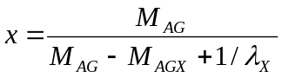 (1)

The hydrophobic content of the Py/Np-SNPs was calculated by using Equation 2 where M_{X} represents the molar mass of the 1-pyrenebutyryl (X = Py) and 1-naphthaleneactyl (X = Np) equal to 271 and 169 g.mol⁻¹, respectively.

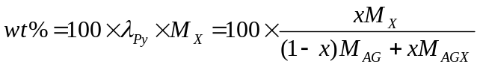 (2)

Table 1. Characteristics of the fluorescently labeled SNP samples
Dye (X) | Samples | mol% of dye | λ_{X} in μmol of dye per gram of polymer | wt% of hydrophobic dye
Pyrene | Py(0.06)-SNP | 0.06 | 3.7 | 0.1
Pyrene | Py(1.0)-SNP | 1.0 | 61 | 1.6
Pyrene | Py(2.3)-SNP | 2.3 | 137 | 3.7
Pyrene | Py(4.8)-SNP | 4.8 | 274 | 7.4
Pyrene | Py(6.7)-SNP | 6.7 | 372 | 10.1
Pyrene | Py(8.0)-SNP | 8.0 | 436 | 11.8
Naphthalene | Np(48)-SNP | 48 | 1,980 | 33.4
Preparation of the aqueous Py/Np-SNP dispersions: The same sample preparation was applied to all aqueous Py/Np-SNP dispersions and it is described in more detail hereafter for the Py(1.0)-SNP sample. Py(1.0)-SNP (50 mg) was placed in a vial with 3.7 g of DMSO to yield a Py-SNP concentration of 14.9 g/L. The vial was covered with aluminum foil to avoid pyrene degradation by light exposure and placed on a hot plate for 30-40 min at 60 ºC. After the yellow solid of Py(1.0)-SNP had fully dissolved in DMSO, the vial was removed from the hot plate and allowed to cool down to room temperature. The yellow clear solution of 14.9 g/L Py(1.0)-SNP in DMSO was used as a stock dispersion. The Py(1.0)-SNP stock dispersion in DMSO (100 mg) was added to 100 mL of milliQ water. This dilution yielded an aqueous dispersion containing 13.6 mg/L of Py(1.0)-SNP after accounting for the different densities of DMSO (1.1 g/mL at 25 ºC) and water (1.0 g/mL at 25 ºC). The solution was transferred to a 125 mL flask wrapped with aluminum foil to protect pyrene from degradation by light. A 300 mM SDS solution was prepared by dissolving SDS (4.33 g, 15.0 mmol) into 50 mL of milliQ water, to which 50 mg of the Py-SNP stock dispersion in DMSO was added. This dispersion contained 13.6 mg/L Py(1.0)-SNP and 300 mM SDS and was wrapped in aluminum foil. A series of dispersions with varying concentrations of SDS ranging from 0 to 300 mM and a constant concentration of Py(1.0)-SNP were prepared by mixing varying ratios of the 13.6 mg/L Py(1.0)-SNP dispersion in water with the 13.6 mg/L Py(1.0)-SNP in 300 mM SDS aqueous dispersion. This procedure ensured that as the SDS concentration was varied, the Py-SNP concentration remained constant and equal to 13.6 mg/L. The same protocol was applied to prepare aqueous dispersions of Py(6.7)-SNP and AOT, as well as mixtures of Py(6.7)-SNP and Np(48)-SNP with both AOT and SDS. In the case of amylopectin, the 14.9 g/L amylopectin dispersion in DMSO used to prepare a 130 mg/L aqueous dispersion was heated at 98 ºC.
Preparation of Quencher solution: Aqueous dispersions of 13.6 mg/L Py(0.06)-SNP with 1 mM SDS were prepared as described in the previous section. 5’-UMP (26.0 mg, 0.08 mmol) was dissolved in 4.0 g of aqueous dispersion of Py(0.06)-SNP with 1 mM SDS to obtain a concentration of 20.0 mM of 5’-UMP solution. Several solutions with different concentration of 5’-UMP were prepared by diluting the quencher solution with different amounts of the aqueous dispersion of 13.5 mg/L Py(0.06)-SNP containing 1 mM of SDS. This procedure ensured that the concentration of Py(0.06)-SNP and SDS remained constant while varying the concentration of 5’-UMP. The same protocol was applied to conduct the quenching studies with 1 mM AOT and in pure water.
Steady-state fluorescence: The steady-state fluorescence spectra of the aqueous Py/Np-SNP dispersions were acquired with a steady-state fluorometer from PTI with excitation at 346 nm for pyrene and 293 nm for naphthalene. The ratio I_{E}/I_{M} was determined by integrating the intensity of the fluorescence spectra over the wavelengths ranging from 500 (425) to 530 (455) nm for the pyrene (naphthalene) excimer (I_{E}) and dividing it by the signal integrated from 372 (321) to 378 (327) nm for the pyrene (naphthalene) monomer (I_{M}). The I_{E}/I_{M} ratio was calculated to describe quantitatively the extent of excimer formation.
Time-resolved fluorescence: Time-resolved fluorescence decays of the aqueous Py-SNP dispersions were acquired with a time-resolved fluorometer from IBH. The excitation wavelength was set at 346 nm. A ludox solution was employed to acquire the instrument response function. The monomer and excimer fluorescence decays were obtained by setting the emission wavelength at 376 nm with a 370 nm cut-off filter and at 510 nm with a 495 nm cut-off filter, respectively. The cut-off filters were utilized to reduce stray scattered photons from reaching the detector. The monomer and excimer decays were obtained with a time per channel of 1.02 ns, with 20,000 counts at the decay maximum. They were fitted separately with a sum of exponentials. All parameters retrieved from the fluorescence decay analysis are provided as Supporting Information (SI) in Tables S1 – S5.
Preparation of Lugol solution: Potassium iodide (0.33 g, 1.97 mmol) was dissolved in 100 mL Milli-Q water through gentle shaking by hand. Iodine (0.04 g, 0.14 mmol) was added to the KI solution. The mixture was heated with gentle stirring until iodine was dissolved. A transparent brownish orange colour solution was obtained.
RESULTS AND DISCUSSION
The interactions between Py-SNPs and SDS were monitored as a function of SDS concentration from the changes observed in the fluorescence spectra of the aqueous dispersions. These changes were substantial and can be seen in Figure 1 for a 13.5 mg.L⁻¹ Py(6.7)-SNP dispersion in water. All fluorescence spectra were normalized to unity at 376 nm which corresponds to the 0-0 transition of pyrene. A large excimer emission was observed at low SDS concentration and its fluorescence intensity remained constant within experimental error for SDS concentrations lower than 0.1 mM. Under these conditions, the pyrene labels were aggregated and direct irradiation of the pyrene aggregates resulted in efficient excimer emission. For SDS concentrations between 0.1 and 6 mM, the relative excimer intensity underwent a rapid decrease with increasing SDS concentration. For SDS concentrations between 6 and 8 mM, the latter concentration corresponding to the CMC of SDS, excimer fluorescence remained constant, before undergoing a further decrease when the SDS concentration was increased from 8 to 300 mM.
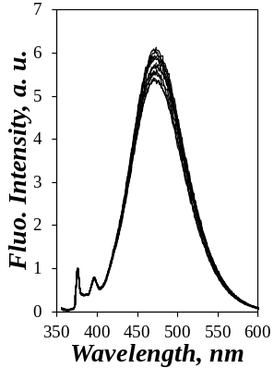  A) | 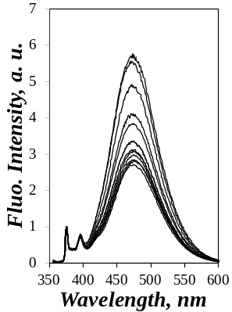  B) | 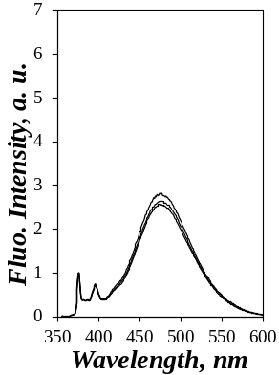  C) | 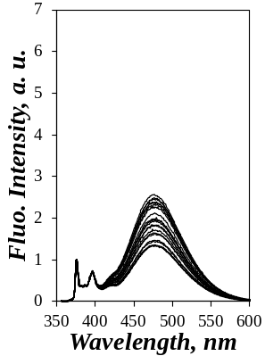  D)
0M<[SDS] <0.1mM | 0.1mM<[SDS]<6mM | 6 mM<[SDS]<8 mM | 8 mM<[SDS]<0.3 M
Figure 1. Changes in the fluorescence spectra normalized at 376 nm of a 13.5 mg/L aqueous dispersion of Py(6.7)-SNP with different SDS concentrations.

The substantial changes observed in the fluorescence spectra of the aqueous Py(6.7)-SNP dispersions upon increasing the SDS concentration from 0 up to 300 mM were a direct result of the interactions taking place between SDS and the Py(6.7)-SNP. The most intriguing aspect of these interactions was that they occurred over well-defined concentration ranges, namely for SDS concentrations between 0.1 and 6 mM in Figure 1B and between 8 and 300 mM in Figure 1D for the first and second drop in excimer fluorescence intensity, respectively. Similar changes in the fluorescence spectra were observed for all Py-SNPs investigated. The results obtained with all Py-SNPs studied were summarized in Figure 2 where the I_{E}/I_{M} ratios were determined for all fluorescence spectra and were plotted as a function of SDS concentration.
The I_{E}/I_{M}-vs-[SDS] profiles in Figure 2 were quite different from those obtained earlier with other mimics of associative thickeners that were labeled with pyrene. The I_{E}/I_{M}-vs-[SDS] profiles for a 10K poly(ethylene oxide) labeled at both end with 1-pyrenemethoxide (Py₂-PEO(10K) with λ_{Py} = 200 μM.g⁻¹) and a terpolymer of methacrylic acid (~ 45 mol%), ethyl acrylate (~ 55 mol%), and a macromonomer (~ 1 mol%) made of a PEO spacer terminated at one end with 1-pyrenemethoxide and at the other end with a methylstyrene unit) (Py-HASE, with λ_{Py} = 34 μM.g⁻¹) used as mimics of, respectively, a Hydrophobically modified Ethoxylated URethane (HEUR) polymer and a Hydrophobically modified Alkali Swellable Emulsion (HASE) copolymer are presented in Figure 3. The polymer concentrations used in Figure 3 are similar to those in Figure 2 being equal to 12.5 and 10 mg/L for Py₂-PEO(10K)²⁷ and Py-HASE,²⁸ respectively. The pyrene content (λ_{Py}) of Py₂-PEO(10K) equal to 200 μmol/g was comparable to that of Py(4.8)-SNP (274 μmol/g in Table 1) while that of 34 μmol/g for Py-HASE was much lower.
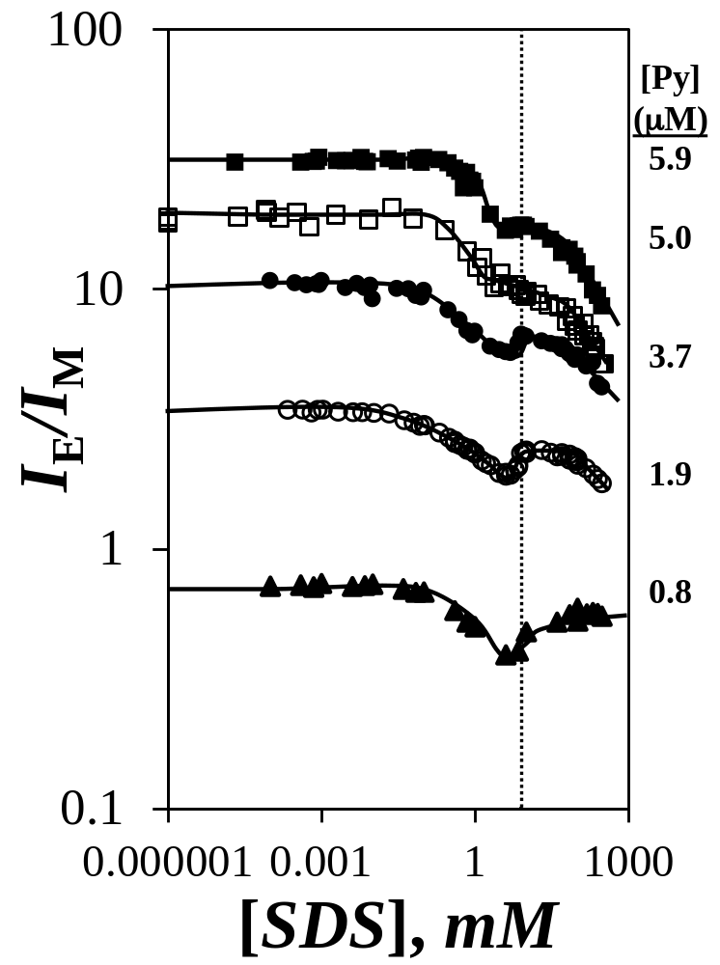
Figure 2. Plot of I_{E}/I_{M} as a function of SDS concentration for () Py(1.0)-SNP, () Py(2.3)-SNP, () Py(4.8)-SNP, () Py(6.7)-SNP, and () Py(8.0)-SNP. [Py-SNP] = 13.5 mg.L⁻¹. The corresponding pyrene concentration is indicated on the right hand side of the plot. The vertical dashed line indicates the CMC (= 8 mM) of SDS.

Numerous studies have established the following rational for the plots shown in Figure 3.²⁷⁻ For both Py₂-PEO(10K) and Py-HASE, the water-soluble polymers were able to stabilize the hydrophobic pyrene labels at low SDS concentration, thus reducing the formation of pyrene aggregates and resulting in low excimer emission. SDS interacted little with the polymers as its concentration was below the CMC. But as the SDS concentration approached the CMC, substantial interactions between SDS and the pyrene labels occurred resulting in the formation of mixed micelles between SDS and the pyrene labels. The mixed micelles concentrated the pyrene labels within them, enabling pyrene excimer formation by dynamic encounters between pyrene labels, and resulting in enhanced excimer formation associated with an increase in I_{E}/I_{M} for SDS concentrations close to the CMC. Formation of SDS micelles at the CMC led to the compartmentalization of the pyrene labels into different SDS micelles, thus hampering their ability to form excimer, reducing excimer fluorescence, and resulting in a decrease in the I_{E}/I_{M} ratio with increasing SDS concentration. This decrease was sharp for Py₂-PEO(10K) in Figure 3A because the pyrene labels were separated by a monodisperse contour length.²⁷ By contrast, Py-HASE, being a random terpolymer with different contour lengths separating every pyrene pairs,^{28,29} led to a more progressive decrease in I_{E}/I_{M} in Figure 3B at high SDS concentration.
The obvious differences observed between the I_{E}/I_{M}-vs-[SDS] profiles shown in Figures 2 and 3 suggested that more complex interactions took place between Py-SNPs and SDS than those between SDS and Py₂-PEO(10K) and Py-HASE. In an effort to elucidate the nature of these interactions, the monomer and excimer fluorescence decays of the Py-SNPs aqueous dispersions were acquired for different SDS concentrations. Two excimer fluorescence decays were presented in Figure 4. The excimer decays acquired at SDS concentrations below the CMC showed no risetime indicating that the excimer was produced by direct excitation of pyrene aggregates followed by static excimer formation. By contrast, the excimer fluorescence decays acquired at SDS concentrations above the CMC showed a pronounced risetime indicating that dynamic excimer formation took place through encounters between an excited and a ground-state pyrene.

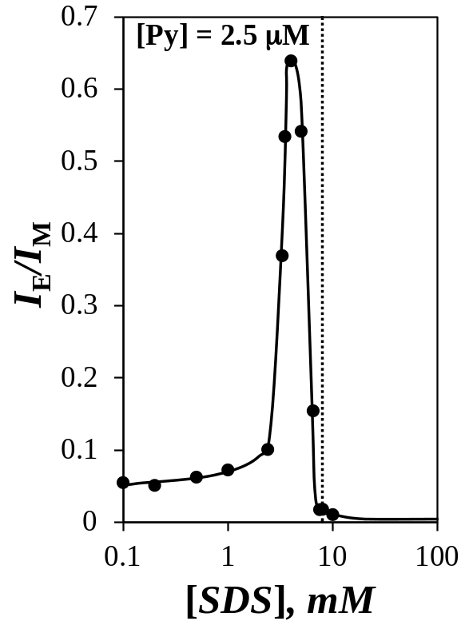  A) | 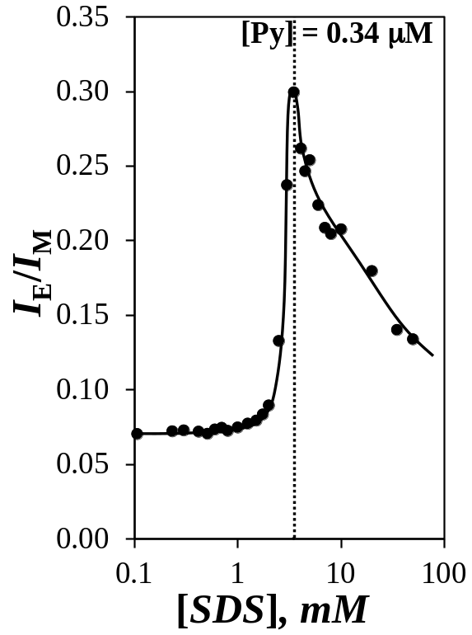  B)
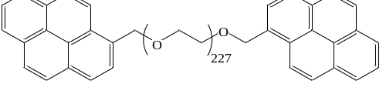  Py₂-PEO(10K) | 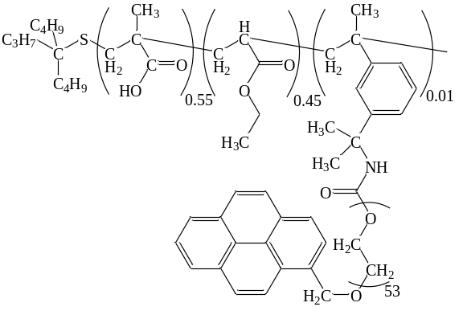  Py-HASE
Figure 3. Plot of I_{E}/I_{M} as a function of SDS concentration for A) 12.5 mg/L Py₂-PEO(10K) in water and B) 10 mg/L of Py-HASE in 0.01 M Na₂CO₃ at pH 9. The vertical dashed lines indicate the CMC (= 8 mM in water and 3.5 mM in 0.01 M Na₂CO₃) of SDS.

A more quantitative description of the risetime in the excimer fluorescence decays was obtained by fitting them with a sum of exponentials to obtain the A_{E−}/A_{E+} ratio representing the ratio of the sum of the negative pre-exponential factors over the sum of the positive pre-exponential factors. The A_{E−}/A_{E+} ratio was plotted as a function of SDS concentration in Figure 4C. The A_{E−}/A_{E+} ratio can take values between 0 and −1.0, the former and latter values corresponding to a situation where excimer is purely produced by direct excitation of pyrene aggregates or dynamic encounters between an excited and a ground-state pyrene, respectively. Based on the trends shown in Figure 5, excimer formation occurred by direct excitation for SDS concentrations lower than the CMC but took place increasingly by dynamic encounters above the CMC.

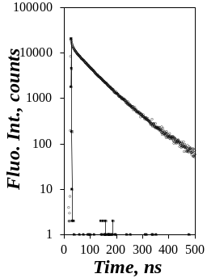  A) | 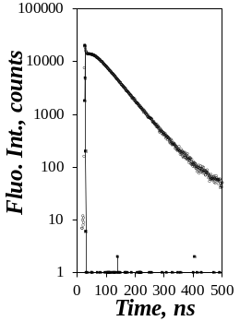  B) | 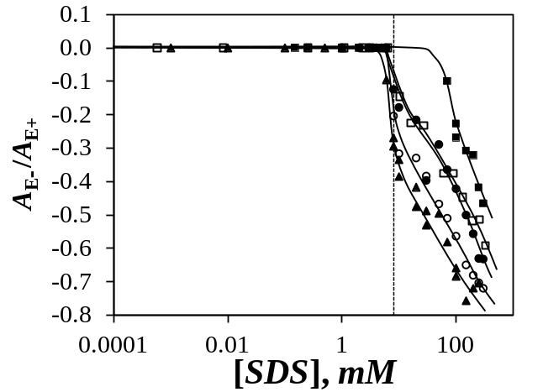  C)
[SDS] = 0 mM  (no rise time) | [SDS] = 250 mM  (rise time)
Figure 4. Excimer fluorescence decays acquired with an aqueous dispersions of Py(8.0)-SNP with SDS concentrations equal to A) 0 and B) 250 mM; λ_{ex} = 346 nm, λ_{em} = 510 nm. C) Plot of A_{E−}/A_{E+} as a function of SDS concentration for () Py(1.0)-SNP, () Py(2.3)-SNP, () Py(4.8)-SNP, () Py(6.7)-SNP, and () Py(8.0)-SNP. [Py(8)-SNP] = 13.5 mg.L⁻¹.

This result had a number of implications. The negative A_{E−}/A_{E+} ratio obtained above the CMC indicated that the pyrene labels formed excimer by dynamic encounters as they would in a non-polar environment. Above the CMC of SDS, the non-polar environment where the pyrenes were located could only be the interior of SDS micelles. Since dynamic encounters resulted in a delay in excimer formation, the increasingly negative A_{E−}/A_{E+} ratio observed with increasing SDS concentration implied that excimer formation became increasingly less efficient with increasing SDS concentration above the CMC compared to direct excitation of pyrene aggregates which resulted in instantaneous excimer formation. This interpretation provided a rational as to why the I_{E}/I_{M} ratio in Figure 2 decreased with increasing SDS concentration for SDS concentrations above the CMC. For SDS concentrations below the CMC, an A_{E−}/A_{E+} value of zero indicated that the pyrene labels leading to pyrene excimer formation were aggregated,³² as would be expected from hydrophobic pendants trying to reduce their exposure to water. Consequently, the first drop in the I_{E}/I_{M} ratio observed for SDS concentrations between 0.1 and 8 mM in Figure 2 could not be rationalized by a change in the photophysics of pyrene excimer formation.
The cause for the first decrease in I_{E}/I_{M} taking place at an SDS concentration of 0.1 mM could be found in the well-known dependency of the I_{E}/I_{M} ratio with the local pyrene concentration [Py]_{loc} experienced by an excited pyrene. Most interestingly, lowering the concentration of Py(6.7)-SNP and Py(8.0)-SNP from 13.5 mg.L⁻¹ to 0.5 and 2.5 mg.L⁻¹, respectively, led to a substantial decrease in I_{E}/I_{M} in Figure 5 at SDS concentrations lower than the CMC but not above the CMC. This observation indicated that the Py-SNPs were aggregated in water which resulted in a high [Py]_{loc}. A decrease in the Py-SNP concentration was accompanied by a decrease in the aggregation of Py-SNPs, thus resulting in a decrease in [Py]_{loc} and an associated decrease in I_{E}/I_{M} at SDS concentration lower than the CMC. The overlapping I_{E}/I_{M}-vs-[SDS] profiles observed for both Py-SNP concentrations in Figure 5 at SDS concentrations larger than the CMC indicated that in this range of SDS concentrations, the Py-SNPs were dissociated and no longer formed Py-SNP aggregates. Consequently the first decrease in I_{E}/I_{M} observed at a 0.1 mM SDS concentration in Figures 2 and 5 was attributed to the dissociation of the Py-SNP aggregates.
Another interesting feature of the I_{E}/I_{M}-vs-[SDS] profiles shown in Figure 5 for the lower Py-SNP concentrations is the increase in the I_{E}/I_{M} ratio observed for SDS concentrations just before the CMC. This behavior was also observed in Figure 2 for those Py-SNP samples with a low pyrene content, which generated fewer interparticulate aggregates as found upon decreasing the Py-SNP concentration in Figure 5. While the decrease in I_{E}/I_{M} with increasing SDS concentration observed at SDS concentrations below the CMC has been assigned to the dissociation of Py-SNP aggregates, the increase in I_{E}/I_{M} just before the CMC was attributed to the same phenomenon that led to the increase in I_{E}/I_{M} just before the CMC for the Py₂-PEO(10K) and Py-HASE described in Figure 3, namely the formation of mixed micelles that would bring the pyrenyl labels together and concentrate them. It is expected that this increase would be much more pronounced, possibly as pronounced as those shown in Figure 3, if these experiments could be conducted at an infinitesimally small Py-SNP concentration where no Py-SNP aggregates could form. Such conditions would result in a much lower I_{E}/I_{M} ratio at low SDS concentrations which would make the increase in I_{E}/I_{M} at SDS concentration close to the CMC much more visible. These conditions would be equivalent to those applied to obtain the I_{E}/I_{M}-vs-[SDS] profiles in Figure 3 for the Py₂-PEO(10K) and Py-HASE samples. In summary, the difference in the I_{E}/I_{M}-vs-[SDS] profiles observed in Figure 2 for the Py-SNP aqueous dispersions could be attributed to strong Py-SNP aggregation at lower SDS concentrations that led to much higher I_{E}/I_{M} ratios compared to those obtained for the Py₂-PEO(10K) and Py-HASE samples.

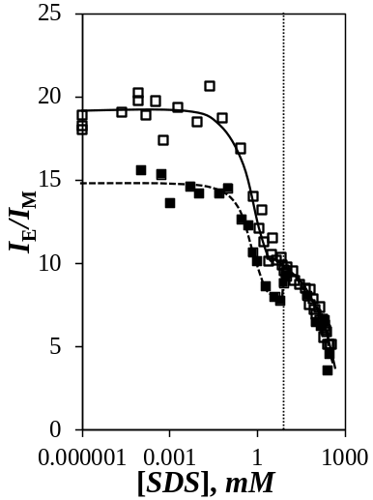 | 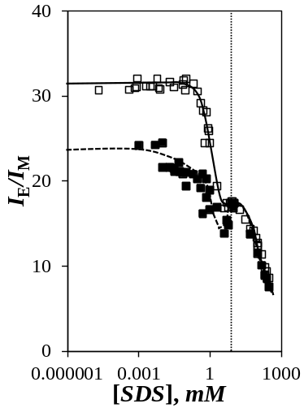  A) | 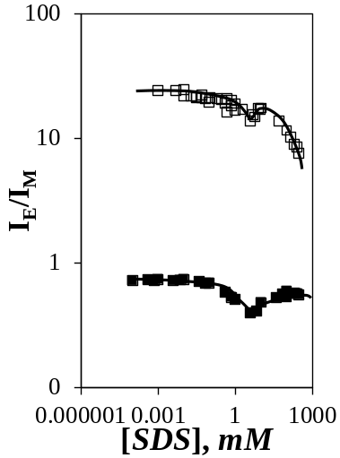  C)  B)

Figure 5. Plot of I_{E}/I_{M} as a function of SDS concentration for A) () 13.5 and () 0.5 mg.L⁻¹ Py(6.7)-SNP, B) () 13.5 and () 2.5 mg.L⁻¹ Py(8.0)-SNP, and C) () 13.5 mg.L⁻¹ ([Py] = 0.82 μM) Py(1.0)-SNP and () 2.5 mg.L⁻¹ ( [Py] = 1.1 μM) Py(8.0)-SNP.

The effect that the pyrene content of the Py-SNP samples had on the magnitude of the I_{E}/I_{M} ratio was illustrated in Figure 5C where the I_{E}/I_{M}-vs-[SDS] profiles were compared for concentrations of Py(1.0)-SNP and Py(8.0)-SNP equal to 13.5 and 2.5 mg.L⁻¹, respectively, corresponding to a similar pyrene concentration close to 1 μM. The I_{E}/I_{M} ratio of Py(8.0)-SNP was more than one order of magnitude larger than that of Py(1.0)-SNP over the entire range of SDS concentration. A higher hydrophobic content was thus capable of generating substantially higher hydrophobic interactions, an expected conclusion that had already been obtained with SNPs modified with propionyl and hexanoyl substituents.¹²
These conclusions were further substantiated by conducting FRET experiments between naphthalene-labeled SNPs (Np(48)-SNP) and Py(6.7)-SNP. Since the emission of naphthalene overlaps the absorption of pyrene and since naphthalene can be selectively excited at 293 nm, the naphthalene/pyrene donor/acceptor pair has been used numerous times as a FRET pair to probe intermacromolecular interactions.²⁵ FRET experiments were conducted with aqueous dispersions of 10.4 mg/L of Np(48)-SNP and 3.1 mg/L Py(6.7)-SNP for an overall 13.5 mg/L Py/Np-SNP concentration. These concentrations ensured that the absorbance of the aqueous dispersions of mixtures of Np(48)-SNP and Py(6.7)-SNP was lower than 0.08 for any wavelengths equal to and higher than 293 nm. In fact, the absorption of the dispersions for wavelengths larger than 310 nm where the naphthalene donor begins to emit was always smaller than 0.02, thus ensuring that the innerfilter effect and reabsorption of the donor emission would not affect the data analysis.²³ The fluorescence spectra of aqueous dispersions of 3.1 mg/L Py(6.7)-SNP, 10.4 mg/L Np(48)-SNP, and a mixture of 10.4 mg/L Np(48)-SNP and 3.1 mg/L Py(6.7)-SNP are shown in Figure 6. When excited at 346 nm where only pyrene absorbs, the fluorescence spectrum in Figure 6A of the aqueous dispersion of 3.1 mg/L Py(6.7)-SNP yielded much more pyrene excimer than the aqueous dispersion of 3.1 mg/L Py(6.7)-SNP in the presence of 10.4 mg/L Np(48)-SNP. The lower pyrene excimer formation (PEF) of the mixture indicated that [Py]_{loc} experienced by an excited pyrene was much lower in the Py/Np-SNP mixture than for the 3.1 mg/L Py(6.7)-SNP aqueous dispersion. It suggested that interactions between the pyrene labels of Py(6.7)-SNP and the naphthalene labels of Np(48)-SNP lowered [Py]_{loc}, thus resulting in a decrease in PEF.
The existence of interactions between the pyrene and naphthalene labels was confirmed by exciting the three dispersions at 293 nm. Since pyrene absorbs little at 293 nm, the fluorescence spectrum of the aqueous dispersion of 3.1 mg/L Py(6.7)-SNP was dwarfed in Figure 6B by that of the aqueous dispersion containing 10.4 mg/L Np(48)-SNP since naphthalene absorbs strongly at 293 nm. Yet, the fluorescence of the pyrene monomer between 376 and 420 nm dominated the fluorescence spectrum of the aqueous dispersion of a mixture of 10.4 mg/L Np(48)-SNP and 3.1 mg/L Py(6.7)-SNP.

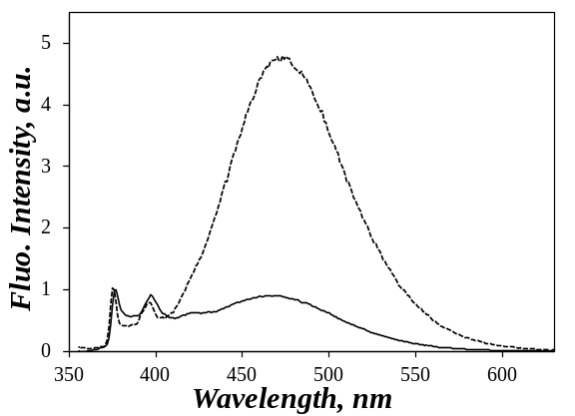  A) | 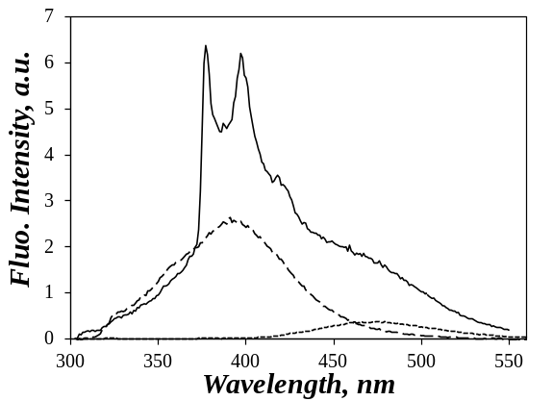  B)
Figure 6. Fluorescence spectra of the aqueous dispersions of () 3.1 mg/L Py(6.7)-SNP, () 10.4 mg/L Np(48)-SNP, and () a mixture of 3.1 mg/L Py(6.7)-SNP and 10.4 mg/L Np(48)-SNP. A) λ_{ex} = 346 nm, fluorescence spectra were normalized at 376 nm and B) λ_{ex} = 293 nm, fluorescence spectra were not normalized.

These fluorescence data indicated that excitation of naphthalene was necessary to induce pyrene emission in the Py/Np-SNP mixture, thus demonstrating FRET between excited naphthalenes to ground-state pyrenes excited at 293 nm. Since the Förster radius for the naphthalene/pyrene pair equals 2.9 nm, much smaller than the 46 nm SNP diameter determined by dynamic light scattering,¹² the observation of FRET implied that intimate contacts between the naphthalene and pyrene labels took place as would be expected from mixed aggregates between Np(48)-SNP and Py(6.7)-SNP. Furthermore, the fact that the pyrene monomer was prominent in the fluorescence spectrum of the mixture when a 3.1 mg/L Py(6.7)-SNP aqueous dispersion only showed pyrene excimer implied that the pyrene labels of Py(6.7)-SNP dissolved as monomers in the naphthalene aggregates of Np(48)-SNP, thus ensuring efficient FRET to the pyrene monomer as observed in Figure 6B. Since Figure 6 demonstrated that pyrene emission in the fluorescence spectrum of the aqueous dispersion of 10.4 mg/L Np(48)-SNP and 3.1 mg/L Py(6.7)-SNP was evidence for FRET, the fluorescence spectra of the Np(48)-SNP and Py(6.7)-SNP mixtures were monitored as a function of SDS concentration. They are shown in Figure 7 together with those of a 10.4 mg/L Np(48)-SNP aqueous dispersion provided as control.
Like pyrene, naphthalene forms excimer and the fluorescence spectra of Np(48)-SNP shown in Figure 7A reflected the dual emission of naphthalene with monomer and excimer emission found around 330 and 400 nm, respectively. The strong excimer emission was observed in water where the hydrophobic naphthalene labels aggregated, but it was reduced upon addition of SDS due to interactions between naphthalene and SDS, particularly above the CMC of SDS when SDS micelles formed. The I_{E}/I_{M} ratio for Np(48)-SNP was plotted as a function of SDS concentration in Figure 7B. As for the I_{E}/I_{M} ratio of the Py-SNP in Figure 2, the I_{E}/I_{M} ratio of Np(48)-SNP took a large value in the absence of SDS due to the presence of naphthalene aggregates before decreasing first progressively for SDS concentration between 1 and 6 mM, and then sharply at the CMC of SDS where SDS micelles interacted with the naphthalene labels, thus reducing the efficiency of excimer formation.

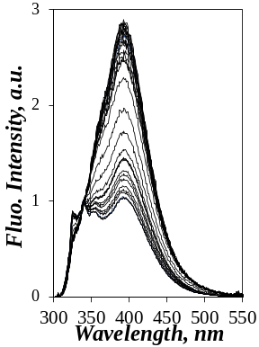  [SDS]  5 μM  335 mM  A) | 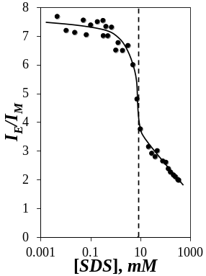  B) | 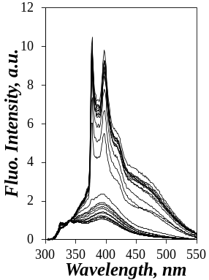  [SDS]  1 μM  345 mM  C) | 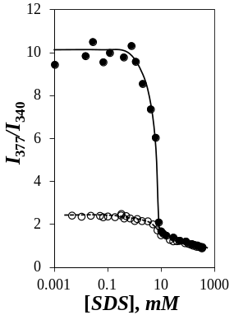  D)
Figure 7. A) Changes in the fluorescence spectra normalized at 340 nm of an aqueous dispersion of 10.4 mg/L Np(48)-SNP upon increasing the SDS concentration from 5 μM to 335 mM. B) Plot of the I_{E}/I_{M} ratio of the spectra shown in Figure 7A as a function of SDS concentration. C) Changes in the fluorescence spectra normalized at 340 nm of the aqueous dispersion of a mixture of 3.1 mg/L Py(6.7)-SP and 10.4 mg/L Np(48)-SNP upon increasing the SDS concentration from 1 μM to 345 mM. D) Plot of I₃₇₇/I₃₄₀ as a function of SDS concentration for aqueous dispersions of () 3.1 mg/L Py(6.7)-SNP and 10.4 mg/L Np(48)-SNP and () 10.4 mg/L Np(48)-SNP.

The fluorescence spectra of the aqueous dispersions of the Py/Np-SNP mixtures are shown in Figure 7C. As SDS was added to the dispersion, the strong pyrene emission decreased until the CMC of SDS above which the pyrene emission literally disappeared as would be expected since pyrene absorbed so little at 293 nm where naphthalene absorbed. The trends shown in Figures 7A and C were summarized in Figure 7D by plotting the ratio I₃₇₇/I₃₄₀ as a function of SDS concentration where I₃₇₇ and I₃₄₀ represented the fluorescence intensity at these wavelengths for pyrene and naphthalene combined and naphthalene alone, respectively. Since the 10.4 mg/L Np(48)-SNP dispersion contained no pyrene, the I₃₇₇/I₃₄₀ ratio showed a trend similar to that of the I_{E}/I_{M} ratio in Figure 7B. The I₃₇₇/I₃₄₀ ratio for the aqueous dispersion of the Np(48)-SNP and Py(6.7)-SNP mixture took a much higher value at low SDS concentration compared to that of the 10.4 mg/L Np(48)-SNP aqueous dispersion due to strong FRET between naphthalene and pyrene promoted by hydrophobic interparticulate associations. At about 1 mM SDS, the I₃₇₇/I₃₄₀ ratio began decreasing reflecting weaker FRET as would be expected from a loosening of the particulate aggregates made up of Py(6.7)-SNP and Np(48)-SNP. As the SDS concentration reached the CMC, the I₃₇₇/I₃₄₀ ratio of the Py(6.7)-SNP and Np(48)-SNP mixture dropped to the I₃₇₇/I₃₄₀ ratio of the 10.4 mg/L Np(48)-SNP dispersion indicating absence of FRET and that the Py(6.7)-SNP and Np(48)-SNP were then fully separated. Except for the onset concentration marking the start of interactions between SDS and the Py-SNPs in Figure 2, the Np(48)-SNPs in Figure 7B, and the mixtures of Np(48)-SNPs and Py(6.7)-SNPs in Figure 7D that were found to equal 0.1, 1.0, and 1.0 mM, respectively, all other conclusions were similar for the three systems. The different onset SDS concentrations might be due to the high dye content of Np(48)-SNP compared to those of the Py-SNPs which might require a larger binding of SDS molecules before an effect could be probed by fluorescence.
Further support of the molecular interactions taking place between the pyrene labels of Py(6.7)-SNP and the naphthalene labels of Np(48)-SNP was obtained by exciting the aqueous dispersions of the mixture of 3.1 mg/L Py(6.7)-SNP and 10.4 mg/L Np(48)-SNP at 346 nm where only pyrene absorbs. The fluorescence spectra of Py(6.7)-SNP in the mixture showed strong variations in Figure 8A when SDS was added. At low SDS concentration, little excimer was produced compared to the 3.1 mg/L Py(6.7)-SNP aqueous dispersion, probably because many pyrene labels were associated with the naphthalene aggregates of Np(48)-SNP where they emitted as monomers. But at the CMC of SDS where the particles broke free from the interparticulate aggregates, the I_{E}/I_{M} ratio increased matching that of the 3.1 mg/L Py(6.7)-SNP dispersion.
Interestingly, the maximum emission of the pyrene excimer in Figure 8A for the Py/Np-SNP mixture was found to shift to lower wavelengths at low SDS concentration. The wavelength (λ_{max}) of the maximum of the excimer fluorescence was determined by fitting the region around the fluorescence intensity maximum with a 2nd order polynomial and equating the wavelength where the derivative of the polynomial equaled zero to λ_{max}. The trend shown in Figure 8C indicated that in the presence of Np(48)-SNP, the emission of the excimer of Py(6.7)-SNP at 465 nm for low SDS concentrations was red-shifted to 478 nm at SDS concentrations above the CMC. Interestingly, the λ_{max} value of 478 nm would be expected for pyrene excimer formed by diffusion in organic solvents. As it turns out, this range of SDS concentration corresponds to the regime where the excimer decays showed a rise time reflected by negative A_{E−}/A_{E+} values in Figure 8C and indicative of excimer formation by diffusion. In contrast, the blue shift in excimer emission found for SDS concentrations smaller than the CMC reflected the existence of ground-state dimers as has been reported in earlier reports,²⁴, and as would be expected from the absence of rise time in the excimer decays. The much less pronounced blue shift observed for the excimer fluorescence spectra of 3.1 mg/L Py(6.7)-SNP in water suggested that the pyrene labels in the absence of Np(48)-SNP were more mobile and generated aggregates where the pyrene labels were better aligned to form an excimer.

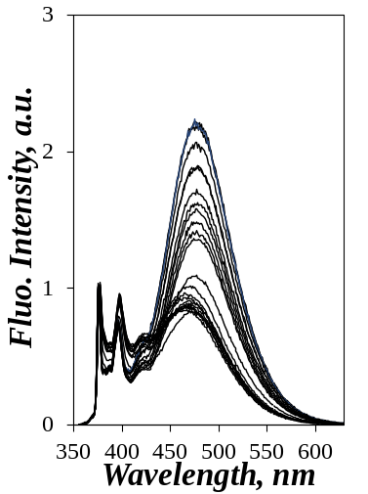  A) | 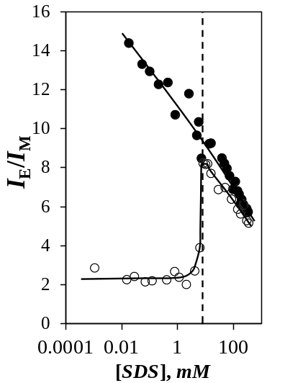  B) | 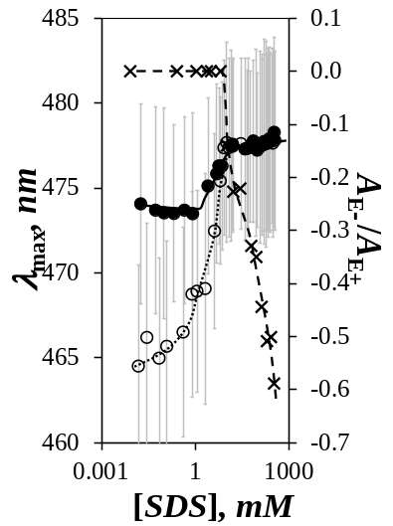  C)
Figure 8. A) Fluorescence spectra normalized at 376 nm of an aqueous dispersion of 3.1 mg/L Py(6.7)-SNP in the presence of 10.4 mg/L Np(48)-SNP. Plots of B) I_{E}/I_{M} and C) (,) λ_{max} and (×) A_{E−}/A_{E+} as a function of SDS concentration for an aqueous dispersion of 3.1 mg/L Py(6.7)-SNP in the () presence and (,×) absence of 10.1 mg/L Np(4.8)-SNP.

In the presence of Np(48)-SNP, hydrophobic interactions between the peripheral pyrene labels of Py(6.7)-SNP and naphthalene aggregates of Np(48)-SNP yielded pyrene excimer fluorescence that only reflected that of pyrene aggregates located at the core of Py-(6.7)-SNPs. It would thus appear that the core of Py(6.7)-SNP is much less mobile resulting in the formation of aggregates with poorly stacked pyrene labels yielding the blue-shifted emission. In the absence of Np(48)-SNP, emission of the 3.1 mg/L Py(6.7)-SNP aqueous dispersion represents the entire population of pyrene aggregates, those that are made of poorly and well stacked pyrene labels at the core and periphery of the particles, respectively, resulting in a λ_{max} value of 474 nm close to that of 478 nm at SDS concentrations above the CMC. Above the CMC, the Py(6.7)-SNPs and Np(48)-SNPs are separated and the pyrene labels emit similarly resulting in the same λ_{max} value in Figure 8C.
All explanations provided so far to rationalize the interactions between the Py/Np-SNPs and SDS suggested solely interactions between the hydrophobic dyes and SDS. We now provide additional evidence that interactions between starch and SDS must also be involved and that they might in fact be the most important contribution to explain the dissociation of Py-SNP aggregates at SDS concentrations below the CMC. The experiments shown in Figure 2 were repeated with Py(6.7)-SNP and sodium dioctylsulfosuccinate (AOT). Figure 9 compares the trends obtained for the ratios I_{E}/I_{M} and A_{E−}/A_{E+} when SDS or AOT was added to an aqueous dispersion of 13.5 mg/L Py(6.7)-SNP. The I_{E}/I_{M} ratio remained constant regardless of AOT concentration up to the CMC of 2.4 ± 0.3 mM. The CMC of 2.4 mM for AOT was determined experimentally in SI and was found to be in agreement with values obtained by fluorescence and surface tension reported in the literature. The 2.4 mM CMC of AOT was lower than that of 8 mM for SDS, thus reflecting the more hydrophobic character of this surfactant. Surprisingly for a more hydrophobic surfactant, hardly any interaction between AOT and Py(6.7)-SNP could be detected within experimental error between 0.1 and 2.4 mM, the same range of surfactant concentration where interactions between all Py-SNPs and SDS were observed in Figure 2. Furthermore, I_{E}/I_{M} was found to increase at the CMC of AOT instead of decreasing like SDS. The increase in I_{E}/I_{M} observed with AOT indicated an increase in [Py]_{loc} whereas a decrease in [Py]_{loc} was found with SDS. Finally, while interactions of SDS micelles and all Py-SNPs resulted in a rise time in the excimer decays for any SDS concentrations above the CMC, no rise time was observed in the excimer decays of Py(6.7)-SNP in the presence of AOT indicating that the pyrene labels remained aggregated at all AOT concentrations, even above the CMC. The radical departure from the trends obtained with SDS was attributed to the branched nature of the dioctyl tails of AOT compared to the linear dodecyl tail of SDS.
Lipids and surfactants like SDS are known to form inclusion complexes with starch whereby the polysaccharide forms a helix with a hydrophobic interior that can host a linear alkyl chain. AOT with its branched structure is much less likely to form such inclusion complexes. Since no interactions between AOT and the pyrene labels of Py(6.7)-SNP could be detected in Figure 9 for surfactant concentrations between 0.1 and 2.4 mM where SDS interacted strongly with Py(6.7)-SNP, the trends shown in Figure 9 suggested that the disruption of the Py(6.7)-SNP aggregates by SDS molecules might not be induced by the binding of SDS to the hydrophobic pyrene aggregates, but rather through the formation of inclusion complexes with starch. This process would generate negative charges at the surface of the Py-SNPs that would stabilize the particles in the aqueous dispersion through electrostatic repulsion. Indeed, this mechanism would rationalize why no rise time was observed (A_{E−}/A_{E+} = 0 in Figure 4) in the excimer fluorescence decays of all Py-SNPs for SDS concentrations between 0.1 and 8 mM where a massive decrease in I_{E}/I_{M} was detected.
By contrast, AOT with its two octyl tails would not form inclusion complexes and thus would not interact with Py(6.7)-SNP at AOT concentrations below the CMC as observed in Figure 9 by the constant I_{E}/I_{M} ratio. Above 2.4 mM, the CMC of AOT, the packing parameter of 1.1 for AOT implied that it could not form micelles like SDS, with a packing parameter of 0.31, and rather formed larger objects with a larger curvature radius such as vesicles. Large objects with a hydrodynamic diameter of ~140 nm where found in a 17.2 mM AOT aqueous solution by dynamic light scattering, in agreement with another report.³⁷ Such large objects would be incapable of penetrating the highly branched, amylopectin-like, interior of Py(6.7)-SNPs preventing the pyrene aggregates hosted inside the particles from accessing the hydrophobic interior of the AOT vesicles. However the hydrophobic bilayer of an AOT vesicle would most certainly attract Py(6.7)-SNPs that would cluster at its surface. Whether this clustering of Py(6.7)-SNPs at the surface of the AOT vesicles would induce an increase in the local interparticulate concentration as evidenced by the increase in the I_{E}/I_{M} ratio shown in Figure 9 needed to be determined.

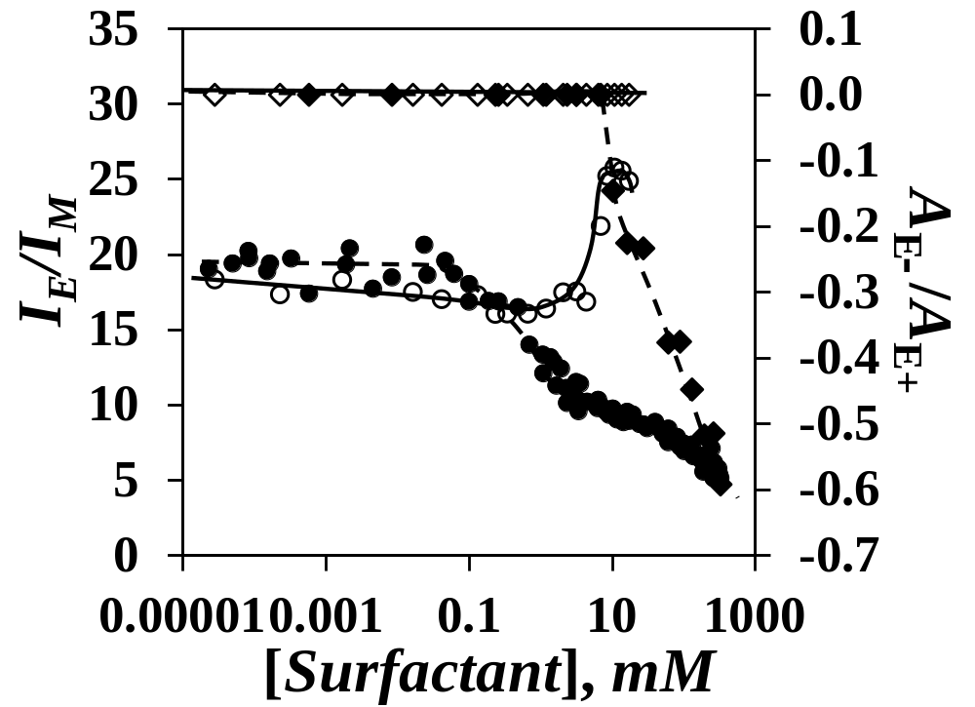
Figure 9. Plots of (,) I_{E}/I_{M} and (,) A_{E-}/A_{E+} as a function of surfactant concentration. Filled symbols with a dashed line and empty symbols with a solid line are for SDS and AOT, respectively.

To this end, FRET and PEF measurements were conducted as a function of AOT concentration with aqueous dispersions of a first mixture of 11.3 mg/L Np(48)-SNP and 2.3 mg/L Py(6.7)-SNP, where 83 wt% of the mixture was constituted by the Np-SNP and was referred to as the 83Np/17Py-SNP mixture, and a second mixture of 12.4 mg/L Np(48)-SNP and 0.4 mg/L Py(6.7)-SNP, where 97 wt% of the mixture was constituted of the Np-SNP and was referred to as the 97Np/3Py-SNP mixture. In the second mixture, Np(48)-SNPs acted as a filler to separate the Py(6.7)-SNPs and investigate how individual Py(6.7)-SNPs behaved as they interacted with AOT vesicles while being surrounded by Np(48)-SNPs. The fluorescence spectra acquired with an excitation wavelength of 293 nm for FRET measurements and 346 nm for PEF measurements are shown in Figures S2 and S3. They were analyzed to obtain the I₃₇₇/I₃₄₀ and I_{E}/I_{M} ratios which were plotted in Figure 10.
As for the 13.5 mg/L Py(6.7)-SNP aqueous dispersion with AOT, the I_{E}/I_{M} ratio was constant at low AOT concentrations before showing a pronounced increase with increasing AOT concentration above 1 mM AOT for the aqueous dispersions of the 83Np/17Py-SNP and 97Np/3Py-SNP mixtures. This result indicated that [Py]_{loc} increased for Py(6.7)-SNP when AOT reached its CMC and AOT began aggregating into large objects, that might probably be vesicles. However the increase in I_{E}/I_{M} in Figures 9 and 10A could not be due solely to interparticulate associations since it was also observed for the 97Np/3Py-SNP mixture in Figure 10B where Py(6.7)-SNPs were surrounded by a large excess of Np(48)-SNPs, could only interact individually with Np(48)-SNPs, and excimer was formed inside a same Py(6.7)-SNP. Thus the increase in I_{E}/I_{M} observed in Figures 9 and 10 with increasing AOT concentration was due in part to an increase in [Py]_{loc} that occurred inside a same Py(6.7)-SNP and not solely through interparticulate interactions.

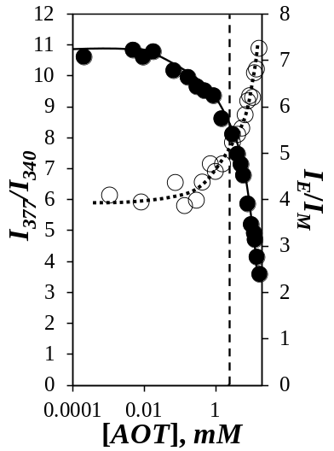  A) | 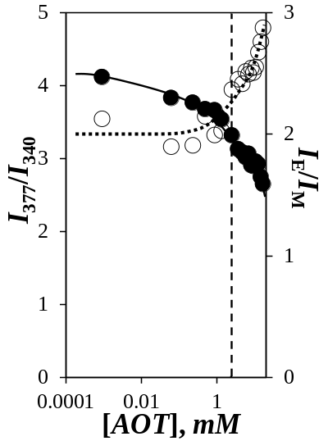  B) | 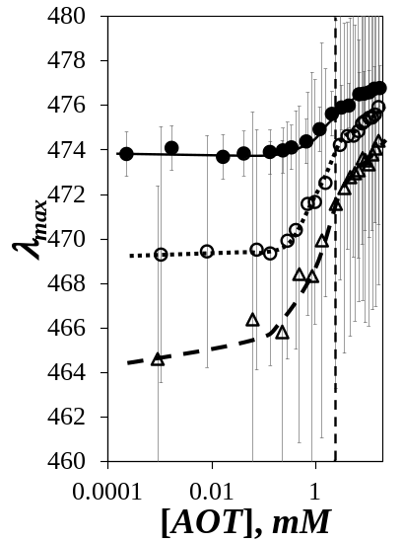  C)
Figure 10. Plots of () I₃₇₇/I₃₄₀ and () I_{E}/I_{M} ratios as a function of AOT concentration for the aqueous dispersions of A) 83Np/17Py-SNP and B) 97Np/3Py-SNP mixtures and C) plot of λ_{max} as a function of AOT concentration for aqueous dispersions of () Py(6.7)-SNP, () 83Np/17Py-SNP, and () 97Np/3Py-SNP.

As it turned out, the presence of AOT aggregates led to a partial decrease in interparticulate interactions as illustrated in Figures 10A and B from the decrease in the I₃₇₇/I₃₄₀ ratio with increasing AOT concentration observed for both the 83Np/17Py-SNP and 97Np/3Py-SNP mixtures. Although reduced, FRET still took place between Np(48)-SNPs and Py(6.7)-SNPs as demonstrated by the strong pyrene monomer fluorescence in Figures S2 and S3 even at high AOT concentration. These observations are consistent with the fact that, clustering of Py-SNPs around AOT aggregates subjected the Py-SNPs to increased osmotic pressure that shrank the SNP volume. Compression of the Py-SNPs excluded segments of other SNPs from their intrinsic volume. This exclusion was reflected by the decrease in FRET efficiency observed as the Np/Py-SNPs interacted with the AOT aggregates past the CMC. As segments of Np(48)-SNP were excluded from Py(6.7)-SNP, fewer pyrene labels interacted with naphthalene aggregates resulting in less efficient FRET. This proposal was further supported by monitoring the position (λ_{max}) of the excimer fluorescence intensity maximum when the 83Np/17Py-SNP and 97Np/3Py-SNP mixtures were excited at 346 nm. As can be seen in Figure 10C, λ_{max} shifted to lower wavelength at low AOT concentration with increasing Np(48)-SNP concentration indicating that increased interactions with Np(48)-SNPs yielded more excimer produced from poorly stacked pyrene labels. Interactions of Py(6.7)-SNP with a larger number of Np(48)-SNPs isolated the peripheral pyrene labels inside naphthalene aggregates thus resulting in lower I_{E}/I_{M} ratios reflecting less efficient excimer formation in the rigid Py(6.7)-SNP core where pyrene labels were less mobile. As the Np/Py-SNPs began to interact with the AOT aggregates, the high local SNP concentration resulted in an increase in osmotic pressure that led to the compression of the Py(6.7)-SNPs from which the Np(48)-SNPs were excluded. The I₃₇₇/I₃₄₀ ratio, and thus FRET efficiency, decreased and the I_{E}/I_{M} ratio, and thus PEF, increased in Figure 10. The more mobile peripheral pyrene labels enabled PEF between well-stacked pyrene labels and λ_{max} approached 475 nm, the value found for the pyrene excimer of the 13.5 mg/L Py(6.7)-SNP dispersion. A separate study on the effect of osmotic pressure on Py-SNPs is on-going and its results will be presented soon.
The fact that SDS did and AOT did no bind to SNPs was further supported by conducting competitive binding experiments between potassium triiodide (KI₃), SDS, and AOT. The results of this study were summarized in Figure 11.
The absorption of the triiodide anion in water is known to change from two sharp bands at 286 and 350 nm to a broad band at 650 nm upon binding onto starch. This transition is accompanied by a color change where the solution turns from yellowish (Cells A1 and A2 for Lugol solution in Figure 11) to pinkish (Cells B1 and B2) upon addition of amylopectin or SNP. If SDS was added to 0.14 mg/L aqueous dispersions of amylopectin (Cell C1, E1, G1) or SNP (Cell C2, E2, G2), the dispersions turned yellowish indicating that the triiodide anions had been displaced by SDS. By contrast, addition of AOT to the aqueous dispersions showed no difference in the pinkish coloration for amylopectin (cells D1, F1, H1) or SNP (Cells D2, F2, H2) demonstrating that AOT bound to neither amylopectin nor SNP for surfactant concentrations below, at, or above the CMC of the surfactants. The experiments described in Figure 11 demonstrated that SDS formed an inclusion complex with SNPs or maize amylopectin and AOT did not.

Amylopectin  [AP] = 0.14 g/L | [Surfactant] =  0 M |  | [Surfactant] ~  0.35 CMC |  | Surfactant ~ [CMC] |  | [Surfactant] ~  3.5 CMC
Amylopectin  [AP] = 0.14 g/L | Lugol solution  A1 | AP  B1 | 2.8 mM SDS  C1 | 0.9 mM AOT  D1 | 9.3 mM SDS  E1 | 2.8 mM AOT  F1 | 26.6 mM SDS  G1 | 9.3 mM AOT  H1
Amylopectin  [AP] = 0.14 g/L | 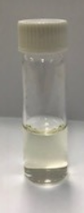 | 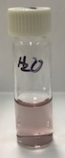 | 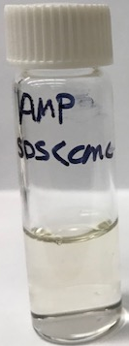 | 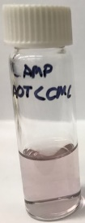 | 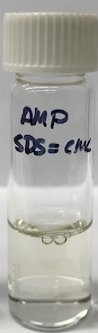 | 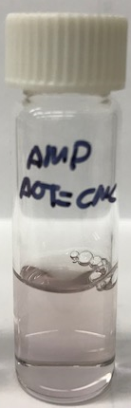 | 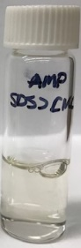 | 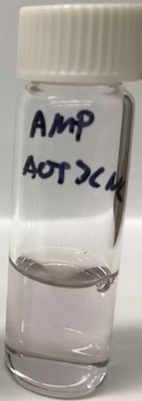
SNP  [SNP] = 0.14 g/L | [Surfactant] =  0 M |  | [Surfactant] ~  0.35 CMC |  | Surfactant ~ [CMC] |  | [Surfactant] ~  3.5 CMC
SNP  [SNP] = 0.14 g/L | Lugol Solution  A2 | SNP  B2 | 2.8 mM SDS  C2 | 0.9 mM AOT  D2 | 9.3 mM SDS  E2 | 2.8 mM AOT  F2 | 26.6 mM SDS  G2 | 9.3 mM AOT  H2
SNP  [SNP] = 0.14 g/L |  |  | 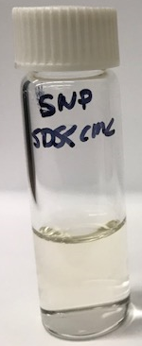 | 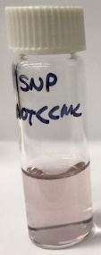 | 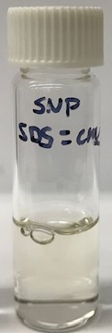 | 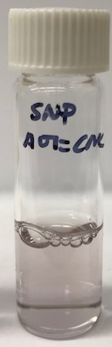 | 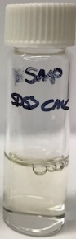 | 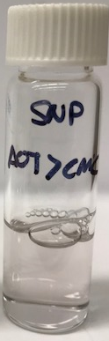
Figure 11. Color of the aqueous dispersions of 0.14 g/L SNP in the presence of KI₃ (1.0 mM I₂ and 16.8 mM KI) to which different amounts of SDS or AOT were added.
A schematic representation of the stabilization of individual Py-SNPs through the formation of inclusion complexes between SDS and starch is shown in Figure 12A. Aggregation between the hydrophobic pyrenyl labels occurs intra- and intermolecularly in water leading to the formation of interparticulate Py-SNP aggregates. Upon addition of SDS to the Py-SNP aqueous dispersions, SDS forms an inclusion complex with starch which introduces some negative charges on the Py-SNPs leading to the electrostatic stabilization of individual Py-SNPs and the disintegration of Py-SNP aggregates.

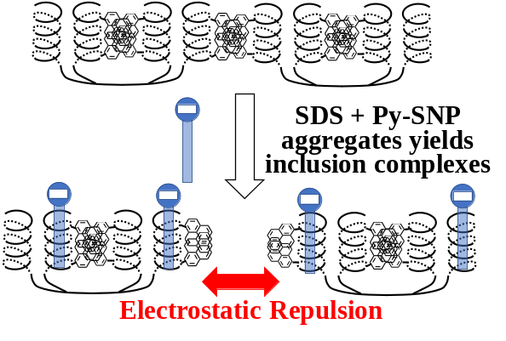  A) | 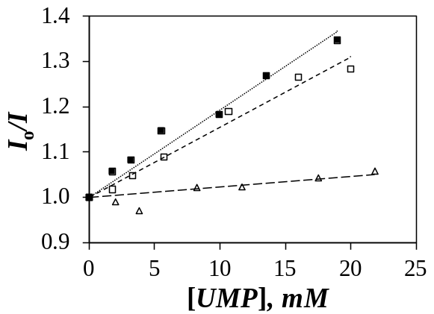  B)
Figure 12. A) Schematic representation of the stabilization of Py-SNPs through the formation of inclusion complexes between SDS and starch. B) Fluorescence quenching experiment of Py(0.06)-SNP with negatively charged disodium uridyl-5-monophosphate (5’-UMP) in () water, () 1 mM AOT, and () 1 mM SDS.

To further confirm the proposal given in Figure 12A, a fluorescence quenching experiment of Py(0.06)-SNP was conducted with disodium uridyl-5-monophosphate (5’-UMP), a known negatively charged quencher of pyrene. Binding of SDS to Py(0.06)-SNP should generate negative charges at the surface of the particles that should repel negatively charged species such as 5’-UMP, resulting in much less quenching than an aqueous dispersion of Py(0.06)-SNP in the presence of AOT. A Stern-Volmer plot was generated in Figure 12B where the ratio of the fluorescence intensity of P(0.06)-SNP without (I_{o}) to that with (I) 5’-UMP was represented as a function of 5’-UMP concentration. Quenching would lead to a decrease in I which would result in an increase in the ratio I_{o}/I as shown in Figure 12B for the Py(0.06)-SNP aqueous dispersions in water and with 1 mM AOT indicating that the pyrene labels were quenched similarly by 5’-UMP suggesting that they were equally accessible. By contrast, the aqueous dispersion of Py(0.06)-SNP showed hardly any quenching by 5’-UMP demonstrating that binding of SDS to the SNP yielded negatively charged particles that repelled 5’-UMP, a clear demonstration of the electrostatic stability imparted by the formation of inclusion complexes between SDS and the polysaccharide.

CONCLUSIONS
The ability of SDS and inability of AOT to form inclusion complexes with starch combined with the nature of the surfactant aggregates, small micelles with a diameter of 3.5 nm for SDS versus large colloidal objects for AOT, are believed to be the reason for the opposite behavior exhibited by the Py-SNPs upon interacting with SDS or AOT. Hydrophobically modified Py-SNPs aggregated in water, but formation of inclusion complexes with SDS resulted in the break-up of the Py-SNP aggregates enabled by their electrostatic stabilization. At the CMC of SDS, the small SDS micelles could penetrate the interior of the Py-SNPs where they solubilized the pyrene labels. By contrast, the branched structure of AOT prevented it from forming inclusion complexes with starch. Py-SNPs showed little to no interaction with AOT below the CMC of this surfactant. When AOT aggregates formed, their hydrophobic bilayers favored the binding of Py-SNP aggregates where the high local SNP concentration raised the osmotic pressure locally, resulting in the separation and compression of the Py/Np-SNPs at the surface of the AOT aggregates. The compression of the Py-SNPs led to an increase in PEF while their separation led to a decrease in FRET.
These studies have highlighted the complexity of the interactions between surfactants and HMSNPs. HMSNPs formed aggregates in water held together by strong hydrophobic interactions. These HMSNP aggregates might be able to dissociate in the presence of surfactants at surfactant concentrations lower than the CMC only if the surfactant can form an inclusion complex with starch. The nature of the interactions between HMSNP and surfactants at surfactant concentrations above their CMC depends on the nature of the entity the surfactants self-assemble into. Small micelles, which can diffuse inside HMSNPs, can interact with the hydrophobes located inside the SNPs while the interior of HMSNPs are inaccessible to large vesicles. In the presence of large surfactant vesicles, HMSNPs cluster at their surface. This study has demonstrated that replacing the hydrophobic pendants of HMSNPs by hydrophobic fluorophores like pyrene or naphthalene enabled the use of powerful fluorescence techniques (PEF or FRET) to probe the molecular interactions that take place in water between HMSNPs and surfactants.

ACKNOWLEDGMENTS
The authors thank EcoSynthetix and the Natural Sciences and Engineering Council of Canada (NSERC) for funding. The authors are also indebted to with Mr. Kuska and Drs. Bloembergen, McLennan, Mesnager, and Smeets for numerous informative discussions.

SUPPORTING INFORMATION
CMC determination of AOT; fluorescence spectra obtained with mixtures of Py/Np-SNPs and AOT; example of fluorescence decay fit; parameters retrieved from the analysis of the fluorescence decays.

REFERENCES . Delcour, J. A.; Bruneel, C.; Derde, L. J.; Gomand, S. V.; Pareyt, B.; Putseys, J. A.; Wilderjans, E.; Lamberts, L. Fate of Starch in Food Processing : From Raw Materials to Final Food Products. Ann. Rev. Food Sci. Technol. 2010, 1 87–111.
. Hancock, R. D.; Tarbet, B. J. The Other Double Helix – The Fascinating Chemistry of Starch. J. Chem. Ed. 2000, 77, 988–992.
. Campos, E.; Branquinho, J.; Carreira, A. S.; Carvalho, A.; Coimbra, P.; Ferreira, P.; Gil, M. H. Designing Polymeric Microparticles for Biomedical and Industrial Applications. Eur. Polym. J. 2013, 49, 2005–2021.
. Rayner, M.; Marku, D.; Eriksson, M.; Sjöö, M.; Dejmek, P.; Wahlgren, M. Biomass-Based Particles for the Formulation of Pickering Type Emulsions in Food and Topical Applications. Colloids Surf. A 2014, 458, 48–62.
. Lehmann, A.; Volkert, B.; Fisher, S.; Schrader, A.; Nerenz, H. Starch Based Thickening Agents for Personal Care and Surfactant Systems. Colloids Surf. A 2008, 331, 150–154.
. Bhosale, R.; Singhal, R. Process Optimization for the Synthesis of Octenyl Succinyl Derivative of Waxy Corn and Amaranth Starches. Carbohydr. Polym. 2006, 66, 521–527.
. He, J.; Liu, J.; Zhang, G. Slowly Digestible Waxy Maize Starch Prepared by Octenyl Succinic Anhydride Esterification and Heat – Moisture Treatment: Glycenic Response and Mechanism. Biomacromolecules 2008, 9, 175–184.
. Yu, H.; Huang, G. Enhanced in Vitro Anti-Cancer Activity of Curcumin Encapsulated Hydrophobically Modified Starch. Food CHem. 2010, 119, 669–674.
. Hategekimana, J.; Bwengye, M. K.; Masamba, K. G.; Yokoyama, W.; Zhong, F. Formation and Stability of Vitamin E Enriched Nanoemulsions Stabilized by Octenyl Succinic Anhydride Modified Starch. Inter. J. Food Eng. 2014, 10, 633-643.
. Kang, B. G.; Yoon, S. H.; Lee, S. H.; Yie, J. E.; Yoon, B. S.; Suh, M. H. Studies on the Physical Properties of Modified Starch- Filled HDPE Film. J. Appl. Polym. Sci. 1996, 60, 1977–1984.
. Tuovinen, L.; Peltonen, S.; Järvinen, K. Drug Release from Starch-Acetate Films. J. Controlled Release 2003, 91, 345–354.
. Kim, D.; Amos, R.; Gauthier, M.; Duhamel, J. Applications of Pyrene Fluorescence to the Characterization of Hydrophobically Modified Starch Nanoparticles. Langmuir 2018, 34, 8611-8621.
. Simi, C. K.; Abraham, T. E. Hydrophobic Grafted and Cross-Linked Starch Nanoparticles for Drug Delivery. Bioprocess Biosyst. Eng. 2007, 30, 173–180.
. Cheng, L.; Guo, H.; Gu, Z.; Li, Z.; Hong, Y. Effects of Compound Emulsifiers on Properties of Wood Adhesive with High Starch Content. Inter. J. Adhes. Adhes. 2017, 72, 92-97.
. Santander-Ortega, M. J.; Stauner, T.; Loretz, B.; Ortega-Vinuesa, J. L.; Bastos-Gonzalez, D.; Wenz, G.; Schaeffer, U. F.; Lehr, C. M. Nanoparticles Made from Novel Starch Derivatives for Transdermal Drug Delivery. J. Controlled Release 2010, 141, 85–92.
. Magnusson, E.; Nilsson, L. Interactions between Hydrophobically Modified Starch and Egg Yolk Proteins in Solution and Emulsions. Food Hydrocolloids 2011, 25, 764-772.
. Marku, D.; Wahlgern, M.; Rayner, M.; Sjöö, M.; Timgren, A. Charaacterization of Starch Pickering Emulsions for Potential Applications in Topical Formulations. Inter. J. Pharm. 2012, 428, 1-7.
. Jonhed, A.; Järnström, L. The Interaction Between Surfactants and 2-Hydroxy-3-(N,N-dimethyl-N-dodecylammonium)-propyloxy Starches. Starch/Staerke 2006, 58, 561-571.
. Eliasson, A.-C.; Finstad, H.; Ljunger, G. A Study of Starch-Lipid Interactions for Some Native and Modified Maize Starches. Starch/Staerke 1988, 40, 95-100.
. Petkova-Olsson, Y.; Altun, S.; Ullsten, H.; Järnström, L. Temperature Effect on the Complex Formation between Pluronic F127 and Starch. Carbohydr. Polym. 2017, 166, 264-270.
. Li, Z.; Wang, J.; Cheng, L.; Gu, Z.; Hong, Y.; Kowalczyk, A. Improving the Performance of Starch-Based Wood Adhesive by Using Sodium Dodecyl Sulfate. Carbohydr. Polym. 2014, 99, 579-583.
. Beeren, S. R.; Hindsgaul, O. Nature’s Dendrimer: Characterizing Amylopectin as a Multivalent Host. Angew. Chem. Int. Ed. 2013, 52, 11265-11268.
. Lakowicz, J. R. Principles of Fluorescence Spectroscopy 2nd Ed., Kluwer Acad. New York, 1999.
. Winnik, F. M. Photophysics of Preassociated Pyrenes in Aqueous Polymer Solutions and in Other Organized Media. Chem. Rev. 1993, 93, 587-614.
. Winnik, F. M.; Regismond, S. T. A. Fluorescence Methods in the Study of the Interactions of Surfactants with Polymers. Colloids Surf. A 1996, 118, 1-39.
. Li, L.; Duhamel, J. Conformation of Pyrene-Labeled Amylose in DMSO Characterized with the Fluorescence Blob Model. Macromolecules 2016, 49, 7965-7974.
. Chen, S.; Duhamel, J.; Peng, B.; Zaman, M.; Tam, K. C. Interactions between a Series of Pyrene End-Labeled Poly(ethylene oxide)s and Sodium Dodecyl Sulfate in Aqueous Solution Probed by Fluorescence. Langmuir 2014, 30, 13164-13175.
. Siu, H.; Duhamel, J. Associations between a Pyrene-Labeled Hydrophobically Modified Alkali Swellable Emulsion Copolymer and Sodium Dodecyl Sulfate Probed by Fluorescence, Surface Tension, and Rheology. Macromolecules 2006, 39, 1144-1155.
. Chen, S.; Siu, H.; Duhamel, J. Interactions between Hydrophobically Modified Alkali-Swellable Emulsion Polymers and Sodium Dodecyl Sulfate Probed by Fluorescence and Rheology. J. Phys. Chem. B 2014, 118, 351-361.
. Hu, Y.-Z.; Zhao, C.-L.; Winnik, M. A.; Sundararajan, P. R. Fluorescence Studies of the Interactions of Sodium Dodecyl Sulfate with Hydrophobically Modified Poly(ethylene oxide). Langmuir 1990, 6, 880-883.
. Anghel, D. F.; Toca-Herrera, J. L.; Winnik, F. M.; Rettig, W.; v. Kliting, R. Steady-State Fluorescence Investigation of Pyrene-Labeled Poly(acrylic Acid)s in Aqueous Solution and in the Presence of Sodium Dodecyl Sulfate. Langmuir 2002, 18, 5600-5606.
. Duhamel, J. Global Analysis of Fluorescence Decays to Probe the Internal Dynamics of Fluorescently Labeled Macromolecules. Langmuir 2014, 30, 2307-2324.
. Cuniberti, C.; Perico, A. Intramolecular Excimer Formation in Polymers. Eur. Polym. J. 1980, 16, 887–891.
. Berlman, I. B. Energy Transfer Parameters of Aromatic Compounds. Academic Press, New York, 1973.
. Birks, J. B. Photophysics of Aromatic Molecules. Wiley: New York, 1970; pp. 301.
. Fowler, M.; Duhamel, J.; Qiu, X.-P.; Korchagina, E.; Winnik, F. M. Temperature-Controlled Interactions Between Poly(N-isopropylacrylamide) Mesoglobules Probed by Fluorescence. Macromolecules 2018, 51, 1946-1956.
. Thapa, U.; Ismail, K. Urea Effect on Aggregation and Adsorption of Sodium Dioctylsulfosuccinate in Water. J. Colloid Interface Sci. 2013, 406, 172-177.
. Puitseys, J.-A.; Lamberts, L.; Delcour, J. A. Amylose-Inclusion Complexes : Formation, Identity, and Physico-Chemical Properties. J. Cereal Sci. 2010, 51, 238-247.
. Simmons, B. A.; Irvin, G. C.; Agarwal, V.; Bose, A.; John, V. T.; McPherson, G. L.; Balsara, N. P. Samll Angle Neutron Scattering Study of Microstructural Transitions in a Surfactant-Based Gel Mesophase. Langmuir 2002, 18, 624-632.
. Nagarajan, R. Molecular Packing Parameter and Surfactant Self-Assembly: The Neglected Role of the Surfactant Tail. Langmuir 2002, 18, 31-38.
. Israelachvili, J. N.; Mitchell, D. J.; Ninham, B. W. Theory of Self-Assembly of Hydrocarbon Amphiphiles into Micelles and Bilayers. J. Chem. Soc., Faraday Trans. 1976, 2, 1525-1568.
. Karve, M. S.; Kale, N. R. A Spectrophotometric Method for the Determination of Iodine Binding Capacity for Starch and its Components. Starch/Stärke 1992, 44, 19-21.
. Lopez, F.; Cuomo, F.; Ceglie, A.; Ambrosone, L.; Palazzo, G. Quenching and Dequenching of Pyrene Fluorescence by Nucleotide Monophosphates in Cationic Micelles. J. Phys. Chem. B 2008, 112, 7338-7344.
. Raimbault, J.; Casier, R.; Little, H.; Duhamel, J. Hydrophobic and Elastic Forces Experienced by a Series of Pyrene End-Labeled Poly(ethylene oxide)s Interacting with Sodium Dodecyl Sulfate Micelles. Macromolecules 2018, 51, 5933-5943. Table of Contents 