Supporting Information

Friction and Adhesion of Microparticle Suspension on Repellent Surfaces
Kiran Raj M, Sirshendu Misra, Sushanta K. Mitra*
Micro & Nano-scale Transport Laboratory, Waterloo Institute for Nanotechnology, Department of Mechanical and Mechatronics Engineering, University of Waterloo, 200 University Avenue West, Waterloo, Ontario N2L 3G1, Canada

Contents:
S1. Calibration of the cantilever
S2. Interfacial tension (IFT) of particle laden droplet
S3. Tilt angle measurement for indirect estimation of friction force
S4. Reflection interference contrast microscopy (RICM) with particle laden droplet
S5. Effect of substrate velocity(U) in friction measurement
S6. FTIR (Fourier-transform infrared spectroscopy) of the coatings
S7. Video of adhesion and friction experiments
S6.1 Video of adhesion measurement (Video S1)
S6.2 Video of friction measurement (Video S2)

S1. Calibration of the cantilever
Figure S1. Calibration of the cantilever. (a) Oil droplet placed on the cantilever. Δz is the deflection (b) The force deflection curve.

Table S1. Estimation of force-displacement characteristics of the cantilever from calibration data
Vol. of droplet, V (μl) | Mass of droplet, m = ρV (μg) | Force, F = mg (μN) | Δz (μm)
0 | 0 | 0 | 0
5 | 9.5 | 93.195 | 383.643
10 | 19 | 186.39 | 682.137
15 | 28.5 | 279.585 | 998.698
20 | 38 | 372.78 | 1120.577

Laser oil with density, ρ = 1900kg/m³ is used for the calibration. Oil drops of varying volume (V) are dispensed to the tip of the cantilever as shown in Figure S1(a) and the corresponding vertical deflection Δz is recorded. The weight of the droplet then gives the force acting on the cantilever tip as F = mg where g is the acceleration due to gravity (9.81 m/s²) and mass m = ρV. The values obtained from the calibration experiment are tabulated in Table S1 and the force-deflection curve is plotted in Figure S1(b). The slope of this linear curve then gives the stiffness constant of the cantilever k from the spring equation given by F = kΔz. For each volume, the experiment was repeated three times to obtain a reliable value of the spring constant for the capillary tube used in this work.

S2. Interfacial tension (IFT) of particle laden droplet
Figure S2. IFT measured for different concentration of the microparticles in aqueous solution used in the present experiment (a) Image of the pendant drop captured for image analysis (b) Variation of IFT with concentration (0 represents DI water (no particles)).
IFT was measured using a pendant drop method based on the Young-Laplace equation given by
$∆P=γ\left(\frac{1}{R1}+\frac{1}{R2}\right)$.
Here, ΔP is the pressure difference between either side of an interface having R₁, R₂ as the principal radii of curvature and γ is the IFT. In this method, the image of a small droplet that is dosed from a metallic needle and suspended in the open air is captured using a high magnification camera as shown in Figure S2 (a). A custom-made image processing algorithm¹ is then employed to estimate the IFT which iteratively attempts to fit the above equation on the identified interface on captured image to yield γ and is plotted in Figure S2 (b).

S3. Tilt angle measurement for indirect estimation of friction force
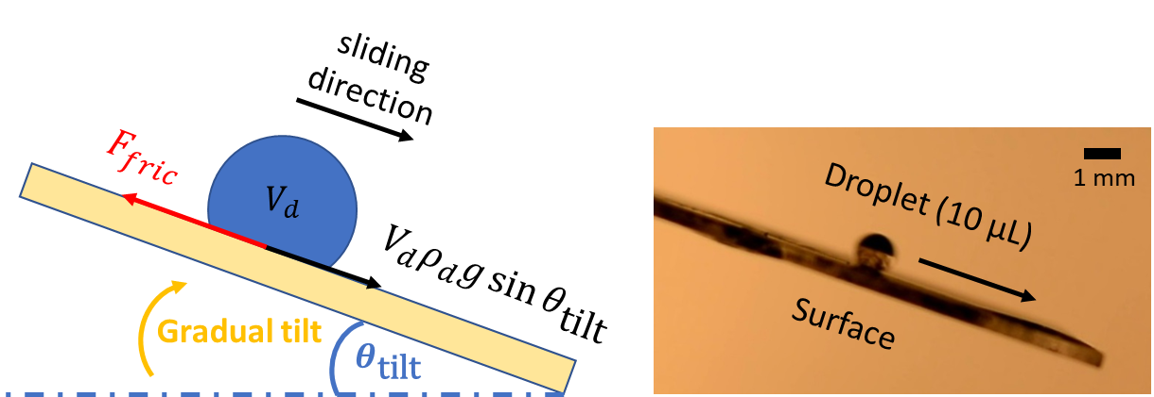
(b)
(a)

Figure S3. (a) Schematic of the sliding experiment used to measure the tilt angle required for a droplet to start sliding down the surface, (b) an experimental snap showing a 10 µL droplet sliding down a tilted repellent surface.
First, a droplet is of desired volume (here 10 µL) is placed on the target substrate and then the substrate is gradually tilted till the droplet starts sliding down the incline. The tilt angle when the droplet starts sliding is denoted as $θ_{\text{tilt}}$. Just when the drop starts sliding, the weight component of the droplet acting along the incline balances with the droplet-surface friction ($F_{fric}$), which yields
$F_{fric}=V_{d}ρ_{d}g\sin{θ_{\text{tilt}}}$ ,
where $V_{d}$ and $ρ_{d}$ are the volume and density of the droplet, respectively, g is the acceleration due to gravity.
The friction force thus estimated was then compared against the value directly measured using our capillary deflection force sensor. As an example, a 10 µL water droplet showed $θ_{\text{tilt}}= 16.33° ± 1.76°$ on S1 (soot) surface, which results in $F_{fric}=27.55 ±2.36 μN$, while our force apparatus registered a friction value of $36.78±9.65 μN$.

S4. Reflection interference contrast microscopy (RICM) with particle laden droplet
In order to probe the capillary bridges formed at the droplet-solid interface we have carried out RICM using a confocal microscope (Zeiss). The sample with Glaco coating (S2) is placed on the microscope stage and a droplet laden with microparticles (concentration = 5 % w/v) is slowly dispensed on the coated surface using a micropipette. Monochromatic laser beam with a wavelength λ = 532nm is focused on the interface and raster scanned over an area of 500μm x 500μm with a 40x objective lens as shown in Figure S4 (a). Due the thin film interference at the curved capillary bridge, alternate dark and bright fringes are formed which is recorded on the camera attached to the microscope as shown in Figure S4 (b).
Figure S4. (a) Schematic of the RICM showing the objective lens which focuses the laser beam to the sample and collect the reflected rays to form image on the camera (b) The fringes formed due to interference at the capillary bridge. Scalebar represents 10μm.

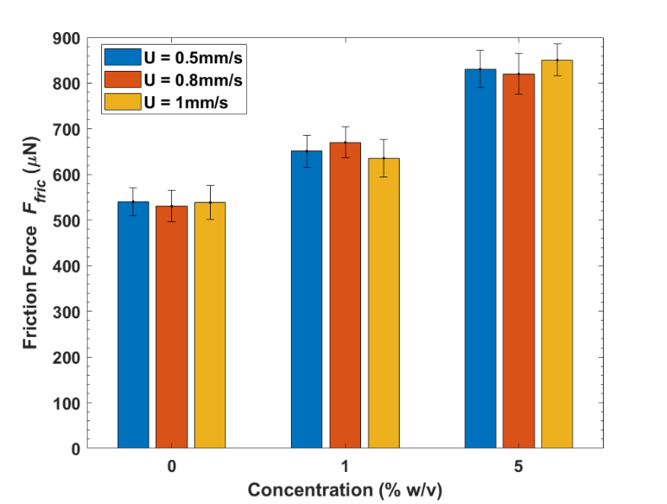
S5. Effect of substrate velocity(U) in friction measurement
Figure S5. Friction force (F_{fric}) measured for different U for the case of S2 for the range of concentration of the microparticles used in the present study. Error bars represent the standard deviation from three runs of experiments.
To investigate the effect of contact line velocity on the friction measurement, the velocity of translation of the substrate (S2) was varied in the range U = 0.5-1 mm/s and the corresponding friction force (F_{fric}) was measured using the method described in the main text. For a given concentration, no significant variation of the F_{fric} was observed, as shown in Figure S5. However, the increase in F_{fric} was observed with increase in the concentration of microparticles as shown in Figure 4(b) in the main text.

S6. FTIR (Fourier-transform infrared spectroscopy) of the coatings
ATR (Attenuated total reflectance) FTIR spectra were recorded at room temperature in the mid IR range (400–4000 cm⁻¹) on a Bruker Vertex Series FTIR spectrometer using Platinum ATR accessory with a single reflection diamond crystal as shown in Figure S6. Typical features of a silicone coating like Si-CH₃, Si-O-Si, C-F are visible for both S2 and S3 due to the constituent ingredients.^{3–5} These were absent in S1 (soot) as it is mostly carbon deposition. Probing at 4-5 random locations for each of the coatings showed similar spectra and thus we conclude that the coating is uniform, without any chemical inhomogeneities.
Figure S6. Transmittance FTIR spectra of the three samples studied. The prominent peaks and corresponding functional groups are identified based on the available literature.

S7. Video of adhesion and friction experiments
The following videos shows the actual experimental recordings corresponding to the adhesion and friction measurement using the experimental setup described in the present study. In both cases, the tip of the cantilever is tracked using the image processing routine to estimate the deflection.⁶
S7. 1. The steps followed in the measurement of adhesion in which a vertically placed sample is moved against the droplet attached to cantilever and then retracted (Video S1).
S7. 2. The friction experiment in which a horizontally placed sample is moved with respect to the droplet attached to the cantilever (Video S2).

References
(1) Berry, J. D.; Neeson, M. J.; Dagastine, R. R.; Chan, D. Y. C.; Tabor, R. F. Measurement of Surface and Interfacial Tension Using Pendant Drop Tensiometry. J. Colloid Interface Sci. 2015, 454, 226–237.
(2) Bhushan, B.; Jung, Y. C. Natural and Biomimetic Artificial Surfaces for Superhydrophobicity, Self-Cleaning, Low Adhesion, and Drag Reduction. Prog. Mater. Sci. 2011, 56 (1), 1–108.
(3) Anderson, D. R.; Smith, A. L. Analysis of Silicones. Wiley-Interscience, New York 1974, 247.
(4) Bellany, L. J. The Infrared Spectra of Complex Molecules. Chapman Hall, London 1975, 1.
(5) Smith, A. L.; Harnly, J. M. Spectrochim. Aeta 1960, 16, 87.
(6) Brown, D. Tracker Free Video Analysis and Modeling Tool for Physics Education. Open Source Phys. comPADRE, USA 2012.

