Probing the Interactions between Mimics of Pour Point Depressants (PPDs) and Viscosity Index Improvers (VIIs) in Engine Oil Using Fluorescently Labeled PPDs

Kiarash Gholami,¹ Sheng Jiang,² Jean Duhamel*^{,1}

¹ Institute for Polymer Research, Waterloo Institute for Nanotechnology, Department of Chemistry, University of Waterloo, Waterloo, ON N2L 3G1, Canada
² Afton Chemical Corporation, 500 Spring Street, Richmond, VA 23219, USA

* To whom correspondence should be addressed.

ABSTRACT
The level of interpolymeric interactions experienced by a pyrene-labeled poly(octadecyl methacrylate) labeled with 6.7 mol% of 1-pyrenebutanol (Py(6.7)-PC₁₈MA) was characterized by fluorescence in the presence of an amorphous (EP(AM)) and a semicrystalline (EP(SM)) ethylene propylene copolymer. These polymers belong to different families of engine oil additives. The fluorescence spectra of Py(6.7)-PC₁₈MA solutions in engine oil were acquired and analyzed to obtain f_{inter}, the molar fraction of pyrene labels that formed excimer intermolecularly upon encounter between an excited and a ground-state pyrene. The fraction f_{inter} was measured as a function of solution temperature between −30 and +25 ºC. The f_{inter}-vs-T profiles obtained for Py(6.7)-PC₁₈MA showed a sharp transition between +10 and +15 ºC indicating an increase in intermolecular interactions at temperatures lower than the transition. This behavior was attributed to the crystallization of the PC₁₈MA octadecyl side chains. Addition of EP(AM) resulted in an increase in interpolymeric interactions between Py(6.7)-PC₁₈MA macromolecules at all solution temperatures studied. Addition of EP(SM) increased f_{inter} for Py(6.7)-PC₁₈MA at high temperatures, but at lower temperatures where EP(SM) formed microcrystals, f_{inter} for Py(6.7)-PC₁₈MA returned to its original value when no EP(SM) was present in solution. These trends indicated that PC₁₈MA interacted with the EP copolymers as long as the copolymers remained solvated. Crystallization of EP(SM) released the polyolefin from PC₁₈MA and PC₁₈MA resumed its original level of intermolecular interactions as if no polyolefin was present in the solution. These experiments extended our earlier finding established with pyrene-labeled EP copolymers that f_{inter} is a powerful analytical means to quantify the level of intermacromolecular interactions taking place during the crystallization of polymers and monitor their interactions with other macromolecules in solution.

INTRODUCTION
The ability of an engine oil to flow at low temperature and maintain a relatively high viscosity at high temperature is essential for the proper operation of internal combustion engines. Unfortunately, wax, which is left in the engine oil to help the oil maintain a higher viscosity at high temperatures, hinders the oil flow at low temperatures by forming crystals. As wax crystals grow in size as the temperature decreases, they aggregate and form a 3D network., Expansion of this network of wax crystals in the oil results in the formation of a gel which prevents oil flow, a regime that can lead to engine failure. The control of wax crystal growth and engine oil viscosity is handled by using, respectively, power point depressants (PPDs) and viscosity index improvers (VIIs) which are the two main polymeric additives employed in engine oils.⁻
The lowest temperature at which the oil is still capable of flowing is called the pour point (PP).¹⁻⁷ Additives used to lower the PP of an engine oil are referred to as PPDs. Alkyl aromatic polymers and poly(alkyl methacrylate)s (PAMAs) are two important families of PPDs used by the lubricants industry. Both types of PPDs interact with wax in a way that perturbs the growth of wax crystals, and thus delays the formation of a wax crystal network at lower solution temperatures. PAMAs have become important polymeric additives that have been employed to effectively reduce the PP of engine oils since the late 1930s.^{-,} The main reason for the widespread acceptance of PAMA by the oil additive industry resides in the easy variation in chemical composition that can be introduced into PAMAs. Typical PAMAs used as PPDs are constituted of two alkyl methacrylate monomers bearing alkyl side chains of various length.¹⁰⁻ With regard to PPD concentration, low concentrations of PPD might not be able to sufficiently reduce the engine oil PP, whereas higher concentrations might result in its crystallization in oil accompanied by a loss of its activity.⁹ Therefore, the concentration of a PPD in engine oil needs to be optimized.
VIIs are meant to counteract the inherent decrease in oil viscosity that occurs upon increasing the oil temperature.^{7,,} The magnitude of the decrease in oil viscosity upon increasing temperature is called the viscosity index (VI), a low VI corresponding to an oil whose viscosity decreases substantially with increasing temperature. Since the good operation of an engine depends on the even flow of the oil regardless of temperature, the oil industry is interested in controlling the oil viscosity within a narrow range, hence the need to increase the VI of the oil by using VIIs. VIIs are polymers such as ethylene propylene (EP) copolymers that accomplish this task by undergoing a coil expansion upon increasing the temperature.^{7,13,14} Since the viscosity of a polymer solution increases when the fraction of the solution volume occupied by the polymer increases, a polymer whose coil expands in oil upon increasing the solution temperature will counteract the decrease in viscosity associated with the increase in temperature.
The different oil additives used in the industry all have a specific purpose, PPDs and VIIs being designed to lower the PP and control the VI of the oil, respectively, and they need to achieve their task optimally without detrimental interactions with one another. For this reason, techniques that provide information on the level of interpolymeric interactions between polymeric additives used by the oil industry are particularly interesting. By fluorescently labeling a polymer with the dye pyrene, this laboratory has established that pyrene excimer fluorescence (PEF) can be applied to provide the molar fraction (f_{inter}) of pyrene labels attached onto a polymer that form excimer intermolecularly, a measure of the level of interpolymeric interactions.^{7,-} Taking advantage of this feature, a poly(octadecyl methacrylate), where 6.7 mol% of the methacrylate units had been labeled with 1-pyrenebutanol (Py(6.7)-PC₁₈MA), was used as a PPD mimic and its fluorescence signal was employed to determine f_{inter} as a function of temperature in a group II engine oil in the absence and presence of ethylene-propylene (EP) copolymers used as VII mimics. Comparison of the f_{inter}-vs-temperature plots obtained for Py(6.7)-PC₁₈MA in oil in the absence and presence of an amorphous (EP(AM)) and a semicrystalline (EP(SM)) EP copolymer provided direct evidence of the level of interactions existing between these polymeric species in oil.

EXPERIMENTAL
Chemicals. 1-Pyrenebutanol (99%), stearyl methacrylate (C₁₈MA), poly(dodecyl methacrylate) (PC₁₂MA) were purchased from Sigma-Aldrich and were employed without further purification. The preparation and characterization of Py(5.6)-PC₁₂MA, Py(6.7)-PC₁₈MA, and Py(14.1)-PC₁₈MA by free radical copolymerization of 1-pyrenebutyl methacrylate and dodecyl or octadecyl methacrylate have been described earlier. The majority of the fluorescence measurements in the present study were carried out with Py(6.7)-PC₁₈MA. A Group II engine oil and two ethylene-propylene copolymers, one semicrystalline (EP(SM)) and one amorphous (EP(AM)), were supplied by Afton Chemical Corporation. The main features of all polymers used in this study are presented in Table 1.
Synthesis of PC₁₈MA. C₁₈MA) was washed three times with a 10 wt% NaOH solution and dried over anhydrous MgSO₄. The recovered monomer was then polymerized using conventional free radical polymerization with azobisisobutyronitrile (AIBN) as the initiator. To a dry Schlenk tube C₁₈MA (4.68 g, 0.014 mol), AIBN (0.0023 g, 14 mol) and 46 mL of tetrahydrofuran (THF) were added. The tube was placed on ice and the solution was then degassed with dry nitrogen for 1 hour. The tube was sealed and then placed in an oil bath at 65 °C for 18 hours. The polymer was precipitated in methanol and then re-dissolved in THF. This precipitation cycle was repeated three more times to obtain a pure white solid.

Table 1. Number (M_{n}) and weight (M_{w}) average molecular weight, dispersity (Đ), ethylene content, pyrene content, and chemical structures of polymers used in this study.
Chemical structure | Sample name | M_{n}  (kg.mol⁻¹) | M_{w}  (kg.mol⁻¹) | Đ
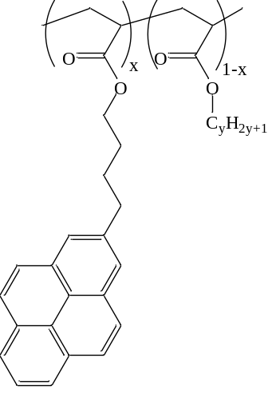 | PC₁₈MA  (x = 0.000)  (y = 18) | 620 | 1,240 | 2.0
 | Py(6.7)-PC₁₈MA  (x = 0.067)ª  (y = 18) | 720 | 1,070 | 1.5
 | Py(14.1)-PC₁₈MA  (x = 0.141)ª  (y = 18) | 770 | 1,120 | 1.5
 | PC₁₂MA  (x = 0.000)  (y = 12) | 290 | 570 | 2.0
 | Py(5.6)-PC₁₂MA  (x = 0.056)ª  (y = 12) | 510 | 870 | 1.7
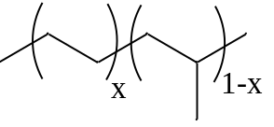 | EP(AM)  (x = 0.60)^{b} | 59.0 | 125 | 2.1
 | EP(SM)  (x = 0.68)^{b} | 22.8 | 146 | 6.4
- Determined by UV-Vis spectroscopy.
- Determined by ¹³C NMR.

Gel Permeation Chromatography (GPC). The number (M_{n}) and weight (M_{w}) average molecular weights for the PC₁₂MA, Py(5.6)-PC₁₂MA, PC₁₈MA, Py(6.7)-PC₁₈MA, and Py(14.1)-PC₁₈MA samples were determined with a Viscotek GPC device equipped with a 305 Triple Detector Array that included a differential refractive index (DRI), viscosity, and light scattering detector using a 1 mL/min flow rate. A Polymer Char high-temperature gel permeation chromatograph (GPC) was used to calculate the molecular weight distribution of the EP samples at 145 °C and with a flow rate of 1 mL/min of 1,2,4-trichlorobenzene (TCB). The GPC instrument was equipped with three detectors, namely a 15º angle light scattering, differential refractive index, and differential viscosity detectors.
Ultraviolet-Visible Spectrophotometer. A Cary 100 and a Cary 5000 UV-Vis spectrophotometer were used to obtain the absorbance of all the solutions in the 200–600 nm wavelength range using quartz cells with 0.1 and 10 mm path length.
Steady-State Fluorometer. The SSF spectra of the Py(6.7)-PC₁₈MA solutions were acquired using a Photon Technology International (PTI) LS-100 fluorometer with a PTI 814 photomultiplier detection system and an Ushio UXL-75Xe xenon arc lamp. For low concentrations of the Py(6.7)-PC₁₈MA between 0.01 and 0.1 g.L⁻¹, a square cell was used to acquire the fluorescence spectra with the right-angle geometry. For higher Py(6.7)-PC₁₈MA concentrations such as 10 g.L⁻¹, a triangular cell was used with the front-face geometry to avoid the inner filter effect when acquiring the fluorescence spectra. To ensure removal of oxygen from the solution, all solutions in oil were degassed for 50-60 minutes under a gentle flow of N₂ before being sealed with a Teflon stopper.⁹ The solutions were excited at a wavelength of 344 nm, and their emission spectra were acquired between 350 and 600 nm. Background corrections were also applied to remove the contribution from the light scattered by the polymer solutions in oil. The fluorescence intensity ratio of the excimer over the monomer, namely the I_{E}/I_{M} ratio, was obtained by integrating the fluorescence signal under the SSF spectra from 372 to 378 nm and from 500 to 530 nm for the pyrene monomer (I_{M}) and excimer (I_{E}) fluorescence intensity, respectively.
Analysis of the SSF Spectra: The molar fraction (f_{inter}) of pyrene labels of the Py-PC₁₈MA samples forming excimer intermolecularly, a quantitative measure of the level of intermolecular interactions between PC₁₈MA macromolecules, was determined by taking advantage of the inherent dependency of the I_{E}/I_{M} ratio on the local pyrene concentration [Py]_{loc} experienced by an excited pyrene. Two fluorescence spectra were acquired, one with a solution of pure Py(6.7)-PC₁₈MA (typically 2.0 g.L⁻¹ in oil) and another containing a mixture of 0.01 g.L⁻¹ of Py(6.7)-PC₁₈MA and 2.0 g.L⁻¹ of unlabeled PC₁₈MA to yield the ratios I_{E}/I_{M}(inter&intra) and I_{E}/I_{M}(intra) which were equal to the products K×[Py]_{loc}(inter&intra) and K×[Py]_{loc}(intra), respectively. The proportionality constant K is a function of all rate constants involved in the process of pyrene excimer formation.^{7,15-17} The molar fraction f_{inter} was then obtained according to Equation 1. Taking the ratio of the I_{E}/I_{M} ratios in Equation 1 eliminated the constant K.
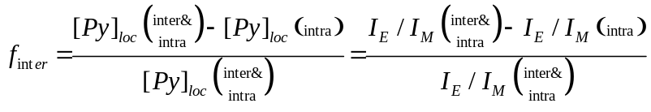 (1)
Cryostat. A cryostat from Oxford Instruments (Optistat DN) was used to run the fluorescence measurements at temperatures ranging from as low as −45 (± 0.2) °C to +25 (± 0.2) °C. To this end, the fluorescence cell containing the degassed solutions was inserted inside the cryostat and the instrument was placed in the steady-state fluorometer. The solutions were cooled down to the lowest temperature required for their f_{inter} study. The temperature of each solution was then increased in 5 °C increments until the maximum temperature (+25 °C) was reached. The solution was left in the cryostat for 5 min after the set temperature of the cryostat had been reached to ensure accuracy and stability of the solution temperature. The fluorescence spectrum was then acquired at that temperature.
Time-Resolved Fluorescence. The Py(6.7)-PC₁₈MA solutions were excited at 344 nm with an IBH time-resolved fluorometer equipped with a 340 nm nano-LED as the excitation source. Model free analysis (MFA) was applied to fit the acquired fluorescence decays with light scattering and background corrections., The monomer and excimer fluorescence decay curves of the Py(6.7)-PC₁₈MA solutions were fit globally to yield the average rate constant <k> of pyrene excimer formation by diffusive encounters and the molar fractions f_{diff}, f_{free}, and f_{agg} of the pyrene labels that formed excimer by diffusion, did not form excimer and behaved as if they were free in solution, and were aggregated and formed excimer by direct excitation, respectively. The pyrene labels that formed or did not form excimer by diffusion had a natural lifetime τ_{M}. A dilute 3.0×10⁻⁶ M solution of 1-pyrenebutanol was employed to determine τ_{M} for the pyrene labels of Py(6.7)-PC₁₈MA in oil as a function of temperature. Two excimer species were considered in the MFA, those that were constituted of two well-stacked (E0*) and two poorly stacked (D*) pyrene labels that emitted with their natural lifetime τ_{E0} and τ_{D}, respectively. The molar fractions of the pyrene monomers that formed the excimer E0* by diffusive encounters of two pyrene labels and by direct excitation of a pyrene aggregate were referred to as f_{diff} and f_{E0}, respectively. This version of the MFA assumed that D* could only be formed through direct excitation of pyrene aggregates involving a molar fraction (f_{D}) of pyrene labels. The overall molar fraction of aggregated pyrenes (f_{agg}) equaled the sum f_{E0}+f_{D}. The parameters retrieved form the MFA were combined to yield the absolute ratio of excimer to monomer referred to as (I_{E}/I_{M})^{TRF} which is given in Equation 2.

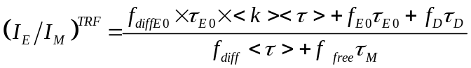 (2)

The global MFA for each pair of monomer and excimer decays was considered good if the obtained χ² was smaller than 1.30 and the residuals and their autocorrelation were randomly distributed around zero. An in-depth description of the MFA of the fluorescence decays acquired with pyrene-labeled macromolecules can be found in earlier publications.^{20,21}

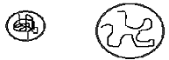
RESULTS AND DISCUSSION
V_{h} (Low Temp.)
Oil
Temperature
Viscosity
Oil + VIIs

V_{h} (High Temp.)
Behavior of Py(6.7)-PC₁₈MA in oil probed by fluorescence: The fluorescence spectra of two solutions, one with 2 g.L⁻¹ Py(6.7)-PC₁₈MA and the other with 0.01 g.L⁻¹ Py(6.7)-PC₁₈MA without excess unlabeled PC₁₈MA, were acquired as a function of temperature. The spectra are presented in Figures 1A and B where the fluorescence intensity of the pyrene monomer at 375 nm was normalized to an arbitrary value of 100. Two distinct regimes were encountered at temperatures lower and higher than +10 °C for both solutions. In both temperature regimes, the intensity of the excimer (I_{E}) relative to that of the monomer (I_{M}) increased continuously with increasing temperature. This trend is reasonable since an increase in temperature lowers the solution viscosity which favors diffusive pyrene-pyrene encounters. The boundary between the two regimes was marked by a step decrease in excimer fluorescence intensity (I_{E}) at +10 °C upon increasing the temperature. While the continuous increase in I_{E} with respect to I_{M} with increasing temperature was attributed to an increase in diffusive encounters between pyrene labels due to a decrease in viscosity, the step decrease in I_{E} observed at +10 °C was attributed to the expansion of the polymer coil due to the melting of crystallized Py(6.7)-PC₁₈MA chains at low temperatures. DSC experiments presented in Figure 2C also confirmed that PC₁₈MA crystallized in oil at 10 ºC, the same temperature where a marked difference in the fluorescence spectra was found.
The behavior observed for the Py(6.7)-PC₁₈MA solutions in Figure 1 is exactly the same as the one observed for pyrene-labeled semicrystalline EP copolymers (Py-EP(SM)) in toluene.^{15-17,} As for Py(6.7)-PC₁₈MA, the transition observed for Py-EP(SM) samples in toluene had been attributed to the crystallization of EP(SM). These results thus suggested that PEF reported on the crystallization of polymers in solution. It was also interesting that the transition attributed to the crystallization of PC₁₈MA was detected at +10 ºC for both the low 0.01 g.L⁻¹ and high 2.0 g.L⁻¹ Py(6.7)-PC₁₈MA concentrations. The ability to detect the crystallization of Py(6.7)-PC₁₈MA at a polymer concentration as low as 10 mg.L⁻¹ was a result of the excellent sensitivity of fluorescence.

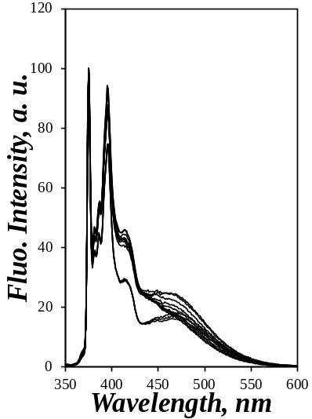  A)  −30 to +10 ºC  −45 to −35 ºC  +15 to +25 ºC  −30 to +25 ºC | 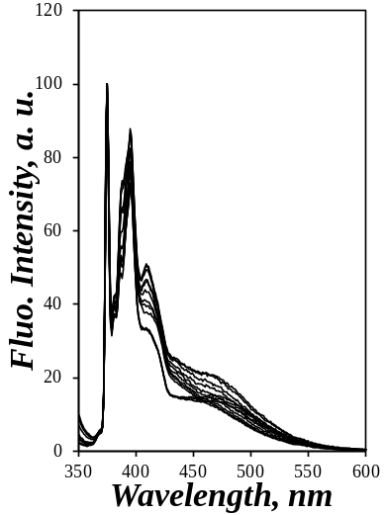  C)  B)  −30 to +10 ºC  −45 to −35 ºC  +15 to +25 ºC  −30 to +25 ºC | 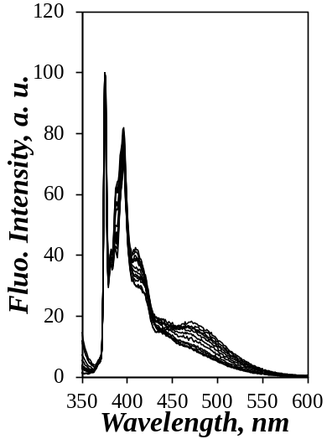
Figure 1. Fluorescence spectra normalized at 375 nm of solutions in oil of A) 2.0 g.L⁻¹ Py(6.7)-PC₁₈MA, B) 0.01 g.L⁻¹ Py(6.7)-PC₁₈MA, and C) 0.01 g.L⁻¹ Py(6.7)-PC₁₈MA and 2.0 g.L⁻¹ PC₁₈MA in oil taken at temperatures ranging from −30 to +25 ºC.

Since the crystallization of PC₁₈MA corresponds to a decrease in solubility of the polymer, intermolecular interactions between Py(6.7)-PC₁₈MA molecules were expected to occur in oil even at 0.01 g.L⁻¹ polymer concentration, as suggested by the clear changes in the fluorescence spectra, particularly in the I_{V} band at 415 nm observed at 10 ºC in Figures 1A and B. Such changes in band intensity have been attributed to the presence of pyrene dimers for other pyrene-labeled polymers undergoing phase separation in solution., In the present case, the crystallization of Py(6.7)-PC₁₈MA concentrated the pyrene labels due to their exclusion during the crystallization of the PC₁₈MA chains. To prevent intermolecular PEF from happening, a mixture of 0.01 g.L⁻¹ Py(6.7)-PC₁₈MA and 2 g.L⁻¹ PC₁₈MA was prepared in oil and its fluorescence spectrum was acquired as a function of temperature as shown in Figure 1C. The clear transition observed at +10 ºC in Figures 1A and B was not found in Figure 1C demonstrating that intermolecular interactions between the pyrene labels of the Py(6.7)-PC₁₈MA molecules were strongly reduced upon adding an excess of PC₁₈MA. Instead, the spectra in Figure 1C showed a continuous increase in I_{E} relative to I_{M} from −30 to +25 ºC reflecting an increase in excimer formation by diffusive encounters due to the decrease in viscosity experienced by the oil as the solution temperature increased.
The I_{E}/I_{M} ratios of the solutions in oil containing 2 g.L⁻¹ Py(6.7)-PC₁₈MA, 0.01 g.L⁻¹ Py(6.7)-PC₁₈MA, and a mixture of 0.01 g.L⁻¹ Py(6.7)-PC₁₈MA and 2 g.L⁻¹ PC₁₈MA were calculated based on the fluorescence spectra shown in Figure 1. They were plotted as a function of temperature in Figure 2. The I_{E}/I_{M} ratios increased in a similar manner with increasing temperature for all three solutions in oil over the entire temperature range. Only the two solutions containing 2 g.L⁻¹ and 0.01 g.L⁻¹ Py(6.7)-PC₁₈MA with no excess of unlabeled PC₁₈MA showed a clear step increase between +10 and +15 ºC upon decreasing the solution temperature which corresponded to the crystallization of PC₁₈MA. The 0.01 g.L⁻¹ Py(6.7)-PC₁₈MA solution with a 2 g.L⁻¹ PC₁₈MA excess showed no transition indicating that pyrene excimer formation occurred intramolecularly over the entire temperature range thus yielding I_{E}/I_{M}(intra) in oil.
The I_{E}/I_{M} ratio for the 2 g.L⁻¹ Py(6.7)-PC₁₈MA solution in oil was always larger than that of the mixture of 0.01 g.L⁻¹ Py(6.7)-PC₁₈MA and 2 g.L⁻¹ PC₁₈MA at a same temperature (Figures 2A and B). This behavior simply reflected that more intermolecular interactions were observed for this high concentration of Py(6.7)-PC₁₈MA. Interestingly, Figure 2B showed that the 0.01 g.L⁻¹ Py(6.7)-PC₁₈MA solution and the mixture of 0.01 g.L⁻¹ Py(6.7)-PC1₈MA with 2 g.L⁻¹ PC₁₈MA yielded similar I_{E}/I_{M} ratios at temperatures above +15 ºC. At lower temperatures, the I_{E}/I_{M} ratio was higher for the solution containing only 0.01 g.L⁻¹ Py(6.7)-PC₁₈MA compared to the I_{E}/I_{M} ratio of the mixture. Such an observation indicated that the 0.01 g.L⁻¹ Py(6.7)-PC₁₈MA solution in oil formed excimer only intramolecularly above its crystallization temperature so that it yielded the ratio I_{E}/I_{M}(intra), whereas at lower temperatures, the I_{E}/I_{M} ratio of the 0.01 g.L⁻¹ Py(6.7)-PC₁₈MA solution yielded I_{E}/I_{M}(inter&intra).
C)
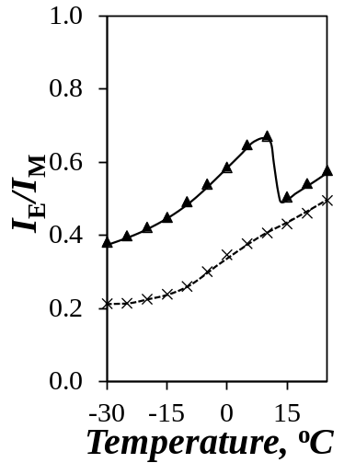  A) | 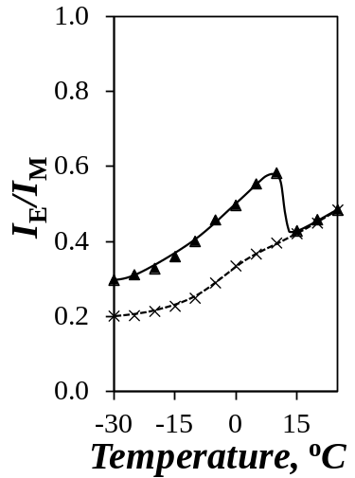  B) | 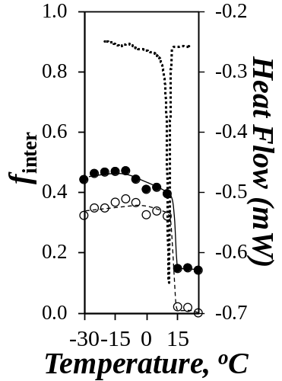
Figure 2. Comparison of the I_{E}/I_{M} plots of A) (▲) the 2 g.L⁻¹ Py(6.7)-PC₁₈MA solution and B) (▲) the 0.01 g.L⁻¹ Py(6.7)-PC₁₈MA with (×) the mixture of 0.01 g.L⁻¹ Py(6.7)-PC₁₈MA and 2 g.L⁻¹ PC₁₈MA in oil as a function of temperature. C) Plots of f_{inter} as a function of temperature for () the 2 g.L⁻¹ Py(6.7)-PC₁₈MA solution and () the 0.01 g.L⁻¹ Py(6.7)-PC₁₈MA solution in oil together with a plot of heat flow as a function of temperature for a 50 g.L⁻¹ PC₁₈MA solution in oil.

The I_{E}/I_{M}(inter&intra) and I_{E}/I_{M}(intra) ratios in Figures 2A and B were combined according to Equation 1 to yield f_{inter} which was plotted as a function of temperature in Figure 2C. For both the high and low concentrations of Py(6.7)-PC₁₈MA, two regimes were observed at temperatures below and above the crystallization temperature (T_{C}). According to the f_{inter}-vs-T profile of the 2 g.L⁻¹ Py(6.7)-PC₁₈MA solution, f_{inter} decreased from 0.44 (±0.03) at temperatures lower than +15 ºC to 0.15 (±0.00) at higher temperatures, remaining more or less constant in each temperature regime. In the case of the 0.01 g.L⁻¹ Py(6.7)-PC₁₈MA solution in oil, no intermolecular interactions took place at temperatures higher than T_{C} where f_{inter} equaled 0.01 (±0.01). However, at temperatures lower than +10 ºC, f_{inter} increased to 0.34 (±0.02) indicating the presence of intermolecular interactions between Py(6.7)-PC₁₈MA chains induced by crystallization at low temperatures even at this low 0.01 g.L⁻¹ Py(6.7)-PC₁₈MA concentration. To further confirm that the transition observed between 10 and 15 ºC was truly due to crystallization of PC₁₈MA, a DSC experiment was conducted by heating a 50 g.L⁻¹ PC₁₈MA solution in oil. A plot of the heat flow as a function of temperature in Figure 2C clearly indicated a sharp transition at 10 ºC that reflected the melting of PC₁₈MA microcrystals in oil.
The results described in Figure 2C for f_{inter} at 0.01 and 2 g.L⁻¹ Py(6.7)-PC₁₈MA concentrations indicated that, first, f_{inter} took larger values at all temperatures for the 2 g.L⁻¹ solution due to increased intermolecular interactions at high concentration, second, f_{inter} equaled zero for the 0.01 g.L⁻¹ solution at temperatures above crystallization when Py(6.7)-PC₁₈MA was solvated and formed excimer intramolecularly, and third, f_{inter} presented the same transition at +10 ºC at both concentrations reporting on the crystallization of PC₁₈MA. To confirm that the procedure applied to determine f_{inter} reflected the behavior of PC₁₈MA and was not affected by the presence of pyrene, the experiments reported thus far were repeated with Py(14.1)-PC₁₈MA, a PC₁₈MA sample labeled with twice more pyrene. The fluorescence spectra of a 2 g.L⁻¹ Py(14.1)-PC₁₈MA solution and a mixture of 0.01 g.L⁻¹ Py(14.1)-PC₁₈MA and 2.0 g.L⁻¹ PC₁₈MA were acquired as a function of temperature and the I_{E}/I_{M} ratios of Py(14.1)-PC₁₈MA were calculated and compared to those of Py(6.7)-PC₁₈MA in Figure 3A. Beside the higher I_{E}/I_{M} ratios obtained for Py(14.1)-PC₁₈MA due to the higher pyrene content compared to that of Py(6.7)-PC₁₈MA, the I_{E}/I_{M}-vs-T trends obtained for the two Py(14.1)-PC₁₈MA solutions showed the same features as those obtained for Py(6.7)-PC₁₈MA. The concentrated 2 g.L⁻¹ Py(14.1)-PC₁₈MA solution showed a transition between 10 and 15 ºC which was attributed to the crystallization of PC₁₈MA whereas the dilute 0.01 g.L⁻¹ Py(14.1)-PC₁₈MA solution in the presence of 2 g.L⁻¹ PC₁₈MA showed a monotonous profile indicating that the Py(14.1)-PC₁₈MA chains were isolated in the mixture. Combining the I_{E}/I_{M} ratios obtained at low and high Py(14.1)-PC₁₈MA according to Equation 1 yielded f_{inter} which was plotted as a function of temperature in Figure 3B. The f_{inter}-vs-T profile obtained for 2.0 g.L⁻¹ Py(14.1)-PC₁₈MA overlapped perfectly that obtained for Py(6.7)-PC₁₈MA. This result demonstrated that labeling of PC₁₈MA with pyrene did not affect the behavior of PC₁₈MA in oil.

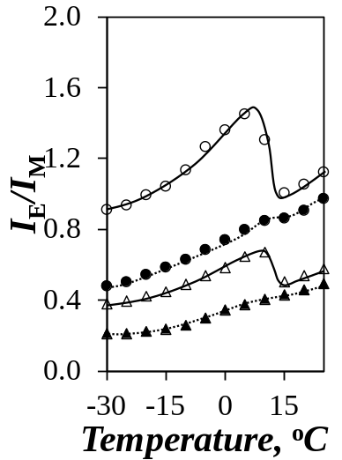  A) | 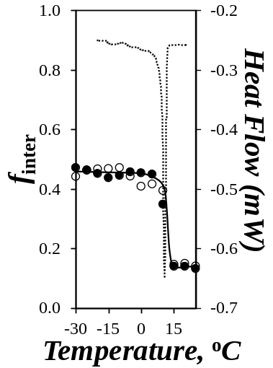  B) | 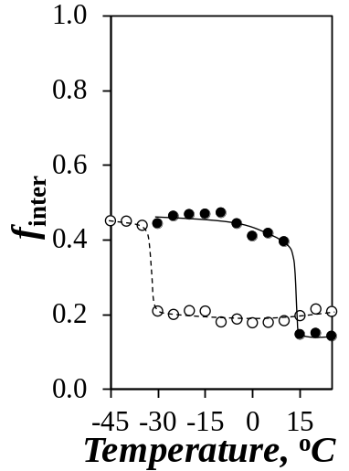  C)
Figure 3. A) Plots of I_{E}/I_{M} as a function of temperature for 2.0 g.L⁻¹ solutions of () Py(14.1)-PC₁₈MA and () Py(6.7)-PC₁₈MA and the mixtures of 2.0 g.L⁻¹ PC₁₈MA and 0.01 g.L⁻¹ () Py(14.1)-PC₁₈MA and () Py(6.7)-PC₁₈MA. B) Plot of f_{inter} as a function of temperature for 2 g.L⁻¹ solutions in oil of () Py(14.1)-PC₁₈MA and () Py(6.7)-PC₁₈MA together with a plot of heat flow as a function of temperature for a 50 g.L⁻¹ PC₁₈MA solution in oil. C) Comparison of the I_{E}/I_{M}-vs-T for 2.0 g.L⁻¹ solutions of () Py(5.6)-PC₁₂MA and () Py(6.7)-PC₁₈MA in oil.

Although the break in the f_{inter}-vs-T plots shown in Figures 2C and 3B could be safely assigned to the crystallization of PC₁₈MA in oil, these trends provided little information on the molecular mechanism inducing crystallization of PC₁₈MA. To address this point, the same fluorescence experiments were repeated with a pyrene-labeled poly(dodecyl methacrylate) (Py(5.6)-PC₁₂MA) and the f_{inter}-vs-T profiles of Py(5.6)-PC₁₂MA and Py(6.7)-PC₁₈MA were compared in Figure 3C. The break in the f_{inter}-vs-T profile shifted from 12.5 (±2.5) ºC for Py(6.7)-PC₁₈MA to −32.5 (±2.5) ºC for Py(5.6)-PC₁₂MA. Interestingly, the temperature difference of 45 (±5) ºC between the two breakpoints in the f_{inter}-vs-T profiles shown in Figure 3C was close to that of 37.8 ºC between the crystallization of dodecane at (−9.6 ºC) and octadecane (+28.2 ºC). Based on this similarity, it would thus appear that crystallization of PC₁₈MA in oil occurs via the octadecyl side chains. This is different from semicrystalline EP copolymers where crystallization occurs via the main chain.
Determination of f_{inter} from the fluorescence decay analysis: One inherent problem associated with the analysis of the SSF spectra acquired with pyrene-labeled macromolecules is that the fluorescence signal is a combination of at least four different pyrene species whose combined emission results in the fluorescence spectra shown in Figure 1. However these four species can be isolated in the global MFA of the pyrene monomer and excimer TRF decays. In order to identify the origin in the change in fluorescence behavior observed between 10 and 15 ºC in Figure 2C by SSF, the monomer and excimer fluorescence decays of the 2.0 g.L⁻¹ Py(6.7)-PC₁₈MA in oil and a mixture of 0.01 g.L⁻¹ Py(6.7)-PC₁₈MA and 2.0 g.L⁻¹ PC₁₈MA in oil were acquired at temperatures ranging from −30 to +25 ºC. Additionally, the monomer decay of a solution of 3×10⁻⁶ mol.L⁻¹ 1-pyrenebutanol used as a model compound was acquired over the same temperature range in order to obtain the pyrene monomer lifetime (τ_{M}). Using the model free analysis (MFA), the molar fractions of those pyrenes that formed excimer by diffusion (f_{diff}), were isolated and did not form excimer (f_{free}), and formed excimer by direct excitation of a dimer constituted of two pyrene labels that were either well-stacked (f_{E0}) or poorly stacked (f_{D}) (f_{agg} = f_{D} + f_{E0}), and the average rate constant of pyrene excimer formation <k> were retrieved from the monomer and excimer fluorescence decays for the two Py(6.7)-PC₁₈MA solutions in oil. They were reported in Tables S1-S6 in Supporting Information (SI).
The molar fractions of the different pyrene species were plotted as a function of temperature in Figures 4A and B. Figure 4A indicates that the molar fractions f_{diff}, f_{free}, and f_{agg} hardly changed with temperature for the dilute Py(6.7)-PC₁₈MA solution containing 2.0 g.L⁻¹ of unlabeled PC₁₈MA. The average rate constant <k> for PEF remained constant and equal to 5.3 (±0.5)×10⁶ s⁻¹. PEF occurred mainly by diffusive encounters between pyrene labels with f_{diff} taking the largest value of the three molar fractions and being equal to 0.68 (±0.05). The constancy of the MFA parameters with temperature was certainly a consequence of the solution mixture containing a large excess of unlabeled PC₁₈MA which enabled Py(6.7)-PC₁₈MA to form excimer intramolecularly.
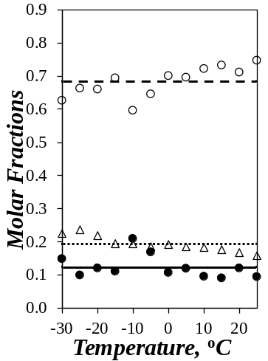  A) | 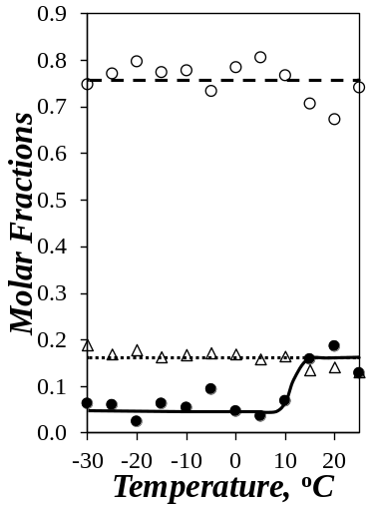  B) | 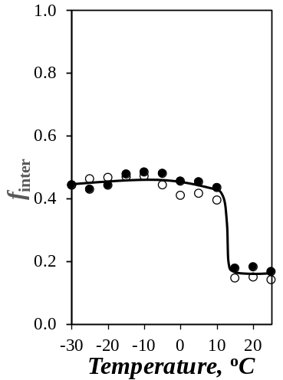  C)
Figure 4. Plots of the molar fractions () f_{diff}, () f_{free}, and () f_{agg} in oil as a function of temperature for A) the mixture of 2.0 g.L⁻¹ PC₁₈MA and 0.01 g.L⁻¹ Py(6.7)-PC₁₈MA and B) the 2.0 g.L⁻¹ Py(6.7)-PC₁₈MA solution in oil. C) Plot of f_{inter} as a function of temperature for a 2.0 g.L⁻¹ Py(6.7)-PC₁₈MA solution in oil obtained by () SSF and () TRF measurements.

Most of the MFA parameters remained constant for the concentrated 2.0 g.L⁻¹ Py(6.7)-PC₁₈MA solution. Within experimental error, the molar fractions f_{diff} and f_{agg} equaled 0.76 (±0.04) and 0.16 (±0.02) and <k> took a value of 4.5 (±0.6)×10⁶ s⁻¹ similar to the value of 5.3 (±0.5)×10⁶ s⁻¹ obtained for the dilute solution. The large f_{diff} value indicated that PEF occurred mostly by diffusive encounters between pyrene labels. The only change in the parameters was the 2/3 decrease in f_{free} between +10 and +15 ºC where PC₁₈MA underwent crystallization. Although a decrease from 0.16 (±0.03) to 0.06 (±0.02) at temperatures, respectively, above +15 ºC and below +10 ºC might seem small, it must be pointed out that the pyrenes that did not form excimer emitted twice more strongly than the pyrenes that formed excimer. This conclusion was drawn from the fact that the natural lifetime τ_{M} of the pyrene labels that did not form excimer was about twice larger than the average lifetime <τ> of the pyrene labels that formed excimer by diffusion. Since the fluorescence quantum yield (φ_{F}) is the product of the radiative rate constant of pyrene by the pyrene lifetime, a doubling in fluorescence lifetime results in a doubling in φ_{F}. Consequently, the small decrease in f_{free} observed at temperatures lower than 10 ºC resulted in a substantial reduction in monomer fluorescence (I_{M}) and the enhancement in I_{E}/I_{M} observed in Figures 2A, 2B, and 3A. It would thus seem that the step increase in the I_{E}/I_{M} ratio between 10 and 15 ºC upon decreasing the solution temperature was due to the disappearance of isolated pyrene labels that became able to form excimer intermolecularly upon the intermacromolecular crystallization of Py(6.7)-PC₁₈MA.
The MFA parameters were then introduced into Equation 2 to yield the ratios (I_{E}/I_{M})^{TRF}(inter&intra) and (I_{E}/I_{M})^{TRF}(intra) for the 2.0 g.L⁻¹ Py(6.7)-PC₁₈MA solution and the mixture of 0.01 g.L⁻¹ Py(6.7)-PC₁₈MA and 2.0 g.L⁻¹ PC₁₈MA in oil, respectively. The (I_{E}/I_{M})^{TRF} ratios were then combined with Equation 1 to determine the f_{inter} value retrieved from the analysis of the fluorescence decays which was compared in Figure 4C with f_{inter} obtained from the analysis of the fluorescence spectra. Most remarkably, a perfect agreement was found in Figure 4C between the trends obtained for the f_{inter} values determined from the analysis of the SSF spectra and TRF decays. The same clear breakpoint was observed between 10 and 15 ºC corresponding to the crystallization temperature of PC₁₈MA. This excellent agreement supported the MFA of the TRF decays and the conclusions about the cause of the breakpoint based on the change in the molar fraction f_{free}.
The fluorescence results presented up to this point reflected the expected behavior of PC₁₈MA in oil and demonstrated the robustness and validity of the method implemented to determine f_{inter}. They also generalized the procedure applied to determine f_{inter} to polymers other than the EP copolymers studied so far.^{6,14} Having confirmed the validity of the procedure to determine f_{inter} from the analysis of the fluorescence spectra and before probing the effect that the presence of an EP copolymer used as a mimic of VII might have on the PC₁₈MA interactions, the temperature-dependent behavior of EP(AM) and EP(SM) was investigated in oil from intrinsic viscosity measurements.
Solution behaviour of EP(AM) and EP(SM): Information about the dependency of the hydrodynamic volume (V_{h}) of the EP copolymers with oil temperature was obtained by conducting intrinsic viscosity [η] measurements. The trends shown in Figures 5A and B indicated that [η] decreased slightly and sharply for EP(AM) and EP(SM), respectively, when the temperature was decreased from +25 to −5 ºC. These behaviours are typical of EP(AM) and EP(SM) and have been reported numerous times in the scientific literature.^{7,15,16,22-}
A)  Temperature (°C) | B)  B)
Figure 5. Plots of intrinsic viscosities as a function of temperature for A) EP(AM) and B) EP(SM) in oil.

The substantial decrease in [η] with decreasing temperature observed for EP(SM) has been attributed to the formation of microcrystals between long ethylene stretches in the EP(SM) backbone that resulted in a decrease in V_{h}. The marked decrease in [η] for EP(SM) began at about 15 ºC which was within the temperature range where crystallization of PC₁₈MA in oil occurred (~ 10 ºC). The amorphous EP(AM) sample showed no such transition indicating that it remained well solvated in the oil between −5 and +25 ºC.
Level of interpolymeric interactions (f_{inter}) of PC₁₈MA in the presence of EP copolymers in oil: Now that the solution behavior of Py(6.7)-PC₁₈MA and the EP copolymers in oil had been well characterized as a function of temperature, the effect that another oil additive might have on the behavior of PC₁₈MA could be investigated. To this end, mixtures of 10 g.L⁻¹ naked EP(AM) or EP(SM) copolymers with either 2 g.L⁻¹ of Py(6.7)-PC₁₈MA or a mixture of 0.01 g.L⁻¹ Py(6.7)-PC₁₈MA and 2 g.L⁻¹ PC₁₈MA were prepared in oil. The fluorescence spectra of the solutions were acquired as a function of temperature. The spectra for the concentrated Py(6.7)-PC₁₈MA solutions with either EP(AM) or EP(SM) were shown in Figures 6A and B, respectively, where the intensity of the monomer at 375 nm (I_{M}) was normalized to 100 for all solutions. As was observed earlier with the Py(6.7)-PC₁₈MA solutions only, two distinct regimes could be identified depending on whether the solution temperature was above or below the crystallization temperature of Py-PC₁₈MA. As for Py(6.7)-PC₁₈MA alone in oil whose fluorescence spectra were shown in Figures 1A and B, the most prominent change in the fluorescence spectra was observed at the fluorescence band I_{V} at 415 nm which has been associated with the presence of pyrene dimers.^{23,24} As the temperature decreased from +25 to −30 °C, I_{E} decreased continuously but showed a punctual step increase at +10 °C. As explained earlier, the continuous decrease in I_{E} observed with decreasing temperature was a consequence of the increase in viscosity that reduced pyrene diffusive encounters. The step increase in I_{E} at +10 °C was the result of a contraction of the polymer coil that promoted interpolymeric interactions and brought the pyrene labels in closer proximity leading to a step increase in excimer formation.
V_{h} (Low Temp.)
Oil
Temperature
Viscosity
Oil + VIIs

V_{h} (High Temp.)

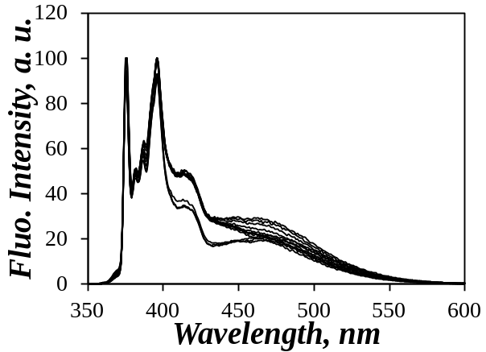  −30 to +10 ºC  +15 to +25 ºC | 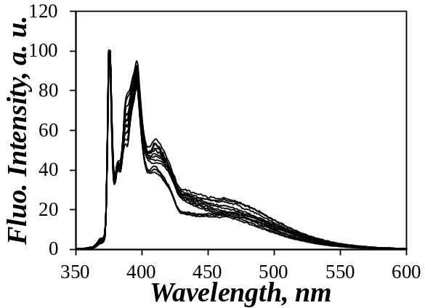  B)  A)  +15 to +25 ºC  −30 to +10 ºC
Figure 6. Fluorescence spectra of a mixture of 2 g.L⁻¹ Py(6.7)-PC₁₈MA and A) 10 g.L⁻¹ EP(AM) and B) 10 g.L⁻¹ EP(SM) in oil as a function of temperature from −30 to +25 ºC.

The fluorescence spectra shown in Figure 6 for the 2 g.L⁻¹ Py(6.7)-PC₁₈MA solution yielded the I_{E}/I_{M}(inter&intra) ratio. The fluorescence spectra of the solutions containing 0.01 g.L⁻¹ Py(6.7)-PC₁₈MA and 2 g.L⁻¹ PC₁₈MA with 10 g.L⁻¹ EP copolymer were also acquired as a function of temperature to yield I_{E}/I_{M}(intra) (spectra not shown). I_{E}/I_{M}(inter&intra) and I_{E}/I_{M}(intra) were plotted as a function of temperature in Figures 7A and B for the solutions with EP(AM) and EP(SM), respectively. They presented the general trends discussed earlier with a continuous increase in the I_{E}/I_{M} ratios observed with increasing temperature due to an increase in diffusive encounters between the pyrene pendants. The main difference in behavior between the dilute and concentrated Py(6.7)-PC₁₈MA solutions was the break point observed at +10 °C for the concentrated Py(6.7)-PC₁₈MA solutions which corresponded to both the crystallization of the side chains as identified in Figures 1 – 4, but also the crystallization of EP(SM) as found in Figure 5B.

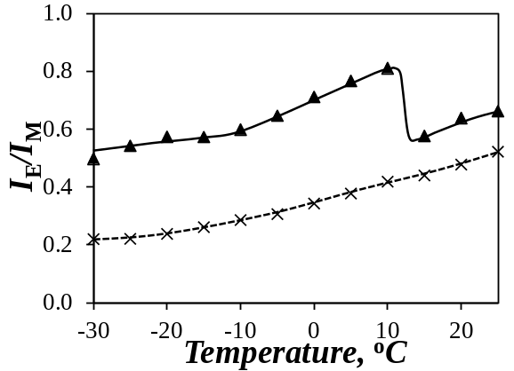  B)  A) | 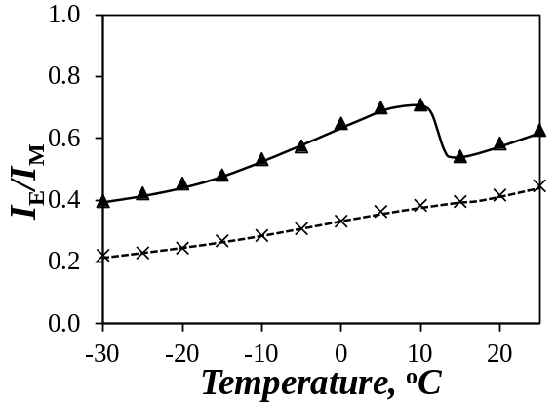
Figure 7. Plots of (▲) I_{E}/I_{M}(inter & intra) and (×) I_{E}/I_{M}(intra) as a function of temperature for mixtures of 10 g.L⁻¹ of A) EP(AM) or B) EP(SM) with either 2 g.L⁻¹ Py(6.7)-PC₁₈MA or a mixture of 0.01 g.L⁻¹ Py(6.7)-PC₁₈MA and 2 g.L⁻¹ PC₁₈MA.

The ratios I_{E}/I_{M}(inter&intra) and I_{E}/I_{M}(intra) were combined according to Equation 1 to yield f_{inter} which was plotted as a function of temperature in Figure 8. For the 2 g.L⁻¹ Py(6.7)-PC₁₈MA solution containing the EP(AM) copolymer, f_{inter} decreased slightly from 0.56 at −30 ºC to 0.48 at +10 ºC, before undergoing a step decrease between +10 and +15 ºC, and plateauing at 0.23 (±0.02) for temperatures between +15 and +25 ºC. f_{inter} remained constant and equal to 0.46 (±0.03) and 0.28 (±0.01) in the high and low temperature regimes, respectively, for the 2 g.L⁻¹ Py(6.7)-PC₁₈MA solution with 10 g.L⁻¹ EP(SM). The overall shape of the f_{inter}-vs-T plots was similar to those observed for the Py(6.7)-PC₁₈MA solutions in Figures 2C and 3B, both plots showing high and low f_{inter} values in the low and high temperature range with a sharp decrease between +10 and +15 ºC. This behavior was attributed to the crystallization of the octadecyl side chains of PC₁₈MA.

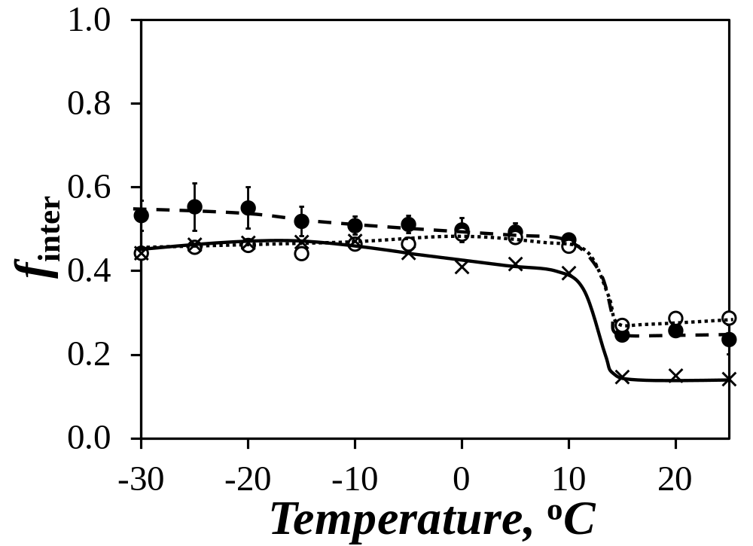
Figure 8. Plots of the molar fraction f_{inter} as a function of temperature for 2 g.L⁻¹ Py-PC₁₈MA solutions in oil (×) without EP copolymer, () with 10 g.L⁻¹ EP(AM), and () with 10 g.L⁻¹ EP(SM2).

Comparison of the f_{inter} plots of Py(6.7)-PC₁₈MA before and after addition of EP copolymers: The f_{inter}-vs-T profiles of the 2 g.L⁻¹ solutions of Py(6.7)-PC₁₈MA in Figure 8 showed a small increase in f_{inter} at temperatures higher than +15 ºC after the addition of both EP copolymers. This result indicated that the addition of EP copolymers promoted intermolecular interactions between Py(6.7)-PC₁₈MA macromolecules, leading to Py(6.7)-PC₁₈MA aggregation and resulting in larger f_{inter} values. At +15 ºC where the side chains of Py(6.7)-PC₁₈MA crystallized, f_{inter} showed a step increase for all solutions and remained larger for the solutions with EP copolymers at temperatures just below the transition. However, whereas f_{inter} remained larger for Py(6.7)-PC₁₈MA with EP(AM) than without EP copolymer over the entire temperature range, the f_{inter} values for the solutions with 10 g.L⁻¹ EP(SM) were found to decrease progressively with decreasing temperature until they matched the f_{inter} values of the 2 g.L⁻¹ Py-PC₁₈MA solution without EP copolymers at temperatures lower than −10 ºC.
The progressive lowering of f_{inter} observed for PC₁₈MA with EP(SM) as the temperature was decreased from +10 to −10 ºC, a 20 ºC spread in temperature, was attributed to the crystallization of EP(SM) which was believed to occur over a much broader temperature range compared to PC₁₈MA. An indication that this was indeed the case could be found in the DSC traces showed in Figure 9. Since the crystallization of PC₁₈MA involved the octadecyl side chains that were well-defined in length, a single sharp transition for the crystallization of PC₁₈MA in the bulk was observed at 21.7 ºC with a full width at half maximum (FWHM) equal to 0.49 ºC. By contrast, the crystallization of EP(SM) was much more diffuse in the bulk occurring over a broad temperature range between +28 and −20 ºC with a FWHM of 21.1 ºC. The difference in behavior between PC₁₈MA and EP(SM) was expected because the crystallization of EP(SM) occurred between oligoethylene segments of different lengths, the segments with a longer and shorter oligoethylene sequence crystallizing earlier and later, respectively. The amorphous EP(AM) showed no response by DSC as expected.

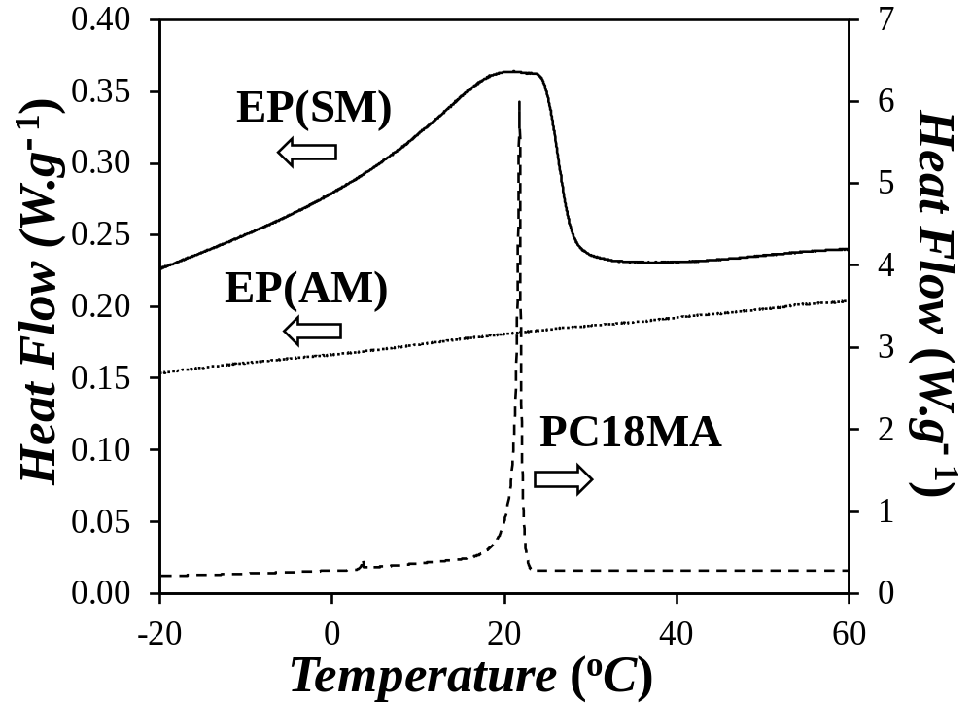
Figure 9. Plot of heat flow as a function of temperature for solid () EP(SM), () EP(AM), and () PC₁₈MA.

As mentioned earlier, the increase in f_{inter} observed for Py(6.7)-PC₁₈MA at temperatures above 15 ºC indicated that Py(6.7)-PC₁₈MA interacted with the solvated EP copolymers. Interactions were further promoted upon the crystallization of Py(6.7)-PC₁₈MA at 10 ºC. However, as the temperature was progressively lowered, the crystallization of EP(SM) induced the dissociation of EP(SM) from Py(6.7)-PC₁₈MA associated with the progressive decrease in f_{inter} observed from +10 to −10 ºC in Figure 8 until f_{inter} for Py(6.7)-PC₁₈MA with EP(SM) matched the value of f_{inter} for PC₁₈MA without EP copolymers, at which point EP(SM) must have fully dissociated from Py(6.7)-PC₁₈MA. By contrast, EP(AM) showed stronger interactions with Py(6.7)-PC₁₈MA resulting in f_{inter} values for Py(6.7)-PC₁₈MA with EP(AM) that were consistently larger than the f_{inter} values obtained without EP(AM). In summary, both solvated and crystallized PC₁₈MA interacted with solvated EP copolymers in oil regardless of whether the polyolefins were amorphous or semicrystalline. Crystallization of EP(SM) led to the progressive dissociation of PC₁₈MA from EP(SM)S as the solution temperature was further decreased, but PC₁₈MA remained associated with the amorphous, and thus solvated, polyolefin in oil even after PC₁₈MA had crystallized.

CONCLUSIONS
These PEF experiments conducted on Py-PC₁₈MA have demonstrated that PEF represents an excellent analytical tool to study the crystallization of macromolecules in solution. They extend the applicability of the procedure from semicrystalline EP copolymers, where the main chain folds onto itself to generate microcrystals, to poly(alkyl methacrylate)s where crystallization occurs via the long alkyl side chains. Most interestingly, they take full advantage of the selective fluorescence of the Py-PC₁₈MA samples to isolate the behavior of the fluorescently labeled macromolecules as they interacted with other non-fluorescent species in oil, in this case two EP copolymers. Thus these experiments provided an experimental means to probe the complex behavior of macromolecules in multicomponent mixtures such as engine oils.

ACKNOWLEDGEMENTS
The authors thank NSERC and Afton Chemical Corporation for financial support.

SUPPORTING INFORMATION
Brief description of the MFA. Tables listing the parameters retrieved from the MFA of the fluorescence decays.

REFERENCES . Radulescu, A.; Fetters, J. L.; Richter, D. Tailored Polymer Additives for Wax (Paraffin) Crystal Control in Crude Oil Emulsions. Eds. Abdel-Raouf, M. E.-S. Intech Europe, Rijeka, Croatia, 2011, pp 205-230.
. Cravey, R. L.; Mead, S. L. Pour Point Depressant Additives for Oil Compositions. 2005, WO2005/097953.
. Heilman, W. J.; Wilburn, B. E. Olefin Polymer Pour Point Depressants. 1993, US005188724A.
. Riga, A. T. Thermomechanical Analysis and Viscometric Properties of Motor Oils at Low Temperatures. Thermochim. Acta 1992, 212, 227-242.
. Barbadsz, E. A.; Lamb, G. D. Additives for Crankcase Lubricant Applications. In Lubricant Additives: Chemistry and Application. Rudnik, L. R., Ed.; CRC Press, Boca Raton: Florida, 2003; pp 458-490.
. Mortier, R. M.; Malcolm, F. F.; Orszulik, S. T. Chemistry and Technology of Lubricants; Springer: London, 2009.
. Pirouz, S.; Duhamel, J. New Approaches to Characterize Polymeric Oil Additives in Solution Based on Pyrene Excimer Fluorescence. J. Polym. Sci. B: Polym. Phys. 2017, 55, 7-18.
. Bruson, H. A. Composition of Matter and Process. 1937, US2091627.
. Van Horne, W. L. Polymethacrylates as Viscosity Index Improvers and Pour Point Depressants. Ind. Eng. Chem. 1949, 41, 952-959.
. Souchik, J. Pour Point Depressants. In Lubricant Additives Chemistry and Applications 2nd Ed. RudnickL. R. Ed. CRC Press, Boca Raton: Florida, 2009; pp 339-353.
. Kazantsev, O. A.; Volkova, G. I.; Prozorova, I. V.; Litvinets, I. V.; Orekhov, D. V.; Samodurova, S. I.; Kamorin, D. M.; Moikin, A. A.; Medzhibovskii, A. S. Poly(alkyl (meth)acrylate) Depressants for Paraffin Oils. Pet. Chem. 2016, 56, 68-72.
. Florea, M.; Catrinoiu, D.; Luca, P.; Balliu, S. The Influence of Chemical Composition on the Pour-Point Depressant Properties of Methacrylate Copolymers Used as Additives for Lubricating Oils. Lubr. Sci. 1999, 12, 31-44.
. Covitch, M. J.; Trickett, K. J. How Polymers Behave as Viscosity Index Improvers in Lubricating Oils. Adv. Chem. Eng. Sci. 2015, 5, 134-151.
. Rubin, I. D. Polymers Make the Grade. Chemtech 1987, 17, 620-623.
. Pirouz, S.; Duhamel, J.; Jiang, S.; Duggal, A. Quantifying the Level of Intermacromolecular Interactions in Ethylene-Propylene Copolymers by Using Pyrene Excimer Formation. Macromolecules 2015, 48, 4620-4630.
. Pirouz, S.; Duhamel, J.; Jiang, S.; Duggal, A. Using Pyrene Excimer Fluorescence to Probe the Interactions between Viscosity Index Improvers and Waxes Present in Automotive Oil. Macromolecules 2017, 50, 2467-2476.
. Jiang, S.; Duggal, A.; Duhamel, J.; Pirouz, S. Quantifying the Level of Intermacromolecular Interactions by Using Pyrene Excimer Formation. 2016, US 20160077012 A1 20160317.
. Farhangi, S.; Weiss, H.; Duhamel, J. Effect of Side-Chain Length on the Polymer Chain Dyanmics of Poly(alkyl methacrylate)s in Solution. Macromolecules 2013, 46, 9738-9747.
. Alshaiban, A.; Soares, J. B. P. Effect of Hydrogen and External Donor on Propylene Polymerization Kinetics with a 4th Generation Ziegler-Natta Catalyst. Macro. React. Eng. 2012, 6, 265-274.
. Siu, H.; Duhamel, J. Comparison of the Association Level of a Hydrophobically Modified Associative Polymer Obtained from an Analysis Based on Two Different Models. J. Phys. Chem. B 2005, 109, 1770-1780.
. Duhamel, J. New Insights in the Study of Pyrene Excimer Fluorescence to Characterize Macromolecules and their Supramolecular Assemblies in Solution. Langmuir 2012, 28, 6527-6538.
. Zhang, M.; Duhamel, J. Study of the Microcrystallization of Ethylene-Propylene Random Copolymers in Solution by Fluorescence. Macromolecules 2007,  .
. Farinha, J. P. S.; Piçarra, S.; Miesel, K.; Martinho, J. M. G. Fluorescence Study of the Coil-Globule Transition of a PEO Chain in Toluene. J. Phys. Chem. B 2001, 105, 10536-10545.
. Piçarra, S.; Relógio, P.; Afonso, C. A. M. ; Martinho, J. M. G. ; Farinha, J. P. S. Coil-Globule Transition of Polydimethylacrylamide: Fluorescence and Light Scattering Study. Macromolecules 2003, 36, 8119-8129.
. CRC Handbook of Chemistry and Physics, 77th Ed.; Boca Raton, FL, 1996.
. Sen, A.; Rubin, I. D. Molecular Structures and Solution Viscosities of Ethylene-Propylene Copolymers. Macromolecules 1990, 23, 2519-2524.
. Rubin, I. D.; Shen, A. Solution Viscosities of Ethylene-Propylene Copolymers in Oils. J. Appl. Polym. Sci. 1990, 40, 523-530. Table of Content 