Application of Pyrene Fluorescence to the Characterization of Hydrophobically Modified Starch Nanoparticles

Damin Kim, Ryan Amos, Mario Gauthier*, Jean Duhamel*
Institute for Polymer Research, Waterloo Institute for Nanotechnology, Department of Chemistry, University of Waterloo, Waterloo, ON N2L 3G1, Canada

* To whom correspondence should be addressed.

ABSTRACT
Several aspects of pyrene fluorescence were applied to gain insight into the nature of the microdomains in hydrophobically modified starch nanoparticles (HM-SNPs), prepared by reacting SNPs with propionic and hexanoic anhydride to yield C3- and C6-SNPs, respectively. The fluorescence experiments took advantage of the inherent hydrophobicity of pyrene to bind onto the hydrophobic domains generated by the HM-SNPs, and its specific response to the polarity of its environment, to probe its accessibility to quenchers such as oxygen or nitromethane dissolved in water. The equilibrium constant K_{B} for the binding of pyrene onto HM-SNPs, the ratio (I₁/I₃)_{o} describing the relative hydrophobicity of the microenvironment experienced by pyrene, its lifetime (τ_{SNP}), and the rate constant of quenching of pyrene bound to the HM-SNPs by water-soluble nitromethane (k_{qSNP}) were determined as a function of the degree of substitution (DS) and weight fraction (wt%) of hydrophobic modifier. The C3- and C6-SNPs yielded similar parameters at low levels of hydrophobic modification, indicating higher hydrophobicity of the modified SNPs with increasing modification level. However SNPs modified with more than 5 wt% of hexanoyl pendants all displayed enhanced hydrophobicity for the C6-SNPs as compared to the C3-SNPs. This substantial enhancement is attributed to the formation of larger hydrophobic microdomains by the hexanoyl pendants of the C6-SNPs above the 5 wt% C6-modification threshold, which did not occur with the C3-SNPs. Finally, the size of the SNPs did not appear to influence their relative hydrophobicity. These experiments demonstrate how the fluorescence of pyrene can be harnessed to provide information about the relative hydrophobicity of HM-SNPs.

INTRODUCTION
Starch and its two main components, linear amylose and branched amylopectin, are the most abundant polysaccharides produced on earth after cellulose., Starch is nontoxic, biocompatible, biodegradable, renewable, and inexpensive. These appealing features explain why researchers have investigated its use to produce drug delivery carriers, associative thickeners, colloidal stabilizers, compatibilizers, and food ingredients to name but a few applications.^{2,,} Without exception, these applications require that starch, which is otherwise a water-soluble polymer, be hydrophobically modified. Besides the reaction of octenyl succinic anhydride (OSA) with the hydroxyl groups of starch, which has been by far the most extensively studied hydrophobic modification of starch,⁻ cholesterol, oleic and stearic acids, epoxyalkanes,, and other hydrophobes, have been used to generate hydrophobically modified starch (HMS).
Detailed characterization of HMS should be able to describe, at the molecular level, how the hydrophobes decorating the HMS arrange themselves to generate hydrophobic microdomains. The microdomains distributed within the confines of the polysaccharide macromolecular volume can be very large, since amylopectin has been reported to have a radius of gyration in the 100’s of nanometers depending on its plant of origin. Fluorescence techniques have a long and successful track record as efficient analytical tools to characterize the hydrophobic microdomains generated by surfactant micelles and lipid bilayers. In these examples the hydrophobes, namely the linear alkyl tails of surfactants and lipids, are free to self-assemble into spherical or tubular micelles or vesicles in water. The situation may be quite different for HMS, since the hydrophobes are covalently attached onto the rigid polysaccharide backbone. In this case, the drive of the hydrophobes to self-assemble in water is expected to be frustrated by the inability of the rigid backbone to rearrange its conformation over the large distances spanning the hydrophobic moieties, which should hinder the formation of hydrophobic microdomains. Under these conditions, only hydrophobes in close proximity may be able to self-assemble into small hydrophobic aggregates, while hydrophobes separated by larger distances inside the macromolecule remain isolated. Consequently, HMSs are expected to have hydrophobic microdomains that are smaller, more diffuse, and with a broader size distribution than micelles formed by free surfactants in water. As a result, the characterization of HMSs may become more challenging, as it needs to reflect the diffuse distribution of hydrophobic microdomains generated throughout the polysaccharide molecule.
Pyrene is a well-established fluorescent probe to study polymeric systems., Its fluorescence has been shown to provide reliable information about the size of surfactant micelles including their aggregation number (N_{agg}), the polarity of the micellar interior through the ratio I₁/I₃ of the first to third fluorescence peak intensities in the pyrene fluorescence spectrum, and the internal dynamics of the micelles from fluorescence quenching measurements.²¹ However, these protocols were developed to study well-defined surfactant micelles, which differ substantially from the ill-defined hydrophobic microdomains expected to be generated in HMS. In particular, the rigid polysaccharide backbone of starch should result in smaller and more diffuse apolar microdomains, which ought to be less hydrophobic than surfactant micelles where the hydrophobic tails are confined within a well-defined volume. Since pyrene has a low solubility in water, it will inevitably partition between water and the hydrophobic microdomains of HMS. This partitioning implies that the contribution to fluorescence of pyrene in water needs to be isolated from the overall signal in order to obtain information about the actual HMS. This is best achieved by applying time-resolved fluorescence, as it can identify the different pyrene species present in an aqueous HMS solution, namely pyrene molecules that are either free in water or bound to HMS, according to their fluorescence lifetime. In turn, the identification of the different pyrene species in an aqueous dispersion of HMS enables one to retrieve structural, dynamic, and chemical information pertaining solely to the hydrophobic microdomains of HMS.
To illustrate this point, this study presents a series of fluorescence experiments taking advantage of several photophysical features of pyrene to provide quantitative information about the relative hydrophobicity of hydrophobically modified starch nanoparticles (HM-SNPs). The samples were prepared by reacting either propionic or hexanoic anhydride with the SNPs, to generate C3- and C6-SNPs with degrees of substitution (DS) ranging from 0 up to 0.30 or 0.15, respectively. The relative hydrophobicity of the HM-SNPs was quantified by monitoring how the lifetime, the equilibrium binding constant, the I₁/I₃ ratio, and the quenching rate constant of pyrene bound to the HM-SNPs varied with the DS. These results provided a measure of the local viscosity and polarity experienced by pyrene bound to the HM-SNPs.

EXPERIMENTAL
Materials: Pyrene (98 %) and organic solvents including dimethyl sulfoxide (DMSO, ACS reagent, ≥ 99.9 %), deuterated DMSO (99.9 % atom), ethanol (HPLC grade), acetone (HPLC, ≥ 99.9 %), and trifluoroacetic acid (Reagent plus, 99 %) were purchased from Sigma Aldrich. Tetrahydrofuran (distilled in glass) was purchased from Caledon. EcoSynthetix (Burlington, ON) supplied two SNP samples, namely SNP-1 and SNP-2, with number-average hydrodynamic diameters (D_{h}) of 46±3 and 8.3±0.7 nm, respectively, as determined by dynamic light scattering (DLS) measurements. Doubly distilled Milli-Q water was obtained from a Millipore Milli-RO 10 Plus or Milli-Q UFPlus (Bedford, MA) system. Dialysis tubing with a 1 kDa MWCO was purchased from Spectrum Laboratories Inc. All chemicals, besides pyrene and the modified and unmodified SNPs, were used as received.
Purification of unmodified SNPs by dialysis: Before chemical modification was carried out, the SNPs provided by EcoSynthetix were dialyzed against water to remove chemical residues leftover from their preparation. Aqueous SNP dispersions were prepared by adding the dry SNP to Milli-Q water at a 20 g.L⁻¹ concentration and shaking the mixture in an Innova 4000 incubator shaker from New Brunswick Scientific at 60 ºC overnight. The homogenous dispersions were removed from the shaker in the morning and allowed to cool to room temperature. The dispersions were transferred to dialysis bags with 1 kDa MWCO that were immersed in Milli-Q water for 5 days with stirring. The Milli-Q water was replaced every day. After 5 days of dialysis, the SNP dispersions were transferred to vials and lyophilized for 3 days. White powders were obtained that were stored in clear vials.
Synthesis of HM-SNPs: The dialyzed SNP-1 and SNP-2 particles were modified with propionic or hexanoic anhydride to yield CN(x)-SNP-Y particles (where N equals 3 or 6 for, respectively, the propionic or hexanoic modification, x is the degree of substitution (DS) achieved, and Y equals 1 or 2 for SNP-1 or SNP-2, respectively). The preparation of sample C3(0.07)-SNP-1 is described in detail hereafter as a specific example. SNP-1 (1.7 g, 10.5 mmol anhydroglucose units) was stirred in 32 g of DMSO at room temperature until a 5 wt% homogenous dispersion was obtained after 1 hr. The clear dispersion had a dark brown color. Propionic anhydride (0.12 g, 0.92 mmol) was added to the dispersion with 4-(dimethylamino)pyridine (DMAP, 0.01 g, 0.08 mmol) and pyridine (0.13 mL, 1.62 mmol). The amount of propionic anhydride, DMAP, and pyridine were adjusted to vary the degree of substitution. The dispersion was stirred overnight and precipitated in acetone. The precipitate was further purified by Soxhlet extraction in acetone for 2 d, to remove residual DMAP and pyridine. The collected solid was dried in a vacuum oven and characterized by ¹H NMR (300 MHz, DMSO). A ¹H NMR spectrum of C3(0.07)-SNP-1 in d₆-DMSO is shown in Figure S1 in the Supporting Information (SI).
Recrystallization of Pyrene: The fluorescence decay of the 98 % pure pyrene purchased from Aldrich in deoxygenated THF could be fitted with a sum of two exponentials and the fit yielded a long decay time of 363 ns with a pre-exponential contribution of 96 %, implying that the pyrene from Aldrich was actually 96 % pure. The pyrene was recrystallized from ethanol at least four times, until the pre-exponential contribution to the decay of the long lifetime reached a minimum contribution of 99.0 %. The recrystallized pyrene was used in all the experiments.
Preparation of Aqueous Dispersions of SNPs and HM-SNPs with Pyrene: A known amount of pyrene solution in THF was added to a vial and the THF was evaporated under a gentle flow of nitrogen. Either Milli-Q water or an aqueous dispersion of SNP or HM-SNP was added to the vial after complete evaporation of THF. Dissolution of pyrene was ensured by gentle shaking of the vial overnight at room temperature. Gentle shaking prevented the hydrophobic pyrene from coming in contact with the plastic lid of the vial, where it would stick. The final concentration of pyrene was 0.5 μM.
Steady-State Fluorescence: Emission spectra were acquired on a Photon Technology International LS-100 fluorometer. The fluorescence spectra were obtained by exciting the pyrene solution at 336 nm and monitoring the fluorescence intensity from 346 to 600 nm. The fluorescence spectra of 0.5 mM pyrene in aqueous dispersions of HM-SNPs were contaminated by the intrinsic fluorescence of the particles (Figure S2A and B in the Supporting Information (SI)). The fluorescence of the particles was eliminated by subtracting the fluorescence spectrum of the unmodified particles in water normalized to the spectrum acquired with pyrene between 350 and 360 nm, where pyrene does not emit. In so doing, the fluorescence spectrum of pyrene was recovered. The I₁/I₃ fluorescence intensity ratio, representing the polarity of the microdomains probed by pyrene, was determined by taking the ratio of the maximum fluorescence intensity at the first (I₁) and the third (I₃) peak in the fluorescence spectrum of pyrene. The errors on the I₁/I₃ ratios are discussed in SI. The fluorescence intensity of the pyrene monomer in the quenching experiments was obtained by integrating the fluorescence spectrum from 369 to 375 nm.
Time-Resolved Fluorescence (Time-Correlated Single Photon Counting (TCSPC)): An IBH Ltd. time-resolved fluorometer equipped with an IBH 340 nm NanoLED was used to acquire the time-resolved fluorescence decays. Aqueous dispersions of SNPs and HM-SNPs exhibited a short-lived fluorescence appearing as a spike at the beginning of the fluorescence decay of pyrene. The magnitude of the spike depended on the concentration of the SNP/HM-SNPs used to prepare the dispersions. SNP/HM-SNPs dispersions were excited at 336 nm and the fluorescence decays of pyrene were acquired at 375 nm. More than 10,000 counts were collected at the decay channel past the decay maximum, where the spike in the decay due to the SNP fluorescence tailed off, to ensure that the part of the fluorescence decay corresponding to the emission of the long-lived pyrene would be represented with a good signal-to-noise ratio.
Analysis of the Fluorescence Decays: The fluorescence decays were fitted with a sum of exponentials as described by Equation 1.
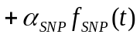 (1)

In Equation 1, τ_{W} and τ_{SNP} are the lifetimes of pyrene in water and bound to the SNPs, respectively. The rate constant k_{qW} represents the quenching of pyrene in water by water-soluble nitromethane. The molar fractions α_{PyW,} α_{PySNP}, and α_{PySNP-P} represent pyrene molecules in water (Py_{W}*), bound to the SNPs but exposed to the solvent (Py_{SNP}*), and bound to the SNPs but protected from quenching (Py_{SNP−P}*), respectively. The molar fraction α_{SNP} corresponds to the contribution of the short-lived SNP fluorescence to the fluorescence decays.
The fluorescence decay analysis accounted for the fluorescence of the SNP or HM-SNP dispersions with a sum of exponentials (see Figure S3A), represented by the function f_{SNP}(t) in Equation 1. The function f_{PySNP}(t), representing pyrene molecules bound to the SNPs that were accessible to quenchers, could be approximated by a single exponential in most case, but required two exponentials for some samples. In fluorescence experiments not involving pyrene quenching ([Q]=0 M), the decay times associated with pyrene in water (τ_{W} = 130 ns) and pyrene bound to the SNPs (τ_{SNP} ≥ 200 ns) were much larger than those representing f_{SNP}(t), which tailed off within 30 ns (see Figure S3A). Under such conditions, the species Py_{SNP}* and Py_{SNP-P}* were equivalent and the analysis program could easily distinguish between the three components of Equation 1. Consequently, the fluorescence decay analysis of pyrene in the presence of SNPs or HM-SNPs was handled by starting the analysis 5 – 10 channels away from the decay maximum, so that f_{SNP}(t) could be approximated by a single exponential with a short (10 – 30 ns) decay time. In this case, the fluorescence decays were fitted with a sum of three exponentials where one exponential had a short decay time that was optimized to represent the shorter-lived component f_{SNP}(t) (~ 10 – 30 ns), another had an intermediate decay time that was set to equal 130 ns, the lifetime of pyrene in water, and the third one had a long floating decay time for the Py_{SNP}* species (τ_{SNP} > 200 ns).
While this procedure was efficient in the absence of quencher, it could not be applied for the fluorescence quenching experiments since pyrene quenching resulted in decreased decay times for the two first terms in Equation 1, approaching those for f_{SNP}(t). These decay times could not be resolved by the decay analysis program, that now dealt with a sum of four distinct components, since the species Py_{SNP}* and Py_{SNP-P}* were no longer equivalent in the presence of quencher. In this case, the decay representing the fluorescence of the SNPs in the aqueous dispersions was fitted with a sum of three exponentials, and the resulting normalized pre-exponential factors and decay times were used to set the expression for f_{SNP}(t) in the decay analysis based on Equation 1. Fits of the fluorescence decays were deemed satisfactory when χ² was lower than 1.2 and the residuals and the auto-correlation function of the residuals was randomly distributed around zero. The parameters retrieved from the analysis of the fluorescence decays are listed in Tables S1-S49. An example of such fits is shown in Figure S3B. The errors on the parameters retrieved from the analysis of the fluorescence decays with Equation 1 for the quenching studies are discussed in SI.
UV-Vis Absorption: A Cary 100 bio-UV-Vis spectrophotometer was used to acquire the absorption spectra. A 1-cm path length UV cell was used for routine absorption measurements. Due to the low solubility of pyrene in aqueous solutions, a UV cell with a 5-cm path length was employed to determine the molar extinction coefficient at 336 nm of pyrene in water and in an aqueous dispersion of C6(0.15)-SNP, the most hydrophobic HM-SNP used in this study. They were found to equal 32.5 (±3.0) and 29.6 (±3.0) mM⁻¹.cm⁻¹, respectively. Their similar values implied that the fractions α in Equation 1, reflecting the contributions to the fluorescence decays of the different pyrene species in water or bound to HM-SNPs, could be taken as molar fractions.
¹H NMR Spectroscopy: ¹H NMR spectra for the SNPs were acquired on a Bruker 300 MHz NMR spectrometer before and after dialysis against Milli-Q water. Deuterated DMSO (99.9 atom% D, Sigma-Aldrich) was used as the solvent, with a few drops of trifluoroacetic acid added to shift the hydroxyl protons of starch downfield. The ¹H NMR spectra for the SNPs were acquired at a concentration higher than 10 g/L to ensure a sufficient signal-to-noise ratio.
Dynamic Light Scattering (DLS): The number-average hydrodynamic diameter of the HM-SNPs was determined on a Malvern Zetasizer Nano-ZS, using HM-SNPs aqueous dispersions at concentrations ranging from 0.2 to 6 g/L. The measurements were done at 25 ºC. The number-average hydrodynamic diameters are reported assuming a spherical geometry for the particles, which is a reasonable assumption based on TEM images.
Lyophilization: The dialyzed SNPs were lyophilized on a Freezone 6, Labconco freeze-dryer.
Centrifugation: Centrifugation was carried out on an Avanti J-30I centrifuge at 20 ºC and 5000 rpm for 3 min.

RESULTS
As discussed in the Introduction, the experiments described herein aimed to use different aspects of pyrene fluorescence to characterize the hydrophobic microdomains present within HM-SNPs. However since these hydrophobic microdomains are expected to be less defined as compared to those generated by surfactant micelles, pyrene may not bind as effectively to them resulting in its partitioning between the aqueous phase and the HM-SNPs. Consequently, the binding constant of pyrene must be estimated first. This was achieved by analysis of the fluorescence decays of pyrene in aqueous HM-SNP dispersions. Since there was no quencher used in this analysis, Equation 1 simplified to Equation 2.

(2)

The analysis of the fluorescence decays acquired for aqueous dispersions of SNP-1 at different concentrations is discussed first. As illustrated in Figure S3A and B and described by Equation 2, two long decay times (τ_{W} and τ_{SNP}) and a much shorter-lived contribution (f_{SNP}(t)) were detected in the 0.5 μM pyrene aqueous dispersions of SNP-1. The short (< 30 ns) decay was due to the intrinsic fluorescence of the SNPs. Increasing the SNP-1 concentration led to an increase in α_{SNP} (Figure S4A) due to the intrinsic fluorescence of SNP-1, but also to increased scattering from the solution (see Figure S4B). The two longer decay times retrieved from the fluorescence decay analysis with Equation 2 were due to pyrene. One decay time, equal to 130 ns, corresponded to the lifetime of pyrene in aerated water (τ_{w}= 130 ns) and was set in Equation 2. The other long decay time, retrieved from the decay analysis, was found to equal 206±5 ns regardless of the SNP-1 concentration (Figure S4C). This decay was attributed to pyrene molecules bound to SNP-1 and is identified as τ_{SNP} in Equation 2. The fact that τ_{SNP} was larger than τ_{W} reflects the lower mobility of pyrene bound to the SNPs, which reduces quenching by oxygen dissolved in water. At low SNP concentrations, little pyrene was bound to the SNPs and the long fluorescence decay could no longer be detected. In this case, the exponential term for τ_{SNP} in Equation 2 was omitted.
The pre-exponential factors in Equation 2 associated with the different lifetimes of pyrene (τ_{W} or τ_{SNP}) were used to determine the molar fractions of pyrene free in water (f_{w}) and bound to SNP (f_{b}), and the equilibrium constant K_{B} for binding of pyrene to the SNPs, by applying Equation 3.
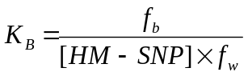 (3)

The expressions for f_{b} and f_{w} are given in Equation 4 in terms of the pre-exponential factors α_{pyW}, α_{pySNP}, and α_{pySNP-P} obtained from the decay analysis with Equation 2.
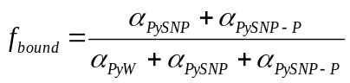 or 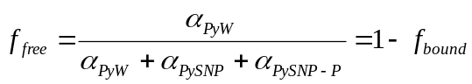 (4)
As the SNP-1 concentration increased from 0 to 19.1 g/L, f_{b} increased and f_{w} decreased (Figure 1A). The f_{b}/f_{w} ratio was also plotted as a function of SNP-1 concentration. A linear relationship was observed between the ratio f_{b}/f_{w} and the SNP-1 concentration, as expected from Equation 3, but f_{b}/f_{w} did not pass through the origin, suggesting that 4 (±2) % of pyrene with a long lifetime was still detected in water from the fluorescence decay analysis. This small contribution is attributed to the analysis program having difficulty distinguishing between background noise and a small contribution of long-lived pyrene species. To overcome this problem, the f_{b}/f_{w} ratio obtained by extrapolating the plot to zero SNP concentration was subtracted from the ratios obtained at all SNP concentrations, resulting in the plot shown in Figure 1B. The binding constant (K_{B}), determined from the slope of the plot in Figure 1B, was 5.0 (± 0.1) × 10⁻² L/g. As the fraction of bound pyrene increased at higher SNP-1 concentrations, the I₁/I₃ ratio obtained from the fluorescence spectra of pyrene decreased only slightly for the unmodified SNP-1 particles (Figure 1C), indicating that pyrene probed the relatively less polar environment of the SNPs.

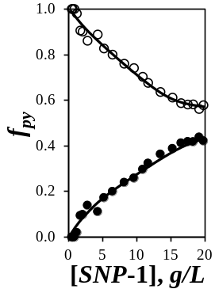  A) | 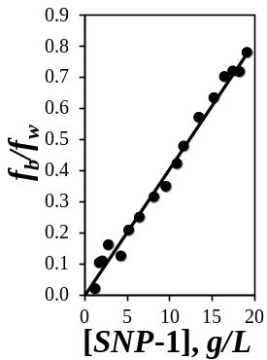  B) | 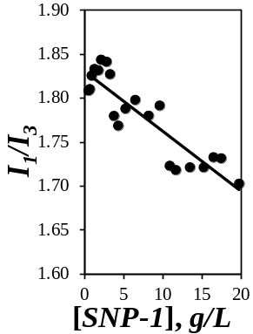  C) | 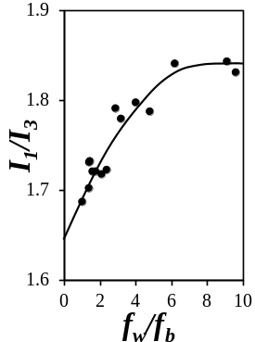  D)

Figure 1. Plots of A) the molar fractions of pyrene (●) bound to SNP-1 (f_{b}) and (○) free in water (f_{w}), B) the ratio f_{b}/f_{w}, and C) the I₁/I₃ ratio as a function of the SNP-1 concentration. D) Plot of the I₁/I₃ ratio as a function of the ratio f_{w}/f_{b}.

While the decrease in the I₁/I₃ ratio for increasing SNP-1 concentrations was subtle for SNP-1 in Figure 1C, it was much more pronounced for the HM-SNPs. This observation led to question which I₁/I₃ ratio should be reported to describe the relative hydrophobicity of a given HM-SNP. To address this concern, the following procedure was implemented. In Figure 1A, f_{W} decreased from 1 to 0.56 as the concentration of SNP-1 increased from 0 to 19.1 g/L. If all pyrene molecules were bound to SNP-1 (f_{b} = 1 and f_{w} = 0), the I₁/I₃ ratio would reflect the polarity of the environment experienced by pyrene bound to SNP-1. The I₁/I₃ ratio was plotted as a function of f_{w}/f_{b} in Figure 1D. The y-intercept of the plot of the I₁/I₃ ratio versus the concentration of SNP-1 was obtained by extrapolating the trend to a zero f_{w}/f_{b} ratio, to yield the (I₁/I₃)₀ ratio corresponding to pyrene bound to SNP-1. Consequently, the (I₁/I₃)₀ ratio differs markedly from the I₁/I₃ ratio reported in the literature for pyrene bound to hydrophobically modified water-soluble macromolecules (HMWSMs), because (I₁/I₃)₀ reports solely on the HMWSMs, in contrast to the straight I₁/I₃ ratio, which is an average between the I₁/I₃ ratios for pyrene partitioned between water and the HMWSM. The (I₁/I₃)₀ ratio obtained equaled 1.66 (± 0.00) in Figure 1D, slightly lower than the I₁/I₃ ratio of 1.8 obtained for pyrene in water,^{22,30,31} thus indicating that the interior of SNP-1, to which pyrene was bound, was fairly polar.
Having established the analytical procedure with the unmodified SNP-1 particles, it was also applied to the HM-SNPs. Fitting the fluorescence decays with Equation 2 yielded the molar fractions f_{b} and f_{w} and the lifetime τ_{SNP}, which remained constant with the HM-SNP concentration. The τ_{SNP} values obtained at different HM-SNP concentrations were averaged and <τ_{SNP}> was plotted as a function of the DS and wt% modification in Figures 2A and B, respectively.

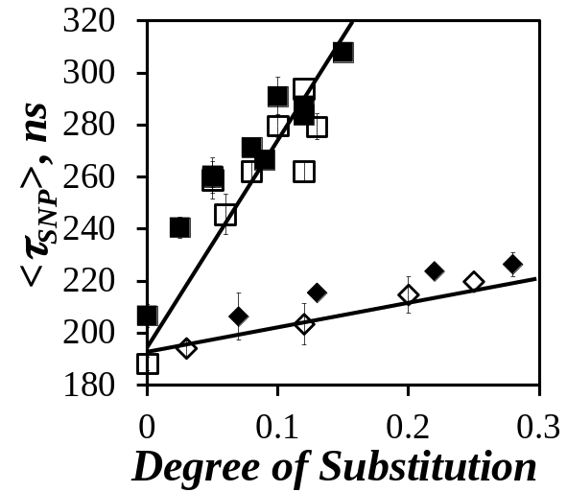  A) | 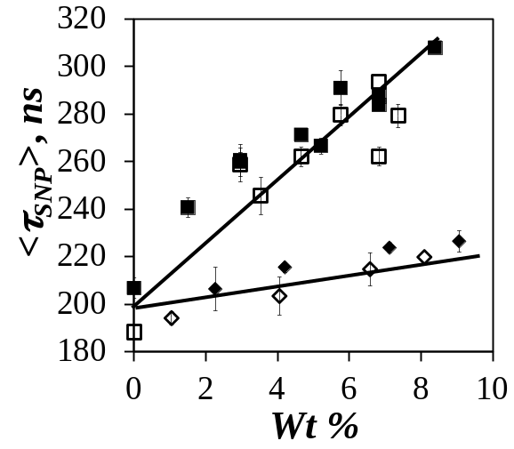  B)
Figure 2. Plots of τ_{SNP} as a function of A) DS and B) wt% of modification for 2 g/L aqueous dispersions of () C6-SNP-1, () C6-SNP-2, () C3-SNP-1, and () C3-SNP-2.

Increasing the degree of substitution resulted in an increase in <τ_{SNP}> in Figure 2A, from 200 ns for the unmodified SNPs up to 300 ns for the C6-modified SNPs. The change in lifetime reflected differences in quenching efficiency by oxygen, a powerful quencher for pyrene, dissolved in water. The introduction of hexanoyl pendants onto the SNPs shielded pyrene from the solvent, resulting in a longer lifetime. Pyrene lifetimes of 300 ns have been found in highly viscous hydrophobic microdomains preventing pyrene from reaching the interface with water, where quenching by oxygen occurs.⁻ The large <τ_{SNP}> lifetimes obtained at high DS of hexanoyl pendants thus suggest that these pendants generate highly viscous microdomains in water. The size of the SNPs used as substrate for these hydrophobic modifications did not seem to affect the <τ_{SNP}> values, which were found to be similar at a same DS irrespective of whether the hydrophobic modification was carried out for SNP-1 or SNP-2. Using propionyl pendants rather than hexanoyl groups resulted in much lower <τ_{SNP}> values in Figure 2, that were hardly larger than <τ_{SNP}> for the unmodified SNPs, indicating that the hydrophobic microdomains generated by the C3-pendants were not as viscous and provided little protection against oxygen quenching as compared to those generated by the C6-pendants.
The molar fractions f_{b} and f_{w} were used to calculate the f_{b}/f_{w} ratios, which were plotted as a function of C6-SNP-1 concentration in Figure 3A. As for the unmodified SNP-1 particles in Figure 1B, the f_{b}/f_{w} ratio increased linearly with increasing C6-SNP-1 concentration, regardless of the DS and as expected from Equation 3. The slope of these straight lines increased with the DS, indicating that a higher level of hydrophobic modification resulted in stronger pyrene binding. As predicted by Equation 3, the slope of these lines yielded K_{B} expressed in L.g⁻¹, which was plotted as a function of the DS and wt% of hydrophobic modification in Figures 3B and 3C, respectively, for the SNPs modified with either propionyl or hexanoyl pendants.
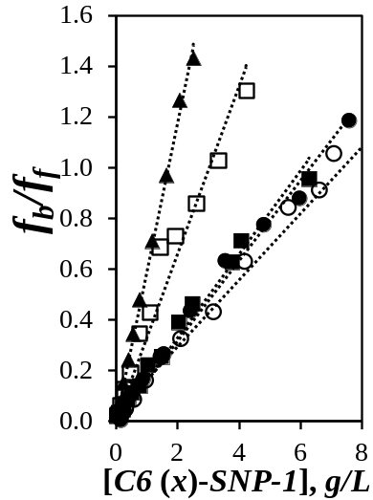 | 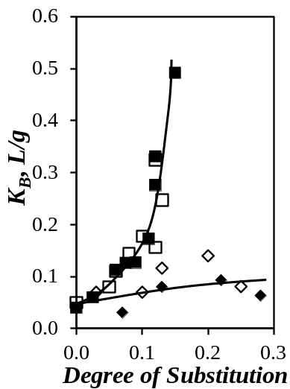  B)_ | 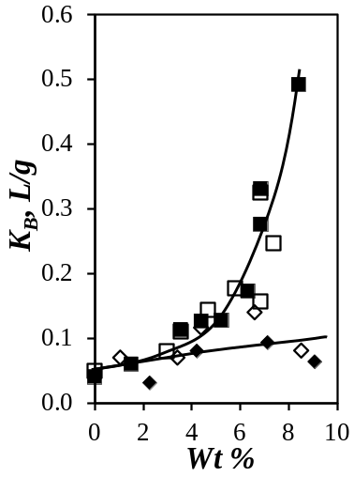  C)_
Figure 3. Plots of A) the ratio f_{b}/f_{w} as a function of C6(x)-SNP-1 concentration with x equal to (●) 0.08, (○) 0.09, (■) 0.11, (□) 0.12, and (▲) 0.15, and K_{B} versus B) DS or C) wt% for () C6-SNP-1, () C6-SNP-2, () C3-SNP-1, and () C3-SNP-2.
A)_

Comparison of the trends observed for the change in K_{B} with the hydrophobic modification level on a molar basis (Figure 3B) shows that the SNP size does not affect K_{B}, but the size of the hydrophobic moiety grafted onto the SNP influences K_{B}, since the propionic pendants resulted in lower values at the same DS. However, since a propionic pendant is shorter than a hexanoic moiety, a better comparison to gauge the effect of hydrophobic modification should be based on the mass of hydrophobic groups attached to the SNPs as done in Figure 3C. A plot of K_{B} versus the weight percentage of modification (wt%) shows that the K_{B} values obtained for both types of modification still reflects the same differences in the <τ_{SNP}> plots, particularly at high modification levels. In fact, binding of pyrene to the C3-SNPs is characterized by an equilibrium constant K_{B} similar to the unmodified SNPs, irrespective of the C3-modification level. In summary, the results in Figure 3C indicate that SNPs modified with a same mass of hydrophobe exhibit a much higher relative hydrophobicity upon modification with hexanoyl pendants. Also noteworthy is the observation of a breakpoint at 5 wt% C6-modification, above which K_{B} increases rapidly for the C6-SNPs as compared to the C3-SNPs. This breakpoint may correspond to the modification level above which hexanoyl pendants are close enough to self-assemble and generate larger hydrophobic microdomains, resulting in enhanced pyrene binding.
For surfactant micelles, the I₁/I₃ ratio of pyrene takes a value lower than 1.8, the ratio for pyrene in water, and that ratio remains constant for surfactant concentrations above the CMC. The interior of surfactant micelles is sufficiently hydrophobic to drive the transfer of hydrophobic pyrene from water to the micelles once the micelles have formed. As illustrated in Figure 4A, this is not the case for the HM-SNPs, as I₁/I₃ decreases more progressively with increasing HM-SNP concentration, due their lower hydrophobicity. Increasing the HM-SNP concentration gradually drives the pyrene molecules out of the water into the HM-SNPs, where they experience a more hydrophobic environment resulting in a lower I₁/I₃ ratio. In turn, this behavior raises the question of how the I₁/I₃ ratio along the trend shown in Figure 4A should be reported to represent the relative hydrophobicity of a given HM-SNP. It is in cases like this that the (I₁/I₃)₀ ratio can be employed to describe the relative hydrophobicity exhibited by the HM-SNPs. To this end, I₁/I₃ obtained from the fluorescence spectra for a given HM-SNP was plotted as a function of f_{w}/f_{b}, obtained by fluorescence decay analysis with Equation 2, as shown in Figure 4B. As f_{w}/f_{b} decreased, more pyrene bonded to the HM-SNPs and the I₁/I₃ ratio decreased, indicating that pyrene probed an environment that was less polar than water. Extrapolation of the I₁/I₃ ratio to a f_{w}/f_{b} ratio equal to zero yielded the (I₁/I₃)₀ ratio, found to equal 1.32 ± 0.02 for sample C6(0.15)-SNP-1. This procedure was applied to all the HM-SNPs, and the resulting (I₁/I₃)₀ ratios were plotted as a function of the DS and the wt% of hydrophobic modification in Figures 4C and D, respectively. The number-average hydrodynamic diameter (D_{h}) was also plotted as a function of the SNP concentration and the f_{w}/f_{b} ratio in Figures 4A and B, respectively. It was found to increase only slightly from 36±1 to 40±1 nm as the SNP concentration was increased from 0.2 to 5 g.L⁻¹. The implications of this observation will be presented in the Discussion.
The plot of (I₁/I₃)₀ as a function of the DS in Figure 4C shows that the C3-SNPs samples depart markedly from the trend obtained for the C6-SNPs, whose (I₁/I₃)₀ ratios clustered along a single line regardless of whether SNP-1 or SNP-2 was used as a substrate for the hexanoyl modification. In analogy to the K_{B} plots in Figure 3, while the data shown in Figure 4C are informative on a molar basis, a comparison was also made with the wt% amount of hydrophobe added to the SNPs in Figure 4D. Here again, the C3- and C6-SNPs had similar (I₁/I₃)₀ ratios at low DS, but (I₁/I₃)₀ was much lower for C6-SNPs containing more than 5 wt% hexanoyl pendants. This result is in agreement with the conclusion reached using K_{B} in Figure 3C, namely that at high levels of hydrophobic modification, the relative hydrophobicity of the C6-SNPs was much higher than for C3-SNPs with the same modification level. Thus all the parameters investigated so far indicated that for a hydrophobic modification level greater than 5 wt%, a hydrophobic pyrene dye binds more strongly to the hydrophobic microdomains generated by C6-SNPs (as reflected in the large K_{B} values in Figure 3C), where it experiences a more hydrophobic environment (low (I₁/I₃)₀ ratio in Figure 4D), and where it is less exposed to water (high <τ_{SNP}> values in Figure 2B). To further support these conclusions, additional fluorescence quenching experiments were carried out with nitromethane, a known water-soluble quencher of pyrene.

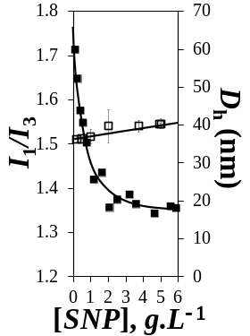  A) | 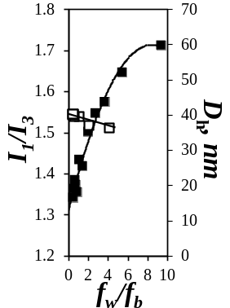  B) | 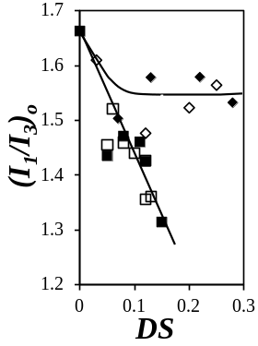  C) | 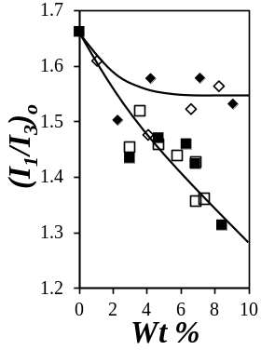  D)
Figure 4. Plots of the I₁/I₃ ratio () and number average hydrodynamic diameter (D_{h}, ) of C6(0.15)-SNP-1 as a function of A) [SNP] and B) the f_{w}/f_{b} ratio, and plot of the (I₁/I₃)₀ ratio of pyrene bound to () C6-SNP-1, () C6-SNP-2, () C3-SNP-1, and () C3-SNP-2 as a function of the C) DS and D) wt% of hydrophobic modification.

Quenching of Pyrene in Water: The binding studies yielding K_{B} established that a significant fraction of pyrene remained in water in the aqueous SNP dispersions. Consequently, the quenching of pyrene in water needed to be characterized. To this end, fluorescence experiments were conducted to determine the rate constant characterizing the quenching of pyrene by nitromethane in water. The fluorescence spectra and decays for pyrene in water were acquired at different nitromethane concentrations. The fluorescence decay of pyrene was analyzed using Equation 5.
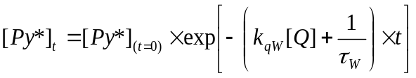 (5)
The quenching of pyrene by nitromethane in water led to decreased fluorescence intensity and faster decay of the pyrene fluorescence, as illustrated in Figures 5A and B, respectively. Fitting the fluorescence decays in Figure 5B with Equation 5 yielded the decay time τ_{PyW} (= (k_{qW}[Q]+1/τ_{W})⁻¹). The bimolecular rate constant k_{qW} for the quenching of pyrene by nitromethane in water was determined by fitting Stern-Volmer plots of I_{o}/I and τ_{w}/τ_{PyW} with Equation 7, which predicts a linear relationship with a slope K_{D} = k_{qW}×τ_{W} between the ratios I_{o}/I and τ_{W}/τ_{PyW} as a function of the nitromethane concentration, as observed in Figure 5C. τ_{W} was determined to equal 130 ns, in agreement with a reported literature value.²⁵ The I_{o}/I and τ_{W}/τ_{PyW} ratios in Figure 5C almost overlap confirming the absence of static quenching between pyrene and nitromethane. Since τ_{W}/τ_{PyW} only describes dynamic quenching, the rate constant k_{qW} in Equation 7 was determined from the ratio K_{D}/τ_{W}, which equaled 6.5 (± 0.05) × 10⁹ M⁻¹s⁻¹, close to reported values.³⁰
A) | 10⁵-  10⁴-  10³-  10²-  10 -  1 - | C)
Figure 5. A) Fluorescence spectra and B) fluorescence decays for pyrene in water with different nitromethane concentrations; [MeNO₂] increases from 0 to 0.082 M from top to bottom. C) Plot of () I_{o}/I and () τ_{W}/τ_{PyW} as a function of nitromethane concentration for 0.5 μM pyrene in water (λ_{ex} = 336 nm).
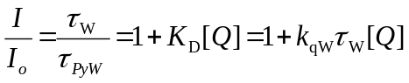 (7)
Quenching of Pyrene in Aqueous Dispersions of SNPs: The SNPs exhibited intrinsic fluorescence that overlapped with the pyrene emission and needed to be taken into account. As discussed in the Experimental Section, the normalized fluorescence spectrum for the aqueous SNP dispersion was subtracted from that of pyrene with the SNPs to obtain the non-contaminated pyrene spectrum. The SNP fluorescence also distorted the fluorescence decays for pyrene, in the form of a sharp peak at early times (see Figure S3B in the SI). The fluorescence of the SNPs was found to decay within 30 ns (Figure S3A) and was taken into account by introducing the function f_{SNP}(t) in Equation 1, which is a sum of three exponentials whose parameters were fixed in the analysis.
As for pyrene in water, the addition of nitromethane to aqueous SNP dispersions containing 0.5 μM pyrene resulted in decreased fluorescence intensity and lifetime, as described in Figures 6A and B, respectively. While the fluorescence spectra for pyrene in a 2 g/L dispersion of SNP-1 in Figure 6A suffered a decrease in fluorescence intensity similar to that observed for pyrene in water (Figure 5A), the fluorescence decays looked quite different: The addition of nitromethane to the aqueous pyrene solutions yielded monoexponential decays in Figure 5, that became shorter-lived at increasing nitromethane concentrations. In contrast, the addition of nitromethane to pyrene in aqueous dispersions of 2 g/L SNP-1 yielded multi-exponential decays with a long-lived component. The multi-exponential behavior of the fluorescence decays in Figure 6B reflects the existence of several pyrene species in the aqueous dispersions. Two of these pyrene species were already identified from the binding experiments, namely pyrenes that are free in water (Py_{w}) and those bound to the SNPs (Py_{b}). Pyrene in water quenched by nitromethane was shown to decay monoexponentially in Figure 5B, so that its decay time τ_{PyW} could be predicted at each nitromethane concentration by rearranging Equation 7 into Equation 8a, with k_{qw} and τ_{w} equal to 6.5 × 10⁹ M⁻¹s⁻¹ and 130 ns, respectively. Consequently, the decay time τ_{PyW} was fixed in Equation 1 for the analysis of the fluorescence decays, after it was calculated for each nitromethane concentration. The Py_{b} species bound to the SNPs were first expected to be represented by the function f_{PySNP}(t) in Equation 1, which was either monoexponential or a sum of two exponentials with decay times τ_{1PySNP} and τ_{2PySNP}. In turn, the number-average decay time <τ_{PySNP}> for f_{PySNP}(t) in Equation 1 was expected to obey Equation 8b, where τ_{SNP} was determined for all the HM-SNPs in Figure 2 and k_{qSNP}, representing the quenching of Py_{b} by nitromethane, was expected to be smaller than k_{qW} since a pyrene molecule bound to a HM-SNP should diffuse more slowly than a free pyrene molecule in water.
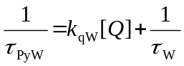 (8a)
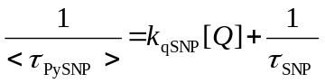 (8b)
Fitting the fluorescence decays acquired at high nitromethane concentrations with a sum of two or three exponentials, one with a decay time τ_{PyW} set to its value determined from Equation 8a and the one or two others representing f_{PySNP}(t) with floating decay times τ_{1PySNP} and τ_{2PySNP}, yielded good fits but with a rather long τ_{2PySNP} approaching τ_{SNP}. This led to the conclusion that some of the pyrenes bound to the SNPs were protected from quenching by nitromethane. As a result, an additional exponential was added with a decay time set to equal τ_{SNP}, the lifetime of pyrene bound to the HM-SNPs in the absence of quencher, as shown in Equation 1. While the fits were good, the molar fractions of pyrene bound to the SNPs that were quenched (α_{PySNP}) and protected from quenching (α_{PySNP-P}) drifted at decreasing quencher concentrations, as shown in Figure S5. At low quencher concentrations, the analysis program could not distinguish between the contributions α_{PySNP} and α_{PySNP-P} in Equation 1 associated with, respectively, f_{PySNP}(t) and τ_{SNP}, since <τ_{PySNP}> approached τ_{SNP} at low nitromethane concentrations according to Equation 8b. However, α_{PySNP} and α_{PySNP-P} could be determined more accurately at high quencher concentrations, where <τ_{PySNP}> and τ_{SNP} were sufficiently different. Indeed, the ratio α_{PySNP}/α_{PySNP-P} reached a constant value at high quencher concentrations in Figure S5. The ratios α_{PySNP} /α_{PySNP-P} that yielded a constant value were averaged, and the average α_{PySNP} /α_{PySNP-P} was then fixed in all the decay analyses with Equation 1.

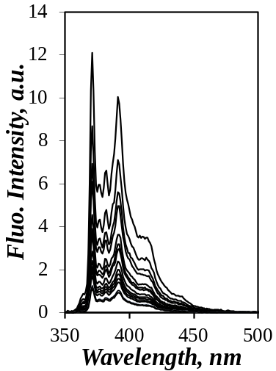  A) | 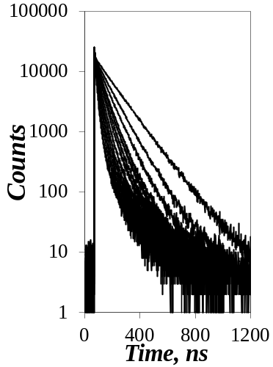  B) | 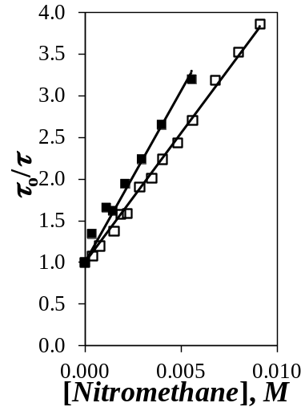  C)
Figure 6. A) Fluorescence spectra and B) fluorescence decays for pyrene in a 2.5 g/L SNP-2 dispersion at different nitromethane concentrations; [MeNO₂] ranges from 0 to 0.09 M from top to bottom. [Py] = 0.5×10⁻⁶ mol/L. C) Plots of τ_{SNP}/τ_{PySNP} for 2.0 g/L aqueous dispersions of () SNP-1 and () SNP-2 as a function of nitromethane concentration.
While the steady-state fluorescence spectra in Figure 6A illustrate the decrease in fluorescence intensity resulting from the addition of nitromethane, the heterogeneity of the aqueous SNP dispersions, where no less than three different pyrene species coexisted, prevented a complete spectrum analysis. In contrast, the analysis of the fluorescence decays was much more straightforward since the specific decay times retrieved could be assigned to each pyrene species in the SNP dispersions. In the case of the unmodified SNP-1 and SNP-2 particles, f_{PySNP}(t) was well-described by a single exponential whose decay time τ_{PySNP} was retrieved from the decay analysis with Equation 1.
The ratio τ_{SNP}/τ_{PySNP} obtained was expected to increase linearly for increasing nitromethane concentrations according to Equation 8b. This was indeed confirmed in Figure 6C for both the SNP-1 and SNP-2 samples. The slope of the straight lines in Figure 6C yielded the product K_{D} = k_{qSNP}×τ_{SNP}. Dividing K_{D} by τ_{SNP} yields the k_{qSNP} values for SNP-1 and SNP-2, which are listed in Table 1. The ratio α_{PySNP-P}/α_{PySNP}, that was fixed in the fluorescence decay analysis, could be rearranged to yield the molar fraction f_{p} (= 1+ 1/(α_{PySNP-P}/α_{PySNP})) ⁻¹ of pyrene molecules protected from quenching. The parameter f_{p} was found to equal 0.27 (± 0.01) and 0.05 (±0.01) for SNP-1 and SNP-2, respectively. The larger f_{P} value retrieved for the larger SNP suggests that their interior has more domains where pyrene can bind and remain hidden from the solution. In contrast, k_{qSNP} is comparable for SNP-1 and SNP-2, being equal to 1.9 (±0.05) x 10⁹ and 1.7 (±0.03) x 10⁹ M⁻¹.s⁻¹, respectively. These k_{qSNP} values are 3.8 times smaller than k_{qW} (6.5 x 10⁹ M⁻¹s⁻¹), as would be expected since pyrene bound to the SNPs is in effect immobile on the timescale of the pyrene fluorescence, and is thus less likely to be quenched as compared to free pyrene in water.

Sample | τ_{SNP}, ns | K_{D}  x 10² M⁻¹ | k_{qSNP}  x 10⁻⁹ M⁻¹.s⁻¹ | f_{p}
SNP-1 | 207 (± 4) | 4.1 | 1.9 (± 0.05) | 0.27 (± 0.01)
SNP-2 | 188 (± 6) | 3.1 | 1.7 (± 0.02) | 0.05 (± 0.01)
Table 1. Parameters τ₀, K_{D}, k_{qSNP}, and f_{p} obtained from the quenching study of pyrene in aqueous dispersions of SNP(x) samples.

Quenching of Pyrene Bound to the HM-SNPs: The fluorescence spectra and decays were acquired for 0.5 μM pyrene in ~ 2 g.L⁻¹ aqueous dispersions of HM-SNPs. They are shown in Figures 7A and B, respectively, for C6(0.15)-SNP-1 quenched by nitromethane. Upon addition of nitromethane, the fluorescence intensity and lifetime decreased in Figures 7A and B, respectively. Since the lifetime τ_{SNP} of pyrene bound to the HM-SNPs was determined in Figure 2 for all the HM-SNPs, it was set in the analysis of the fluorescence decays with Equation 1. The same protocol applied to fit the fluorescence decays with 0.5 μM pyrene in aqueous dispersions of unmodified SNPs was employed for the HM-SNPs. The only difference was that for some HM-SNP samples, two exponentials (rather than one) were needed to handle the function f_{PySNP}(t), representing pyrenes bound to the HM-SNPs that were quenched by nitromethane. To further improve the fluorescence decay analysis, the ratio α_{PyW} /α_{PySNP} which remained more or less constant in the analysis was also fixed to its average value when the analysis required two exponentials to represent the pyrene molecules that were bound to the HM-SNPs and accessible to the quencher.
In this case, the number-average lifetime <τ_{PySNP}> of pyrene bound to the HM-SNP accessible to the quencher was determined. The ratio τ_{SNP}/<τ_{PySNP}> was plotted as a function of the quencher concentration in Figure 7C. Straight lines were obtained for every HM-SNP sample, implying that Equation 8b could be applied to determine the rate constant k_{qSNP} which was plotted as a function of the DS and wt% hydrophobe content for the HM-SNPs in Figures 8A and B, respectively.

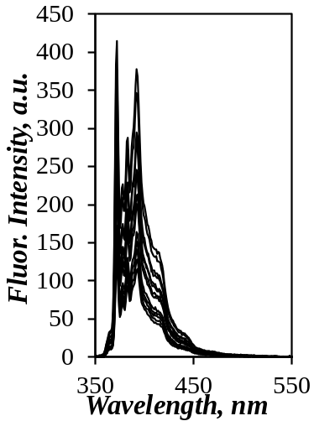  A) | 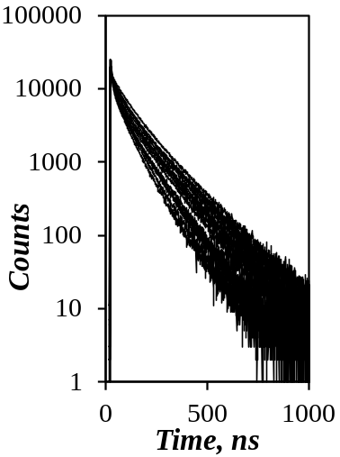  B)
Figure 7. Fluorescence A) spectra and B) decays for 0.5 μM pyrene in aqueous dispersions of C6(0.15)-SNP-1; [MeNO₂] increases from 0 to 5 mM from top to bottom. C) Plot of τ_{SNP}/<τ_{PySNP}> versus nitromethane concentration for C6(x)-SNP-1 samples, where x varies from 0 to 0.15.

Modification with the C6 units led to a decrease in k_{qSNP} for increasing DS and wt% hydrophobe content. The rationale for this trend is similar to the one used for τ_{SNP} in Figure 2. Increasing the DS or the wt% of hydrophobe generated more viscous hydrophobic microdomains in the C6-SNP particles, which decreased the mobility of the pyrene bound to the particles. Pyrene bound to these hydrophobic microdomains diffused more slowly to the water interface where quenching by nitromethane could occur, thus reducing the probability of quenching reflected in lower k_{qSNP} values. For C3-SNPs with low propionyl group contents, increasing C3-modification also led to a decrease in k_{qSNP} by up to 5 wt%, above which k_{qSNP} remained constant regardless of the C3-modification level. The trends shown in Figure 8B indicate that at high wt% hydrophobe, the pyrene probe was much less exposed to water when it was located in a hydrophobic microdomain generated by C6- rather than C3-pendants. This conclusion agrees with the trends obtained with τ_{SNP} in Figure 2, which also yielded a much longer <τ_{SNP}> for pyrene bound to C6- versus C3-SNPs. It is also interesting that the same departure between the trends obtained for the k_{qSNP} values of C3-SNP and C6-SNP was observed at a 5 wt% modification, as observed for (I₁/I₃)_{o} and K_{B}. This further supports the suggestion that the hydrophobic microdomains generated by the hexanoyl pendants at high DS enhance the relative hydrophobicity of these HM-SNPs. The protection level of pyrene afforded by the HM-SNPs was described by the molar fraction of protected pyrene, f_{p}, given in Figure 8C, obtained by analysis of the fluorescence decays. Although the data were scattered, f_{p} was consistently higher at low substitution levels for the larger SNP-1 (D_{h} = 46 nm) than for the smaller SNP-2 (D_{h} = 8.3 nm) particles. This suggests that an increase in SNP size makes it more difficult for a water-soluble quencher to reach and quench pyrene, probably due to the longer distance the quencher must travel inside the larger SNP-1 particles.

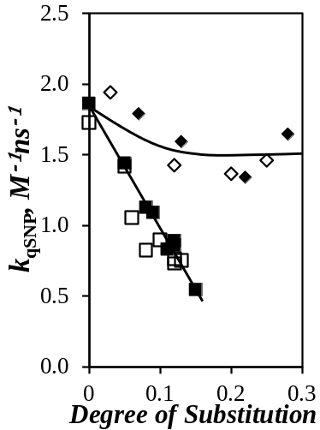  A) | 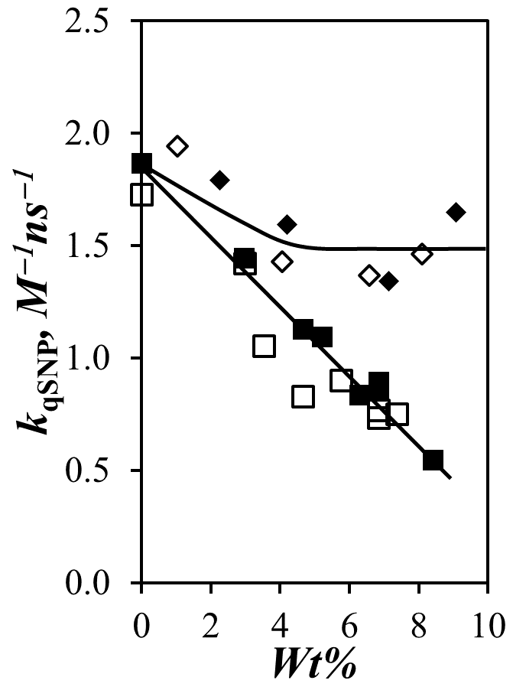  B) | 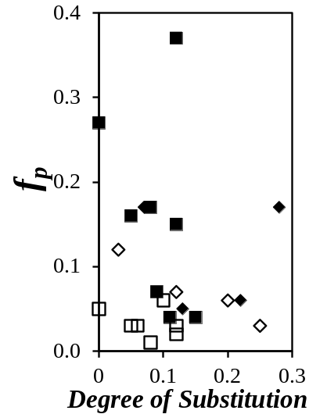  C)
Figure 8. Plots of k_{qSNP} as a function of A) DS and B) wt% and C) plot of f_{P} versus DS for () C6-SNP-1, () C6-SNP-2, () C3-SNP-1, and () C3-SNP-2.

DISCUSSION
Amphiphilic molecules are notorious for their ability to spontaneously self-assemble in water above a certain concentration. This self-assembly is often entropically driven by a reduction in exposure of the hydrophobic moieties to water, resulting in the formation of aggregates where the hydrophobic moieties associate to form hydrophobic microdomains in water stabilized by polar groups. Surfactants are well-studied amphiphilic molecules that self-assemble into micelles above their critical micellar concentration (CMC). Since pyrene is a hydrophobic molecule whose I₁/I₃ ratio changes with the solvent polarity,^{22,,} its fluorescence has been applied to determine the CMC of surfactants by monitoring the I₁/I₃ ratio of dilute pyrene solutions in water as a function of the surfactant concentration. In this analysis, the surfactant concentration at which I₁/I₃ decreases from 1.8 for pyrene in water to a lower value (1.1 for pyrene in SDS micelles) corresponds to the CMC of the surfactant. Based on this description, it is thus hardly surprising that researchers have interpreted a decrease in I₁/I₃ for pyrene in aqueous dispersions of HM-SNPs as an indication of HM-SNP aggregation.^{8,10}
However as illustrated in Figure 4A, the analogy between surfactants and HM-SNPs is wrong. Indeed, if a decrease in I₁/I₃ were to indicate the aggregation of HM-SNPs, a large increase in hydrodynamic diameter (D_{h}) of the aqueous HM-SNPs dispersions would be expected in the same concentration range where I₁/I₃ decreases. As shown in Figure 4A for C6(0.15)-SNP-1, hardly any change in D_{h} was observed while I₁/I₃ decreased. The results presented in Figure 4A make it clear that stronger binding of pyrene to the HM-SNP occurred upon increasing the HM-SNP concentration, but did not lead to obvious HM-SNP aggregation. In contrast to surfactants, the hydrophobes attached onto rigid polysaccharides are first protected from exposure to water by the polysaccharide interior, and second, have difficulty to re-arrange and self-assemble due to the rigid backbone. Consequently, the C6-SNPs do not aggregate up to concentrations of a few wt%, corresponding to their overlap concentration. Increasing the concentration of HM-SNPs in water simply drives pyrene out of the water phase and into the hydrophobic microdomains inside the particles, according to the binding constant K_{B} determined in Figure 3.
The trends observed for the parameters K_{B}, (I₁/I₃)_{o}, and k_{qSNP} in Figures 3C, 4C, and 8B, respectively, all indicated enhanced hydrophobicity of the C6-SNPs for hydrophobic modification levels greater than 5 wt%. The most probable rationale for this is that the 5 wt% modification level marks the onset of substantial aggregation of the C6-pendants inside the individual HM-SNP to form large hydrophobic microdomains. These microdomains drive enhanced binding of pyrene to the HM-SNPs (reflected in larger K_{B} values), whereby pyrene probes a more hydrophobic environment (lower (I₁/I₃)_{o} ratios) and is less exposed to the solvent (lower k_{qSNP} values). The C3-pendants, being less hydrophobic, are unable to induce the formation of hydrophobic microdomains and the type of hydrophicity enhancement observed for the C6-SNPs. These effects are schematically represented in Figure 9.

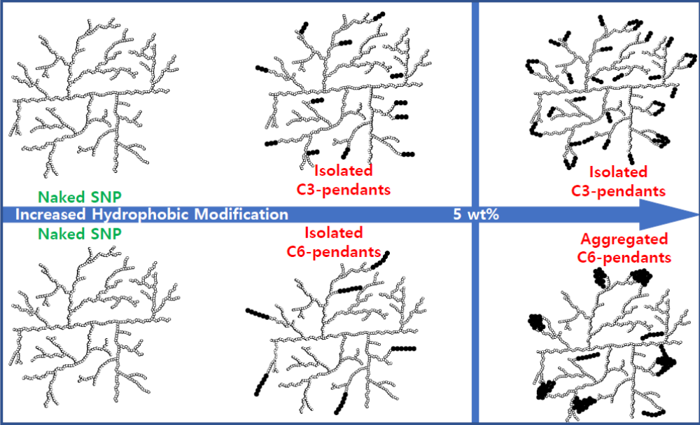
Figure 9. Schematic representation of the internal arrangement of C3- and C6-hydrophobes in the HM-SNPs as a function of the level of hydrophobic modification.

CONCLUSIONS
The experiments based on pyrene fluorescence described in this report highlighted the differences between the response of HM-SNPs and more traditional surfactants. In particular, the inherent rigidity of the polysaccharide backbone onto which the hydrophobes are covalently attached affects their ability to associate within the particle interior. This results in the formation of hydrophobic domains that are much less defined as compared to those generated by free surfactants in solution. Furthermore, the hydrophobic modification of SNPs throughout the particle interior implies that the hydrophobes are shielded from water, which reduces the tendency for HM-SNP association below their overlap concentration (C*). Pyrene fluorescence experiments provide information about the relative polarity of the interior of HM-SNPs and the microviscosity of the hydrophobic microdomains. In contrast to surfactants, a decrease in I₁/I₃ does not indicate interparticle HM-SNP association, since the hydrodynamic diameter of the HM-SNPs did not increase much with the HM-SNP concentration, but rather reflects increased binding of pyrene onto the HM-SNPs. In turn, the equilibrium constant K_{B} for the binding of pyrene onto the HM-SNPs is a measure of their relative hydrophobicity, as is the (I₁/I₃)_{o} ratio. Information about the viscosity of the hydrophobic microdomains was obtained from the pyrene lifetime and the quenching rate constant, which respectively increased and decreased for increasing microviscosity. A change in hydrophobic modification from propionyl to hexanoyl groups resulted in a change in relative polarity of the HM-SNPs based on the K_{B} and (I₁/I₃)_{o} parameters, and a substantial increase in viscosity of the hydrophobic microdomains (larger <τ_{SNP}> and smaller k_{qSNP} values). The size of the SNPs was found to have no effect on the parameters K_{B}, <τ_{SNP}>, k_{qSNP}, and (I₁/I₃)_{o}, indicating that it had little effect on the relative hydrophobicity of the HM-SNPs. Such an observation may be important for the design of HM-SNPs as delivery vehicles for hydrophobic drug cargoes.

ACKNOWLEDGEMENTS
This research was funded by EcoSynthetix and NSERC. The authors are also thankful for numerous fruitful discussions with Drs. Bloembergen, McLennan, Mesnager, and Smeets.

SUPPORTING INFORMATION
¹H NMR spectrum for a C3-modified SNP. Figures describing the procedures applied to analyze the fluorescence spectra and decays, and tables of parameters retrieved from the fluorescence decay analysis.

REFERENCES . Delcour, J. A.; Bruneel, C.; Derde, L. J.; Gomand, S. V.; Pareyt, B.; Putseys, J. A.; Wilderjans, E.; Lamberts, L. Fate of Starch in Food Processing : From Raw Materials to Final Food Products. Ann. Rev. Food Sci. Technol. 2010, 1 87–111.
. Hancock, R. D.; Tarbet, B. J. The Other Double Helix – The Fascinating Chemistry of Starch. J. Chem. Ed. 2000, 77, 988–992.
. Le Corre, D.; Bras, J.; Dufresne, A. Starch Nanoparticles: A Review. Biomacromolecules 2010, 11, 1139–1153.
. Campos, E.; Branquinho, J.; Carreira, A. S.; Carvalho, A.; Coimbra, P.; Ferreira, P.; Gil, M. H. Designing Polymeric Microparticles for Biomedical and Industrial Applications. Eur. Polym. J. 2013, 49, 2005–2021.
. Rayner, M.; Marku, D.; Eriksson, M.; Sjöö, M.; Dejmek, P.; Wahlgren, M. Biomass-Based Particles for the Formulation of Pickering Type Emulsions in Food and Topical Applications. Colloids Surf. A 2014, 458, 48–62.
. Bhosale, R.; Singhal, R. Process Optimization for the Synthesis of Octenyl Succinyl Derivative of Waxy Corn and Amaranth Starches. Carbohydr. Polym. 2006, 66, 521–527.
. He, J.; Liu, J.; Zhang, G. Slowly Digestible Waxy Maize Starch Prepared by Octenyl Succinic Anhydride Esterification and Heat – Moisture Treatment: Glycenic Response and Mechanism. Biomacromolecules 2008, 9, 175–184.
. Yu, H.; Huang, G. Enhanced in Vitro Anti-Cancer Activity of Curcumin Encapsulated Hydrophobically Modified Starch. Food CHem. 2010, 119, 669–674.
. Marku, D.; Wahlgren, M.; Rayner, M.; Sjöö, M.; Timgren, A. Characterization of Starch Pickering Emulsions for Potential Applications in Topical Formulations. Int. J. Pharm. 2012, 428, 1–7.
. Gu, F.; Li, B.-Z.; Xia, H.; Adhikari, B.; Gao, Q. Preparation of Starch Nanospheres through Hydrophobic Modification Followed by Initial Water Dialysis. Carbohydr. Polym. 2015, 115, 605–612.
. Kang, B. G.; Yoon, S. H.; Lee, S. H.; Yie, J. E.; Yoon, B. S.; Suh, M. H. Studies on the Physical Properties of Modified Starch-Filled HDPE Film. J. Appl. Polym. Sci. 1996, 60, 1977–1984.
. Simi, C. K.; Abraham, T. E. Hydrophobic Grafted and Cross-Linked Starch Nanoparticles for Drug Delivery. Bioprocess Biosyst. Eng. 2007, 30, 173–180.
. Lehmann, A.; Volkert, B.; Fisher, S.; Schrader, A.; Nerenz, H. Starch Based Thickening Agents for Personal Care and Surfactant Systems. Colloids Surf. A 2008, 331, 150–154.
. Ju, B.; Yan, D.; Zhang, S. Micelles Self-Assembled from Thermoresponsive 2-Hydroxy-3-Butoxypropyl Starches for Drug Delivery. Carbohydr. Polym. 2012, 87, 1404–1409.
. Tuovinen, L.; Peltonen, S.; Järvinen, K. Drug Release from Starch-Acetate Films. J. Controlled Release 2003, 91, 345–354.
. Santander-Ortega, M. J.; Stauner, T.; Loretz, B.; Ortega-Vinuesa, J. L.; Bastos-Gonzalez, D.; Wenz, G.; Schaeffer, U. F.; Lehr, C. M. Nanoparticles Made from Novel Starch Derivatives for Transdermal Drug Delivery. J. Controlled Release 2010, 141, 85–92.
. Millard, M. M.; Dintzis, F. R.; Willett, J. L.; Klavons, J. A. Light-Scattering Molecular Weights and Intrinsic Viscosities of Processed Waxy Maize Starches in 90% Dimethyl Sulfoxide and H₂O. Carbohydr. 1997, 74, 687–691.
. Lakowicz, J. R. Principles of Fluorescence Spectroscopy 2nd Ed., Kluwer Acad. New York, 1999.
. Winnik, F. M. Photophysics of Preassociated Pyrenes in Aqueous Polymer Solutions and in Other Organized Media. Chem. Rev. 1993, 93, 587-614.
. Winnik, F. M.; Regismond, S. T. A. Fluorescence Methods in the Study of the Interactions of Surfactants with Polymers. Colloids Surf., A 1996, 118, 1 – 39.
. Fowler, M.; Hisko, V.; Henderson, J.; Casier, R.; Li, L.; Thoma, J.; Duhamel, J. DiPyMe in SDS Micelles – Artefacts and their Implications on Micellar Properties. Langmuir 2015, 31, 11971–11981.
. Kalyanasundaram, K. Thomas, J. K. Environmental Effects on Vibronic Band Intensities in Pyrene Monomer Fluorescence and their Application in Studies of Micellar Systems. J. Am. Chem. Soc. 1977, 99, 2039–2044.
. Yi, W. Characterization of Starch Nanoparticles by Fluorescence Techniques. M. Sc. Thesis at the University of Waterloo, 2014.
. Chu, D. Y.; Thomas, J. K. Photophysical and Photochemical Studies on a Polymeric Intramolecular Micellar System, PA-18K2. Macromolecules 1987, 20, 2133–2138.
. Binana-Limbele, W.; Zana, R. Fluorescence Probing of Microdomains in Aqueous Solutions of Polysoaps: 2. Study of the Size of the Microdomains. Macromolecules 1990, 23, 2731–2739.
. Claracq, J.; Santos, S. F. C. R.; Duhamel, J.; Dumousseaux, C.; Corpart, J.-M. Rigid Interior of Styrene-Maleic Anhydride Copolymer Aggregates Probed by Fluorescence Spectroscopy. Langmuir 2002, 18, 3829–3835.
. Siddique, B.; Duhamel, J. Effect of Polypeptide Sequence on Polypeptide Self-Assembly. Langmuir 2011, 27, 6639–6650.
. Fowler, M. A.; Siddique, B.; Duhamel, J. Effect of Sequence on the Ionization Behaviour of a Series of Amphiphilic Polypeptides. Langmuir 2013, 29, 4451–4459.
. Tanford, C. The Hydrophobic Effect: Formation of Micelles and Biological Membranes 2nd Ed. New York, Wiley, 1980.
. Dong, D. C.; Winnik, M. A. The Py Scale of Solvent Polarities. Solvent Effects on the Vibronic Fine Structure of Pyrene Fluorescence and Empirical Correlations with ET and Y Values. Photochem. Photobiol. 1982, 35, 17–21.
. Dong, D. C.; Winnik, M. A. The Py Scale of Solvent Polarities. Can. J. Chem. 1984, 62, 2560–2565.
. Dominguez, A.; Fernandez, A.; Gonzalez, N.; Iglesias, E.; Montenegro, L. Determination of Critical Micelle Concentration of Some Surfactants by Three Techniques. J. Chem. Educ. 1997, 74, 1227–1231. Table of Content

