This document is the Accepted Manuscript version of a Published Work that appeared in final form in Macromolecules, copyright © American Chemical Society after peer review and technical editing by publisher. To access the final edited and published work see https://doi.org/10.1021/acs.macromol.6b02455

Characterization of the Long Range Internal Dynamics of Pyrene-Labeled Macromolecules by Pyrene Excimer Fluorescence

Shiva Farhangi, Remi Casier, Lu Li, Janine Thoma, Jean Duhamel*

Institute for Polymer Research, Waterloo Institute for Nanotechnology,
Department of Chemistry, University of Waterloo, 200 University Avenue West,
Waterloo, ON N2L 3G1, Canada

* To Whom correspondence should be addressed

ABSTRACT
The Long Range Internal Dynamics (LRID) of 74 pyrene-labeled macromolecules (PyLMs) were characterized in four solvents representing a broad range of dielectric constants equal to 2.4 (toluene), 7.6 (tetrahydrofuran, THF), 37.8 (N,N-dimethylformamide, DMF) and 46.7 (dimethylsulfoxide, DMSO). The LRID of the PyLMs were quantified based on the parameters retrieved from the global Model Free Analysis (MFA) of the time-resolved fluorescence (TRF) decays of the pyrene monomer and excimer. These parameters were combined to yield <k>, the average rate constant of pyrene excimer formation in the PyLMs, and (I_{E}/I_{M})^{TRF}(f_{free}=0), the ratio of excimer to monomer fluorescence intensity obtained in the absence of pyrene labels that do not form excimer. (I_{E}/I_{M})^{TRF}(f_{free}=0) was found to increase linearly with increasing <k> values over three orders of magnitude in the four solvents studied with a slope that equaled the average lifetime of the pyrene excimer (τ_{E}). The <k> values obtained to build these master lines could be correlated back to the expected LRID of the macromolecules. The lowest <k> values were obtained for the end-labeled linear chains holding the pyrene groups far apart whereas the branched macromolecules bringing the pyrene labels close to each other yielded the larger <k> values. Furthermore the fact that these master curves were observed for so many different PyLMs in the four solvents covering such a broad range of solvent polarity suggests that this relationship represents a general physical phenomenon that applies to all PyLMs. Considering the importance of characterizing the LRID of macromolecules in solution, the (I_{E}/I_{M})^{TRF}(f_{free}=0)-vs.-<k> plots presented in this report can be viewed as calibration curves against which the LRID of any PyLM can now be compared. Thus the 3-order of magnitude range found for these master curves offers the scientific community an impressive analytical opportunity to gauge the LRID of macromolecules in solution.

INTRODUCTION
The rate constant of excimer formation through the diffusive encounter of an excited and a ground-state pyrene covalently attached onto a macromolecule provides a direct measure of the Long Range Internal Dynamics (LRID) of macromolecules in solution., Compared to many other techniques that yield the rotational diffusion coefficient of a specific unit of a macromolecule such as NMR, dynamic light scattering, or fluorescence anisotropy to name just but a few, pyrene excimer formation offers the much rarer feature of probing translational diffusion whereby two pyrene molecules covalently attached to different segments of a macromolecule diffuse through space until they come within 1 nm of each other to form an excimer. Thus pyrene excimer formation is ideally suited to describe the LRID of macromolecules as it provides a direct measure of how different segments of a macromolecule diffuse within the macromolecular volume. As a result, numerous macromolecules have been pyrene-labeled in a variety of ways, namely at the ends of linear monodisperse chains, at the terminals of highly branched dendrimers, randomly along a chain, or at specific internal positions in proteins, or polymers., Unfortunately this variety in pyrene-labeling schemes has substantially complicated the quantitative analysis of fluorescence data acquired with PyLMs.
As it turns out, all but one photophysical process depicted in Scheme 1, which is the accepted kinetic scheme to describe excimer formation in pyrene-labeled macromolecules (PyLMs), are well understood in the literature. Upon absorption of a photon, an excited pyrene monomer can either fluoresce with its natural lifetime τ_{M} or form one of two possible excimers referred to as E0* or D* upon encounter with a ground-state pyrene. The existence of a second excimer D* is usually observed when excimer formation occurs in restricted geometries that hinder the mobility of pyrene which, in turn, leads to poor stacking of two pyrenyl moieties. Such conditions can be encountered in PyLMs. Once formed, excimers E0* and D* can dissociate, but since the dissociation rate constant (k₋₁) is usually small when compared to the inverse of their lifetime (k₋₁ << τ_{E0}⁻¹ or τ_{D}⁻¹), k₋₁ is often neglected when modelling the process of pyrene excimer formation.^{1,2}
(PyPy)
(PyPy)*
Py_{diff}*
Py
Py_{diff}
Py
hν
hν
f(t)
τ_{E0}⁻¹
τ_{D}⁻¹
τ_{M}⁻¹
k₋₁

Scheme 1. Excimer formation between pyrenyl groups covalently attached onto a PyLM.

Compared to all these photophysical processes, the one process that remains the most difficult to handle mathematically is the time-dependent rate constant of pyrene excimer formation described by the function f(t) in Scheme 1. When excimer formation is monitored between several pyrene labels covalently attached to a macromolecule, each contour length separating every pair of pyrene labels is expected to generate one rate constant so that pyrene excimer formation must be described by a distribution of rate constants (DRC) reflecting the distribution of contour lengths. While much effort has been devoted over the past four decades to carefully determine the exact expression of the DRC in fluorescently labeled macromolecules, the DRC being unimodal and monodisperse for a monodisperse linear end-labeled polymer (one contour length yields one rate constant),⁷ Poisson for randomly labeled macromolecules,⁹ or involving a 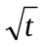-term in high viscosity media such as lipid bilayers, the average rate constant <k> of the DRC for pyrene excimer formation is usually the most important information required to describe the main dynamical features of a macromolecule. It is in this context that the Model Free Analysis (MFA)^{1,2,8} becomes particularly appealing, especially when considering the simplicity of its derivation as shown hereafter.
The MFA is based on the observation that regardless of the nature of the PyLM (linear, branched, or helical) and the strategy selected for pyrene-labeling (randomly or at specific positions), the fluorescence decays of the pyrene monomer can always be fitted with a sum of exponentials as shown in Equation 1. Starting from this insight, an expression of the excimer decay is derived in a remarkably straightforward manner. Rearranging Equation 2 yields an expression for the time-dependent rate constant f(t) which takes the form of a sum of exponentials to represent the DRC. The expression of the rate constant f(t) can then be introduced into Equation 3 to provide after integration the equation describing the excimer fluorescence decay which is a sum of exponentials that includes the same pre-exponential factors a_{i} and decay times τ_{i} used in Equation 1. The sums of exponential describing the monomer [M*] and excimer [E*] concentrations are provided in Equations S1 and S5 in SI. The mathematical derivation presented with Equations 1-3 can be easily expanded to include a second excimer D* if required.

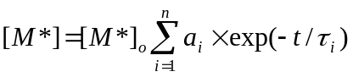 (1)
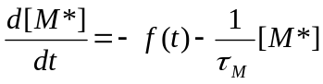 (2)
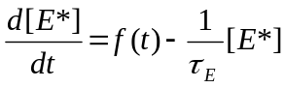 (3)

The sums of exponentials obtained for [M*] (Equation S1) and [E*] (Equation S2) are used to fit globally the monomer and excimer decays of a PyLM where both the a_{i} and τ_{i} parameters are optimized simultaneously in the expressions of [M*] and [E*]. Surprisingly this apparently innocuous analytical detail represented a major departure from all other global analyses of monomer and excimer fluorescence decays of PyLMs conducted outside this laboratory because these other analyses optimized τ_{i} as a same parameter in the expressions of [M*] and [E*] but their respective pre-exponential factors a_{i} in Equations S1 and b_{i} = a_{i}×(1/τ_{i} – 1/τ_{M})/(1/τ_{i} – 1/τ_{E0}) in Equation S2 were optimized separately and independently in the monomer and excimer decays. Since optimization programs seek out a best fit without regard for the physical meaning of the parameters retrieved, the global fit of the monomer and excimer decays yielded a_{i} values obtained from the fits of the monomer decays that did not match the a_{i} values obtained after rearranging the b_{i} coefficients and τ_{i} decay times obtained from the fit of the excimer decays. Invariably this outcome resulted in rather laborious, sometimes erroneous, and often impossible interpretations of the decay analysis results. These considerations have been documented in an earlier publication. By contrast, implementation of the MFA only yields meaningful a_{i} and τ_{i} parameters thanks to the additional constrains imposed during their optimization. In turn, the a_{i} and τ_{i} parameters are applied to determine <k> and the absolute ratio of excimer over monomer, namely the (I_{E}/I_{M})^{TRF} ratio obtained by time-resolved fluorescence (TRF) according to Equations 4 and 5, respectively.¹⁵ In Equations 4 and 5, <τ> is the number average lifetime of the monomer decay accounting for all decay times τ_{i} other than τ_{M}, where τ_{M} represents those pyrene labels that do not form excimer and emit as if they were free in solution. The molar fractions f_{free}, 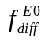, 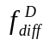, f_{E0}, and f_{D} used in Equation 5 represent those pyrene species that do not form excimer, form the excimer E0* or D* by diffusion or quasi-instantaneously upon direct excitation of a pyrene aggregate, respectively. When f_{free} is set to equal zero to represent the (I_{E}/I_{M})^{TRF} ratio in the absence of those pyrene labels that do not form excimer, the (I_{E}/I_{M})^{TRF} ratio is referred to as (I_{E}/I_{M})^{TRF}(f_{free}=0).^{16,}

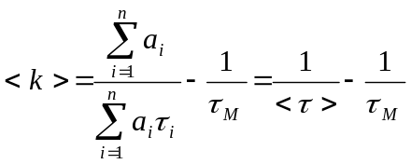 (4)
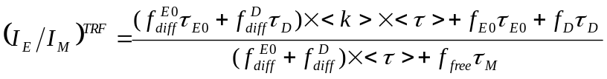 (5)

In a study conducted in THF on 32 PyLMs representing the largest number and structural variety of PyLMs to have been studied to date, all (I_{E}/I_{M})^{TRF}(f_{free}=0) and <k> values were found to line up on a master straight line that spanned three orders of magnitude, as long as all pyrene labels of the PyLMs formed excimer by diffusion. The slope of this master straight line equaled the excimer lifetime in the solvent considered. The PyLMs composed of a more flexible backbone or exhibiting a larger local pyrene concentration were found to take the largest (I_{E}/I_{M})^{TRF}(f_{free}=0) and <k> values. Consequently this master curve obtained for a series of PyLMs in THF provided a means to rank these PyLMs according to their ability to form excimer which reflected their compactness and LRID in that solvent.
Recognizing the importance of having a robust experimental means to rank quantitatively macromolecules according to the magnitude of their LRID, the present report demonstrates the general nature of the master straight line obtained between (I_{E}/I_{M})^{TRF}(f_{free}=0) and <k> that was first established for PyLMs in THF¹⁶ by showing that similar master straight lines can be generated not only in THF, but also in less polar toluene and more polar N,N-dimethylformamide (DMF) and dimethyl sulfoxide (DMSO). This study also expands on the range of PyLMs being characterized earlier by including nine series of poly(alkyl methacrylate)s, amylose, amylopectin, and polystyrene that were randomly labeled with 1-pyrenebutyl derivatives and one series of pyrene end labeled poly(ethylene oxide)s. DiPyMe, pyrene end-labeled dendrimers, poly(1-pyrenebutyl methacrylate), and poly(1-pyrenemethoxydiethoxydiethyl methacrylate) were also added to this study as representatives of macromolecules with high pyrene contents capable of forming excimer very efficiently. Together 74 PyLMs were investigated which represents by far the largest set of PyLMs ever investigated in the literature. The fact that a same behavior was found for so large a group of PyLMs with such a broad range of architectures demonstrates that the MFA is a robust and versatile analytical tool to study any type of PyLM.
The four master straight lines established in solvents having dielectric constants equal to 2.4 (toluene), 7.6 (THF), 37.8 (DMF), and 46.7 (DMSO) at 25 ºC cover a broad range of solvent polarities. This wide range in solvent polarity implies that at least one of these four solvents should be able to dissolve any PyLM whose LRID can then be characterized from its <k> value. Since <k> can be easily determined for any PyLM from Equation 4 by fitting the monomer decay with a sum of exponentials where the longest decay time is fixed to equal the lifetime (τ_{M}) of the pyrene derivative used to prepare the PyLM (see Equation S1), the master straight lines obtained in the four solvents provide the scientific community with a means to gauge the magnitude of the LRID of any new PyLM by determining and comparing its <k> value to those obtained in this study.

EXPERIMENTAL
Materials: Dimethyl sulfoxide (DMSO) was purchased from Sigma-Aldrich. Distilled in glass toluene, tetrahydrofuran (THF), and dimethylformamide (DMF) were supplied by Caledon.
The chemical structures of all the pyrene-labeled constructs are presented in Table 1. All these PyLMs have been prepared for previous studies¹⁷⁻ and their synthesis and characterization has been described in detail earlier. The nine series of pyrene-labeled poly(alkyl methacrylate)s were prepared by copolymerizing 1-pyrenebutyl methacrylate with either methyl methacrylate, n-butyl methacrylate, n-hexyl methacrylate, n-octyl methacrylate, n-dodecyl methacrylate, n-stearyl methacrylate, tert-butyl methacrylate, or cyclohexyl methacrylate to yield Py-PC1MA, Py-PC4MA, Py-PC6MA, Py-PC8MA, Py-PC12MA, Py-PC18MA, Py-PC4TBMA, or Py-PC6CyMA, respectively.¹⁸ Py-PC1A was obtained by copolymerizing 1-pyrenebutyl acrylate with methyl acrylate.¹⁸ Similarly a series of polystyrenes randomly labelled with pyrene was synthesized by copolymerizing 1-pyrenebutyl acrylate with styrene to yield Py-CoE-PS.¹⁹ Amylose and amylopectin were randomly labeled with pyrene by reacting their hydroxyl groups with 1-pyrenebutyric acid in the presence of diisopropylcarbodiimide to yield Py-Amylose and Py-Amylopectin, respectively.²⁰ Three pyrene end-capped monodisperse poly(ethylene oxide)s were obtained by reacting 1-pyrenemethoxide onto the corresponding tosylated PEOs to yield the Py₂-PEO series.²¹ The reaction of 1-pyrenemethoxide with 1-pyrenemethyl chloride yielded DiPyMe.²² A series of bis(hydroxymethyl)propionic acid of generation 2 – 4 dendrons end-labelled with 1-pyrenebutyric acid (PP-G2-BuPy₄, PP-G3-BuPy₈, PP-G4-BuPy₁₆) were also investigated.¹⁷ PPyBuMA and PPyEG₃MA were homopolymers of 1-pyrenebutyl methacrylate and 1-pyrenemethoxydiethoxyethyl methacrylate prepared by radical polymerization.²³

Table 1: Chemical structure, pyrene contents in mol%, λ_{Py} in μmol/g, number-average molecular weights , and PDIs of the pyrene-labeled constructs used in this study.
Chemical  Structure | Py-PC1MA |  |  |  |  |  |  |  | Chemical  Structure |  | Py-PC4MA
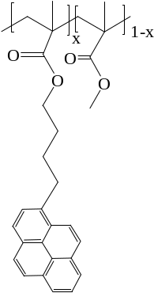 | Pyrene Content |  |  | λ_{Py} |  |  | M_{n} | PDI | 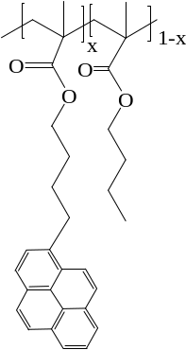 |  | Pyrene Content |  | λ_{Py} |  |  |  |  | M_{n} |  | PDI
 | (mol %) |  |  | (μmol/g) |  |  | (kg/mol) | [-] |  |  | [mol %] |  | (μmol/g) |  |  |  |  | (kg/mol) |  | [-]
 | 2.6 |  |  | 248 |  |  | 200 | 1.33 |  |  | 2.2 |  | 149 |  |  |  |  | 296 |  | 1.44
 | 4.1 |  |  | 371 |  |  | 135 | 1.60 |  |  | 3.0 |  | 200 |  |  |  |  | 197 |  | 1.39
 | 5.2 |  |  | 464 |  |  | 206 | 1.70 |  |  | 3.6 |  | 242 |  |  |  |  | 264 |  | 1.68
 | 5.3 |  |  | 471 |  |  | 101 | 2.10 |  |  | 5.3 |  | 345 |  |  |  |  | 275 |  | 1.97
 | 5.6 |  |  | 491 |  |  | 170 | 1.55 |  |  | 7.2 |  | 461 |  |  |  |  | 416 |  | 1.76
 | 7.3 |  |  | 618 |  |  | 176 | 1.80
Chemical  Structure | Py-PC6MA |  |  |  |  |  |  |  | Chemical  Structure |  | Py-PC8MA
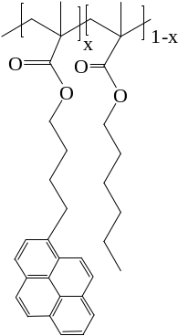 | Pyrene Content | λ_{Py} |  |  |  | M_{n} |  | PDI | 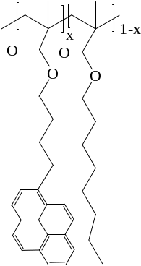 |  | Pyrene Content |  |  | λ_{Py} |  | M_{n} |  |  |  | PDI
 | (mol %) | (μmol/g) |  |  |  | (kg/mol) |  | [-] |  |  | (mol %) |  |  | (μmol/g) |  | (kg/mol) |  |  |  | [-]
 | 2.0 | 113 |  |  |  | 139 |  | 1.93
 | 3.3 | 188 |  |  |  | 125 |  | 1.95 |  |  | 2.7 |  |  | 131 |  | 312 |  |  |  | 1.75
 | 4.7 | 268 |  |  |  | 151 |  | 1.97 |  |  | 4.3 |  |  | 209 |  | 146 |  |  |  | 2.04
 | 5.8 | 324 |  |  |  | 183 |  | 1.84 |  |  | 5.1 |  |  | 258 |  | 371 |  |  |  | 1.83
 | 6.7 | 366 |  |  |  | 116 |  | 1.76 |  |  | 6.1 |  |  | 292 |  | 234 |  |  |  | 1.88
 | 8.1 | 442 |  |  |  | 179 |  | 1.97 |  |  | 7.3 |  |  | 350 |  | 271 |  |  |  | 2.07
Chemical  Structure | Py-PC12MA |  |  |  |  |  |  |  |  | Chemical  Structure |  | Py-PC18MA
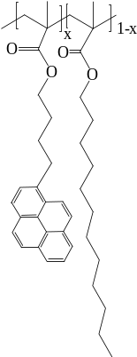 | Pyrene Content |  | λ_{Py} |  | M_{n} |  |  | PDI |  | 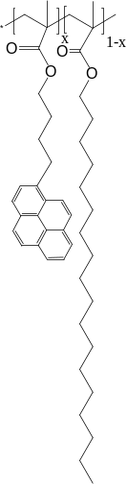 |  | Pyrene Content |  |  | λ_{Py} |  | M_{n} |  |  |  |  | PDI
 | (mol %) |  | (μmol/g) |  | (kg/mol) |  |  | [-] |  |  |  | (mol %) |  |  | (μmol/g) |  | (kg/mol) |  |  |  |  | [-]
 | 1.4 |  | 54 |  | 265 |  |  | 1.70 |  |  |  | 1.4 |  |  | 42 |  | 810 |  |  |  | 1.52
 | 3.5 |  | 137 |  | 244 |  |  | 2.43 |  |  |  | 4.5 |  |  | 132 |  | 480 |  |  |  | 1.44
 | 5.6 |  | 216 |  | 507 |  |  | 1.70 |  |  |  | 5.9 |  |  | 174 |  | 663 |  |  |  | 1.42
 | 6.0 |  | 232 |  | 174 |  |  | 2.17 |  |  |  | 6.8 |  |  | 201 |  | 705 |  |  |  | 1.41
 | 7.7 |  | 295 |  | 662 |  |  | 2.10 |  |  |  | 6.7 |  |  | 198 |  | 719 |  |  |  | 1.49
 | 10.2 |  | 389 |  | 265 |  |  | 1.68 |  |  |  | 14.2 |  |  | 417 |  | 770 |  |  |  | 1.45
Chemical  Structure | Py-PC1A |  |  |  |  |  |  |  |  | Chemical  Structure |  | Py-PC4TMA
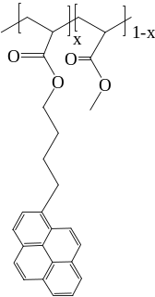 | Pyrene Content |  | λ_{Py} |  | M_{n} |  |  | PDI |  | 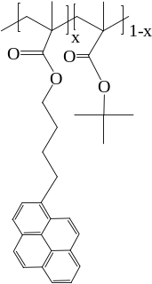 |  | Pyrene Content |  |  | λ_{Py} |  |  | M_{n} | PDI
 | (mol %) |  | (μmol/g) |  | (kg/mol) |  |  | [-] |  |  |  | (mol %) |  |  | (μmol/g) |  |  | (kg/mol) | [-]
 | 1.7 |  | 193 |  | 148 |  |  | 2.00 |  |  |  | 3.6 |  |  | 239 |  |  | 127 | 1.72
 | 2.6 |  | 284 |  | 236 |  |  | 1.40 |  |  |  | 3.8 |  |  | 254 |  |  | 183 | 1.56
 | 2.6 |  | 284 |  | 313 |  |  | 1.40 |  |  |  | 4.7 |  |  | 310 |  |  | 233 | 1.25
 | 5.0 |  | 342 |  | 138 |  |  | 2.08 |  |  |  | 5.6 |  |  | 363 |  |  | 147 | 1.65
 | 6.7 |  | 655 |  | 870 |  |  | 2.40 |  |  |  | 7.6 |  |  | 486 |  |  | 141 | 2.19

Chemical  Structure | Py-PC6CyMA |  |  |  | Chemical  Structure | Py-CoE-PS
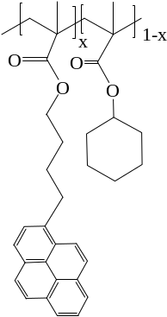 | Pyrene Content | λ_{Py} | M_{n} | PDI | 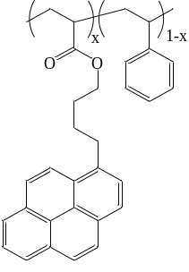 | Pyrene Content | λ_{Py} |  | M_{n} |  | PDI
 | (mol %) | (μmol/g) | (kg/mol) | [-] |  | (mol %) | (μmol/g) |  | (kg/mol) |  | [-]
 | 2.0 | 121 | 187 | 1.61 |  | 2.1 | 190 |  | 46 |  | 1.65
 | 3.0 | 172 | 206 | 2.00 |  | 3.1 | 280 |  | 43 |  | 1.67
 | 3.8 | 218 | 244 | 2.14 |  | 4.5 | 390 |  | 49 |  | 1.62
 | 5.1 | 290 | 263 | 2.19 |  | 5.4 | 467 |  | 53 |  | 1.69
 | 6.2 | 346 | 192 | 2.04 |  | 6.0 | 510 |  | 46 |  | 1.68
 | 7.0 | 389 | 268 | 1.67
Chemical  Structure | Py-Amylose |  |  |  | Chemical  Structure | Py-Amylopectin
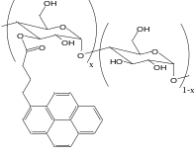 | Pyrene Content | λ_{Py} | M_{n} | PDI | 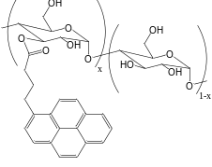 | Pyrene Content |  | λ_{Py} |  | M_{n} |  | PDI
 | (mol %) | (μmol/g) | (kg/mol) | [-] |  | (mol %) |  | (μmol/g) |  | (kg/mol) |  | [-]
 | 5.1 | 289 |  |  |  | 4.1 |  | 237
 | 5.6 | 314 |  |  |  | 5.7. |  | 321
 | 5.6 | 318 |  |  |  | 8.7 |  | 470
 | 7.5 | 410 |  |  |  | 9.6 |  | 510
 | 10.1 | 532 |  |  |  | 12.0 |  | 618

Chemical  Structure | Py₂-PEO(X)  X = 3.4, 5, and 6K |  |  |  |  |  |  |  | Chemical  Structure |  |  | Pyn-GX-PP  N = 4, 8, 16; X = 2 – 3
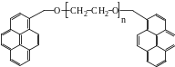 | Pyrene Content |  |  | λ_{Py} |  | M_{n} |  | PDI | 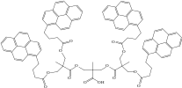 |  |  | Pyrene Content |  | λ_{Py} | M_{n} |  | PDI
 | (mol %) |  |  | (μmol/g) |  | (kg/mol) |  | [-] |  |  |  | (mol %) |  | (μmol/g) | (kg/mol) |  | [-]
PEO(3.4K) | n.a. |  |  | 522 |  | 3.1 |  | 1.0 | PP-G2-BuPy4 |  |  | n.a. |  | 2,766 | 1.45 |  | 1.0
PEO(5K) | n.a. |  |  | 368 |  | 5 |  | 1.0 | PP-G3-BuPy8 |  |  | n.a. |  | 2,676 | 2.99 |  | 1.0
PEO(6K) | n.a. |  |  | 311 |  | 6 |  | 1.0 | PP-G4-BuPy16 |  |  | n.a. |  | 2,632 | 6.08 |  | 1.0
Chemical  Structure |  | Poly(PyBuMA) |  |  |  |  |  |  |  | Chemical  Structure | Poly(PyEG₃MA)
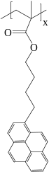 |  | Pyrene Content | λ_{Py} |  | M_{n} |  | PDI |  |  | 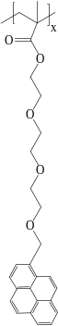 | Pyrene Content |  | λ_{Py} |  |  | M_{n} | PDI
 |  | (mol %) | (μmol/g) |  | (kg/mol) |  | [-] |  |  |  | (mol %) |  | (μmol/g) |  |  | (kg/mol) | [-]
 |  | 100 | 2920 |  | 71 |  | 1.67 |  |  |  | 100 |  | 2312 |  |  | 30 | 1.6

Chemical  Structure | DiPyMe
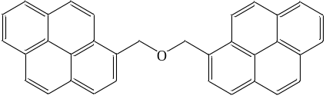 | Pyrene Content | λ_{Py} | M_{n} | PDI
 | (mol %) | (μmol/g) | (g/mol) | [-]
 | n.a | 4479 | 446.56 | -

Steady-state fluorescence: The steady-state fluorescence measurements were carried out on a Photon Technology International (PTI) LS-100 steady-state fluorometer equipped with an Ushio UXL-75Xe Xenon lamp and a PTI 814 photomultiplier detection system. To avoid intermolecular interactions between PyLMs, all fluorescence spectra were acquired with dilute PyLMs solutions having a pyrene concentration of ca. 2.5×10⁻⁶ M. For all solvents beside DMSO which was used under both aerated and deoxygenated conditions, the PyLM solutions were deoxygenated by passing a gentle stream of nitrogen through the solution for 30 minutes before sealing the solution for the fluorescence experiments. The PyLM solutions were excited at the S⁰₂ transition at about 344 nm with some variation depending on the solvent and the fluorescence spectra were acquired between 350 and 600 nm.
Time-resolved fluorescence: The same solutions used to acquire the fluorescence spectra were then placed in an IBH Ltd. time-resolved fluorometer equipped with an IBH 340 nm NanoLED or a Horiba FluoroCube Ultrafast System using a 340 Deltadiode excitation source and a Picosecond Photon Detector (PPD) Module model 650. The PyLM solutions were excited at 340 nm and the monomer and excimer fluorescence was monitored at 375 and 510 nm, respectively. All acquired decays were fitted according to the MFA with equations used for the monomer and excimer fluorescence decays which are provided in Supporting Information (SI). All parameters retrieved from the MFA of the fluorescence decays including the pre-exponential factors and decay times have been listed in Tables S1-S12 in SI. The quality of the fits was evaluated from the random distribution of the residuals and the autocorrelation of the residuals and the χ² value smaller than 1.30.

RESULTS AND DISCUSSION
The fluorescence spectra of the 74 PyLMs listed in Table 1 have already been acquired in a few solvents¹⁷⁻²³ and their features will not be discussed again in this report which focuses on the characterization of their LRID through the global MFA of their monomer and excimer fluorescence decays. Another reason for paying less attention to the analysis of the steady-state fluorescence spectra obtained with PyLMs is that it is plagued by the fact that fluorescence spectra represent the entire population of pyrene species in the solution and do not distinguish which species among them forms excimer by diffusion. Unfortunately, that latter pyrene species is the only one that matters in the characterization of the LRID of a PyLM. In fact, work from this and other laboratories has established that at least four different pyrene species contribute to the fluorescence spectra.^{1,2,} The inability of steady-state fluorescence experiments to distinguish quantitatively between the different pyrene species makes it particularly difficult to obtain quantitative information about the LRID of PyLMs based on the analysis of fluorescence spectra alone. These species were already presented in the Introduction and they are depicted in Table 2. The first entry on the left of Table 2 represents those pyrene labels of a PyLM that are isolated either because the LRID of the macromolecule are too slow, the solvent is too viscous, or the pyrene content is too low. These pyrene labels cannot form excimer and they fluoresce as if they were free in solution with the natural lifetime τ_{M} of pyrene. They are referred to as 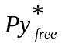.

Table 2: Diagrams of the four excited pyrene species often encountered in PyLMs.
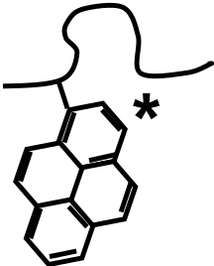 | 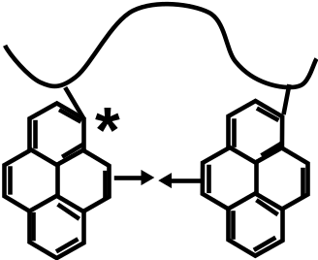 | 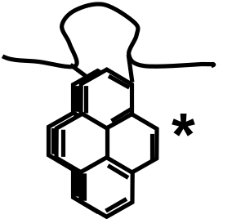 | 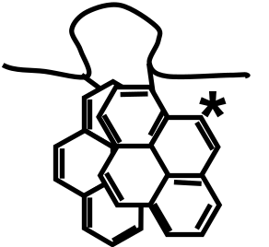
 | 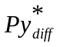 | E0* | D*

The second species in Table 2 considers those pyrenyl groups that form excimer by diffusion. Because the pyrenyl groups are often sterically hindered when attached onto a macromolecule, diffusive encounters between an excited and a ground-state pyrene can result in the formation of one of two excimers referred to as E0* or D* in Table 2. E0* is an excimer emitting with a lifetime τ_{E0} generated by the proper stacking of two pyrene monomers whereas D* is an excimer emitting with a lifetime τ_{D} resulting from the improper stacking of two pyrene labels. E0* and D* can be generated by either the direct excitation of a pyrene aggregate or the diffusive encounter between a ground-state and an excited pyrene referred to as 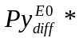 and 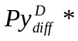 depending on whether they will form an E0* or D* excimer type, respectively. Since the and species are indistinguishable in the pyrene monomer fluorescence decays, they are referred to as in Table 2. Fitting globally the monomer and excimer fluorescence decays according to the MFA yields the molar fractions f_{free}, , , f_{E0}, and f_{D} for the pyrene species , , , E0*, and D*, respectively. In some cases, a single excimer species E0* is required to fit the decays but it is often necessary to introduce the second excimer D*. Fitting of the monomer and excimer decays with the MFA proceeds in stepwise fashion where the excimer decays are fitted first assuming one excimer E0* with contributions and f_{E0}, then with a second excimer D* with a contribution f_{D} only, and finally with a second excimer D* with contributions and f_{D}. Only if a notable improvement in the quality of the fit is observed in terms of reduced χ² or better random distribution of the residuals and autocorrelation function of the residuals around zero would an additional parameter be included in the analysis of the fluorescence decays. As shown in Figure 1 for the Py(5.0)-PC1A sample in DMF, the fits of the monomer and excimer fluorescence decays acquired with the PyLMs were excellent and all parameters retrieved from the global MFA of the monomer and excimer decays have been listed in Tables S1-12 as SI.
Due to the immense benefit associated with having access to a calibration curve that would enable the ranking of PyLMs according to their LRID, PyLMs were selected for their solubility in solvents having a broad range of polarity, from low polarity toluene to high polarity DMSO and including solvents of intermediate polarity such as THF and DMF. The series of Py₂-PEO and Py_{n}-GX-PP constructs and DiPyMe, poly(PyBuMA), and poly(PyEG₃MA) were found to be soluble in all four solvents. The poly(alkyl methacrylate)s Py-PC1MA and Py-PC4MA were soluble in toluene, THF, and DMF but not in more polar DMSO. The more polar Py-PC1A was soluble in THF, DMF and DMSO but not in toluene. All other poly(alkyl methacrylate)s were studied in THF only. Finally, amylose and amylopectin were studied in polar DMF and DMSO but could not be dissolved in toluene and THF. By adjusting the polarity of PyLMs and solvents, a sufficiently large number of PyLM/solvent pairs could be assembled in toluene, THF, DMF, and DMSO to build a calibration curve describing the LRID of these PyLMs in each solvent.
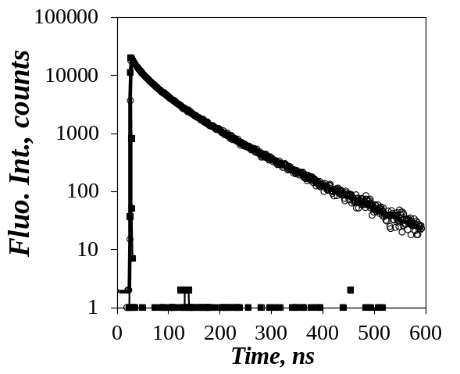 | 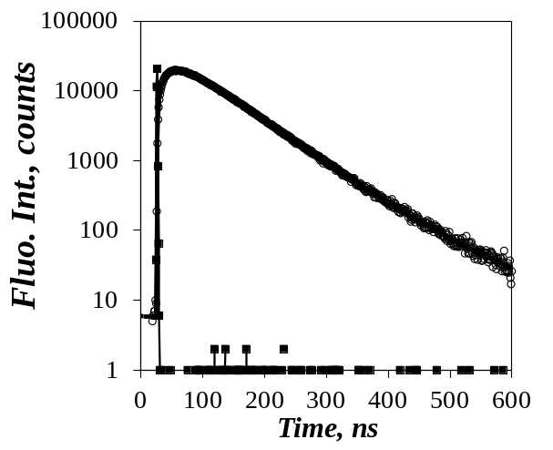
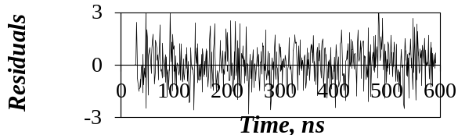 | 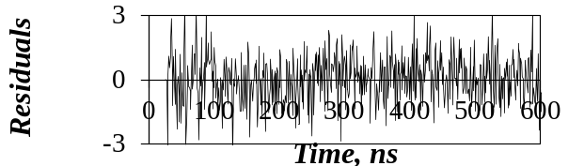
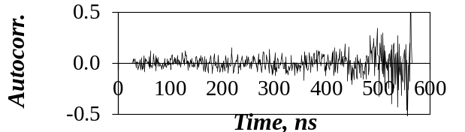 | 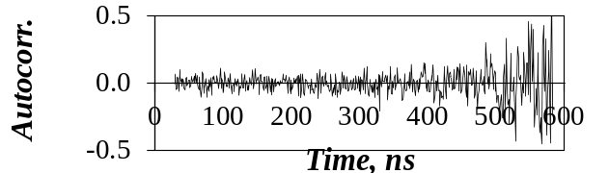
Figure 1. MFA of the monomer (left, λ_{ex} = 344 nm, λ_{em} = 375 nm) and excimer (right, λ_{ex} = 344 nm, λ_{em} = 510 nm) fluorescence decays of Py(5.0)-PC1A in DMF. χ² = 1.1.

To this end, the parameters retrieved from the MFA were employed to calculate <k> and (I_{E}/I_{M})^{TRF}(f_{free}=0) for all 74 PyLMs in the solvent where they were soluble and <k> and (I_{E}/I_{M})^{TRF}(f_{free}=0) were plotted against each other in Figure 2. In the plots obtained for the four solvents, (I_{E}/I_{M})^{TRF}(f_{free}=0) increased linearly with increasing <k> and this linear relationship was found to hold over 3 orders of magnitude which represents an impressive dynamic range.

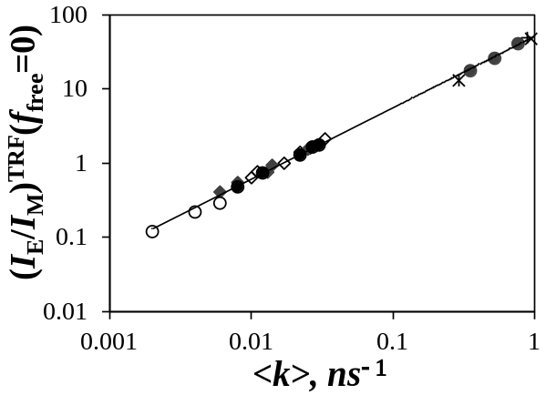  A) | 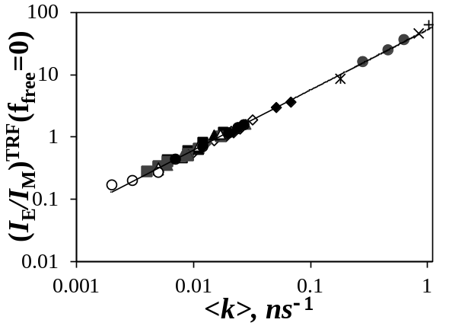  B)
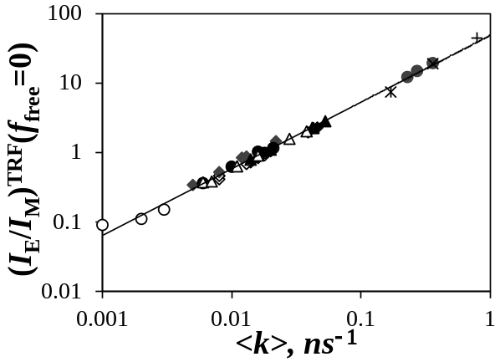  C) | 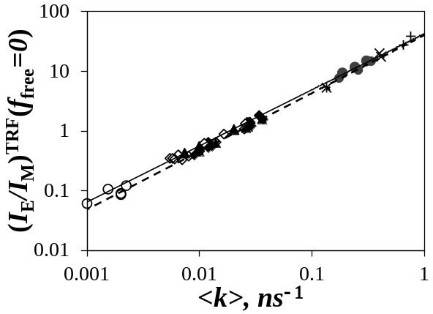  D)

Figure 2. Plots of (I_{E}/I_{M})^{TRF}(f_{free}=0) as a function of <k> in A) degassed toluene, B) degassed THF, C) degassed DMF, and D) (_____) degassed and (- - - -) aerated DMSO. () Py-PC1A in B-D, () Py-PC1MA in A-C, () Py-PC4MA in A-C, () Py-PC4TMA in B), () Py-PC6MA in B), () Py-PC6CyMA in B), () Py-PC8MA in B) or Py-Amylose in C-D, () Py-PC12MA in B) or Py-Amylopectin in C-D, () Py-PC18MA in B, () Py-CoE-PS in A-C, () Py₂-PEO in A-D, () Py_{n}-GX-PP in A-D, () PPyBuMA in A-D, () PPyEG₃MA in A-D, and () DiPyMe in A-D.

Considering the complicated expression of (I_{E}/I_{M})^{TRF} in Equation 5, the linear relationship observed in Figure 2 between <k> and (I_{E}/I_{M})^{TRF}(f_{free}=0) might appear fortuitous. But under ideal conditions where all pyrene labels of a PyLM form one excimer E0* by diffusion, the molar fractions f_{free}, , f_{E0}, and f_{D} equal zero and equals unity. Under this condition, the expression of (I_{E}/I_{M})^{TRF} in Equation 5 simplifies remarkably to give Equation 6.

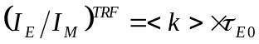 (6)

As it turns out, Equation 6 is predicted by Birks’ scheme when excimer formation can be described by a single rate constant (k₁) so that <k> = k₁ and the excimer dissociation rate constant (k₋₁) is negligible (k₋₁ = 0). Since the PyLMs are prepared to favor pyrene excimer formation by diffusion, f_{free}, , f_{E0}, and f_{D} are often much smaller than which approaches unity. However some precautions still have to be taken, particularly for those PyLMs that form excimer on very short time scales such as the Py_{n}-GX-PP dendrimer series. In this case, the pyrene monomer is extremely short-lived and <τ> in the denominator of Equation 5 becomes very small, so small in fact that even a small f_{free} value can lead to major errors in the (I_{E}/I_{M})^{TRF} value since τ_{M} is then orders of magnitude larger than <τ>.¹⁷ It is to avoid this complication that (I_{E}/I_{M})^{TRF}(f_{free}=0) was plotted as a function of <k> in Figure 2. Other macromolecules that were fairly compact such as helical amylose and branched amylopectin or had very high pyrene contents such as poly(PyBuMA) or poly(PyEG₃MA) were found to yield large f_{E0} and f_{D} values in DMF and DMSO, an indication of residual pyrene aggregation in these solvents. Since <k> only reports on those pyrene labels that lead to excimer formation by diffusion, f_{E0} and f_{D} were not accounted for in Equation 5 for these PyLMs in DMF and DMSO.
Since the plots shown in Figure 2 covered a dynamic range going over three orders of magnitude, the trends were fitted according to Equation 7 where τ_{E} represents an equivalent excimer lifetime and α is a scaling exponent. The values of τ_{E} and α were obtained by fitting the data shown in Figure 2 and their values obtained in the four solvents are listed in Table 3.

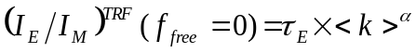 (7)

In all cases, α approached unity within experimental error confirming the linear relationship that appears to exist between <k> and (I_{E}/I_{M})^{TRF}(f_{free}=0) in Figure 2. The excimer lifetime τ_{E} was found to equal 49, 50, 53, and 44 ns in deoxygenated toluene, THF, DMF, and DMSO. These excimer lifetimes are typical of what would be expected for pyrene derivatives in degassed organic solvents. The τ_{E} value of 50 (± 1) ns obtained in THF with these PyLMs matches that of 51 ns obtained earlier in THF for 32 PyLMs. In aerated DMSO, a slightly shorter excimer lifetime of 40 ns was obtained, certainly due to oxygen quenching. The values of these excimer lifetimes are reasonable when compared to published results for pyrene in organic solvents.
The plots presented in Figure 2 revealed some general features for the LRID of PyLMs. For all series of PyLMs and regardless of the macromolecular architecture, the most important parameter that influenced excimer formation was the average contour length <L_{Py}> separating every two pyrene labels. Indeed, <k> and (I_{E}/I_{M})^{TRF}(f_{free}=0) always decreased with increasing <L_{Py}>. In the case of the Py₂-PEO series where <L_{Py}> equals the length of the fully extended PEO chain, a larger <L_{Py}> was associated with a longer PEO chain and (I_{E}/I_{M})^{TRF}(f_{free}=0) or <k> were found to decrease with increasing chain length for the pyrene end-labeled linear chains. In the case of the Py_{n}-GX-PP series, a higher dendrimer generation resulted in a smaller <L_{Py}>, which in turn led to more excimer formation. For the randomly labeled polymers, a higher pyrene content meant a smaller <L_{Py}> resulting in larger (I_{E}/I_{M})^{TRF}(f_{free}=0) and <k> values.

Table 3. Parameters τ_{E} and α used to fit (I_{E}/I_{M})^{TRF}(f_{free}=0) as τ_{E}×<k>^{α}
Solvent | τ_{E} (ns) | Δτ_{E} (ns) | α | Δα
Toluene  (degassed) | 49 | ± 2 | 0.95 | ± 0.01
THF  (degassed) | 50 | ± 1 | 0.95 | ± 0.01
DMF  (degassed) | 53 | ± 2 | 0.98 | ± 0.02
DMSO  (aerated) | 40 | ± 1 | 0.97 | ± 0.01
DMSO  (degassed) | 43 | ± 1 | 0.94 | ± 0.01

Compared to all other PyLMs, DiPyMe was the construct where the pyrene moieties were held in closest proximity to each other and thus had the shortest <L_{Py}>. In all solvents, its <k> value was larger than for the pyrene-labeled linear chains but smaller than for the branched Py_{n}-GX-PP, poly(PyBuMA), and poly(PyEG₃MA) macromolecules. This result indicates that proximity of the pyrene labels is not the sole factor controlling the efficiency of pyrene excimer formation, but that the conformation of the macromolecule must play a part as well. As shown in Figure 2, the branched macromolecules provided better opportunities for having pyrene-pyrene encounters than DiPyMe.
The macromolecular architecture of the PyLMs was also found to affect pyrene excimer formation. The pyrene end-labeled linear chains held the pyrene labels far apart, limiting pyrene-pyrene encounters and resulting in the smallest (I_{E}/I_{M})^{TRF}(f_{free}=0) or <k> values. The branched PyLMs such as the pyrene-labeled dendrimers, poly(PyBuMA), and poly(PyEG₃MA) all yielded large (I_{E}/I_{M})^{TRF}(f_{free}=0) or <k> values since their branched architecture brought the pyrene labels closer to each other in a conformation that favored pyrene-pyrene encounters. The randomly labeled linear chains took (I_{E}/I_{M})^{TRF}(f_{free}=0) or <k> values that were intermediate between those obtained for the end-labeled Py₂-PEOs and Py₂-GX-PP dendrimers.
Within a series of similar polymers randomly labeled with pyrene such as for the Py-PCXMA series with X = 1 – 18, the <k> values reported in Figure 2B for THF could be employed to draw conclusions on the effect of the side chain length on the LRID of the poly(alkyl methacrylate)s. Since these polymers were randomly labeled with pyrene, this effect has already been described by applying the Fluorescence Blob Model Analysis (FBMA) to the fluorescence decays.¹⁸ Based on this analysis, the product <k_{blob}×N_{blob}> which reflects the magnitude of the LRID of polymers randomly labeled with pyrene was found to decrease continuously with increasing side chain length. Since <k> obtained from the MFA of the fluorescence decays can be mathematically rearranged into <k^{MF}>^{blob} which has been shown to mimic the product <k_{blob}×N_{blob}>,¹⁶ the <k> values obtained in Figure 2B for the poly(alkyl methacrylate)s in THF were rearranged to yield <k^{MF}>^{blob} according to Equation 8.

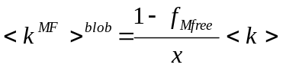 (8)

In Equation 8, f_{Mfree} represents the molar fraction of the species in Table 2 that contribute to the monomer decays and x is the molar fraction of structural units bearing a pyrene label. Figure 3 shows a plot of <k^{MF}>^{blob} as a function of the molar percentage of pyrene-labeled monomers in the pyrene-labeled poly(alkyl methacrylate)s. Despite the scatter in the data points, a general trend was observed where Py-PC1MA with the shortest side chain took the largest <k^{MF}>^{blob} value and <k^{MF}>^{blob} was found to decrease continuously with increasing side chain length. The average <k^{MF}>^{blob} values were plotted in Figure 3B as a function of the number of carbon atoms in the side chains. After a substantial decrease for short side chains, the <k^{MF}>^{blob} value was found to stabilize for side chains made of 12 and more carbon atoms. For these longer side chains, a further increase in side chain length resulted in a marginal decrease in LRID.
<k^{MF}>^{blob} was also calculated for the Py-C1A, Py-PC4TMA, and Py-PC6CyMA constructs and was found to equal 0.88 ± 0.14, 0.19 ± 0.04, and 0.17 ± 0.04 ns⁻¹, respectively. Removal of the methyl substituent from the Py-PC1MA backbone resulted in a much larger <k^{MF}>^{blob} value of 0.88 ns⁻¹ for the Py-PC1A series instead of 0.41 ± 0.03 ns⁻¹ for Py-PC1MA. This doubling in <k^{MF}>^{blob} value from Py-PC1MA to Py-PC1A reflects the faster LRID of the polyacrylate backbone. Similarly, stiffening of the side chain resulted in slower LRID. Indeed <k^{MF}>^{blob} was found to decrease from 0.27 ± 0.05 ns⁻¹ for Py-PC4MA to 0.19 ± 0.04 ns⁻¹ for Py-PC4TMA and from 0.19 ± 0.02 ns⁻¹ for Py-PC6MA to 0.17 ± 0.04 ns⁻¹ for Py-PC6CyMA. These results match how the LRID are expected to vary with the nature of the side chain and are in complete agreement with earlier conclusions drawn from the FBMA of the fluorescence decays acquired with the pyrene-labeled poly(alkyl methacrylate)s in THF.¹⁸

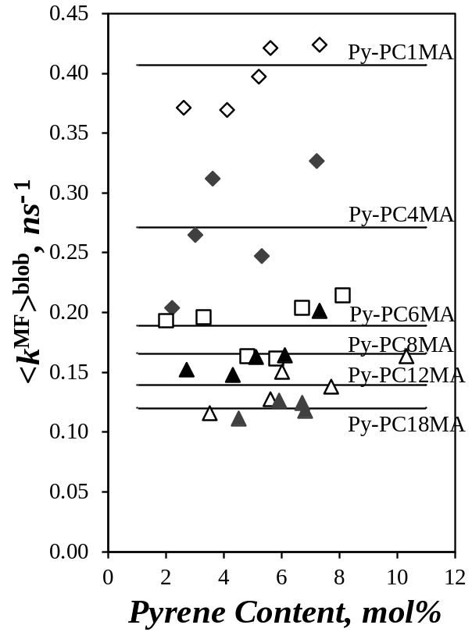  A) |  | 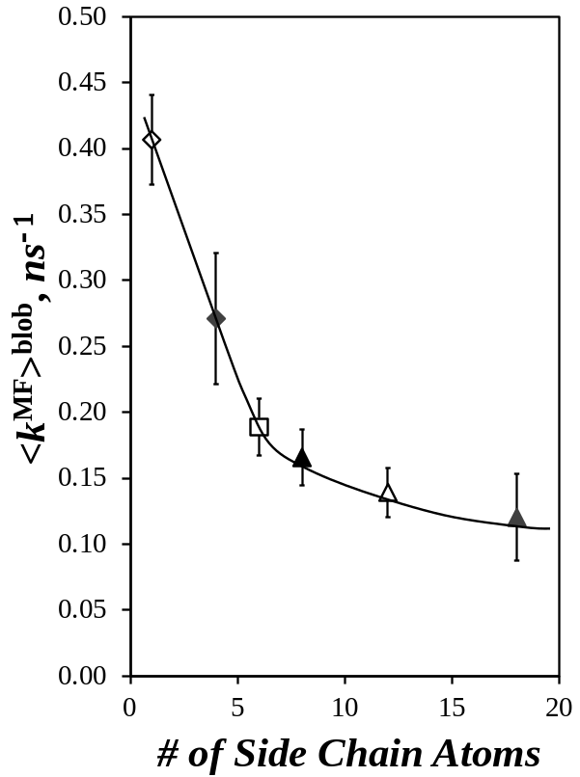  B)
Figure 3. Plot of <k^{MF}>^{blob} versus A) pyrene content and B) the number of side chain atoms for a series of poly(alkyl methacrylate)s randomly labeled with pyrene in THF. () Py-PC1MA, () Py-PC4MA, () Py-PC6MA in B), () Py-PC8MA, () Py-PC12MA, () Py-PC18MA.

CONCLUSIONS
The trends shown in Figure 2 in four different solvents for 74 PyLMs demonstrate that the kinetics of excimer formation between pyrene labels covalently attached onto a macromolecule follow some very general physical principles regardless of the architecture of the macromolecule (linear versus branched) and the selection of the pyrene labeling scheme (at specific positions versus randomly). This study has demonstrated that the rate constant <k> can be used to describe quantitatively the LRID of macromolecules in solution. In fact, the plots presented in Figure 2 offer researchers a unique means of gauging the LRID of a macromolecule of interest with the LRID of other PyLMs by simply pyrene-labeling the macromolecule and determining <k> according to Equation 4 with the parameters retrieved from fitting the monomer fluorescence decay with a sum of exponentials where the longest decay time is fixed to equal the lifetime (τ_{M}) of the pyrene monomer. The broad range of solvent polarity selected for the present study with dielectric constants equal to 2.4, 7.6, 37.8, and 46.7 for, respectively, toluene, THF, DMF, and DMSO ensures that any macromolecule should be soluble in at least one of these four solvents, and that the corresponding <k> value can be determined and compared to that of the other PyLMs used to build the calibration curves presented in Figure 2.

ACKNOWLEDGEMENTS
The authors thank NSERC for financial support.

SUPPORTING INFORMATION
Description of the equations used to fit the fluorescence decays and tables listing the parameters retrieved from the MFA of the fluorescence decays.

REFERENCES

. Duhamel, J. New Insights in the Study of Pyrene Excimer Fluorescence to Characterize Macromolecules and their Supramolecular Assemblies in Solution. Langmuir 2012, 28, 6527-6538.
. Duhamel, J. Global Analysis of Fluorescence Decays to Probe the Internal Dynamics of Fluorescently Labeled Macromolecules. Langmuir 2014, 30, 2307-2324.
. Dais, P.; Spyros, A. 13C Nuclear Magnetic Relaxation and Local Dynamics of Synthetic Polymers in Dilute Solution and in the Bulk State. Prog. Nucl. Magn. Res. Spectrosc. 1995, 27, 555-633.
. Li, J.; Ngai, T.; Wu, C. The Slow Relaxation Mode: From Solutions to Gel Networks. Polym. J. 2010, 42, 609-625.
. Viovy, J. L.; Monerie, L. Fluorescence Anisotropy Technique Using Synchrotron Radiation as a Powerful Means for Studying the Orientation Correlation Function of Polymer Chains. Adv. Polym. Sci. 1985, 67, 99-122.
. Duhamel, J.; Winnik, M. A.; Baros, F.; André, J.-C.; Martinho, J. M. G. Diffusion Effects on Pyrene Excimer Kinetics : Determination of the Excimer Formation Rate Coefficient Time Dependence. J. Phys. Chem. 1992, 96, 9805-10.
. Winnik, M. A. End-to-End Cyclization of Polymer Chains. Acc. Chem. Res. 1985, 18, 73-79.
. Duhamel, J. Internal Dynamics of Dendritic Molecules Probed by Pyrene Excimer Formation. Polymers 2012, 4, 211-239.
. Duhamel, J. Polymer Chain Dynamics in Solution Probed with a Fluorescence Blob Model. Acc. Chem. Res. 2006, 39, 953-960.
. Bains, G. K.; Kim, S. H.; Sorin, E. J.; Narayanaswami, V. The Extent of Pyrene Excimer Fluorescence Emission is a Reflector of Distance and Flexibility: Analysis of the Segment Linking the LDL Receptor-Binding and Tetramerization Domains of Apolipoprotein E3. Biochemistry 2012, 51, 6207-6219.
. Mizuguchi, C.; Hata, M.; Dhanasekaran, P.; Nickel, M.; Phillips, M. C.; Lund-Katz, S.; Saito, H. Fluorescence Analysis of the Lipid Binding-Induced Conformational Change of Apolipoprotein E4. Biochemistry 2012, 51, 5580-5588.
. Lee, S.; Winnik, M. A. Cyclization Rates for Two Points in the Interior of a Polymer Chain. Macromolecules 1997, 30, 2633– 2641.
. Wilken, R.; Adams, J. End-Group Dynamics of Fluorescently Labelled Dendrimers. Macromol. Rapid Commun. 1997, 18, 659-665.
. Zachariasse, K. A.; Busse, R.; Duveneck, G.; Kühnle, W. Intramolecular Monomer and Excimer Fluorescence with Dipyrenylpropanes: Double-Exponential versus Triple-Exponential Decays. J. Photochem. 1985, 28, 237-253.
. Martins, J.; Melo, E. Molecular Mechanism of Lateral Diffusion of py₁₀-PC and Free Pyrene in Fluid DMPC Bilayers. Biophys. J. 2001, 80, 832-840.
. Siu, H.; Duhamel, J. Comparison of the Association Level of a Hydrophobically Modified Associative Polymer Obtained from an Analysis Based on Two Different Models. J. Phys. Chem. B 2005, 109, 1770-1780.
. Fowler, M. A.; Duhamel, J.; Bahun, G. J.; Adronov, A.; Zaragoza-Galán, G.; Rivera, E. Studying Pyrene-Labeled Macromolecules with the Model Free Analysis. J. Phys. Chem. B 2012, 116, 14689-14699.
. Yip, J.; Duhamel, J.; Bahun, G.; Adronov, A. A Study of the Branch Ends of a Series of Pyrene-Labeled Dendrimers Based on Pyrene Excimer Formation. J. Phys. Chem. B 2010, 114, 10254-10265.
. Farhangi, S.; Weiss, H.; Duhamel, J. Effect of Side-Chain Length on the Polymer Chain Dyanmics of Poly(alkyl methacrylate)s in Solution. Macromolecules 2013, 46, 9738-9747.
. Ingratta, M.; Mathew, M.; Duhamel,J. How Switching the Substituent of a Pyrene Derivative from a Methyl to a Butyl Affects the Fluorescence Response of Polystyrene Randomly Labeled with Pyrene. Can. J. Chem. 2010, 88, 217-227.
. Lu, L.; Duhamel, J. Conformation of Amylose in DMSO Probed by Pyrene Excimer Fluorescence. In preparation.
. Chen, S.; Duhamel, J.; Winnik, M. A. Probing End-to-End Cyclization Beyond Willemski and Fixmann. J. Phys. Chem. B 2011, 115, 3289-3302.
. Fowler, M.; Hisko, V.; Henderson, J.; Casier, R.; Li, L.; Thoma, J.; Duhamel, J. DiPyMe in SDS Micelles – Artefacts and their Implications on Micellar Properties. Langmuir 2015, 31, 11971-11981.
. Farhangi, S.; Duhamel, J. Probing Side Chain Dynamics of Branched Macromolecules by Pyrene Excimer Fluorescence. Macromolecules 2016, 49, 353-361.
. Seixas de Melo, J.; Costa, T.; da G.Miguel, M. ; Lindman, B. ; Schillen, K. Time-Resolved and Steady-State Fluorescence Studies of Hydrophobically Modified Water-Soluble Polymers. J. Phys. Chem. B 2003, 107, 12605-12621.
. Birks, J. B. Photophysics of Aromatic Molecules; Wiley: New York, 1970; p 301. Table of Contents 