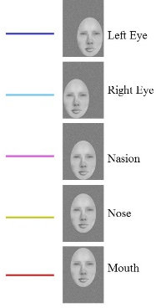
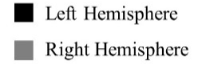
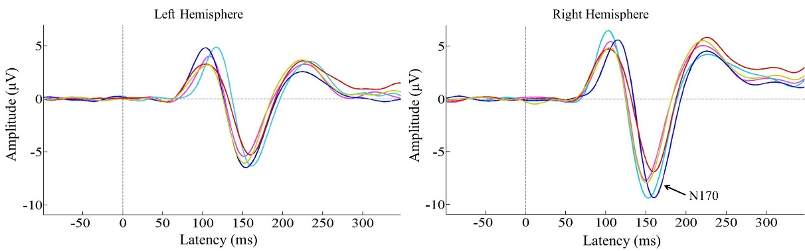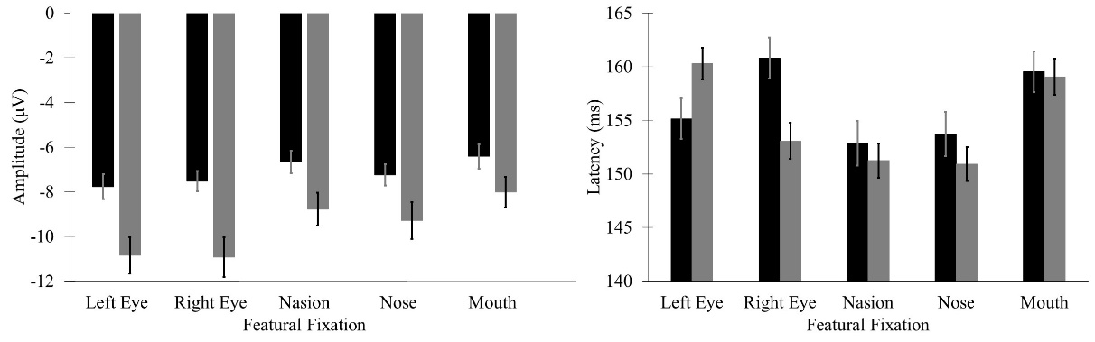
C
A
B

Supplementary Figure. Peak N170 amplitudes and latencies for full face fixations. All error bars represent ±1 SEM. Panel A: Group ERP waveforms for each featural fixation within a full face (averaged across the electrodes at which the N170 was maximal for each participant). Panel B: Mean N170 peak amplitudes for each fixation location within a full face. Note the larger amplitudes in the right hemisphere. Left and right eye fixations yielded the largest N170 amplitudes, followed by nose and nasion fixations, with mouth fixation eliciting the smallest N170 amplitude. Panel C: Mean N170 peak latencies for each fixation location within a full face. Note the faster latencies for nasion and nose fixations, followed by ipsilateral eye fixations, with contralateral eye and mouth fixations producing the slowest latencies.

