Supporting Information

A study of thin film solid phase microextraction methods for analysis of fluorinated benzoic acids in seawater

Ezel Boyacı^{a,1}, Krzysztof Gorynski^{a,b,1}C. Ricardo Viteri^{c,1}, Janusz Pawliszyn^{a*}

ªDepartment of Chemistry, University of Waterloo, 200 University Avenue West, Waterloo, Ontario, N2L 3G1, Canada

^{b}Department of Pharmacodynamics and Molecular Pharmacology, Faculty of Pharmacy, Collegium Medicum in Bydgoszcz, Nicolaus Copernicus University in Toruń, Toruń, Poland

^{c}Entanglement Technologies, Inc. 42 Adrian Ct. Burlingame, CA 94010

∗ Corresponding author. Tel.: +1 519 888 4641/+1 519 885 1210; fax: +1 519 746 0435/+15197460434.
E-mail address: janusz@uwaterloo.ca (J. Pawliszyn).
1 These authors contributed equally to the work.

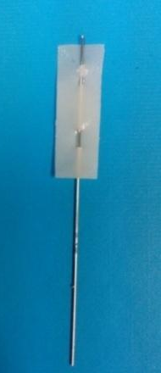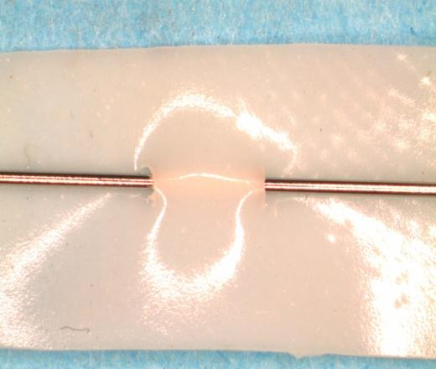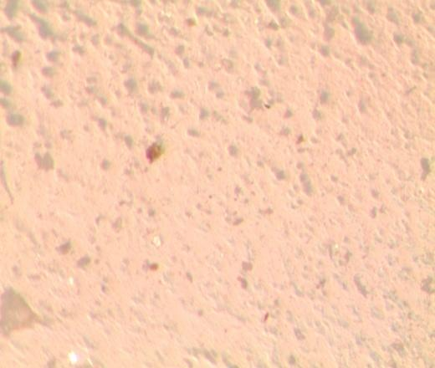

Figure 1S. DVB-PDMS membrane under various magnifications

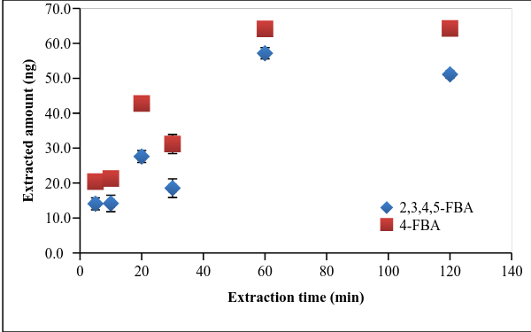
Figure 2S.Extraction time profile of FBAs using HLB as extraction phase

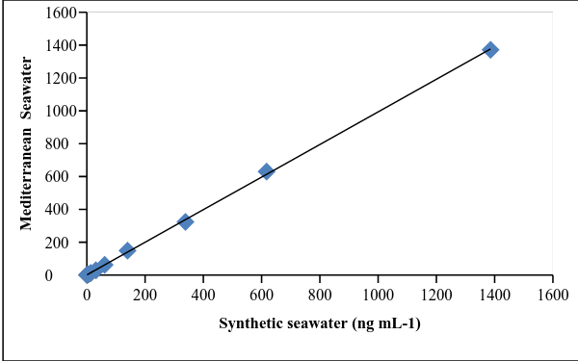
Figure 3S. Correlation in the extracted amounts of 2,3,4,5-tetraFBA in real and synthetic seawaters

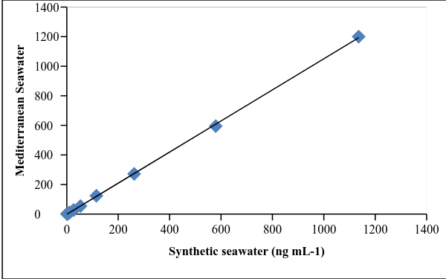
Figure 4S. Correlation in the extracted amounts of 4-FBA in real and synthetic seawaters

(a)
(b)
Figure 5S. Chromatograms of 4-FBA and 2,3,4,5-tetraFBA obtained after extraction with developedmethod (a) Synthetic seawater and (b) Mediterranean Seawater(spiked concentrations in samples: 10 ng mL⁻¹)
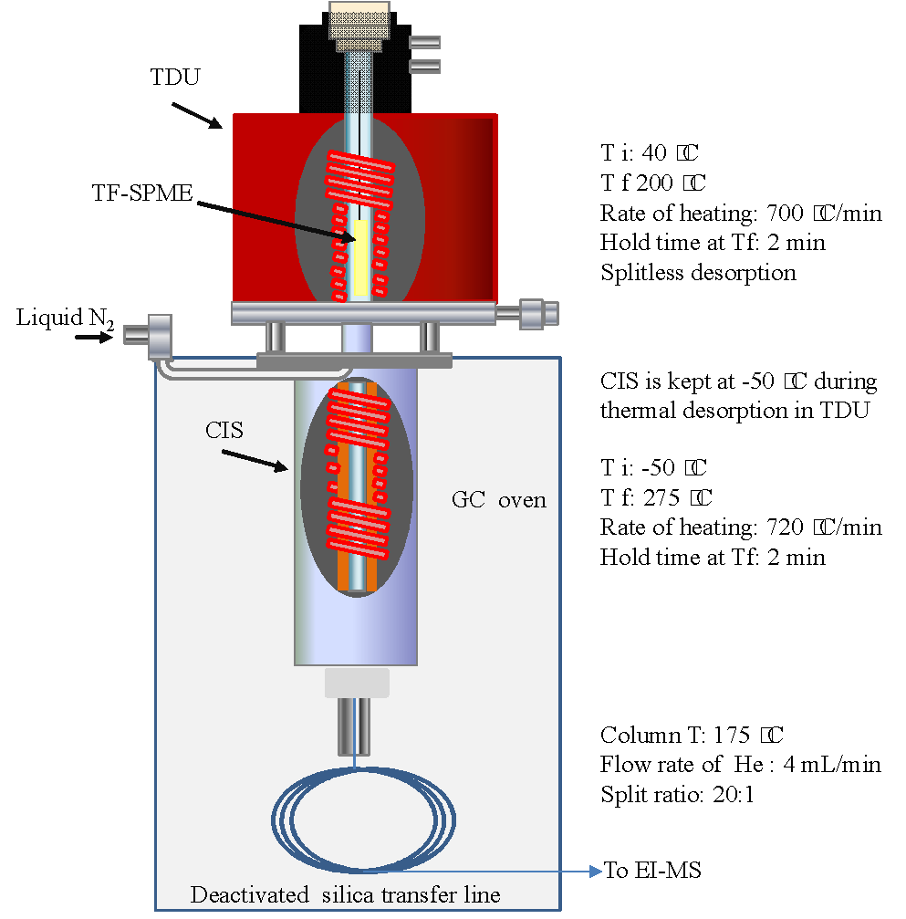
Figure 6S. Schematic and working conditions for direct thermal desorption of extracted analytes to mass spectrometry (CIS: cooling injection system, TDU: thermal desorption unit, TF-SPME: thin film solid phase microextraction, GC: gas chromatography, ES-MS: electron impact ionization mass spectrometry, Ti: initial temperature, Tf: final temperature).

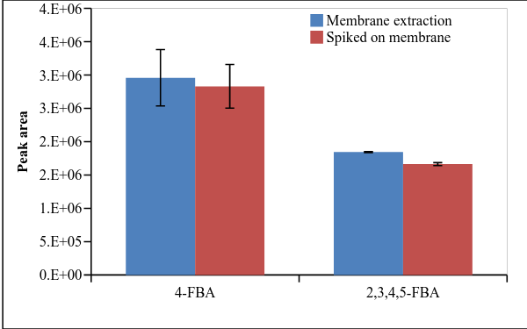

Figure 7S. Comparison of absolute recoveries for FBAs using DVB-PDMS membranes (Extraction conditions: extraction volume: 1.9 mL of GOM acidified with conc. HCl, analyte concentration: 132 ng mL⁻¹, agitation conditions: 1800 rpm, extraction time: 60 min. Spike conditions: 1 µL of 250 µg mL⁻¹ analyte spiked on the membrane or blade and injected in the instrument after solvent evaporation)

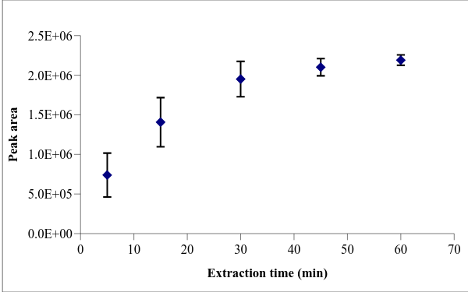
Figure 8S. Extraction time profile of 4-FBA using DVB-PDMS membrane (extraction volume: 1.9 mL of GOM acidified with conc. HCl, analyte concentration: 132 ng mL⁻¹, agitation conditions: 1800 rpm)

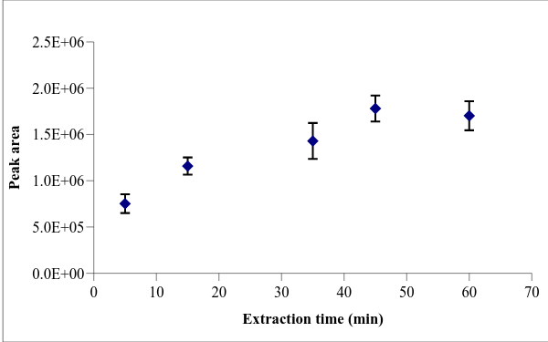

Figure 9S. Extraction time profile of 2,3,4,5-tetraFBA using DVB-PDMS membrane (extraction volume: 1.9 mL of GOM acidified with conc. HCl, analyte concentration: 132 ng mL⁻¹, agitation conditions: 1800 rpm)

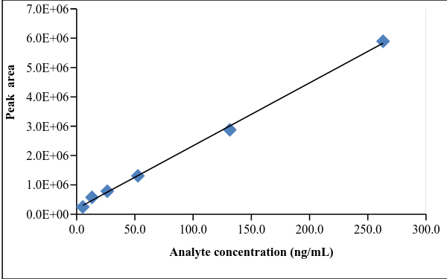

Figure 10S. Linear range of extraction of 4-FBA using DVB-PDMS membrane (extraction volume: 1.9 mL of GOM acidified with conc. HCl, analyte concentrations: 5, 13, 26, 52, 132 and 263 ng mL⁻¹, extraction time: 60 min, agitation conditions: 1800 rpm).

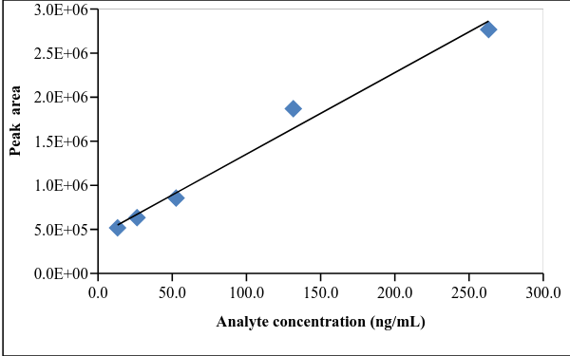

Figure 11S. Linear range of extraction of 2,3,4,5-tetraFBA using DVB-PDMS membrane (extraction volume: 1.9 mL of GOM acidified with conc. HCl, analyte concentrations: 13, 26, 52, 132 and 263 ng mL⁻¹, extraction time: 60 min, agitation conditions: 1800 rpm).

Table 1S.Gulf of Mexico brine recipe
Reagent | To make 1 liter,
 | add (in grams):
CaCl2•2H2O | 1.451
SrCl2•6H2O | 0.023
MgCl2•6H2O | 10.561
NaCl | 26.839
KCl | 0.692
Na2SO4 | 4.085
CaBr2•2H2O | 0.119
Note: SrCl₂ and CaBr₂ were not added

Table 2S. Instrumental parameters used for ESI ExactiveTM Orbitrap mass spectrometer
Instrumental parameters | Value
Spray voltage | 3.2 kV
Capillary temperature | 275 ºC
Sheath gas flow rate | 55 au
Auxiliary gas flow rate | 30 au
Sweep gas flow rate | 5 au
Capillary voltage | -67.5 V
Tube lens voltage | -117 V
Skimmer voltage | -25 V

Table 3S. Carry-over on each TF-SPME blades determined in second desorption (extraction conditions: concentrations of analytes in PBS: 50 ng mL⁻¹, extraction and desorption volumes: 1.5 mL, extraction and desorption times: 60 min, n=3)
 | HLB |  | C18 |  | SAX |  | SAX-HLB |  | PS-DVB-WAX
 | 4-FBA | 2,3,4,5- tetraFBA | 4-FBA | 2,3,4,5-tetraFBA | 4-FBA | 2,3,4,5-tetraFBA | 4-FBA | 2,3,4,5-tetraFBA | 4-FBA | 2,3,4,5-tetraFBA
Solvent A | ˂LOQ | 6% | ˂LOQ | ˂LOQ | ˂LOQ | ˂LOQ | ˂LOQ | 6% | 18% | 8%
Solvent B | ˂LOQ | 1% | ˂LOQ | ˂LOQ | ˂LOQ | 14% | ˂LOQ | 3% | ˂LOQ | 6%
Solvent C | ˂LOQ | 2% | ˂LOQ | ˂LOQ | ˂LOQ | ˂LOQ | ˂LOQ | 1% | 9% | 14%
Solvent D | ˂LOQ | 2% | ˂LOQ | ˂LOQ | ˂LOQ | ˂LOQ | ˂LOQ | 2% | 8% | 11%

Solvent A: ACN/MeOH/H₂O (40/40/20, v/v/v) acidified to contain 0.1% (v/v) FA
Solvent B: ACN/H₂O (80/20, v/v)
Solvent C: ACN/H₂O (80/20, v/v) acidified to contain 0.5% (v/v) FA
Solvent D: ACN/MeOH (80/20, v/v)
˂LOQ: below limit of quantification

