Divergent Effects of Distance versus Velocity Disturbances on Emotional Experiences during Goal Pursuit

James W. Beck, Abigail A. Scholer, and Jeffrey Hughes
University of Waterloo

Manuscript published in
Journal of Applied Psychology

Supplemental material: http://dx.doi.org/10.1037/apl0000210.supp

Author Note:

This research was supported by a Social Sciences and Humanities Research Council of Canada (SSHRC) Insight Development Grant (430-2014-00874) awarded to James W. Beck and Abigail A. Scholer. A previous version of this research was presented at the 32nd meeting of the Society of Industrial and Organizational Psychologists in Orlando, FL. Correspondence concerning this article should be addressed to James W. Beck, Department of Psychology, University of Waterloo, Waterloo ON, Canada N2L 3G1

Full Citation:

Beck, J. W., Scholer, A. A., & Hughes, J. (2017). Divergent effects of distance versus velocity disturbances on emotional experiences during goal pursuit. Journal of Applied Psychology, 102, 1109-1123.

Abstract

Disturbances are factors outside of a person’s control that influence goal progress. Although disturbances are typically included in theoretical accounts of goal pursuit, relatively little empirical research has explicitly considered the effects of disturbances on the goal-striving process. We address this gap in the literature by examining the effects that disturbances have on the emotional experience of goal pursuit. More importantly, we differentiate between distance disturbances (changes to the amount of progress made) and velocity disturbances (changes to the rate of progress made). We conducted two experiments (N = 62 and N = 134) in which participants completed work simulation tasks to earn a $5.00 reward. Partway through the experiment participants’ progress was inhibited by either a distance disturbance or a velocity disturbance. Importantly, the distance and velocity disturbances were equated in terms of their influence on the likelihood of obtaining the cash prize. In both studies the introduction of a disturbance decreased enthusiasm and increased frustration. However, over time the effects of distance and velocity disturbances on enthusiasm and frustration diverged. Specifically, the velocity disturbance had a more enduring effect on these emotions, relative to the distance disturbance. Downstream, in Study 1 enthusiasm positively predicted goal commitment. In Study 2 enthusiasm positively predicted goal commitment, effort, and task performance. Likewise, in Study 2 frustration negatively predicted goal commitment and task performance. Therefore, relative to distance disturbances, velocity disturbances appear to be more disruptive to goal pursuit. We discuss theoretical implications and practical implications for managing employee motivation.

Keywords: disturbances, velocity, self-regulation, enthusiasm, frustration
Across occupations individuals strive to achieve goals, defined as internal representations of desired outcomes (Austin & Vancouver, 1996). Individuals make progress toward their goals by exerting effort and engaging in relevant behaviors (Lord & Hanges, 1987). Yet, in addition to an individual’s effort and behavior, goal progress is also influenced by factors outside of his or her control, which are called disturbances (Carver & Scheier, 1998; Powers, 1978). Disturbances are common in most workplaces, as formal definitions of job performance acknowledge that the outcomes workers achieve are a function of the worker’s behavior and external factors (Campbell, McCloy, Oppler, & Sager, 1993; Motowidlo & Kell, 2013). However, little effort has been made to understand how disturbances affect the emotional experience of goal pursuit. Furthermore, we are unaware of any efforts to systematically categorize disturbances and evaluate how different types of disturbances influence emotions and self-regulatory processes. Yet, the nature of a disturbance may have important implications for downstream emotional and motivational outcomes. The current research was designed to bridge these important gaps.
Specifically, we introduce a distinction between distance disturbances and velocity disturbances. Distance and velocity are central concepts in the self-regulation literature (Carver & Scheier, 1990, 1998), yet no prior research has systematically examined the effects of disturbances that uniquely affect distance versus velocity. We define distance disturbances as external factors (i.e., not behavior) resulting in changes to the amount of progress made toward a goal, whereas velocity disturbances are external factors resulting in changes to the rate of progress. Although both distance and velocity disturbances can either impede or facilitate goal progress (and both are worthy of study), the current research is focused on disturbances that impede goal progress, given the importance of understanding how individuals respond to adverse events at work (Britt, Shen, Sinclair, Grossman, & Klieger, 2016). We see the distinction between negative distance and velocity disturbances as critical in this regard.
Importantly, although distance and velocity disturbances can have objectively similar influences on a person’s likelihood of reaching a goal, the subjective emotional experiences associated with these two types of disturbances may be very different. In particular, although we expect both types of disturbances to reduce enthusiasm and increase frustration, we expect the effects of velocity disturbances on these emotions to be more enduring compared to the effects of distance disturbances. As such, we expect velocity disturbances to be more disruptive to the goal striving process than distance disturbances, with important downstream consequences for self-regulatory outcomes such as goal commitment, effort allocation, and task performance.
Below we present the results of two experimental studies that allowed us to manipulate the type of disturbance (distance vs. velocity), while at the same time equating the objective influence of the disturbance on the probability of reaching the assigned goal across conditions. These studies make an important contribution to the literature by demonstrating that the emotions associated with goal pursuit are not simply driven by the functional properties of the situation (e.g., the likelihood of reaching the goal). Instead, even functionally equivalent distance and velocity disturbances can result in very different patterns of emotional responses, with downstream implications for several self-regulatory outcomes. Thus, this work contributes to a growing recognition that it is important to understand how the goal striving process is experienced (e.g., Bledow, Schmitt, Frese, & Kühnel, 2011; Debus, Sonnentag, Deutsch, & Nussbeck, 2014). A deeper understanding of these processes is critical for developing evidence-based recommendations to manage and improve employee motivation.
Disturbances in Self-Regulation
To date, disturbances have primarily been included in self-regulatory studies as a methodological means of demonstrating the fact that individuals engage in behaviors to reduce discrepancies between current states and goals (e.g., Vancouver & Putka, 2000). A disturbance is often used to create a discrepancy between the goal and the current state, and self-regulation is inferred to have occurred by observing behaviors that bring the current state back in line with the goal (Powers, 1978; Runkel, 1990). Disturbances have rarely been the central feature of theory and research, although two exceptions stand out. First, Vancouver, Weinhardt, & Vigo (2014) developed a computational model of multiple goal pursuit in which the model “learned” to adjust for disturbances in the environment when allocating time and effort resources among goals. Second, Schmidt, Dolis, and Tolli (2009) conducted a study in which the presence versus absence of disturbances was manipulated. These authors found that when outcomes were only a function of the person’s behavior (i.e., no disturbances) individuals tended to work sequentially, achieving one goal before moving on to another. Yet, when outcomes were a function of both the person’s behavior and disturbances, individuals tended to switch back and forth between goals, allocating time to whichever goal had the largest discrepancy.
Although this research shows that disturbances influence goal-striving behavior, little attention has been paid to how experiencing a disturbance influences subsequent emotional states. We are unaware of any studies that have directly addressed this issue, yet there is indirect evidence that disturbances may be unpleasant. For instance, situational constraints—characteristics of a work environment that are beyond the worker’s control and interfere with his or her ability to perform the job—are associated with increased frustration and decreased satisfaction in both the lab (Peters, Chassie, Lindholm, O’Connor, & Kline, 1982) and field (O’Connor et al., 1984). However, whereas some situational constraints are disturbances (e.g., insufficient tools), others are not (e.g., insufficient time). In a similar vein, being interrupted while performing a task is often an unpleasant experience (Jett & George, 2003). Nonetheless, it is unclear the degree to which interruptions are disturbances (i.e., having direct effects on outcomes) versus competing goals (i.e., competing for resources).
As a whole this work indicates that individuals compensate for disturbances when allocating time and effort, and that dealing with disturbances may be unpleasant. However, very little prior research has been designed to isolate the effects of disturbances (versus other aspects of situational constraints and interruptions) on emotions and downstream motivational outcomes. Even more importantly, this research has been silent on whether different types of disturbances result in different subjective experiences during goal pursuit. We propose that there may be important, systematic differences between disturbances that disrupt distance versus velocity.
Distance vs. Velocity Disturbances
The discrepancy between a person’s goal and his or her current situation can be conceptualized both in terms of distance and velocity. Distance refers to a person’s proximity to accomplishing his or her goal at a given moment, whereas velocity refers to rate of progress (Carver & Scheier, 1990, 1998). That is, distance is the size of the discrepancy between a goal and the current state, and velocity is the speed at which that discrepancy is being reduced. Importantly, as noted above, we argue that disturbances can uniquely disrupt distance or velocity, leading to different emotional responses.
We propose that in approach goal contexts in which individuals strive to reduce discrepancies between current states and goals, both types of disturbances should primarily influence high-activation positive and negative emotions. This prediction is based on findings that the pursuit of approach goals is typically associated with the experience of high-activation emotions such as enthusiasm and frustration (Carver, 2004; Carver & Harmon-Jones, 2009). Furthermore, because we are interested in goal pursuit situations for which success is still possible (though not assured), emotions such as enthusiasm and frustration are most relevant, compared to emotions tied to post-pursuit outcomes such as dejection or relief (Carver & Scheier, 2011). Thus, in the current research we selected two clusters of emotions: enthusiasm and frustration. Enthusiasm is a high-activation pleasant emotional experience characterized by excitement and an eagerness to pursue one’s goals. Frustration is a high-activation unpleasant emotional experience characterized by annoyance and irritation.
In general, we predict that the introduction of a disturbance—distance or velocity—during goal pursuit will be experienced as a negative event, resulting in an immediate decrease in enthusiasm and an increase in frustration. We make this prediction because emotions serve as phenomenological indicators of threats and opportunities (e.g., Lazarus & Folkman, 1984). Therefore, the emergence of emotions is an adaptive response that helps individuals to adjust behavior appropriately to situational demands (e.g., Frijda, 1986), such as disturbances.
H1a: Relative to the time preceding the disturbance, enthusiasm will be significantly decreased immediately following a disturbance.
H1b: Relative to the time preceding the disturbance, frustration will be significantly increased immediately following a disturbance.
However, it is also important to consider potential divergence in emotional reactions to distance versus velocity disturbances over time. Our logic is built on Carver and Scheier’s (1990, 1998) control theory. Specifically, Carver and Scheier theorized that individuals regulate an “action loop” in which the discrepancy between a person’s current situation and the goal (i.e., distance) is monitored, and a “meta-loop” in which the discrepancy between a person’s actual and desired velocity is monitored. With regard to the meta-loop, Carver and Scheier argued that individuals possess internal standards for desired velocity. Potential sources of these standards include external sources (e.g., supervisors), the velocity required to complete a task on time, or past experience with the task. More importantly, Carver and Scheier argued that discrepancies between a person’s velocity standard and his or her actual velocity cause emotional reactions. Slow progress (relative to the standard) is said to result in negative emotions, whereas fast progress (again, relative to the standard) is said to result in positive emotions. Empirical work has generally supported these propositions (Chang, Johnson, & Lord, 2010; Johnson, Howe, & Chang, 2012; Lawrence, Carver, & Scheier, 2002; Wilt, Bleidorn, & Revelle, in press).
It is the difference between the action loop and meta-loop that leads us to expect the type of disturbance to have differential implications for emotional experience over time. By definition, distance disturbances cause discrepancies in the action loop. This discrepancy is reduced over time as progress is made toward the goal. Furthermore, following a distance disturbance individuals continue to work toward their goal at the same pre-disturbance velocity. This means there is no discrepancy in the meta-loop between his or her velocity standard (based on past experience) and his or her actual velocity. As such, following a distance disturbance we expect enthusiasm and frustration to return to baseline. Because we predicted that enthusiasm would be decreased immediately after the disturbance, this return to baseline is manifested as a positive slope between time and enthusiasm. Likewise, because we predicted that frustration would be increased immediately after the disturbance, the return to baseline is manifested as a negative slope between time and frustration.
On the other hand, velocity disturbances cause discrepancies in the meta-loop. Specifically, following a velocity disturbance progress is made at a slower rate compared to the period of time prior to the disturbance. Because prior experience with a task is often the basis for the velocity referent (Carver & Scheier, 1998), this creates a discrepancy in the meta-loop. Importantly, discrepancies in the meta-loop caused by velocity disturbances are not affected by the proximity to achieving the goal; instead the meta-loop discrepancy remains even as individuals reduce the discrepancy in the action loop. Thus, the lowered enthusiasm and increased frustration associated with slower-than-referent goal progress are likely to persist over time. In other words, the discrepancy caused by a velocity disturbance is continuous, rather than discrete, decreasing the likelihood of affective adaptation (Wilson & Gilbert, 2008). As such, we predict that the changes to enthusiasm and frustration experienced following a velocity setback are likely to endure over time, as long as the below-standard velocity persists.
H2a: Following a disturbance there will be a positive slope between time and enthusiasm, yet this relationship will be moderated by the type of disturbance experienced. This relationship will be stronger for individuals who have experienced a distance disturbance, relative to individuals who have experienced a velocity disturbance.
H2b: Following a disturbance there will be a negative slope between time and frustration, yet this relationship will be moderated by the type of disturbance experienced. This relationship will be stronger for individuals who have experienced a distance disturbance, relative to individuals who have experienced a velocity disturbance.
Downstream Consequences of Disturbances
In turn, based on prior research (e.g., Richard & Diefendorff, 2011; Seo & Ilies, 2009) we predict enthusiasm and frustration will influence subsequent self-regulatory outcomes. In both studies we consider the effects of enthusiasm and frustration on goal commitment and task performance. In Study 2 we also include effort as an outcome. These outcomes capture three important aspects of self-regulation: an antecedent of behavior (goal commitment), the behavior itself (effort), and the consequences of the behavior (task performance). Specifically, goal commitment is the degree to which an individual believes that achieving the goal is important, effort refers to the degree to which individuals work hard by exhibiting behaviors to achieve their goal, and task performance refers to the amount of progress an individual makes toward his or her goals in a given amount of time.
In single-goal settings emotions serve as a signal of whether further investment of resources (e.g., effort) into pursuing the goal is warranted. Progress signalled via positive emotions indicate that further investment in a goal is warranted, whereas the lack of progress signalled via negative emotions indicates that further investment in the goal may not be warranted (Ilies & Judge, 2005; Orehek, Bessarabova, Chen, & Kruglanski, 2011; Seo & Ilies, 2009). Because in the current study participants were striving to complete a single goal, we predict that enthusiasm will be positively related to goal commitment, effort, and task performance, and frustration will be negatively related to these outcomes. Specifically, we predict that enthusiasm and frustration will predict task performance incrementally, beyond the direct effects of disturbance type on performance.
H3a: Following the disturbance enthusiasm will be positively related to goal commitment, effort, and task performance.
H3b: Following the disturbance frustration will be negatively related to goal commitment, effort, and task performance.
Finally, we are predicting that disturbances will have an indirect effect on self-regulatory outcomes via enthusiasm and frustration. More importantly, because we are predicting that the effects of velocity disturbances on enthusiasm and frustration will persist longer than the effects of distance disturbances, velocity disturbances are expected to be more disruptive to the goal striving process than distance disturbances. Specifically, velocity disturbances will cause lower goal commitment, effort, and task performance, relative to distance disturbances.
H4a: Disturbance type will have an indirect effect on goal commitment, effort, and task performance via enthusiasm. Velocity disturbances will be more detrimental in terms of these self-regulatory processes compared to distance disturbances.
H4b: Disturbance type will have an indirect effect on goal commitment, effort, and task performance via frustration. Velocity disturbances will be more detrimental in terms of these self-regulatory processes compared to distance disturbances.
Study 1
Method
Participants. Participants were 72 undergraduate students from a Canadian university. Ten participants opted to discontinue the study midway through the experiment. Therefore, our results are based on the 62 participants (74% female, M_{age}=20.50 years, SD=3.89) who completed the study. Participants received course credit and a chance to earn a cash payment.
Procedure. Participants performed a work simulation individually on laboratory computers. Participants were randomly assigned to either a distance disturbance (n = 31) or a velocity disturbance (n = 31) condition. The entire study required approximately 45 minutes to complete. During the initial portion of the study participants were: (1) introduced to the cover story, (2) given their assigned performance goal, (3) told about the incentive for reaching the goal, and (4) introduced to the experimental task. This introductory portion of the experiment lasted approximately 25 minutes, although participants were free to move at their own pace. Next, participants performed six trials of the task. Performance on these trials determined whether the participant met his or her assigned goal, and thus, whether the participant earned the cash reward. Each trial lasted exactly two minutes, meaning participants spent 12 minutes total (across trials) performing the task. After each trial participants reported enthusiasm, frustration, and goal commitment. The experimental timeline is summarized in Figure 1.
Experimental task. Participants were told that they were to act as managers for a large commercial trucking company. The participant’s task was to decide whether truck driver’s contracts should be renewed (vs. terminated), and if so, what salary the driver should be offered. To make the decision, participants retrieved three pieces of information about each driver from a database: (1) whether the driver had a moving violation in the past year, (2) the number of kilometers driven in the past year, and (3) the driver’s current salary. Participants applied a series of rules to use this information to determine how the driver’s contract should be handled. The rules for combining the information were simple and easy to learn. Furthermore, the rules were posted on the wall in front of each participant computer, meaning participants were able to reference the rules throughout the study. Thus, the task was designed such that performance would be primarily determined by persistence and motivation, rather than skills or abilities.
Importantly, velocity was manipulated via the type of database to which participants had access. Specifically, under fast conditions the database entries were sorted by each driver’s last name. Thus, a given driver could be quickly located in the database. Conversely, under slow conditions the database entries were unsorted, meaning it took longer to retrieve the information needed to make a decision about the driver’s contract. It is important to note that automated search functions (e.g., Ctrl + F) could not be used to search the database, meaning the database needed to be searched manually. The efficacy of this velocity manipulation was verified via Pilot Study 1 (N = 63; see Supplemental Materials for description).
Assigned performance goal. All participants were assigned a goal to complete 36 contracts by the end of the study. Participants who completed 36 or more contracts were paid $5.00 immediately following the experiment. Each trial contained the names of 10 drivers, meaning participants could complete a maximum of 10 contracts per trial and 60 contracts across the entire experiment. Thirty-six contracts was chosen as the assigned goal level based on the results of Pilot Study 1. This is explained in detail in the following section.
Disturbance manipulation. All participants performed the first three trials using the sorted (i.e., fast) database. After performing the third trial (and before reporting enthusiasm, frustration, and goal commitment) participants experienced a disturbance. Participants in the distance disturbance condition received a message indicating that 11 of the contracts they had completed during the first three trials belonged to drivers who had voluntarily left the company. As such, these contracts could not be counted toward the goal of completing 36 contracts by the end of the experiment. Consequently, following trial three the distance between the current number of contracts completed and the goal of completing 36 contracts was increased. Yet, these participants continued using the sorted (fast) database for the remainder of the experiment.
Conversely, following the third trial participants in the velocity disturbance condition were told there was an error with the database and that for the remainder of the experiment they would need to use an unsorted database. Thus, these participants did not lose any of the progress they had accumulated to that point, yet their rate of progress for the remainder of the experiment was slower than it had been earlier. These participants were shown side-by-side screenshots of the sorted and unsorted databases in order to ensure they understood the nature of the change.
The assigned goal of completing 36 contracts by the end of the experiment was based on data from Pilot Study 1. We set the assigned performance goal based on the expected level of performance for individuals in the velocity disturbance condition. These participants would perform three trials using the fast database (trials 1-3) and three trials using the slow database (trials 4-6). An average participant in the velocity setback condition would be expected to complete approximately 23 contracts by the end of the study. Because we wanted the performance goal to be difficult, yet achievable, we set the performance goal based on the number of contracts for a participant performing at +1 SD above the mean. Specifically, a high-performing (+1 SD) participant in the velocity setback condition would be expected to complete approximately 37 contracts. We set the performance goal at 36 (rather than 37) so that the average number of contracts needing to be completed per trial was a whole number.
Next, we determined the magnitude of the distance disturbance. As stated above, participants in the distance disturbance condition were told that 11 of the contracts they had completed would not count toward their goal of completing 36 contracts. The value 11 was chosen such that the distance disturbance would match the velocity disturbance in terms of the influence on the probability of attaining the goal by the end of the experiment. That is, based on the velocities derived from Pilot Study 1, a high performing (i.e., +1 SD) participant in the distance disturbance condition would be expected to complete approximately 47 contracts by the end of the study. Thus, we set the distance disturbance to be 11 contracts, meaning by the end of the experiment a participant in the distance setback condition would be expected to have completed 36 contracts, after accounting for the disturbance (i.e., 47 – 11 = 36).
Measures. Enthusiasm and frustration were measured using affective descriptors that represent the high activation / pleasant and high activation / unpleasant quadrants of the affect circumplex, respectively (e.g., Russell, 1980). Specifically, enthusiasm was measured using four affective descriptors: enthusiastic, happy, excited, and alert. Participants responded to the statement “At the moment I feel…” for each affective descriptor. Responses were made on a Likert scale (1 = not at all; 2 = a little; 3 = moderately; 4 = quite a bit; 5 = extremely). Alpha ranged between .85 and .93 across the six trials. Frustration was also measured using four affective descriptors: frustrated, angry, irritable, and hostile. Alpha ranged between .85 and .91. Goal commitment was measured using two items developed by Hollenbeck, Klein, O’Leary, and Wright (1989) on a scale from 1 (strongly disagree) to 7 (strongly agree). The items were: “I am strongly committed to pursuing this goal” and “Quite frankly, I don’t care if I achieve this goal or not” (reverse coded). The Spearman-Brown corrected (k = 2) reliability ranged between .64 and .76 across the six trials. Finally, task performance was operationalized as the sum of contracts completed during a trial. This variable was recorded automatically by the program.
Analysis. The analyses reported below refer to the post-disturbance trials. In analyses including the disturbance condition a dummy variable was used where 0 = distance disturbance and 1 = velocity disturbance. In analyses including the trial variable, trial was centered on trial 3, meaning the first trial immediately following the disturbance was coded as 0. H1 was tested using a paired samples t-test. H2 and H3 were tested using multilevel modeling (MLM; e.g., Raudenbush & Bryk, 2002). The significance of the indirect effect (H4) was tested using Tofighi and MacKinnon’s (2011) RMediation macro, which computes asymmetric confidence intervals around the indirect effect to account for the skewed sampling distribution of indirect effects.
Results
Descriptive statistics. Table 1 contains means, standard deviations, and correlations. Between-person correlations are reported above the diagonal, and within-person correlations are reported below the diagonal. Lagged enthusiasm and frustration variables were used to compute correlations where appropriate such that the correlations match the hypothesis tests.
Establishing baseline enthusiasm and frustration. We used the average rating of enthusiasm across the first two trials (i.e., before the disturbance occurred) to create a baseline enthusiasm variable. The same approach was used to create a baseline frustration variable. Paired-samples t-tests indicated no change in enthusiasm (t₍₆₁₎ = -.15, SE = .06, p > .10) nor frustration (t₍₆₁₎ = .46, SE = .04, p > .10) across the first two trials. Furthermore, neither enthusiasm (t₍₆₀₎ = 1.14, SE = .28, p > .10) nor frustration (t₍₆₀₎ = .77, SE = .18, p > .10) differed across conditions during the pre-disturbance trials. Therefore, we were justified in averaging across these two trials to create the baseline measures of these variables.
Hypothesis 1. We predicted that enthusiasm would be reduced following a disturbance (H1a), and we predicted that frustration would be increased following a disturbance (H1b). Each person’s enthusiasm following trial 0 (i.e., immediately following the disturbance) was subtracted from his or her baseline enthusiasm. The same procedure was followed for frustration. Enthusiasm was significantly decreased from baseline following the disturbance (t₍₆₁₎ = -4.73, SE = .08, p < .001, d = -.60), meaning H1a was supported. Likewise, frustration significantly increased from baseline following the disturbance (t₍₆₁₎ = 3.99, SE = .09, p < .001, d =.51), meaning H1b was also supported. As expected, there was no significant difference across disturbance type conditions in the change in enthusiasm (t₍₆₀₎ = -1.89, SE = .15, p > .05) nor frustration (t₍₆₀₎ = -.34, SE = .18, p > .10) from the baseline trials to the post-disturbance trial.
Hypothesis 2. H2a predicted enthusiasm would increase over time following the disturbance, but that this relationship would be stronger for individuals who had experienced a distance disturbance, relative to individuals who had experienced a velocity disturbance. Initial results for this hypothesis are presented in the top half of Table 2. As predicted, disturbance type moderated the relationship between trial number and enthusiasm. Furthermore, as shown in Figure 2a, the nature of this interaction was as predicted. There was a positive relationship between trial number and enthusiasm for individuals who had experienced a distance disturbance (γ = .25, SE = .04, p < .001), yet enthusiasm did not change over time for individuals in the velocity disturbance condition (γ = .01, SE = .04, p > .10). Therefore, H2a was supported.
H2b predicted frustration would decrease over time following the disturbance, but that this relationship would be stronger for individuals who had experienced a distance disturbance, relative to individuals who had experienced a velocity disturbance. Initial results are presented in the bottom half of Table 2. In line with H2b, disturbance type moderated the relationship between trial number and frustration. As shown in Figure 2b, there was a negative relationship between trial number and frustration for individuals who had experienced a distance disturbance (γ = -.18, SE = .04, p < .001), yet frustration did not change over time for individuals who had experienced a velocity disturbance (γ = -.05, SE = .04, p > .10). These results support H2b.
Hypothesis 3. H3a predicted that following the disturbance enthusiasm would be positively related to goal commitment and task performance, and H3b predicted that frustration would be negatively related to goal commitment and task performance. To test H3 we conducted two separate MLM analyses; first we regressed goal commitment on enthusiasm and frustration simultaneously, and next we regressed task performance on enthusiasm and frustration simultaneously. In both sets of analyses we controlled for trial, the disturbance condition, and the trial × disturbance condition interaction. Between- and within-person effects were disambiguated via within-person centering and controlling for the between-person aggregated enthusiasm and frustration variables (Hofmann & Gavin, 1998). In the analysis in which task performance was the dependent variable enthusiasm and frustration were lagged (before centering), such that enthusiasm and frustration at trial “t” predicted task performance at trial “t+1.” This lagging resulted in the loss of one observation period, meaning these results are based on n = 186 observations nested within N = 62 individuals.
Results from these analyses are summarized in Table 3. As predicted, enthusiasm was positively related to goal commitment at both the within- and between-person levels of analysis, accounting for 9% and 14% of the variance in goal commitment, respectively. However, there was no statistically significant relationship between frustration and goal commitment at either level of analysis. Similarly, neither enthusiasm nor frustration predicted task performance at either level of analysis. Therefore, H3a was only partially supported, and H3b was not supported.
Hypothesis 4. H4a predicted indirect effects of disturbance type on goal commitment and task performance via enthusiasm, and H4b predicted indirect effects of disturbance type on goal commitment and task performance via frustration. It was predicted that experiencing a velocity disturbance would be more detrimental in terms of these self-regulatory outcomes compared to experiencing a distance disturbance. This indirect effect (α × β) was manifested as the product of the regression weight from the model in which enthusiasm or frustration was regressed on disturbance type (α) and the regression weight from the model in which the dependent variable (goal commitment or task performance) was regressed on enthusiasm or frustration, controlling for disturbance type (β). Furthermore, the significant trial × disturbance type interaction in Table 2 indicates that the effects of disturbance type on both enthusiasm and frustration varied over time. Therefore, we tested these indirect effects at each post-disturbance trial.
These results are summarized in Table 4. As predicted in H4a, there was a negative indirect effect of disturbance type on goal commitment via enthusiasm. Furthermore, this indirect effect increased over time, such that the effect was non-significant shortly after the disturbance (trials 0 and 1) yet became statistically significant during later trials (2 and 3). However, there were no indirect effects of disturbance type on task performance via enthusiasm, meaning H4a was only partially supported. There were no significant indirect effects of disturbance type via frustration on goal commitment or task performance. Thus, H4b was not supported.
Auxiliary analyses: Assigned goal achievement by condition. Finally, we assessed the likelihood of achieving the assigned goal as a function of disturbance type. Participants in the distance disturbance condition were more likely to meet the goal compared to participants in the velocity disturbance condition (χ²₍₁₎ = 12.17, p < .001). Specifically, in the distance disturbance condition 17 participants achieved the goal, and 14 participants did not (53% success rate). In the velocity disturbance condition four participants achieved the goal, and 27 participants did not (13% success rate). This difference in goal achievement could be attributed to several factors.
For one, the difference in success rates could be due to differences in engagement across disturbance type conditions. On the one hand, individuals in the distance disturbance condition reported higher goal commitment compared to participants in the velocity disturbance condition. However, neither enthusiasm nor frustration predicted task performance incrementally beyond disturbance type. Another possible explanation for this finding is that the magnitude of the distance disturbance was not large enough to fully match the effects of the velocity disturbance on the likelihood of meeting the goal. That is, we may have underestimated the magnitude that the distance setback needed to be in order for approximately 16% (i.e., +1 SD) of the participants in the distance disturbance condition to meet the goal. Although we set the magnitude of the disturbance based on the results of the Pilot Study 1 data, there is sure to be sample to sample variance in the rates at which participants are able to complete contracts. Therefore, we introduced a revised task in Study 2 to address this possibility.
Discussion
Study 1 supported our predictions regarding the effects of disturbances on the emotional experience of goal pursuit. The introduction of a disturbance during goal pursuit resulted in decreased enthusiasm and increased frustration. However, the degree to which these emotions persisted over time varied by disturbance type. Specifically, enthusiasm and frustration tended to return to baseline levels for individuals who experienced a distance disturbance, yet this was not the case for individuals who experienced a velocity disturbance. Study 1 provided mixed support for the downstream effects of these emotions on goal commitment and task performance. In support of our predictions, enthusiasm was positively related to goal commitment. Further, there was a significant indirect effect of disturbance type on goal commitment via enthusiasm, such that experiencing a velocity disturbance was more detrimental to goal commitment, relative to experiencing a distance disturbance. In contrast to our predictions, there were no effects on task performance, nor was frustration related to goal commitment.
We believe it is possible that the nature of the study design contributed to the mixed findings for goal commitment and performance. We attempted to design the Study 1 experimental task such that the number of contracts participants were able to complete (i.e., task performance) was not a function of ability. As such, our logic was that variance in task performance would reflect variance in effort and the type of database used. Thus, in a model in which the disturbance type was included as a control variable, incremental effects of enthusiasm and frustration beyond disturbance type would represent effects of effort. However, even with very simple tasks ability tends to predict performance (Hunter & Hunter, 1984), meaning that residual variance in task performance (beyond disturbance type) was likely not solely a function of effort. Therefore, to address this limitation we changed the nature of the disturbance (described below) and included a self-reported measure of effort in Study 2.
Furthermore, another limitation of Study 1 was that using the unsorted database may have been more challenging and may have required more energy and attention than using the sorted database. Therefore, an alternative explanation for the results of Study 1 could be that the persistent changes in enthusiasm and frustration in the velocity versus distance disturbance condition may have been due to fatigue, rather than discrepancies between desired velocity and actual velocity. This limitation was also addressed via the use of a different experimental task in Study 2. Briefly, the task used in Study 2 was designed to require the same amount of attention and energy across the “fast” and “slow” conditions. As such, replicating the results from Study 1 using this new task provides additional evidence that the difference in emotional reactions to disturbances observed across disturbance types was indeed due to differences in velocity, rather than differences in task demands.
Study 2
Method
Participants. Participants were 161 undergraduate students from the same university as Study 1. Twenty-two participants either discontinued the study early or otherwise failed to follow instructions. A priori, we decided to exclude participants (5) who received impossible feedback following the disturbance. If participants had completed fewer than seven contracts prior to the disturbance they would have been told the total number of contracts completed was negative. Therefore, our results are based on the 134 participants (68% female, mean age = 20.46 [SD = 2.70]) who followed all instructions and did not receive impossible feedback. Participants received course credit and a chance to earn a cash payment (described below).
Procedure. Participants performed a work simulation that was similar to the one used in Study 1, yet the task used in the current study had important distinctions that are detailed in the following section. As was done in Study 1, participants were randomly assigned to either a distance disturbance (n = 71) or a velocity disturbance (n = 63) condition that are described in greater detail below. However, whereas Study 1 was conducted in a laboratory, the current study was conducted online. Specifically, participants were free to logon to the study at a time that was convenient and complete the study from home or another self-chosen location. The study could only be completed on a desktop or laptop computer; mobile devices could not be used to access the study. Similar to Study 1 the entire study required approximately 45 minutes to complete, yet participants could move at their own pace through the instructions and measures. Also like Study 1, participants performed six trials of the task, and each trial lasted exactly two minutes. Between each trial participants reported enthusiasm, frustration, goal commitment, and effort. Finally, following the sixth trial participants completed a measure of fatigue. We included this measure in order to help rule out the alternative explanation that the differences in emotions that were experienced by participants across disturbance type conditions in Study 1 were due to differences in task demands, rather than differences in velocity across the conditions.
Experimental task. Similar to Study 1, participants’ task was to determine how the employment contracts for several fictional truck drivers should be handled. Specifically, participants needed to retrieve information about driver job performance and combine the information using a series of rules to determine the salary that the driver should be offered in the future. As was the case for Study 1, the rules were simple and easy to learn. Also, the rules were visible on participants’ computer screens at all time for easy reference while performing the task.
The critical difference between the task used in the current study and the task used in Study 1 is the manner in which the information needed to make a decision about driver salaries was retrieved. In Study 1 participants needed to retrieve the relevant information from a sorted or unsorted database. In the current study information was retrieved by clicking buttons. Specifically, for each driver buttons labeled “current salary,” “distance driven,” “cargo delivered,” and “value of cargo” were displayed. When a button was clicked the relevant information was displayed. Participants needed to click all four buttons in order to retrieve the necessary information to make a decision regarding the driver’s new salary.
Velocity was manipulated by varying the delay between the time when the button was clicked and when the information was displayed. Under fast conditions there was no delay; information was displayed instantly when a button was clicked. Conversely, under slow conditions there was a two second delay between the time when the button was clicked and when the information was displayed. Yet, regardless of the length of the delay, the same behavior (clicking the button) was used to display the information. Thus, the same demands (e.g., attention, energy) were placed on participants across conditions. The efficacy of this velocity manipulation was verified via Pilot Study 2 (N = 84; see Supplemental Materials for description).
Assigned performance goal. Participants who completed at least 48 contracts were paid $5.00. Forty-eight was chosen as the assigned goal level based on the results of Pilot Study 2. Because the experiment was conducted online, participants who earned the $5.00 reward were instructed to pick up their payment from an on-campus location during a designated time.
Disturbance manipulation. All participants performed the first three trials under fast conditions (i.e., no delay), and after the third trial participants experienced a disturbance. In the distance disturbance condition participants received a message indicating that seven of the contracts they had completed during the first three trials belonged to drivers who had voluntarily left the company and could not be counted toward the goal of completing 48 contracts. Conversely, participants in the velocity disturbance condition were told that there was an error with the program used to retrieve driver information and that for the remainder of the experiment there would be a delay between the time when information was requested and when the information was displayed. Following the disturbance these participants were given two sample drivers on which to practice in order to help them understand the nature of the change. The assigned goal of 48 contracts and the magnitude of the distance disturbance were determined using the data from Pilot Study 2 in the same manner as was done in Study 1.
Measures. Fatigue was measured using the 10-item short form version of Ciarocco, Twenge, Muraven, and Tice’s (2004) State Self-control Capacity Scale. Sample items were “I feel drained” and “I feel like my willpower is gone.” Participants responded on a 7-point scale from “strongly disagree” to “strongly agree.” Alpha was .89. Enthusiasm (alpha = .87-.92), frustration (alpha = .82-.89), and goal commitment (Spearman-Brown reliability = .64-.78) were measured in the same way as was done in Study 1. Effort was measured using a four-item measure originally developed for a study conducted by Schmidt and DeShon (2010). Items were slightly reworded to fit the context of the current study. Example items were “I tried very hard to perform well on the previous set of 10 contracts” and “I worked very intensely on the previous set of 10 contracts.” Participants responded on a 7-point scale (1 = “strongly disagree” to 7 = “strongly agree”). Alpha ranged between .96 and .99 across the six trials. Finally, task performance was computed as the sum of contracts completed during a trial.
Analysis. All analyses were conducted in the same manner as Study 1.
Results
Descriptive statistics. Table 5 contains means, standard deviations, and correlations.
Assessing potential differences in fatigue across conditions. Fatigue data were available for 120 participants. There was no meaningful difference in fatigue across the disturbance type conditions (t₍₁₁₈₎ = .08, SE = .24, p > .10, d = .02). Therefore, differences in enthusiasm and frustration across disturbance type conditions cannot be attributed to one condition being more taxing than the other.
Establishing baseline enthusiasm and frustration. As with Study 1, there was no change in enthusiasm (t₍₁₃₃₎ = .56, SE = .05, p > .10) nor frustration (t₍₁₃₃₎ = .93, SE = .04, p > .10) across the first two trials. Likewise, there were no significant differences between condition on enthusiasm (t₍₁₃₂₎ = .29, SE = .19, p > .10) nor frustration (t₍₁₃₂₎ = -1.94, SE = .11, p > .05) during the pre-disturbance trials. Therefore, the decision to create baseline measures was justified.
Hypothesis 1. In line with H1a, enthusiasm was significantly decreased from baseline following the disturbance (t₍₁₃₃₎ = -6.04, SE = .05, p < .001, d = -.52). Likewise, in line with H1b, frustration significantly increased from baseline following the disturbance (t₍₁₃₃₎ = 6.97, SE = .05, p < .001, d =.60). Therefore, H1 was fully supported. As was the case in Study 1, there was no significant difference across disturbance type conditions in the change in enthusiasm (t₍₁₃₂₎ = -.86, SE = .11, p > .10) nor frustration (t₍₁₃₂₎ = 1.86, SE = .10, p > .05) from the baseline trials to the post-disturbance trial.
Hypothesis 2. H2a predicted that enthusiasm would increase over time following a disturbance, yet that this relationship would be stronger for individuals who had experienced a distance disturbance compared to individuals who had experienced a velocity disturbance. As shown in the top half of Table 6, although the interaction between trial number and disturbance condition on enthusiasm did not reach the p < .05 level of statistical significance using a two-tailed test, the interaction was significant with a one-tailed test. Given that the interaction term was in the expected direction, the effect was statistically significant with a one-tailed significance test, and the effect was significant in Study 1, we proceeded to probe the interaction. As shown in Figure 3a, there was a positive relationship between trial number and enthusiasm for individuals who had experienced a distance disturbance (γ = .12, SE = .02, p < .001). Although enthusiasm also significantly increased over time for individuals in the velocity disturbance condition (γ = .06, SE = .02, p < .05), the marginally significant interaction term indicates that this slope was not as steep as in the distance disturbance condition. Overall these results support H2a, yet this support is more tentative than in Study 1.
H2b predicted that frustration would decrease over time following a disturbance and that this relationship would be stronger for individuals who had experienced a distance disturbance relative to individuals who had experienced a velocity disturbance. The interaction between trial number and disturbance condition on frustration was statistically significant (see lower half of Table 5). As shown in Figure 3b, there was a negative relationship between trial number and frustration for individuals who had experienced a distance disturbance (γ = -.09, SE = .02, p < .001), yet there was no significant relationship between trial number and frustration for individuals who had experienced a velocity disturbance (γ = -.00, SE = .03, p > .10). Therefore, H2b was supported.
Hypothesis 3. Results for H3 are summarized in Table 7. As predicted by H3a, enthusiasm was positively related to goal commitment, effort, and task performance, albeit only at the between-person level of analysis for effort and task performance. Therefore, H3a was supported. With regard to H3b, frustration was significantly negatively related to goal commitment (at both levels of analysis) and task performance (at the between-person level of analysis only). Thus, H3b was partially supported.
Hypothesis 4. Results for H4 are summarized in Table 8. There were no statistically significant indirect effects of disturbance type on goal commitment, effort, nor task performance via enthusiasm. Thus, H4a was not supported. Nonetheless, it should be mentioned that the time × disturbance type interaction did predict enthusiasm, and enthusiasm did have downstream effects on goal commitment, effort, and task performance. However, the indirect effects of disturbance type on these outcomes via enthusiasm are nonsignificant due to the weak nature of the interaction shown in Figure 3a. On the other hand, there were marginally significant (p < .05 with a one-tailed test) negative indirect effects of disturbance type on goal commitment and task performance via frustration. Because this was a directional hypothesis (we predicted a negative effect), a one-tailed significance test is appropriate. Therefore, H4b was partially supported.
Auxiliary analyses: Assigned goal achievement by condition. There was no statistically significant difference in the likelihood of meeting the assigned goal across disturbance type conditions in the current study (distance = 13% success; velocity = 10% success; χ²₍₁₎ = .33, p > .10). Thus, even with a more rigorous design (relative to Study 1) in which overall goal achievement was equivalent across conditions, we still observed differences in task performance following the disturbance. It is important to note that this lack of difference in success rates across conditions does not undermine the results of the hypothesis tests. That is, participants in the velocity disturbance condition experienced lower enthusiasm and higher frustration compared to participants in the distance disturbance condition, and a statistically significant portion of variance in task performance (number of contracts) was accounted for by these emotions. Furthermore, although goal achievement was a function of performance, it was possible for performance to vary within groups of participants who achieved the goal and who did not achieve the goal. That is, all participants who completed fewer than 48 contracts total (i.e., 8 contracts per trial on average) did not meet the goal, whereas all participants who completed 48 contracts or more total (i.e., at least 8 contracts per trial on average) did meet the goal. Therefore, task performance can still vary even in the absence of overall group differences in goal achievement.
Discussion
Study 2 provided a replication of Study 1 using a methodology that ensured that post-disturbance task demands were equivalent across conditions. Both types of disturbances resulted in an immediate decrease in enthusiasm and an increase in frustration, yet the effects of disturbance type on emotional experience diverged over time. However, across Studies 1 and 2 there was mixed support for the predicted indirect effects of disturbance type on self-regulatory outcomes. Whereas Study 1 found an indirect effect of disturbance type via enthusiasm on goal commitment, Study 2 found an indirect effect of disturbance type via frustration on goal commitment and performance. These differences in findings might be attributable to differences in the tasks used across the studies. Most notably, in Study 1, 81% of the variance in task performance was accounted for by the disturbance type (see Table 1), leaving only 19% of the variance left unexplained. In contrast, in Study 2 the disturbance type only accounted for 19% of the variance in task performance (see Table 5). Therefore, the lack of effects of enthusiasm and frustration on task performance in Study 1 may say more about the experimental task than the true relationships among these constructs. Unfortunately, we did not measure effort in Study 1. Had we done so our results may have been more supportive of our predictions. Nonetheless, the current research suggests that both enthusiasm and frustration are intervening variables between disturbances and self-regulatory outcomes.
The differences in the magnitude of the direct effect of the manipulation on task performance may also explain the differences in goal achievement rates across Studies 1 and 2. Recall that in Study 1 individuals in the distance disturbance condition were more likely to reach the goal. We modified the design of Study 2 partly to more rigorously ensure that our distance and velocity manipulations were functionally equivalent. Consistent with this aim, in Study 2 equivalent proportions of individuals achieved the goal in each condition (i.e., whether or not individuals met the goal in the current study was less dependent on the condition to which they were assigned). However, consistent with our predictions, there was still variation in the more sensitive measure of task performance (number of contracts completed). As such, in the current study we were able to observe indirect effects of disturbance type on task performance, albeit only via frustration. In other words, the current study provides additional evidence that functionally equivalent disturbances can have different implications for downstream self-regulatory outcomes via their effects on emotions.
General Discussion
Although disturbances are commonly included in self-regulatory theories, and it is widely acknowledged that work outcomes can be influenced by factors outside of workers’ control, relatively little research has spoken directly to the effects that disturbances have on self-regulation. Across two studies we demonstrated that experiencing a disturbance while pursuing a goal resulted in increased frustration and decreased enthusiasm. More importantly, the type of disturbance – distance vs. velocity – was a critical determinant of whether the effects of the disturbance were enduring versus fleeting. Although both types of disturbances had similar functional implications for goal success and initially influenced enthusiasm and frustration to the same degree, velocity disturbances had enduring effects on emotions, whereas distance disturbances did not. Downstream, enthusiasm was positively related to goal commitment (Studies 1 and 2), effort (Study 2), and task performance (Study 2). Likewise, frustration was negatively related to goal commitment (Study 2) and task performance (Study 2).
Theoretical Implications
Recently self-regulatory theory has begun to rely on formal (i.e., mathematical) models to describe and predict motivated behavior (e.g., Ballard, Yeo, Loft, Vancouver, & Neal, 2016; Vancouver, Weinhardt, & Schmidt, 2010), and it is typical for these models to include disturbances. Indeed, a central feature of Vancouver and colleagues’ (2014) model is the ability to anticipate and adjust for disturbances when allocating resources. However, to date these models have only included functional aspects of disturbances; that is, the direct effects that disturbances have on the variable being regulated (e.g., number of contracts completed). As such, the emotional consequences of disturbances have been absent from these models. However, the current research indicates that the emotions associated with disturbances can influence subsequent effort and behavior, thereby having indirect effects on controlled variables. Therefore, to provide a more complete view of self-regulation, in the future it will be important to include the emotional consequences of disturbances in formal theories of self-regulation.
Furthermore, the current research underscores the importance of differentiating between disturbances that affect the action loop (i.e., distance disturbances) and disturbances that affect the meta-loop (i.e., velocity disturbances). Specifically, the time required to “move on” emotionally from a distance disturbance is likely to be shorter compared to the time required to move on from a velocity disturbance. As a result, disturbances to the meta-loop are likely to be more disruptive to the goal pursuit process, compared to functionally equivalent disturbances to the action loop. The disparity between the effects of distance and velocity disturbances is driven by the fact that discrepancies in the action loop are reduced as the person makes progress toward the goal, regardless of the type of disturbance (distance or velocity). Yet, in the case of velocity disturbances, discrepancies in the meta-loop remain, even as the person approaches goal attainment. Past theory and research indicates that individuals are particularly sensitive to discrepancies in the meta-loop, such that meta-loop discrepancies (rather than action loop discrepancies) are the primary causes of emotional reactions during goal pursuit (Carver & Scheier, 1998). This relatively higher sensitivity to velocity rather than distance may have developed as a way to regulate long-term goals; specifically, if the discrepancy between one’s goal and current state is very large, he or she is able to stay motivated and engaged in goal pursuit as long as his or her rate of progress is perceived to be reasonable (Chang et al., 2010).
Along these lines, the current studies also contribute more broadly to an understanding of the role of distance and velocity in self-regulation. In particular, although it is generally understood that velocity is an antecedent of affect (Johnson et al., 2012), the reason is not always clear. Carver and Scheier (1998) claimed that in addition to affect, velocity is related to “…a hazy and nonverbal sense of expectancy” (p. 122), such that slower-than-referent velocity is associated with doubt, and faster-than-referent velocity is associated with confidence. However, it is not clear as to whether this hazy sense of expectancy is the cause of affect, or if affect is the cause of expectancy (both may be true). Likewise, it is not entirely clear how a construct that is “hazy and nonverbal” is best represented in empirical research. Nevertheless, there is evidence that velocity is causally associated with variance in concrete assessments of expectancy (Chang et al., 2010). In the current research we addressed this issue in two ways.
First, we equated the objective probability of success across distance and velocity disturbance conditions. Yet, because it is possible for subjective expectancies to diverge from objective probabilities (Tversky & Kahneman, 1992), we also measured participants’ self-reported expected probability of attaining the goal after each trial in the current studies. In both studies the disturbance reduced expectancy relative to the baseline trials (d = -.31 and d = -.32), yet the magnitude of this reduction did not differ between disturbance type, either immediately after or during the following trial. Thus, although participants in both conditions had similar chances of reaching the goal following the disturbance, the unpleasant emotions only persisted for participants who experienced a velocity disturbance. We see this pattern of results as indicating that slower-than-referent velocity is unpleasant for reasons beyond initial changes in expectancies. Although the current data cannot speak directly to these reasons, we offer some speculation and directions for future research.
For one, it may be the case that slow velocity is often associated with failure to achieve a goal, and thus individuals apply a heuristic that slower-than-referent velocity is indicative of low likelihood of success, even in situations in which success is not heavily dependent on velocity. It is also possible that disturbances leading to discrepancies in the meta-loop, relative to discrepancies in the action loop, may be associated with greater attributional ambiguity about locus of control and personal responsibility (e.g., Weiner, 1974; Weiner, Nierenberg, & Goldstein, 1976). In the case of distance disturbances, an external attribution appears relatively easy to make (e.g., “I’m behind on these contracts because several employees left the company”). For velocity disturbances, although the initial trigger for a change in rate is unambiguous, there is no easy way to assess how much that external factor should affect velocity. It is possible that individuals may attribute decreased velocity to their own effort and ability (e.g., “I know this change will slow me down, but I wonder if I should be able to work faster”). This potential difference in attributional ambiguity about locus of control may contribute to the reason velocity (versus distance) disturbances have more persistent effects: individuals may be more likely to make an internal attribution for the decreased velocity, affecting subsequent effort and engagement in goal pursuit. Investigating this potential mechanism is worthy of future research.
Finally, the results of the current study have implications for the role of emotions during goal pursuit. For one, the enthusiasm individuals experienced following the disturbances was positively related to goal commitment in both studies, and enthusiasm was positively related to effort and task performance at the between-person level of analysis in Study 2. As stated above, the lack of a relationship between enthusiasm and task performance in Study 1 may have been largely a function of the experimental task, and effort was not measured in Study 1. Furthermore, the fact that the relationships between enthusiasm and effort and task performance were only observed at the between-person level of analysis was likely a function of the experimental design; that is, disturbances – the primary causal antecedent of enthusiasm in this study – only varied between-subjects.
Likewise, although the frustration individuals experienced following the disturbance did not predict goal commitment in Study 1, there were significant relationships between frustration and goal commitment in Study 2 at both levels of analysis. Given that this finding is in line with the literature, the lack of an effect in Study 1 may simply have been due to sampling error (Stanley & Spence, 2014). For this same reason we are hesitant to interpret the lack of a significant relationship between frustration and effort in Study 2. Finally, although frustration did not predict task performance in Study 1, frustration was negatively related to task performance in Study 2 (i.e., where the direct effects of the disturbance on task performance were less pervasive). Taken as a whole the results of the current study highlight the importance of including emotions in self-regulatory theory. That is, even functionally equivalent situations can lead to very different subjective emotional experiences, which in turn can influence subsequent self-regulation.
Practical Implications
Our results suggest that managers should be cognizant of the potential for disturbances to hinder employee motivation. With regard to velocity disturbances in particular, managers may be able to help employees form appropriate internal velocity referents by acknowledging the presence of a velocity disturbance. That is, by communicating that he or she understands the reason for the slowed progress (the disturbance), a manager can help reduce discrepancies in the meta-loop, thereby easing the influence of the disturbance on enthusiasm, frustration, and downstream self-regulatory outcomes. Conversely, managers may counteract a velocity disturbance by investing resources in factors that increase actual velocity (e.g., buying new software that makes employees’ tasks more efficient). Indeed, our results suggest that this approach may be more effective (in terms of employee motivation) than trying to counteract the disturbance via factors that affect distance (e.g., hiring a temporary employee).
Limitations and Strengths
In both studies the task participants performed was novel. However, compared to novel tasks, individuals tend to have more sophisticated scripts and mental models for familiar tasks (Murphy & Wright, 1984). As such, individuals may be better able to compensate and adjust for disturbances on familiar tasks, whereas disturbances on novel tasks may be more disruptive. Similarly, the current studies were performed over the span of approximately 45 minutes, yet many work tasks are performed over longer periods of time. A change in timeframe could conceivably decrease or increase the effect of disturbances on subsequent goal pursuit. For instance, goals pursued over long periods of time are inherently subject to a greater number of disturbances (Buehler, Peetz, & Griffin, 2010), meaning individuals may learn to adjust (Vancouver et al., 2014). However, it may be easier to comprehend the concrete effects of a disturbance on a goal that is to be completed in the short-term, whereas the effects on a goal to be completed in the distant future may be more abstract (Liberman & Trope, 2008).
In addition, although we provided a cash incentive of $5.00 in an effort to ensure participant engagement, this is a relatively low stakes incentive compared to incentives in the workplace (e.g., raises, bonuses, termination). On the one hand, this difference in incentives may make the experience of the disturbance less extreme: a disturbance that negatively impacts the likelihood of earning $1,000 is likely to be experienced more negatively than a disturbance that negatively impacts the likelihood of earning $5.00. On the other hand, when the goal being pursued is highly valuable, individuals’ behavioral reactions to disturbances may be muted. Even if the disturbance is discouraging, a person may still invest the same amount of effort (or even more effort in an attempt to compensate for the disturbance) if the goal is highly valuable. Thus, a productive area for future research is to consider goal importance as a boundary condition of the effects observed in the current research.
Nonetheless we believe it is important to interpret these limitations in the context of the strengths provided by the experimental approach. Specifically, by randomly assigning participants to distance and velocity disturbance conditions we were able to rule out third-variable influences on emotions. This in turn allowed for much stronger causal inferences than could have been drawn from a correlational design. Furthermore, the current studies allowed for repeated measurement of emotions, goal commitment, and effort, as well as unobtrusive measurement of task performance. Lastly, distance and velocity disturbances could be equated in terms of their influence on the likelihood of reaching the assigned goal. This methodology allows us to clearly make the inference that objectively similarly distance and velocity disturbances can be subjectively experienced very differently, leading to downstream effects on behavior.

References
Austin, J. T., & Vancouver, J. B. (1996). Goal constructs in psychology: Structure, process and content. Psychological Bulletin, 120, 338–375.
Ballard, T., Yeo, G., Loft, S., Vancouver, J. B., & Neal, A. (2016). An integrative formal model of motivation and decision making: The MGPM*. Journal of Applied Psychology, 101, 1240-1265.
Bledow, R., Schmitt, A., Frese, M., & Kühnel, J. (2011). The affective shift model of work engagement. Journal of Applied Psychology, 96, 1246-1257.
Britt, T. W., Shen, W., Sinclair, R. R., Grossman, M. R., & Klieger, D. M. (2016). How much do we really know about employee resilience? Industrial and Organizational Psychology: Perspectives on Science and Practice, 9, 378-404.
Buehler, R., Peetz, J., & Griffin, D. (2010). Finishing on time: When do predictions influence completion times? Organizational Behavior and Human Decision Processes, 111, 23-32.
Campbell, J. P., McCloy, R. A., Oppler, S. H., & Sager, C. E. (1993). A theory of performance. In N. Schmitt, W. C. Borman, & Associates (Eds.), Personnel selection in organizations (pp. 35–70). San Francisco: Jossey-Bass.
Carver, C. S. (2004). Negative affects deriving from the behavioral approach system. Emotion, 4, 3-22.
Carver C. S., & Harmon-Jones, E. (2009). Anger is an approach-related affect: Evidence and implications. Psychological Bulletin, 135, 183-204.
Carver, C. S., & Scheier, M. F. (1990). Origins and functions of positive and negative affect: A control-process view. Psychological Review, 97, 19-35.
Carver, C. S., & Scheier, M. F. (1998). On the self-regulation of behavior. New York: Cambridge University Press.
Carver, C.S., & Scheier, M.F. (2011). Self-regulation of action and affect. In K.D. Vohs & R.F. Baumeister (Eds.), Handbook of self-regulation (pp. 3–21). New York, NY: Guilford.
Chang, C-H., Johnson, R. E., & Lord, R. G. (2010). Moving beyond discrepancies: The importance of velocity as a predictor of satisfaction and motivation. Human Performance, 23, 58-80.
Ciarocco, N., Twenge, J., Muraven, M., & Tice, D. (2004). The state self-control capacity scale: Reliability, validity, and correlations with physical and psychological stress. Unpublished manuscript, San Diego State University.
Debus, M. E., Sonnentag, S., Deutsch, W., & Nussbeck, F. W. (2014). Making flow happen: The effects of being recovered on work-related flow between and within days. Journal of Applied Psychology, 99, 713-722.
Frijda, N. H. (1986). The emotions. London, UK: Cambridge University Press.
Hofmann, D. A., & Gavin, M. B. (1998). Centering decisions in hierarchical linear models: implications for research in organizations. Journal of Management, 24, 623-641.
Hollenbeck, J. R., Klein, H. J., O'Leary, A. M., & Wright, P. M. (1989). Investigation of the construct validity of a self-report measure of goal commitment. Journal of Applied Psychology, 74, 951-956.
Hunter, J. E., & Hunter, R. F. (1984). Validity and utility of alternative predictors of job performance. Psychological Bulletin, 96, 72-98.
Ilies, R., & Judge, T. A. (2005). Goal regulation across time: the effects of feedback and affect. Journal of Applied Psychology, 90, 453-467.
Jett, Q. R., & George, J. M. (2003). Work interrupted: A closer look at the role of interruptions in organizational life. Academy of Management Review, 28, 494-507.
Johnson, R. E., Howe, M., &, Chang, C-H., (2013). The importance of velocity, or why speed may matter more than distance. Organizational Psychology Review, 3, 62-85.
Lawrence, J. W., Carver, C. S., & Scheier, M. F. (2002). Velocity toward goal attainment in immediate experience as a determinant of affect. Journal of Applied Social Psychology, 32, 788-802.
Lazarus, R.S., & Folkman, S. (1984). Stress, appraisal and coping. New York: Springer.
Liberman, N., & Trope, Y. (2008). The psychology of transcending the here and now. Science, 322, 1201-1205.
Lord, R. G. Hanges , P. J. (1987). A control system model of organizational motivation: Theoretical development and applied implications. Behavioral Science, 32, 161-178.
Motowidlo, S. J., & Kell, H. J. (2013). Job performance. In N. W. Schmitt, S. Highhouse, & I. Weiner (Eds.), Handbook of psychology, volume 12: Industrial and organizational psychology, 2nd edition (pp. 82-103). Hoboken, NJ: Wiley.
Murphy, G. L., & Wright, J. C. (1984). Changes in conceptual structure with expertise: Differences between real-world experts and novices. Journal of Experimental Psychology: Learning, Memory, and Cognition, 10, 144-155.
O’Connor, E. J., Peters, L. H., Pooyan, A., Weekley, J., Frank, B., & Erenkrantz, B. (1984). Situational constraint effects on performance, affective reactions, and turnover: A field replication and extension. Journal of Applied Psychology, 69, 663-672.
Orehek, E., Bessarabova, E., Chen, X., & Kruglanski, A. W. (2011). Positive affect as informational feedback in goal pursuit. Motivation and Emotion, 35, 44–51.
Peters, L. H., Chassie, M. B., Lindholm, H. R., O’Connor, E. J., & Rudolf Kline, C. (1982). The joint influence of situational constraints and goal setting on performance and affective outcomes. Journal of Management, 8, 7-20.
Powers, W. T. (1978). Quantitative analysis of purposive systems: Some spadework at the foundations of scientific psychology. Psychological Review, 85, 417-435.
Raudenbush, S. W., & Bryk, A. S. (2002). Hierarchical linear models: Applications and data analysis methods (2nd ed.). CA: Sage Publications.
Richard, E. M., & Diefendorff, J. M. (2011). Self-regulation during a single performance episode: Mood-as-information in the absence of formal feedback. Organizational Behavior and Human Decision Processes, 115, 99-110.
Runkel, P. J. (1990). Research method for control theory. American Behavioral Scientist, 34, 14-23.
Russell, J. A. (1980). A circumplex model of affect. Journal of Personality and Social Psychology, 39, 1161–1178.
Schmidt, A. M. & DeShon, R. P. (2010). The moderating effects of performance ambiguity on the relationship between self-efficacy and performance. Journal of Applied Psychology, 95, 572-581.
Schmidt, A. M., Dolis, C. M., & Tolli, A. P. (2009). A matter of time: Individual differences, contextual dynamics, and goal progress effects on multiple-goal self-regulation. Journal of Applied Psychology, 94, 692-709.
Seo, M., & Ilies, R. (2009). The role of self-efficacy, goal, and affect in dynamic motivational self-regulation. Organizational Behavior and Human Decision Processes, 109, 120-133.
Stanley, D. J., & Spence, J. R. (2014). Expectations for replications: Are yours realistic? Perspectives on Psychological Science, 9, 305-318.
Tofighi, D., & MacKinnon, D. P. (2011). RMediation: An R package for mediation analysis confidence intervals. Behavior Research Methods, 43, 692-700.
Tversky, A., & Kahneman, D. (1992). Advances in prospect theory: Cumulative representation of uncertainty. Journal of Risk and Uncertainty, 5, 297-323.
Vancouver, J. B., & Putka, D. P. (2000). Analyzing goal-striving processes and a test of the generalizability of perceptual control theory. Organizational Behavior and Human Decision Processes, 82, 334-362.
Vancouver, J. B., Weinhardt, J. M., & Schmidt, A. M. (2010). A formal, computational theory of multiple-goal pursuit: Integrating goal-choice and goal-striving processes. Journal of Applied Psychology, 95, 985-1008.
Vancouver, J. B., Weinhardt, J. M., & Vigo, R. (2014). Change one can believe in: Adding learning to computational models of self-regulation. Organizational Behavior and Human Decision Processes, 124, 56-74.
Weiner, B. (Ed.) (1974). Achievement motivation and attribution theory. Morristown, N.J.: General Learning Press.
Weiner, B., Nierenberg, R., & Goldstein, M. (1976). Social learning (locus of control) versus attributional (causal stability) interpretations of expectancy of success. Journal of Personality, 44, 52-68.
Wilson, T. D., & Gilbert, D. T. (2008). Explaining away: A model of affective adaptation. Perspectives on Psychological Science, 3, 370-386.
Wilt, J. A., Bleidorn, W., & Revelle, W. (in press). Velocity explains the links between personality states and affect. Journal of Research in Personality.

Table 1
Means, Standard Deviations, and Correlations (Study 1)
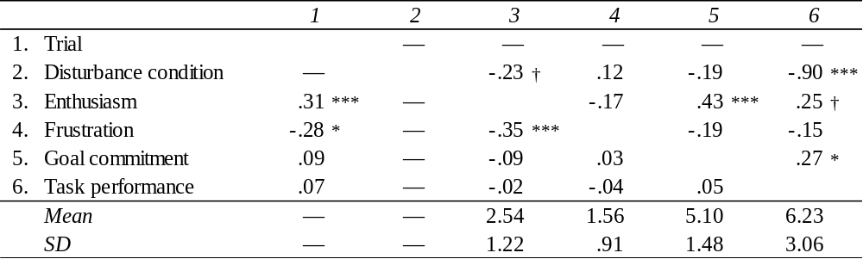
Note: Between-subjects correlations are shown above the diagonal (N = 62 individuals). Within-subjects correlations are shown below the diagonal (n = 248 observations for correlations not including goal commitment and/or task performance; n = 186 observations for correlations including goal commitment and/or task performance). †p < .10, *p < .05, **p < .01, ***p < .001.
Table 2
Trial × Disturbance Type Interaction on Enthusiasm and Frustration (Study 1)
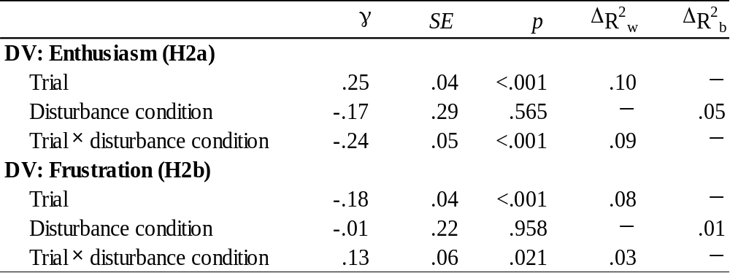
Note: n = 248 observations nested within N = 62 individuals. ΔR²_{w} refers to the variance accounted for at the within-person level of analysis when the variable is added to the model. Disturbance condition was coded 0 = distance disturbance and 1 = velocity disturbance. ΔR²_{b} refers to the variance accounted for at the between-person level of analysis when the variable is added to the model. Missing R² values indicate that the predictor does not vary at that level of analysis and thus cannot account for variance. Variables were added to the model in the order in which they appear in the table.
Table 3
Multilevel Modeling Results of Goal Commitment and Task Performance Regressed on Enthusiasm and Frustration (Study 1)
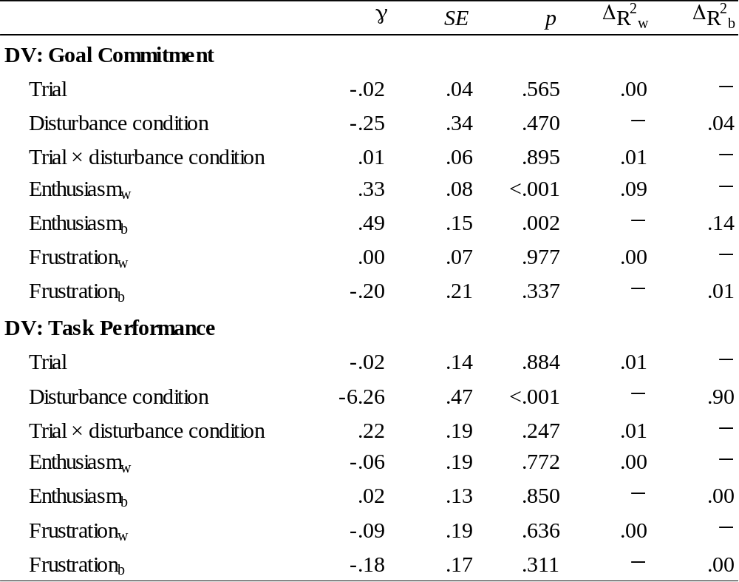
Note: For the model in which goal commitment is the dependent variable, n = 248 observations nested within N = 62 individuals. For the model in which task performance is the dependent variable, n = 186 observations nested within N = 62 individuals. A subscript "w” next to a predictor indicates a within-person centered variable. A subscript "b” next to a predictor indicates a variable that has been aggregated (i.e., averaged) to the between-person level of analysis. ΔR²_{w} refers to the variance accounted for at the within-person level of analysis when the variable is added to the model. ΔR²_{b} refers to the variance accounted for at the between-person level of analysis when the variable is added to the model. Missing R² values indicate that the predictor does not vary at that level of analysis and thus cannot account for variance. Control variables were added to the model in the order in which they appear in the table. The R² statistics for the hypothesis test variables refer to the variance accounted for when the variable was added to the model last.
Table 4
Between-person Moderated Indirect Effects of Disturbance Type on Goal Commitment and Task Performance via Enthusiasm and Frustration (Study 1)
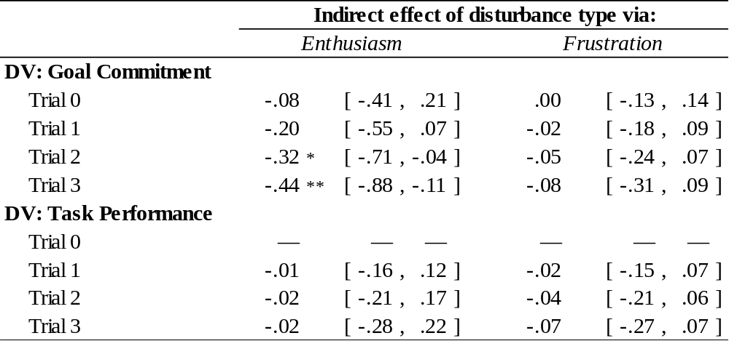
Note: *p < .05, **p < .01. Lower and upper bounds of the 95% confidence interval are shown in brackets. For the model in which goal commitment is the dependent variable, n = 248 observations nested within N = 62 individuals. For the model in which task performance is the dependent variable, n = 186 observations nested within N = 62 individuals. Indirect effects of disturbance type on task performance are missing at Trial 0 due to the lagging of the enthusiasm and frustration variables in the models predicting task performance.
Table 5
Means, Standard Deviations, and Correlations (Study 2)
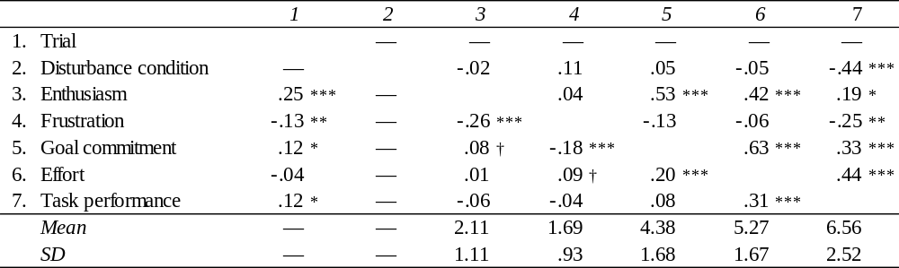
Note: Between-subjects correlations are shown above the diagonal (N = 134 individuals). Within-subjects correlations are shown below the diagonal (n = 536 observations for correlations not including goal commitment, effort, and/or task performance; n = 402 observations for correlations including goal commitment, effort, and/or task performance). †p < .10, *p < .05, **p < .01, ***p < .001.
Table 6
Trial × Disturbance Type Interaction on Enthusiasm and Frustration (Study 2)
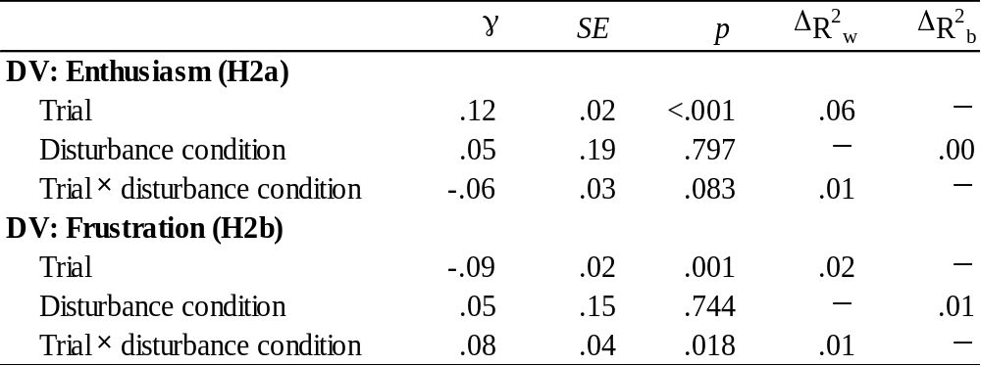
Note: n = 536 observations nested within N = 134 individuals. ΔR²_{w} refers to the variance accounted for at the within-person level of analysis when the variable is added to the model. Disturbance condition was coded 0 = distance disturbance and 1 = velocity disturbance. ΔR²_{b} refers to the variance accounted for at the between-person level of analysis when the variable is added to the model. Missing R² values indicate that the predictor does not vary at that level of analysis and thus cannot account for variance. Variables were added to the model in the order in which they appear in the table.
Table 7
Multilevel Modeling Results of Goal Commitment, Effort, and Task Performance Regressed on Enthusiasm and Frustration (Study 2)
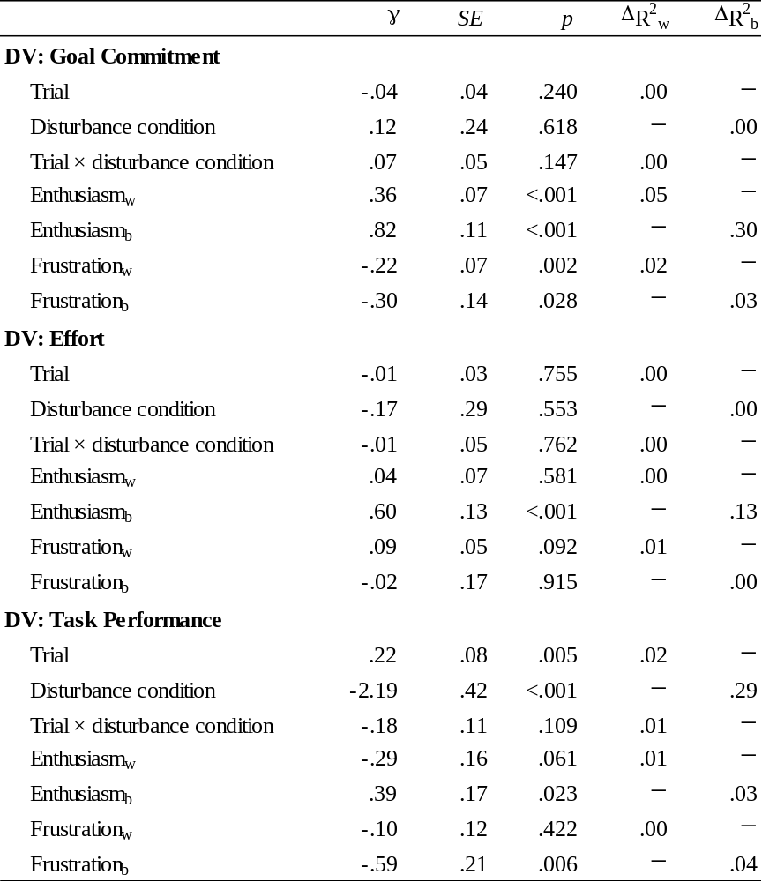
Note: For the model in which goal commitment is the dependent variable, n = 536 observations nested within N = 134 individuals. For the models in which effort and task performance are the dependent variable, n = 402 observations nested within N = 134 individuals. A subscript "w” next to a predictor indicates a within-person centered variable. A subscript "b” next to a predictor indicates a variable that has been aggregated (i.e., averaged) to the between-person level of analysis. ΔR²_{w} refers to the variance accounted for at the within-person level of analysis when the variable is added to the model. ΔR²_{b} refers to the variance accounted for at the between-person level of analysis when the variable is added to the model. Missing R² values indicate that the predictor does not vary at that level of analysis and thus cannot account for variance. Control variables were added to the model in the order in which they appear in the table. The R² statistics for the hypothesis test variables refer to the variance accounted for when the variable was added to the model last.

Table 8
Between-person Moderated Indirect Effects of Disturbance Type on Goal Commitment, Effort, and Task Performance via Enthusiasm and Frustration (Study 2)
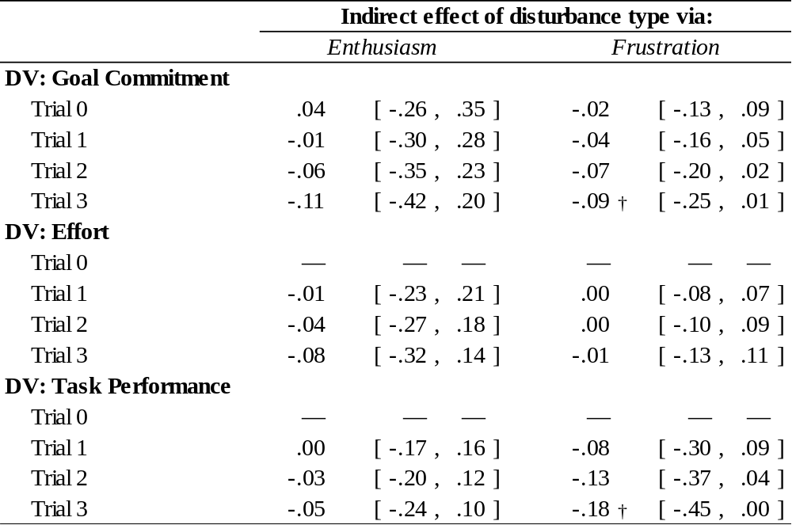
Note: †p < .10. Lower and upper bounds of the 95% confidence interval are shown in brackets. For the model in which goal commitment is the dependent variable, n = 536 observations nested within N = 134 individuals. For the models in which effort and task performance are the dependent variable, n = 402 observations nested within N = 134 individuals.
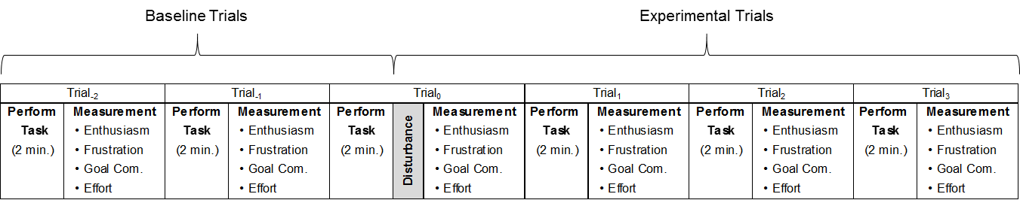
Figure 1. Summary of experimental timeline.

Notes: Effort was only measured in Study 2. Effort items referred to the amount of effort put forth on the previous trial.

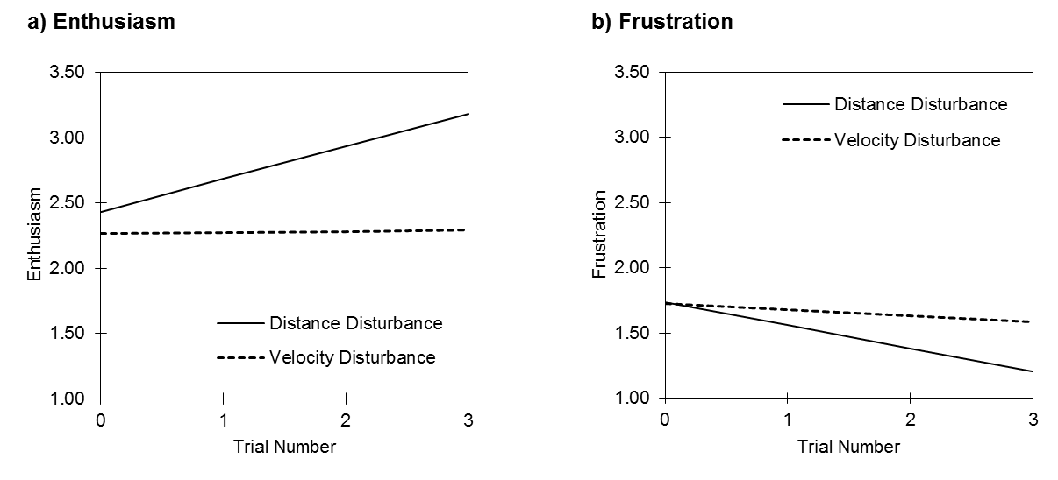
Figure 2. Interactions between trial number and disturbance type on (a) enthusiasm and (b) frustration in Study 1.
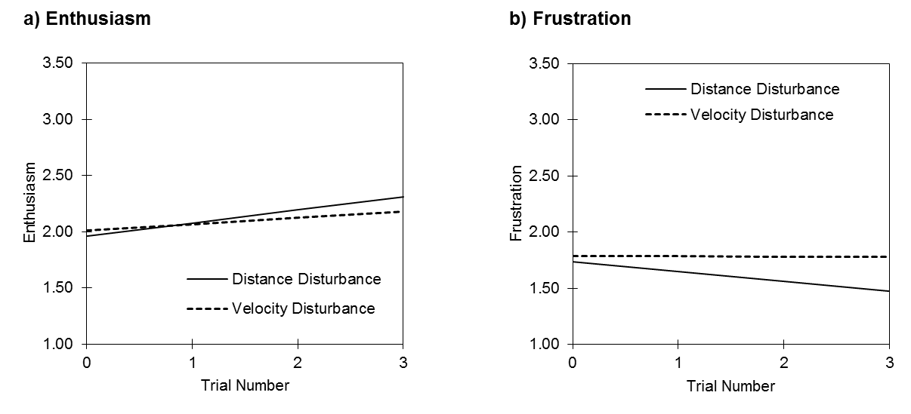
Figure 3. Interactions between trial number and disturbance type on (a) enthusiasm and (b) frustration in Study 2.

