Estimating ancient seawater isotope compositions and global ocean redox conditions by coupling the molybdenum and uranium isotope systems of euxinic organic-rich mudrocks

Appendix A. Supplementary materials

Xinze Lu^{1,} *, Tais W. Dahl², Wang Zheng³, Su Wang¹, Brian Kendall¹

¹Department of Earth & Environmental Sciences, University of Waterloo, Waterloo, ON, Canada
²GLOBE Institute, University of Copenhagen, Copenhagen K, Denmark
³Institute of Surface-Earth System Science, Tianjin University Tianjin, China

*Corresponding author: xlv@uwaterloo.ca

Sensitivity analyses of the coupled Mo-U isotope mass balance model
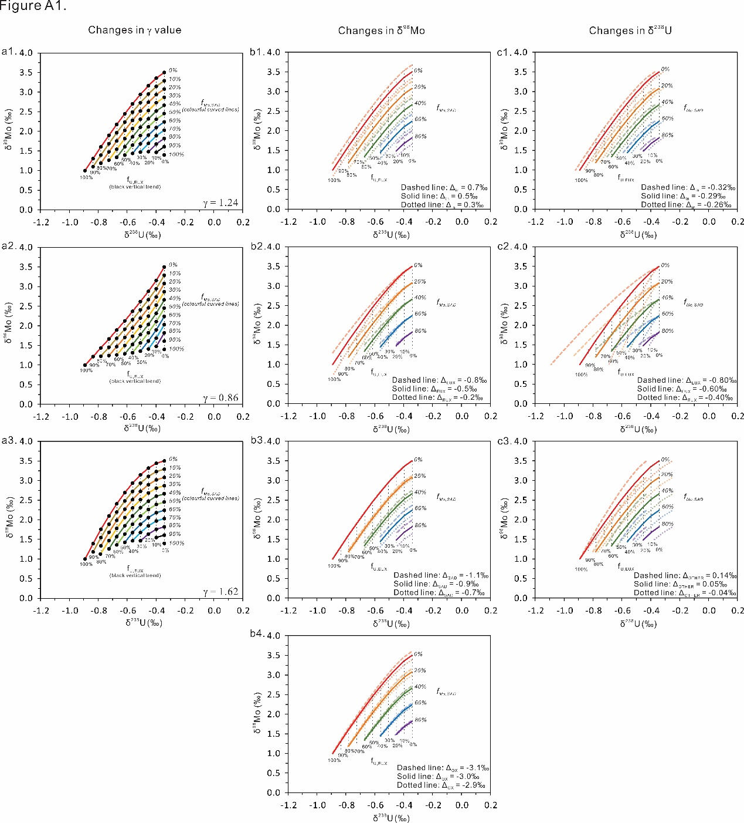
Figure A1. Sensitivity analysis of the coupled Mo-U isotope mass balance model. The left columns represent how the model changes with different γ values. The middle and right columns represent how the model solutions change with different Mo and U isotope compositions (of inputs and sinks) with γ = 1.24, respectively. The curved colorful lines in each figure of the middle and right columns are based on the a1 in the left column. Variations in δ²³⁸U of inputs and sinks have a larger impact on the model solutions compared with variations in δ⁹⁸Mo of inputs and sinks.
Geological Backgrounds
The 640 Ma Black River Dolomite
The Black River Dolomite was deposited on the Western Tasmania Terrane, which was a part of Antactica continental block during the Neoproterozoic (Direen and Crawford, 2003; Kendall et al., 2009). The depositional setting is a continental margin, and lithologies include dolostones, organic-rich sediments, and diamictite (Calver and Walter, 2000). The organic-rich mudrock interval is at the top of the Black River Dolomite, which has a depositional age of 640.7 ± 4.7 Ma based on Re-Os geochronology (Kendall et al., 2009). Iron speciation data suggest that bottom waters during deposition were anoxic (Fe_{HR}/Fe_{T} > 0.79) and sulfidic (Fe_{py}/Fe_{HR} > 0.90), which is also supported by elevated Mo concentrations (14-30 µg/g, Mo EF = 12-33) (Kendall et al., 2015). Molybdenum isotope compositions of the organic-rich shales are variable, ranging from 0.39‰ to 1.15‰ (Kendall et al., 2015).

The 520 Ma Yu’anshan Formation
The core samples of the Yu’anshan Formation are carbonaceous black shales with high TOC and pyrite contents (Dahl et al., 2010). The depositional environment was under debate: isolated from the open ocean (Hagadorn, 2002) vs well-connected to the open ocean (Babcock et al., 2001). Dahl et al. (2010) interpreted the environment to be a semi-restricted basin. The U-Pb dating of detrital zircons from Yu’anshan Shale provided a maximum age of 518.03 ± 0.69 Ma (2σ uncertainty), which is in an agreement with previous paleontological data suggesting a depositional age of 521-517 Ma (Babcock et al., 2001; Zhu et al., 2001; Yang et al., 2018). The Yu’anshan shales are suggested to contain ~2% TOC, Mo concentrations of 8-19 µg/g, and Mo isotope composition of 0.46-1.01‰ (Dahl et al., 2010). The euxinic bottom water conditions are based on iron speciation data (Fe_{HR}/Fe_{T} = 0.41-0.55, Fe_{py}/Fe_{HR} = 0.83-0.89; Dahl et al., 2010).

The 500 Ma and 485 Ma Alum Shale Formation
The Alum Shale Formation is suggested to be deposited in a shallow epicontinental sea in Baltica from the Middle Cambrian to the Early Ordovician (Schovsbo, 2003; Dahl et al., 2010). Shale samples are extremely enriched in TOC (up to 25%) and have high pyrite content (Schovsbo, 2003). Trilobites and brachiopods are the dominant fossils and are well preserved in the Cambrian Alum shale (Henningsmoen, 1957), whereas graptolites are more common in the Ordovician Alum shale (Tjernvik, 1958). Both Cambrian and Ordovician intervals were deposited under euxinic conditions based on Fe speciation data (Dahl et al., 2010). However, the Cambrian Alum shale (500 Ma) has slightly higher and more uniform Mo isotope compositions (δ⁹⁸Mo = 0.93-1.29‰) than the Ordovician Alum shale (485 Ma, δ⁹⁸Mo = 0.20-1.04‰) (Dahl et al., 2010).

The 465 Almelund Shale
The Almelund Shale is carbonaceous dark shale deposited on a continental outer shelf of Baltica (or a foreland basin) during the Middle Ordovician (465-462 Ma), and has a TOC of ~2% (Bergström et al., 2002; Dahl et al., 2010). It contains abundant graptolite and some small brachiopods (Maletz, 1995). Iron speciation suggests euxinic bottom water conditions (Fe_{HR}/Fe_{T} = 0.36-0.90, Fe_{py}/Fe_{HR} = 0.71-0.73) during deposition. However, Mo concentrations and isotope compositions are only 4.4-5.4 µg/g and 0.58-0.85‰, respectively (Dahl et al., 2010).

The 442 Ma Rastrites Shale
The Rastrites Shale was deposited on the marginal area of Baltica at the Ordovician-Silurian boundary (Koren and Bjerreskov, 1997; Schovsbo, 2003; Dahl et al., 2010). These black shales contain up to 3% TOC and are enriched in graptolites (Koren and Bjerreskov, 1997; Schovsbo, 2003). The bottom water redox conditions during deposition were anoxic (Fe_{HR}/Fe_{T} = 0.42-0.52) and sulfidic (Fe_{py}/Fe_{HR} = 0.72-0.78) (Dahl et al., 2010). Molybdenum concentrations in the Rastrites Shale (5.6-226.9 µg/g) are higher than that of the Almelund Shale. The Mo isotope compositions range from 0.42‰ to 1.28‰ (Dahl et al., 2010).

The 442 Ma Birkhill Shale
The Birkhill Shale was deposited on a continental margin with minimal restrictions to the open ocean (Scotese and McKerrow, 1990). The depositional age is broadly coeval with the Rastrites Shale (Cocks, 1985; Dahl et al., 2010). The Fe speciation data suggest mostly anoxic bottom water conditions (Fe_{HR}/Fe_{T} = 0.32-0.91, Fe_{py}/Fe_{HR} = 0.37-0.73; Dahl et al., 2010). The Mo isotope compositions of the Birkhill Shale are between −0.21‰ and 1.44‰ (Dahl et al., 2010).

The 365 Ma New Albany Shale and Chattanooga Shale
The New Albany Shale was deposited in the intracratonic Illinois Basin, whereas the Chattanooga Shale was coevally deposited ~300 km south of the New Albany Shale (Dahl et al., 2010). The conodont biozones of the Chattanooga Shale suggest a depositional age of 359.2-374.5 Ma (Over et al., 2009). Samples were taken from outcrops without weathering surfaces. Iron speciation data and high Mo concentrations support a euxinic depositional environment (Fe_{HR}/Fe_{T} = 0.66-0.71, Fe_{py}/Fe_{HR} = 0.70-0.80; Mo > 200 µg/g) for both shale intervals (Dahl et al., 2010). The New Albany Shale and the Chattanooga Shale have Mo isotope compositions of 1.65-1.85‰ and 1.37-1.58‰, respectively (Dahl et al., 2010).

Compilations of coupled Mo and U isotope compositions from published euxinic ORM (the Zaonega Formation, the upper Velkerri Formation, the Doushantuo Formation Member IV, the Fjäcka Shale, the Tanezzuft Formation, the Kettle Point Formation) are listed in Table S1.

References
Babcock, L. E., Zhang, W., & Leslie, S. A. (2001). The Chengjiang biota: Record of the Early Cambrian diversification of life and clues to exceptional preservation of fossils. GSA Today, 11, 4-9.
Bergström, S. M., Larsson, K., Pålsson, C., & Ahlberg, P. (2002). The Almelund Shale, a replacement name for the Upper Didymograptus Shale and the Lower Dicellograptus Shale in the lithostratigraphical classification of the Ordovician succession in Scania, Southern Sweden. Bulletin of the Geological Society of Denmark, 49, 41-47.
Calver, C. R., & Walter, M. R. (2000). The late Neoproterozoic Grassy Group of King Island, Tasmania: correlation and palaeogeographic significanc. Precambrian Research, 100, 299-312.
Cocks, L. (1985) The Ordovician-Silurian boundary. Episodes 8(2), 98-100.
Dahl, T. W., Hammarlund, E. U., Anbar, A. D., Bond, D. P. G., Gill, B. C., Gordon, G. W., Knoll, A. H., Nielsen, A. T., Schovsbo, N. H., & Canfield, D. E. (2010). Devonian rise in atmospheric oxygen correlated to the radiations of terrestrial plants and large predatory fish. Proceedings of the National Academy of Sciences, 107(42), 17911-17915.
Direen, N. G., & Crawford, A. J. (2003). Fossil seaward-dipping reflector sequences preserved in southeastern Australia: a 600 Ma volcanic passive margin in eastern Gondwanaland. Journal of the Geological Society, London, 160, 985-990.
Hagadorn, J. W. (2002). Chengjiang: early record of the Cambrian explosion. Columbia University Press, pp 35-60.
Henningsmoen, G. (1957). The trilobite family Olenidae: With description of Norwegian material and remarks on the Olenid and Tremadocian Series. Skrifter Utgitt av det Norske Videnskaps-Akademi I Oslo, I, Matematisk-naturvidenskapelig Klasse, 1-303.
Kendall, B., Creaser, R. A., Calver, C. R., Raub, T. D., & Evans, D. A. D. (2009). Correlation of Sturtian diamictite successions in southern Australia and northwestern Tasmania by Re–Os black shale geochronology and the ambiguity of “Sturtian”-type diamictite–cap carbonate pairs as chronostratigraphic marker horizons. Precambrian Research, 172(3-4), 301-310.
Kendall, B., Komiya, T., Lyons, T. W., Bates, S. M., Gordon, G. W., Romaniello, S. J., Jiang, G., Creaser, R. A., Xiao, S., McFadden, K., Sawaki, Y., Tahata, M., Shu, D., Han, J., Li, Y., Chu, X., & Anbar, A. D. (2015). Uranium and molybdenum isotope evidence for an episode of widespread ocean oxygenation during the late Ediacaran Period. Geochimica et Cosmochimica Acta, 156, 173-193.
Koren, T., & Bjerreskov, M. (1997). Early Llandovery monograptids from Bornholm and the southern Urals: taxonomy and evolution. Bulletin of the Geological Society of Denmark, 44, 1-43.
Maletz, J. (1995). The Middle Ordovician (Llanvirn) graptolite succession of the Albjära core (Scania, Sweden) and its implication for a revised biozonation. Zeitschrift für Geologische Wissenschaften, 23, 249-259.
Over, D. J., Lazar, R., Baird, G. C., Schieber, J., & Ettensohn, F. R. (2009). Protosalvinia Dawson and Associated Conodonts of the Upper Trachytera Zone, Famennian, Upper Devonian, in the United States. (Translated from English) Journal of Paleontology, 83(1), 70-79.
Schovsbo, N. H. (2003). The geochemistry of Lower Palaeozoic sediments deposited on the margins of Baltica. Bulletin of the Geological Society of Denmark, 50, 11-27.
Scotese, C. R., & McKerrow, W. S. (1990). Revised World maps and introduction. In W. S. McKerrow & C. R. Scotese (Eds.), Paleozoic Paleogeography and Biogeography (Vol. 12, pp. 1-21): Geological Society London Memoirs.
Tjernvik, T. E. (1958). The Tremadocian Beds at Flagabro in South-Eastern Scania (Sweden). Geologiska Föreningen i Stockholm Förhandlingar, 80(3), 259-276.
Yang, C., Li, X.-H., Zhu, M., Condon, D. J., & Chen, J. (2018). Geochronological constraint on the Cambrian Chengjiang biota, South China. Journal of the Geological Society, 175(4), 659-666.
Zhu, M., Zhang, J., & Li, G. (2001). Sedimentary environments of the Early Cambrian Chengjiang Biota: Sedimentology of the Yu'anshan Formation in Chengjiang county, eastern Yunnan. Acta Palaeontologica Sinica, 40 (Sup.), 80-105.

